**Emma Prager**

**ITMD 411**

**Lab 04**

**April 19, 2019**

Improve the program for Bank of IIT to help in deciphering whom from its records should be exclusive to premium loans versus those offered micro or less premium loans.

A database is used to store then present Loan analysis information from your data BankRecords objects from prior labs. Three additional files were added

* DBConnect.java to allow an object to connect / close a database connection.
* Dao.java where Dao stands for Data Access Object. This will allow for database connectivity and CRUD (Create Read Update Delete) like operations.
* LoanProcessing.java acts as a driver file (i.e., includes main function) to call the database CRUD methods and create some resulting output.

The results are displayed to the console:

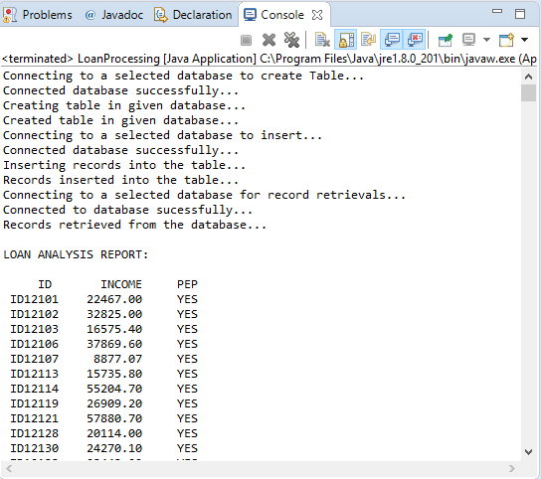

/*

* Emma Prager

* 04/19/2019

* DBConnect.java

* Lab 04

*/

**import** java.sql.Connection;

**import** java.sql.DriverManager;

**import** java.sql.SQLException;

**public** **class** DBConnect {

// Code database URL

**static** **final** String ***DB_URL*** = "jdbc:mysql://www.papademas.net:3307/411labs?autoReconnect=true&useSSL=false";

// Database credentials

**static** **final** String ***USER*** = "db411", ***PASS*** = "411";

**public** Connection connect() **throws** SQLException {

**return** DriverManager.*getConnection*(***DB_URL***, ***USER***, ***PASS***);

}

}

/*

* Emma Prager

* 04/19/2019

* Dao.java

* Lab 04

*/

**import** java.sql.ResultSet;

**import** java.sql.SQLException;

**import** java.sql.Statement;

**public** **class** Dao {

//Declare DB objects

DBConnect conn = **null**;

Statement stmt = **null**;

// constructor

**public** Dao() { //create db object instance

conn = **new** DBConnect();

}

// CREATE TABLE METHOD

**public** **void** createTable() {

**try** {

// Open a connection

System.***out***.println("Connecting to a selected database to create Table...");

System.***out***.println("Connected database successfully...");

// Execute create query

System.***out***.println("Creating table in given database...");

stmt = conn.connect().createStatement();

String sql = "CREATE TABLE e_Prag_tab " +

"(pid INTEGER not NULL AUTO_INCREMENT, " +

" id VARCHAR(10), " +

" income numeric(8,2), " +

" pep VARCHAR(4), " +

" PRIMARY KEY ( pid ))";

stmt.executeUpdate(sql);

System.***out***.println("Created table in given database...");

conn.connect().close(); //close db connection

} **catch** (SQLException se) {

// Handle errors for JDBC

se.printStackTrace();

}

}

// INSERT INTO METHOD

**public** **void** insertRecords(BankRecords[] robjs) {

**try** {

System.***out***.println("Connecting to a selected database to insert...");

System.***out***.println("Connected database successfully...");

// Execute a query

stmt = conn.connect().createStatement();

String sql = **null**;

System.***out***.println("Inserting records into the table...");

// Include all object data to the database table

**for** (**int** i = 0; i < robjs.length; ++i) {

// finish string assignment to insert all object data

// (id, income, pep) into your database table

sql = "INSERT INTO e_Prag_tab(id, income, pep) " + "VALUES (' "+robjs[i].getId()+" ', ' "+robjs[i].getIncome()+" ', ' "+robjs[i].getPep()+" ' )";

stmt.executeUpdate(sql);

}

System.***out***.println("Records inserted into the table...");

conn.connect().close();

} **catch** (SQLException se) { se.printStackTrace(); }

}

**public** ResultSet retrieveRecords() {

ResultSet rs = **null**;

System.***out***.println("Connecting to a selected database for record retrievals...");

**try** {

stmt = conn.connect().createStatement();

System.***out***.println("Connected to database sucessfully...");

} **catch** (SQLException e) {

// **TODO** Auto-generated catch block

e.printStackTrace();

}

String sql = "select id, income, pep from e_Prag_tab order by pep desc";

**try** {

rs = stmt.executeQuery(sql);

System.***out***.println("Records retrieved from the database...");

} **catch** (SQLException e) {

// **TODO** Auto-generated catch block

e.printStackTrace();

}

**try** {

conn.connect().close();

} **catch** (SQLException e) {

// **TODO** Auto-generated catch block

e.printStackTrace();

}

**return** rs;

}

}

/*

* Emma Prager

* 04/19/2019

* LoanProcessing.java

* Lab 04

*/

**import** java.sql.ResultSet;

**import** java.sql.SQLException;

**public** **class** LoanProcessing **extends** BankRecords{

**public** **static** **void** main(String[] args) {

BankRecords br = **new** BankRecords();

br.readData();

Dao dao = **new** Dao();

//dao.createTable();

//dao.insertRecords(robjs); // perform inserts

ResultSet rs = dao.retrieveRecords(); // fill result set object

// Create heading for display

System.***out***.println("\nLOAN ANALYSIS REPORT:\n");

//print out all the records from the recordset to the console in a nice columnar format

//included with heading names for id, income and pep

System.***out***.printf("%7s %12s %7s\n", "ID", "INCOME", "PEP");

// Extract data from result set

**try** {

**while** (rs.next()) {

// Retrieve data by column name (i.e., for id,income,pep)

// Display values for id,income,pep

String id = rs.getString("id").toUpperCase();

Double income = rs.getDouble("income");

String pep = rs.getString("pep");

// print the results

System.***out***.printf("%7s %10.2f %7s\n", id, income, pep);

}

} **catch** (SQLException e) {

// **TODO** Auto-generated catch block

e.printStackTrace();

}

**try** {

rs.close(); // closes result set object

} **catch** (SQLException e) {

// **TODO** Auto-generated catch block

e.printStackTrace();

}

}

}