EPRI Lightning Transients Program
32-bit Console-Mode Version

This manual describes a console-mode version of the transients program used in LPDW and SDW. The console-mode version of this program is EPRI research-grade code, because it lacks a sophisticated user interface. LPDW’s DFlash module uses a Microsoft Windows version of this transients program to calculate flashover performance and transformer protection of distribution lines. The LPDW CFlash module uses this program to evaluate arrester protection of underground distribution cables. SDW uses this program to perform insulation coordination studies of incoming lightning surges.

The LPDW and SDW users do not see the direct input or output from this transients program. DFlash forms the transients program input from the user's project database, and automatically selects the cases to run for each pole design. DFlash also interprets and stores the output. The transient program input and case selection is constrained by DFlash, so that the user is not responsible for debugging input files. Similarly, SDW constructs input for the transient program based on the substation database. Thus, LPDW’s and SDW’s use of this transients program is considerably simpler than a typical use of the Electromagnetic Transients Program (EMTP).

There are few error checks on the input data, and no checks on whether the data is reasonable. The LPDW and SDW user interfaces handle this input data checking. It may be possible to "crash" the console-mode version of this program with inappropriate input data.

The console-mode version is not covered by the Electric Power Software Center's user support, including the ESWorkstation Hotline. Please contact the EPRI project manager with any questions or comments. We will attempt to respond, but cannot guarantee full support.

A previous version of this program was distributed with LPDW versions 1.0 through 4.0. This version has been revised as follows:

- Converted to 32-bit, and must be run from an MS-DOS Prompt window in either Windows NT or Windows 95.
- Renamed from LT.EXE to ELT.EXE.
- Added a surge waveshape with concave front, and maximum steepness near the peak.
- Added a leader progression insulator model.
- Added an arrester model with Bezier spline fit to multiple VI characteristic points, and a dynamic turn-on conductance for steep fronts.
- Networked systems can be simulated.
- More than one span configuration can be used in the model.
- Spans can have non-uniform lengths, and non-uniform number of conductors

These changes make the program suitable for substation insulation coordination studies, and also for lightning protection studies of combined overhead/underground systems.

Table of Contents

1 INTRODUCTION 4
1.1 Analyzing Pole Designs from DFlash 6
1.2 Analyzing Substations from SDW 6
2 INSTALLING AND RUNNING THE PROGRAM 8
3 ENGINEERING ASSUMPTIONS AND MODEL CHARACTERISTICS 9
3.1 Bus Conductors 9
3.2 Surge Current 10
3.2.1 1-cosine Front 10
3.2.2 Concave Front 11
3.3 Insulators 12
3.3.1 Destructive Effect Model 12
3.3.2 Leader Progression Model 13
3.4 Surge Arresters 15
3.4.1 Switch Model 15
3.4.2 Spline Model 16
3.5 Pole Grounds 19
3.6 Power Frequency Source 20
3.7 Pole-Top Transformer and Service Drop 21
3.8 Pre-Discharge Currents 21
4 INPUT AND OUTPUT FORMATS 23
4.1 Required Simulation Control Parameters 25
4.2 Required Conductor Data 26
4.3 Optional Pole Components 27
4.4 "Pairs" Input 31
4.5 "Poles" Input 31
4.6 Program Output 31
4.7 Network System Input 31
5 EXAMPLES 34
6 REFERENCES 40

List of Figures

Figure 1 The Circuit Structure is a series of poles and line sections. 5
Figure 2 1-cosine Surge Current Parameters 11
Figure 3 Typical Lightning Surge Current Parameters, surge vs. steepfront Models. 12
Figure 4 Air-Porcelain Insulator Volt-Time Curves, Destructive Effect and Leader Progression Models. 14
Figure 5 Volt-Time Curves Extended to Long Flashover Times 15
Figure 6 Surge Arrester Switch Model. 18
Figure 7 Arrester vs. Arrbez Model, 20 kA, 1x20 Discharge Current. 18
Figure 8 Bezier Spline vs. Piecewise Linear Characteristic, 20 kA, 1x20 Discharge Current. 19
Figure 9 Arrbez Turn-On Conductance and Inductance Model, Uref = 0.051, L = 0.3 μH, 20 kA, 1x20 Discharge Current. 19
Figure 10 Pre-discharge Currents on a Single-phase Line. 22
Figure 11 Example Conductor Configuration. 27
Figure 12 Scout and Cable Arrester Application 36
Figure 13 138-kV Substation Application 39

List of Tables

Table 1 Bus Conductor Surge Impedances 10
Table 2 Built-in Surge Arrester Discharge Characteristics 16
Table 3 Transients Program Input Formats for Non-Network System 24
Table 4 Text Output 33
Table 5 Example Program Input for Overhead Line 35
Table 6 Example Program Input for Scout Arrester Scheme 37
Table 7 Example Program Input for 138-kV Substation 38

1 INTRODUCTION

This program simulates the effect of direct lightning flashes to electric power distribution lines. The main application would be analysis of the effect of surge arresters, pole grounding, and insulation strength on the flashover rate from direct flashes to the line. A planned enhancement to the program will simulate nearby lightning flashes. Another application is the simulation of surges entering a substation from a shielding failure or backflash out on the line.

The solution algorithms are similar to those used in the "industry standard" Electromagnetic Transients program (EMTP)[1]. However, the program input and overall structure have been customized and simplified for this particular application.

Figure 1 shows the circuit structure analyzed for overhead lines. It includes a series of one or more poles, with each pole connected by a section of line with one or more conductors. One conductor, typically the neutral, may be grounded at selected poles or at all poles. Each line section must have the same span length and conductor configuration.

Figure 1 also shows optional features, connected to some of the poles. These include:

- Insulators
- Surge arresters
- Terminations, with optional D.C. voltage bias
- Meters for plotted voltage output
- Meters for arrester, pole ground, and service drop currents
- Surge current to represent a direct flash to a conductor

The program can also simulate lumped resistors, inductors, and capacitors. However, it is not suitable for the study of switching transients.
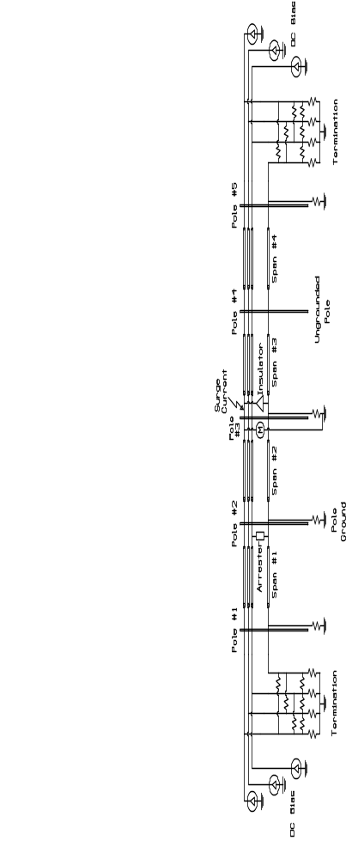
Figure 1 The Circuit Structure is a series of poles and line sections.

1.1 Analyzing Pole Designs from DFlash

When DFlash calculates the Flashovers for a Pole Design, it runs a version of ELT.EXE. The basic input file is copied to the hard disk in a file called DRIVENLT.DAT, which may be found in the LPDW subdirectory. You can use this file as input to the console-mode version of ELT.EXE, make changes with a text editor, and view results with TOP. Some things to be aware of include:

- You may wish to add some meters and current outputs to the DRIVENLT.DAT file. DFlash use the summary results, but it generates plotted waveforms only as an option.
- The lightning stroke current magnitude and front time in DRIVENLT.DAT, and the stroke location, are "typical" values. DFlash changes these under control of an iteration algorithm; you should change these manually.
- ELT.EXE does not simulate induced voltages from nearby strokes.
- The DRIVENLT.DAT file will have SI (metric) units, even if you specified English units in the DFlash user interface.
- The lines in DRIVENLT.DAT are separated by a "line feed", but no "carriage return". Many text editors will display these lines properly, but some will not. You may need to manually insert "carriage returns" in the DRIVENLT.DAT file.

To calculate an overall number of flashovers for a given design, you must properly combine the results of many cases. DFlash does this automatically. Appropriate uses of this console-mode program might include:

- Exploration of models and assumptions used in LPDW and SDW.
- Plotting and examining surge waveshapes for an LPDW pole design.
- Modelling special situations - unlike DFlash, each pole can be different in this program.
- Exploring the effect of predischarge currents.
- Modelling underground systems connected to overhead lines.

References 2 and 3 of this manual describe a method of simulating induced voltages from nearby lightning strokes. However, DFlash uses the simplified induced voltage equations described in the on-line reference and the LPDW User Seminar Notes. Also, DFlash does not use the pre-discharge current model described in this manual.

1.2 Analyzing Substations from SDW

SDWorkstation generates ELT input files using the network model format described in Section 4.7. The model components will include arrbez for the surge arresters, lpm for the insulators, and steepfront for the incoming surges. A power-frequency offset is also used. There are no ground resistances in the substation, but a Norton equivalent for the incoming surge may include a tower footing resistance.

Insulator flashovers are disabled during the simulation, but the severity index for each insulator is calculated at the end of the simulation. The binary plot file includes insulator voltages, arrester voltages, and arrester discharge currents.

Most of the parameter adjustments can be made through the SDWorkstation user interface. The console-mode transients program could be used to explore:

- effect of using the destructive effect insulator model
- effect of adjusting the arrester model’s turn-on conductance
- effect of changing the insulator leader progression model parameters

The rest of this manual covers the following topics:

- Directions for installing and running the simulation and plotting programs
- Engineering assumptions and model characteristics
- Input and output formats
- Examples

2 INSTALLING AND RUNNING THE PROGRAM

This software requires Windows 95 or Windows NT. The Output Processor (TOP) software must be installed to plot waveform outputs. A text editor is also needed to create the input files. The mouse is not used. The software is a console-mode application that must be run from a DOS command prompt.

To install the software, first create a subdirectory on the hard disk. Then copy elt.zip to that directory, and use pkunzip or Winzip to unzip the following files:
ELT.EXE the executable program
ELT.DOC this manual, in Microsoft Word 97 format
*.DAT several sample cases, described later in this manual
RUNTESTS.BAT batch file to solve all the sample cases

Other input files may be created with a text editor, according to formats described later in this manual. The input file must be named with a ".dat" extension.

The lightning transients program reads an input file, and creates one or two files for printed output and plot data. The command to execute this program is:

Command: elt overhead

Reads: overhead.dat
Writes Plot Data File: overhead.elt
Writes Output File: overhead.out

Note that the program always uses file extension .dat for input files, .out for text output files, and .elt for binary plot output files. The program only creates plot data if the input file specifies voltage or current outputs.

The voltage and current meter outputs may be plotted with The Output Processor (TOP) software. The file type to open in TOP is called “EPRI Lightning Transients” and the file extension is *.elt. See the TOP manual or on-line help for more information.

3 ENGINEERING ASSUMPTIONS AND MODEL CHARACTERISTICS

The multi-conductor overhead line sections are subject to the following simplifying assumptions:

1. Earth return path has perfect conductivity.
2. Conductors have no resistance.

These assumptions produce the following self and mutual surge impedances for travelling waves:

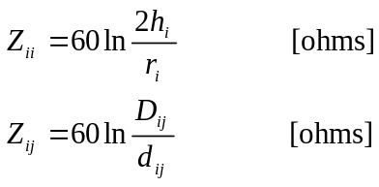

Where: i, j = conductor #'s
h = conductor height [m]
r = conductor radius [m]
d = distance between two conductors [m]
D = Distance between conductor i and image (below ground)
of conductor j [m]

The transmission line equations are then decoupled into single-phase modes. Because of assumption #1 above, travelling waves propagate at the speed of light in all modes. The travelling wave model is similar to EMTP's[1].

As an alternative to conductor data, the user may input the surge impedance and travelling wave velocity directly. This option is only available for uncoupled conductors. This option is useful for cables, which have lower surge impedances and travelling wave velocities than overhead lines. It can also be used for surge arrester leads.

All other model components are connected to poles. The solution of these lumped component models is also similar to EMTP's[1]. The following paragraphs describe model characteristics for these lumped components.

3.1 Bus Conductors

The SDWorkstation includes three kinds of bus conductor:

- round tube, described by outside radius R₀
- angle, described by side lengths L and W, and wall thickness t
- IWCB, also described by side lengths L and W, and wall thickness t
These bus conductor types are simulated by adjusting the input conductor radius. Round tubes are modelled the same way as stranded overhead line conductors. Because all high-frequency current is assumed to flow on the surface of the conductor, the round tube’s outer radius is input.

In both the angle and IWCB types, high-frequency currents tend to concentrate in the corners. Based on finite element simulations, it is apparent that currents in the angle bus concentrate on the two open edges, but not on the interior corner. Currents in the IWCB bus will concentrate on all four corners of the square or rectangle. The standard formulas for bundled conductors can approximate these distributions of current. The equivalent bus conductor radius is:
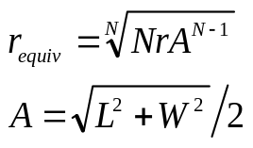

where:
N = number of conductors in bundle, 2 for angle and 4 for IWCB
r = subconductor radius = t/2
t = bus wall thickness
L = one side length of angle or IWCB cross section
W = adjacent side length of angle or IWCB cross section
A = radius of circle through subconductor centers

There will be a slight error in using these equations for IWCB with rectangular rather than square cross sections.

For example, consider the self impedance of a single bus conductor at height 10 meters. For a round tube, the outside diameter is 6 inches, or 0.1524 meters. For the angle and IWCB, the length and width are both 0.1524 meters, and the wall thickness is 0.5 inches, or 0.0127 meters. The equivalent radii and surge impedances are:

Table 1 Bus Conductor Surge Impedances
Bus Type | N | r | A | r_{equiv} | Z
Round Tube | 1 | 0.0762 | N/A | 0.0762 | 334.2
Angle | 2 | 0.00635 | 0.1078 | 0.0370 | 377.6
IWCB | 4 | 0.00635 | 0.1078 | 0.0751 | 335.1

The IWCB has nearly the same surge impedance as a round tube with similar outer dimensions, while the angle bus has a higher surge impedance. There will be no effect on mutual surge impedances between bus conductors.

3.2 Surge Current

There are two surge current waveshape models in the program. The surge component uses a 1-cosine front. This component was used in LPDW version 1.0 through 4.0, including the transmission line simulations in version 4.0. A steepfront component, with concave front, was added for SDWorkstation.

3.2.1 1-cosine Front

The surge current waveshape has a 1-cosine front, and an exponential tail decay. As Figure 2 shows, this waveshape has a "toe" at the front and a relatively flat peak. For a direct flash to the line, a surge current should be connected from the struck conductor to ground. The program allows a delayed starting time for the surge, which would shift the waveshape in Figure 2 to the right.

3.2.2 Concave Front

Typical lightning current surges have a pronounced toe, flat peak, and maximum current steepness near the peak of the surge. Based on [9], the steepfront surge component uses Bezier splines to define a current front with maximum steepness at 90% of the crest value, with a flat peak and exponential tail. In contrast, the 1-cosine shape has maximum steepness at 50% of the crest value. Figure 3 shows a 30-kA surge, with 3.67-us front, represented by the two different surge models. The concave shape reaches its peak later, but its virtual zero based on the 30% and 90% points also occurs later. This difference in virtual zeros must be accounted for when constructing volt-time curves for insulators. Both shapes have the same front time, based on the 30% and 90% points. The concave shape is more realistic, and could produce higher voltages in arrester-protected systems, due to the higher maximum steepness.

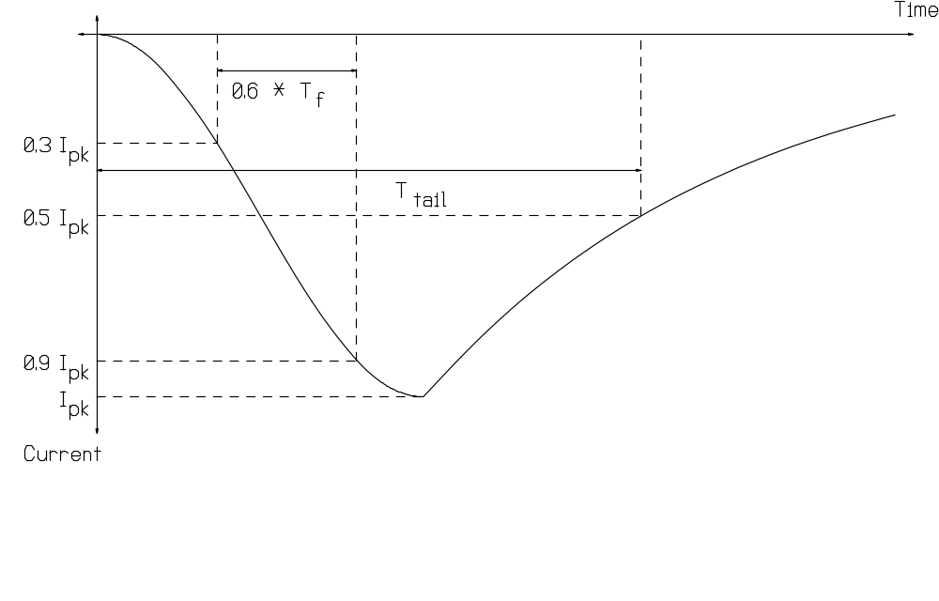
Figure 2 1-cosine Surge Current Parameters

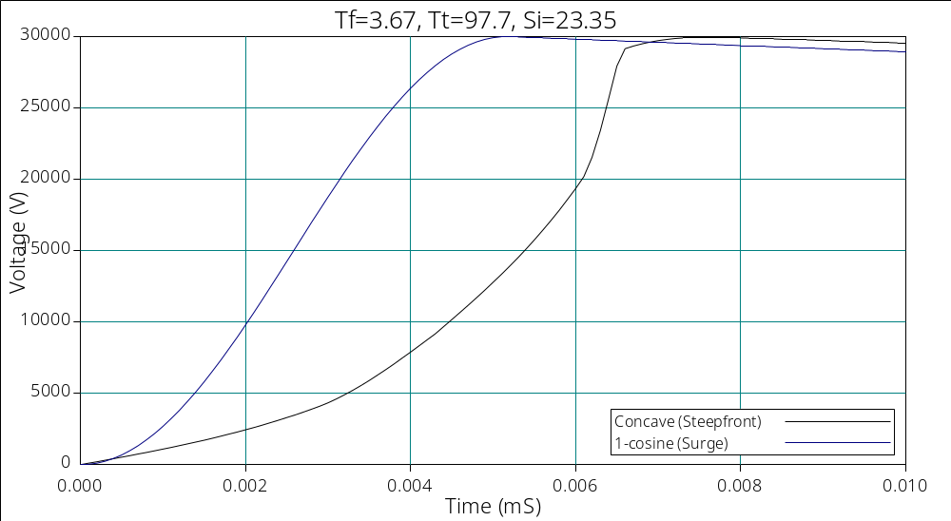
Figure 3 Typical Lightning Surge Current Parameters, surge vs. steepfront Models.

3.3 Insulators

Insulators may be connected between pairs of conductors, or between a conductor and ground. The typical phase insulator would be connected from a phase conductor to the neutral conductor, rather than from phase conductor to ground. There are two insulator models available. LPDW version 1.0 through 4.0 used the destructive effect model, while SDWorkstation and future versions of DFlash will use the leader progression model.

3.3.1 Destructive Effect Model

The program integrates voltage across the insulator to determine a "Destructive Effect":

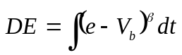

where: e = magnitude of voltage across insulator
Vb = minimum breakdown voltage
ß = exponent

When DE exceeds a critical level, the insulator flashes over. This equation simulates the volt-time curve, as illustrated in Figure 4. For an insulator with Critical Flashover Voltage of 100 kV, typical parameters are:

Vb = 0.0
ß = 5.42434
DEmax = 8.4265E21

The program integrates DE only when the magnitude of "e" exceeds Vb. The program maintains both positive and negative polarity DE values, either of which may produce a flashover. If the voltage changes polarity, the DE value is maintained until the voltage changes polarity again. Thus, the DE values can never decrease during a simulation; they may only increase or remain constant. This crudely simulates the leader progression process.

Each insulator is an open circuit, not affecting the simulation, unless the destructive effect across the insulator exceeds the critical level. At that instant, the insulator becomes a short circuit, connecting the two conductors for the rest of the simulation.

If the insulator does not flash over, the program outputs a "per-unit severity index." The insulator would probably flash over if the voltage across the insulator were increased by a factor 1.0/SI, but kept the same waveshape.

3.3.2 Leader Progression Model

The leader progression model is based on the based on the physics of flashover [9], whereas the destructive effect method is more of a curve-fitting approach. The leader progression model generally gives more accurate results.

Only the leader propagation time is modeled; the corona inception time and streamer propagation time are ignored. The program keeps track of the remaining unbridged gap length in both positive and negative directions. The leader propagation velocity is:
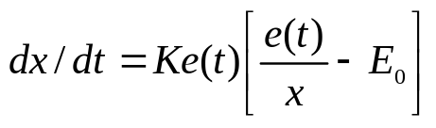

where K = propagation constant
E₀ = breakdown gradient
x = unbridged gap length
e(t) = voltage across gap

The unbridged gap length, x, starts at a value given by CFO / E₀. Two instances of this equation are integrated at each time step, one for positive e(t) and one for negative e(t). Only one leader can grow at each time step, and only if e(t) exceeds E₀.

For air-porcelain insulations, E₀ = 535.0e3 and K = 7.785e-7. For apparatus insulations, E₀ = 551.3e3 and K = 1.831e-6.

Whenever either the positive or negative leader’s x reaches zero, the insulator flashes over. The program can also run in a mode where insulator flashovers are disabled. The waveshape across each insulator is saved in memory. At the end of the simulation, the saved waveshape is scaled up and down using the bisection method to determine the crest voltage that just barely causes flashover. This produces the severity index for each insulator. The severity index can be greater than one if insulator flashovers were disabled. If an insulator flashover occurs during the simulation, the program reports a severity index of 1.0.

Figure 4 shows the volt-time curves for a 100 kV CFO insulation in air, using both insulator models. Each model was run with both 1-cosine and concave surge waveshapes for a 1.2 x 50 waveshape, but Figure 4 shows that the surge front model had little impact on the results. Figure 4 shows that the leader progression model takes longer to flash over at a given crest voltage.

At voltages below the CFO, Figure 5 shows that flashovers can still occur with the destructive effect model, which might be considered a defect. These flashovers can be eliminated by using a non-zero value for V_{b}, but then the curve fit isn’t as good at higher voltages and lower flashover times. The leader progression model should work better over a wider range of crest voltages and times to flashover.
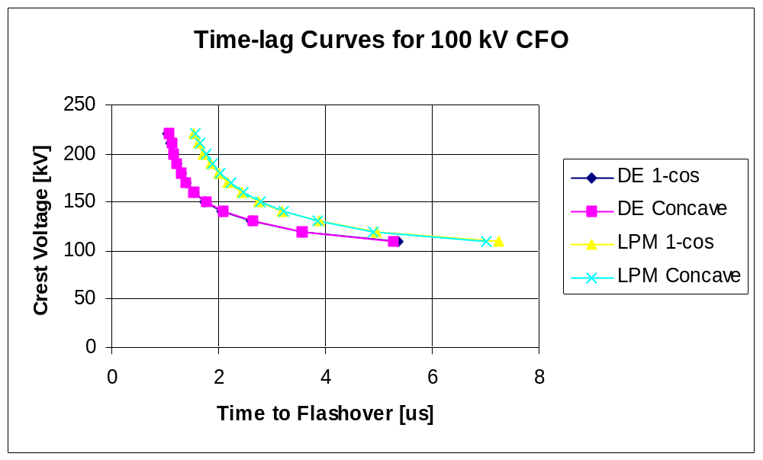
Figure 4 Air-Porcelain Insulator Volt-Time Curves, Destructive Effect and Leader Progression Models.
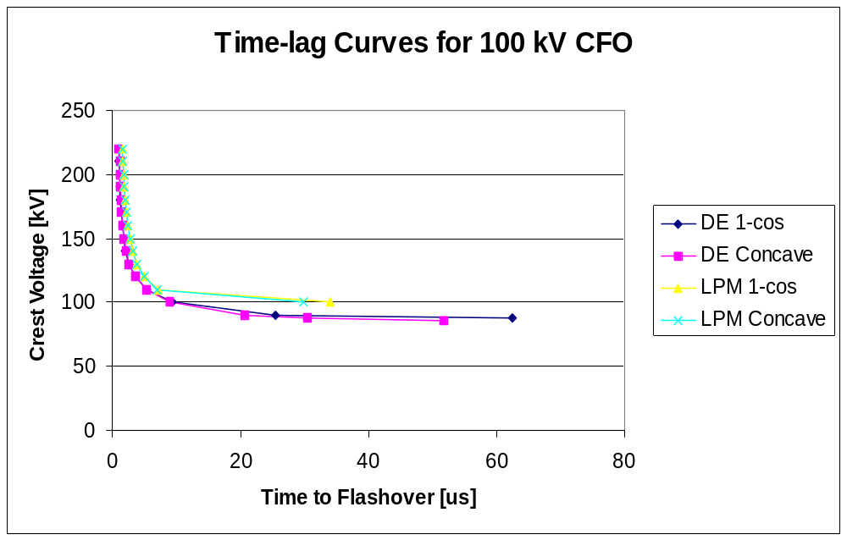
Figure 5 Volt-Time Curves Extended to Long Flashover Times

3.4 Surge Arresters

There are two surge arrester models available. Both models have optional built-in series gap and lead inductance. LPDW versions 1.0 through 4.0 used a simple switched model, with one linear segment for the discharge characteristic.

If the surge arrester gap sparks over, it will conduct until the voltage falls below Vknee. At that point, the gap recovers its full strength for voltage transients of positive or negative polarity.

The arrester model includes a built-in lead inductance, which may be input as zero. With a non-zero inductance, the output voltage at the arrester lead terminals will be increased for short impulses. However, the program keeps track of the actual arrester voltage for energy calculations.

On distribution lines, most surge arresters would be connected from a phase conductor to the neutral conductor.

3.4.1 Switch Model

A surge arrester includes a non-linear resistance designed to limit transient overvoltages. Some surge arresters have a gap that allows a higher peak transient voltage than the discharge voltage across the non-linear resistance. These characteristics are shown in Figure 6. In this program, the surge arrester switch model is an open circuit until the voltage exceeds Vgap or Vknee, whichever is greater. At that time, the discharge characteristic follows a single linear segment. Using this model, it is possible to fit two points on the discharge characteristic; LPDW versions 1.0 through 4.0 matched the 10-kA and 20-kA points.

3.4.2 Spline Model

There are two built-in 8x20 discharge characteristics, obtained from the data General Electric provides for its metal oxide arresters. Both characteristics are provided in per-unit of the 10-kA discharge voltage. One characteristic is for arresters rated 48 kV and below, or a 10-kA discharge voltage of 140 kV and below. The other characteristic is for arresters rated 54 kV and above. Both characteristics are shown in Table 2; the program selects one based on the input 10-kA discharge voltage.

Table 2 Built-in Surge Arrester Discharge Characteristics
I [A] | V/V₁₀
 | V₁₀ < 140e3 | V₁₀ ≥ 140e3
0.00 | 0.000 | 0.000
0.01 | 0.500 | 0.500
1.0 | 0.663 | 0.691
10.0 | 0.696 | 0.725
100.0 | 0.743 | 0.769
500.0 | 0.794 | 0.819
1000.0 | 0.824 | 0.847
2000.0 | 0.863 | 0.881
5000.0 | 0.937 | 0.946
10000.0 | 1.000 | 1.000
15000.0 | 1.069 | 1.061
20000.0 | 1.123 | 1.109
40000.0 | 1.288 | 1.251

Figure 7 shows the simulated arrester discharge characteristics for a 1.2 x 50 current discharge of 20 kA peak through both the switch and Bezier spline models. The 10-kA discharge voltage was input as 40 kV in both cases, but the spline model is more accurate over the whole range of currents. The Bezier spline technique ensures continuous first derivatives at the breakpoints given in Table 2, with no oscillatory behavior between the breakpoints. However, the discharge voltages aren’t exactly matched at the breakpoints. The error could be made arbitrarily small by choosing more tightly spaced breakpoints.

The simulation was repeated with a piecewise linear model. Figure 8 shows the region around the characteristic’s knee, and the Bezier spline’s error at the breakpoints is not significant.

For steep wavefronts, the surge arrester inductance plus lead inductance adds to the discharge voltage, primarily near the peak of the discharge current because the dI/dt is highest near the peak. Test results show that the discharge voltage peaks well in advance of the discharge current peak. This effect cannot be represented with just a series inductance.

The Cigre method [10] adds a turn-on conductance in series with the inductance and nonlinear discharge characteristic. The conductance starts at zero, and increases with time according to:
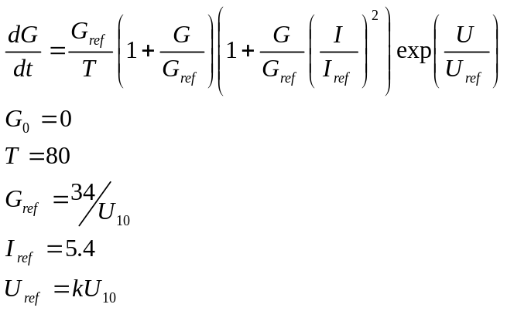

where U₁₀ = 10-kA discharge voltage, in kV
U = voltage across the arrester, in kV
I = current through the arrester, in kA
k = constant ranging from about 0.03 to 0.05, depending on manufacturer

The effect is to delay the start of current conduction through the arrester, while the voltage continues to build up. Figure 9 shows a discharge characteristic with turn-on conductance, and with series inductance plus turn-on conductance. The upper part of the loop tracks the front of the wave, and the lower part of the loop tracks the tail. With just the turn-on conductance, the discharge voltage is increased only in the range from 0 to 5 kA on the wave front. This is caused by an effective delay in the start of conduction. With both turn-on conductance and series inductance, the discharge voltage is increased all the way up to the 20 kA peak on the wave front.

An IEEE working group has presented another model for these dynamics [11], using two nonlinear resistors, along with some linear resistors and inductors. The IEEE model can be implemented with off-the-shelf EMTP components, but requires iterative parameter adjustments to tune the model for each arrester. The Cigre model proved more convenient for this program, because the series inductance and time-dependent turn-on conductance could be built into the arrester model.

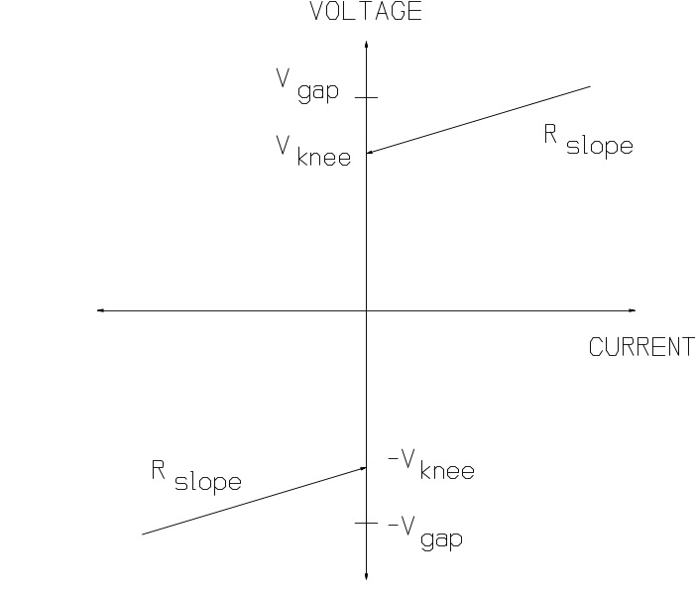
Figure 6 Surge Arrester Switch Model.

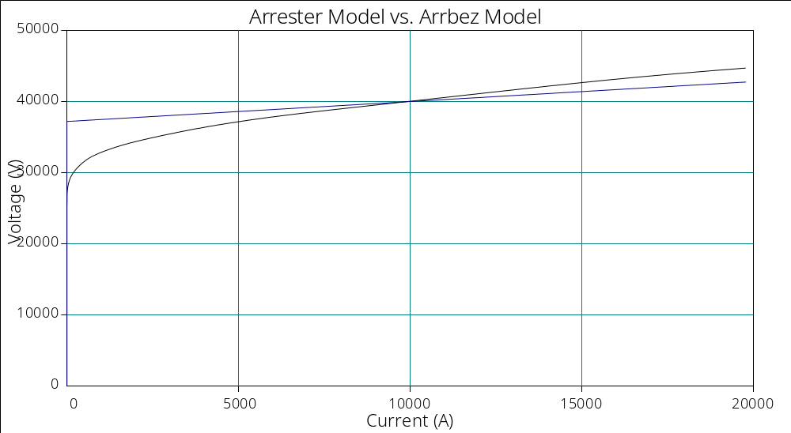
Figure 7 Arrester vs. Arrbez Model, 20 kA, 1x20 Discharge Current.

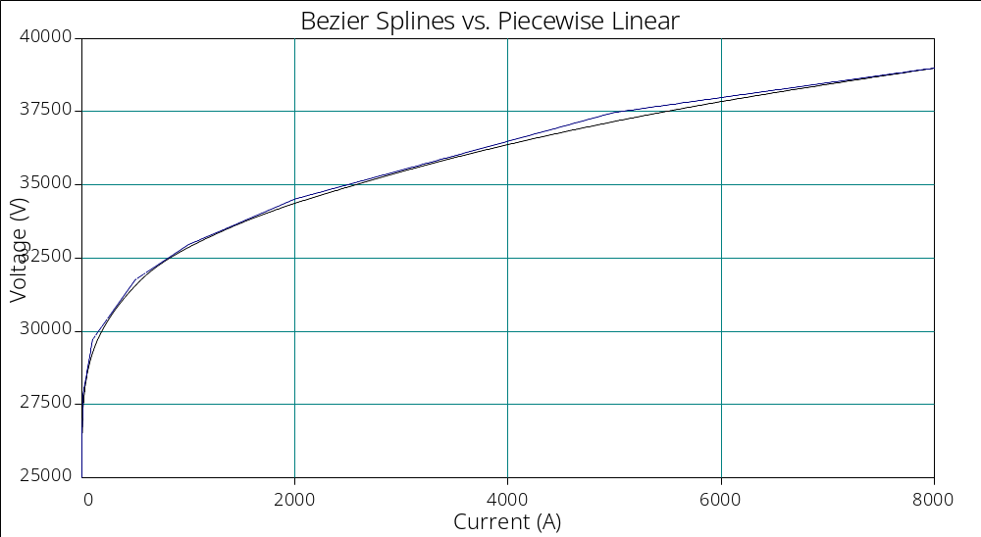
Figure 8 Bezier Spline vs. Piecewise Linear Characteristic, 20 kA, 1x20 Discharge Current.
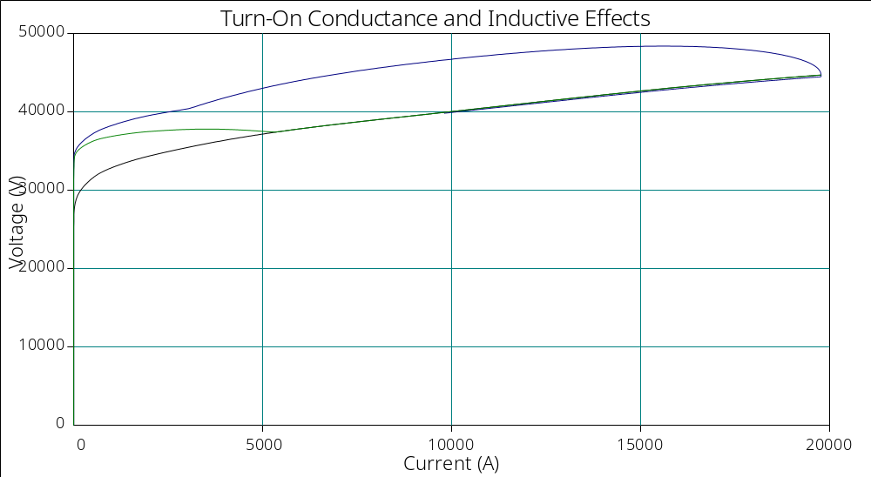
Figure 9 Arrbez Turn-On Conductance and Inductance Model, Uref = 0.051, L = 0.3 μH, 20 kA, 1x20 Discharge Current.

3.5 Pole Grounds

The neutral conductor at each pole, or at selected poles, is grounded through a resistance. The impulse ground resistance is less than the measured or calculated 60-Hz resistance, because significant ground currents cause voltage gradients sufficient to break down the soil around the ground rod. The following equations govern this behavior:
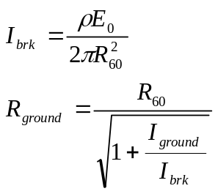

Where: E0 = soil breakdown gradient, typically 400 kV/m
ρ = soil resistivity [Ω-m]
R60 = measured or calculated 60-Hz ground resistance [Ω]

These equations assume that the pole ground consists of a single ground rod, which is typical of distribution lines. The program uses a supplemental current injection to model the decreasing resistance. The ground model includes a built-in pole downlead inductance, which may be input as zero. With a non-zero inductance, the output "ground" voltage will increase for steep current fronts. The model does not include capacitance in the pole ground.

3.6 Power Frequency Source

The program can automatically add a surge impedance termination at each end pole in Figure 1. This termination absorbs travelling waves, with no reflections back into the circuit model. The program calculates this termination to match the input conductor data. The program can also run with either or both end poles left open-circuited.

The program can also simulate a power frequency bias voltage on one or more conductors. The bias is modelled as a D.C. voltage, assuming the power frequency voltage will not change very much during the short time of interest for lightning transients.

Initial conditions for the line sections, plus any capacitors and inductors, are calculated to support this D.C. bias voltage. Injected currents are added to each end pole termination, to maintain the bias voltage across each surge impedance termination.

The bias voltage is input with the conductor data. First, convert the nominal line-to-line RMS voltage to peak volts line-to-ground. Then, select a phase A voltage angle. The conductor bias voltages for a 13.8-kV system, with instantaneous phase A voltage angle of 20 degrees, would be:
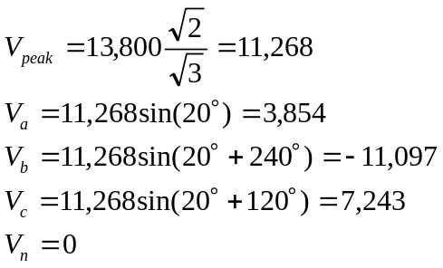

Because the bias voltage is D.C., any lumped inductors connected between phase conductors must include some series resistance. A pure inductance cannot support a D.C. voltage (V = L dI/dt = 0 for D.C.). Even with a series resistance, the solution for an inductor with D.C. bias would probably not be valid for the actual situation with an A.C. "bias." Lumped inductors should not be used in this program with a power frequency bias, unless the inductor is connected from neutral to ground (and the neutral has no power frequency voltage).

3.7 Pole-Top Transformer and Service Drop

The program can simulate the house ground current and transformer secondary terminal X2 current, according to a simplified model[4]. Normally, the transformer would be attached to a pole with a primary arrester and a pole ground. The program automatically adds a house ground with service drop inductance, and connects it to the pole.

Assuming the house load is shorted by gap sparkover in the service entrance meter, the X2 terminal current is:

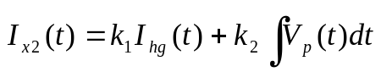

Where: Ihg = simulated house ground current
Vp = simulated transformer primary voltage

k1 and k2 are constant coefficients that depend on the transformer and service drop inductances[4]. k2 is zero if the transformer secondary winding inductances are balanced. k1 is much less for triplex service drops than for open-wire service drops. k1 increases somewhat if the transformer has interlaced secondary windings, which have lower inductances than non-interlaced windings.

3.8 Pre-Discharge Currents

Pre-discharge currents flow between two parallel conductors, or a pipe gap, when the voltage between them exceeds the insulation breakdown voltage[8]. Pre-discharge limits the voltage and delays final breakdown by a few microseconds or more. The effect can be modeled as a simple surge arrester connected between the conductors, with a knee voltage equal to the Critical Flashover Voltage (CFO), and a single slope resistance of 4300 ohm-feet, or 1311 ohm-meters. The resistance is lower, and more current flows, between longer conductors.

Pre-discharge currents only begin to flow when the voltage exceeds the pipe gap's CFO. It is possible to coordinate the pipe gap to protect substation equipment insulation. On an overhead line, however, the pole or tower insulation is the weak link, because its CFO is less than the CFO of the air gap between the conductors (which governs the flow of pre-discharge current). Figure 10 illustrates this coordination problem for a single-phase distribution line. Using an air breakdown gradient of 610 kV/m (186 kV/ft), the CFO between conductors is estimated at 744 kV. At the pole, the pin insulator and wood combine for an estimated CFO of 328 kV. The "protective level" provided by the pipe gap is over twice the CFO of the insulation to be protected.

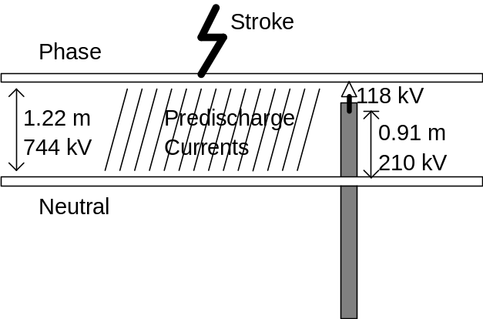
Figure 10 Pre-discharge Currents on a Single-phase Line.
Generally, the main effect of pre-discharge currents is to make midspan flashovers much less likely. Instead, flashovers occur at the pole. The PIPEGAPS.DAT, PAPERGAP.DAT, and PAPERARR.DAT test cases illustrate the use of this model. The LT.EXE screen output labelled "pipegaps" is the largest pre-discharge current through any of the line sections, in amps. Usually, this line section with maximum pre-discharge will be next to the stroke location.

4 INPUT AND OUTPUT FORMATS

The program input format for an overhead line is shown in Table 3. DFlash uses this type of format. CFlash and SDW use an alternate form of input for network models, described in Section 4.7. The input must be created with a text editor and saved in a file before running the program.

The program uses SI (metric) units for input:

meters
seconds
volts
amperes
ohms
ohm-meters
henries
farads
volts per meter

Exponential notation may be used for numerical input:

1.0e-6 for 1 ms
-10.0e3 for -10 kA

Floating point input data may have a decimal point. Inputs that are defined as integers must not have a decimal point.

Text input may be upper or lower case, or a mixture, but the spelling of keywords must be correct. All model parameters must be provided in the correct order, and no missing parameters are allowed.

Inputs on the same line must be separated by one or more blanks or tabs. There may be any number of blank lines between the data entries in Table 3.

Comment lines begin with an asterisk (*).
Table 3 Transients Program Input Formats for Non-Network System
Ncond Npole Span l_term r_term dT Tmax (required)
Conductor # h x r Vbias (Ncond entries required)
Conductor # h x r Vbias
Node #
ground (-)R60 r E0 L d
pairs ....
poles ....
surge Ipeak Tfront Ttail Tstart
pairs ....
poles ....
steepfront Ipeak Tfront Ttail Tstart SI
pairs ....
poles ....
arrester (-)Vgap Vknee Rslope L d
pairs ....
poles ....
arrbez Vgap V10 Uref L d amps
pairs ....
poles ....
insulator CFO Vb β DE
pairs ....
poles ....
lpm (-)CFO E0 KL
pairs ....
poles ....
meter
pairs ....
poles ....
labelphase N C
labelpole N name
resistor R
pairs ....
poles ....
inductor R L
pairs ....
poles ....
capacitor C
pairs ....
poles ....
customer Rhg r E0 Lhg d N Lp LS1
LS2 Lcm rA rN DAN DAA L
pairs ...
poles ...
pipegap V R
pairs ...
poles ...

Notes for Table 3:

pairs ... = one or more pairs of conductor #'s for component connections, at the specified poles.
conductor 0 = ground
limits: 0 < conductor # < Ncond
poles ... = one or more pole #'s to connect components between specified conductor pairs.
"poles all" means every pole
"poles even" means all even-numbered poles
"poles odd" means all odd-numbered poles
limits: 1 < pole # < Npole
Negative R60 or Vgap requests plotted current output for grounds and arresters, respectively.
Use "Meter" components to request plotted voltage output.
The "Customer" component produces plotted house ground and X2 terminal currents automatically.
For plotted arrester and pole ground current output, input the first numerical parameter with a negative sign (-Vgap for arresters, -R60 for grounds). For plotted arrbez currents, set “amps” to 1.
Negative CFO for the lpm component disables insulator flashover during simulation, but severity index is calculated at the end.
Negative V₁₀ for the arrbez component causes piecewise linear rather than Bezier spline fit to VI characteristic.

The input file is divided into three subsections:

1. Required simulation control parameters

2. Required conductor or cable data

3. Optional pole component data

4.1 Required Simulation Control Parameters

These five parameters must be input on the first non-blank line in the file, in this order:

Ncond (integer): number of conductors
A three-phase line with neutral would have Ncond = 4.

Npole (integer): number of poles in the circuit
The poles are numbered from 1 to Npole.

Span (float): line section span length in meters
For distribution lines, the span length is probably between 20 and 100 meters.

lt (integer): 1 to terminate pole at left end, 0 to leave open

rt (integer): 1 to terminate pole at right end, 0 to leave open

dT (float): simulation time step in seconds.
As a rule of thumb, choose dT as the smallest of the following two values:
a. dT = 0.1 * Tfront (for a surge input)

b. dT = 0.2e-6 * (span / 300.0)

Tmax (float): maximum simulation time in seconds
Tmax should be at least three times Tfront for the surge current input. To calculate surge arrester discharge duties, Tmax should be at least two times Ttail for the surge current input.

4.2 Required Conductor Data

There must be one line for each conductor. The conductors are numbered in sequence from 1 to Ncond. In addition, conductor 0 is "remote ground."

Each line of conductor data begins with the "conductor" keyword, followed by data in the following order:

# (integer): conductor number, from 1 to Ncond

h (float): conductor height above ground, in meters.
Use the height at the pole, or an average height accounting for sag.

x (float): conductor horizontal position, in meters.
Use the pole centerline as a reference, and enter conductors to "left" of the centerline with negative x, conductors to the "right" with a positive X.

r (float): conductor radius, in meters.

Vbias (float): instantaneous power frequency voltage, in volts to ground
See the previous section for equations to calculate Vbias. Enter 0.0 for conductors with no power frequency voltage.

The last "conductor" may be a pole node, with no physical conductor attached. This is entered in the form "node #". A typical usage is for arrester-protected lines with no grounded conductor. All arresters and phase-ground insulators are connected from phase to the pole node, and then the pole ground is connected from the pole node to 0.

A sample conductor configuration is shown in Figure 11.

Instead of the preceding "conductor" input, the alternative "cable" keyword may be used, followed by this data:

# (integer): conductor number, must = 1

Z (float): surge impedance [?]

V (float): travelling wave velocity, in meters per second

Vbias (float): instantaneous power frequency voltage, in volts to ground

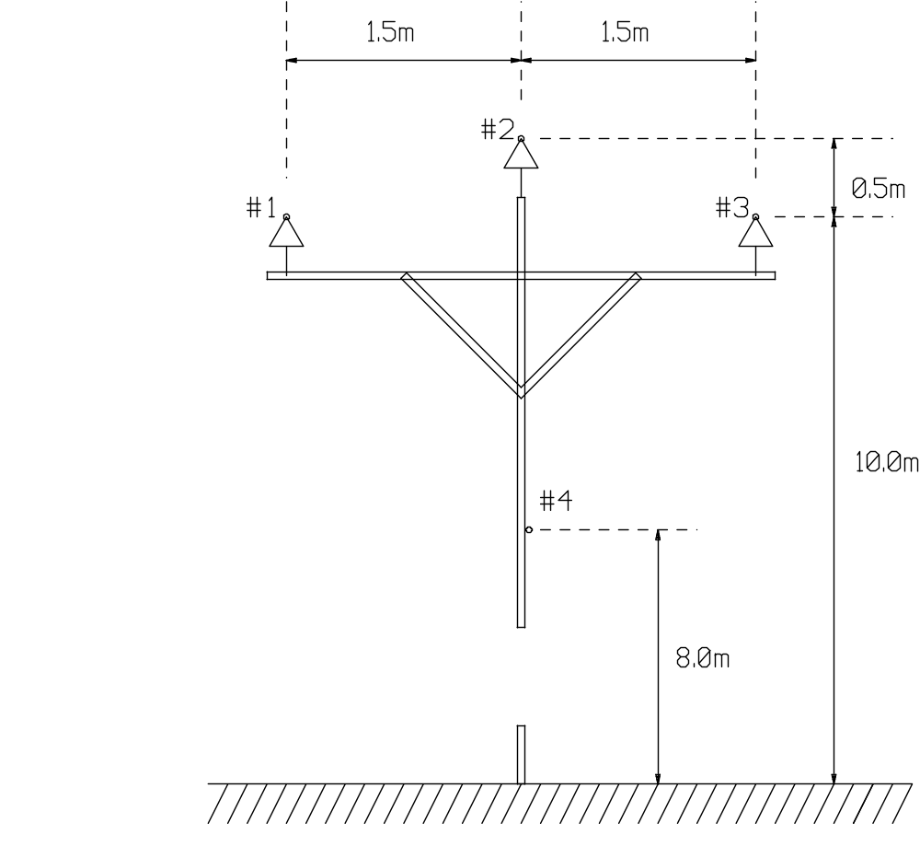
Figure 11 Example Conductor Configuration.

4.3 Optional Pole Components

Input for lumped components connected to poles must follow the required conductor data. Each section of optional input contains three lines, with no intervening blank lines, as follows:

1. Identifying keyword and component parameters

2. Conductor pair connections

3. Pole locations

These optional sections may be placed in any order in the input. A useful simulation case would include at least a "surge" input, but the program does not require this. An input file with no optional components would produce constant output voltages equal to the conductor bias voltages. Also, there would be no voltage output without some "meter" components.

There may be more than one input section for each type of optional component. For example, there might be two separate "insulator" components for the phase-to-ground and phase-to-phase insulation. There might also be two separate "arrester" components with identical characteristics, but one requests plotted currents at a selected pole, while the second places arresters at other poles and requests no plotted current output.

The optional component keywords and parameters follow:

ground parameters: R60 = measured or calculated ground resistance, in Ω
(If R60 is < 0, the ground current will be output for plotting.)
ρ = soil resistivity, in Ω-m
(typical ρ = 250.0)
Eo = soil breakdown gradient, in volts per meter
(typical Eo = 400.0e3)
L = inductance per unit length of downlead
d = length of downlead in consistent units (may be 0.0)

surge parameters: Ipeak = crest current, in amperes
Tfront = 30-90 front time, in seconds
Ttail = 50% tail time, in seconds
Tstart = surge starting time after simulation time zero, in seconds
(usually, Tstart = 0.0)

steepfront parameters Ipeak = crest current, in amperes
Tfront = 30-90 front time, in seconds
Ttail = 50% tail time, in seconds
Tstart = surge starting time after simulation time zero, in seconds
(usually, Tstart = 0.0)
S_{I} = maximum current steepness, in per-unit of 30-90 steepness

arrester parameters: Vgap = sparkover voltage for arresters that have gaps, in volts
(use Vgap < Vknee for gapless arresters)
(If Vgap is < 0, the arrester discharge current will be output for plotting.)
Vknee = "turn-on" voltage of the arrester's nonlinear discharge characteristic, in volts
Rslope = slope of the arrester's non-linear discharge characteristic, in Ω
L = inductance per unit length of arrester lead
d = arrester lead length in consistent units (may be 0.0)

arrbez parameters V_{gap} = sparkover voltage for arresters that have gaps, in volts
V₁₀ = 10-kA, 8x20 crest discharge voltage from manufacturer’s catalog, in volts. Negative V₁₀ signifies piecewise linear characteristic, rather than Bezier spline fit.
U_{ref} = reference voltage for dynamic turn-on conductance, in per-unit of V₁₀
L = inductance per unit length of arrester lead
d = arrester lead length in consistent units (may be 0.0)
amps = use 1 to plot arrester current, 0 otherwise

insulator parameters: CFO = critical flashover voltage, in volts
(usually 95.0e3 < CFO < 500.0e3 for phase-to-neutral insulators)
Vb = minimum voltage for destructive effect calculation at 100 kV CFO
β = exponent for destructive effect calculation
DE = minimum destructive effect to cause flashover when the CFO is 100 kV

lpm parameters CFO = critical flashover voltage, or BIL, in volts. A negative number indicates these insulators will not flashover during simulation, but severity index will be calculated at the end. SDW runs in this mode.
E₀ = minimum breakdown gradient, in V/m. Use 535.0e3 for air-porcelain insulations, and 551.3e3 for apparatus insulations.
K_{L} = Use 7.85e-7 for air-porcelain insulations, and 1.831e-6 for apparatus insulations.

meter parameters: none

labelphase parameters: N = wire number, from 0 to N_{cond}
C = character label for plots in TOP (eg., G, N, A, B, C)

labelpole parameters: N = pole number, from 0 to N_{pole}. For network input, N must correspond to one of the poles input with line data.
name = location label for plots in TOP (eg., xfmr). No embedded blanks are allowed. For 16-bit versions of TOP, it is best to limit “name” to 5 characters.

resistor parameters: R = resistance, in Ω

inductor parameters: R = series resistance, in Ω
L = series inductance, in henries

capacitor parameters: C = capacitance, in farads

customer parameters: Rhg = 60-Hz house ground resistance, in Ω
ρ = soil resistivity, in Ω-m
E0 = soil breakdown gradient, in volts per meter
Lhg = inductance per unit length of house ground downlead, in henries per meter
d = house ground lead length, in meters
N = transformer turns ratio
Lp = transformer primary winding inductance, in henries
LS1, LS2 = secondary winding inductances, in henries
Lcm = service drop common-mode inductance, in henries per meter (typical Lcm = 1.8 e-6)
rA, rN = service drop phase and neutral conductor radii, in meters
DAN, DAA = Service drop phase and neutral conductor spacings, in meters
L = service drop length, in meters

pipegap parameters V = the CFO between conductors, in volts
(If V is < 0, the pipegap current will be output for plotting.)
R = series resistance to pre-discharge currents, in Ω

Each optional component parameter line must be followed by two lines for "pairs" and "poles." These lines specify where the components are connected. Each component will have identical parameters. During the simulation, the program will track the status of individual grounds, insulators, arresters, and other components at each location.

4.4 "Pairs" Input

The keyword "pairs" is followed by pairs of integer conductor numbers specifying the component connections at each pole. Conductor #0 is ground. For example:

pairs 4 0 specifies connection from conductor 4 (neutral to conductor 0 (ground)

pairs 1 4 2 4 3 4 specifies three component connections, from conductors 1, 2, and 3 to 4

For a "customer" component, the second conductor in the pair will have the house ground attached. This should be the neutral conductor.

4.5 "Poles" Input

The keyword "poles" is followed by one or more integer pole numbers. The program also recognizes short-cuts "all", "even", and "odd" in place of the integer pole numbers. The specified poles and pairs are used to place components in the circuit model.

The following example places a ground at each odd-numbered pole, from conductor 4 to ground. The pole downlead has a 5-μH inductance:

ground 85.0 250.0 400.0e3 0.5e-6 10.0
pairs 4 0
poles odd

The following example places a surge only at pole 16, from conductor 1 to ground:

surge -10.0e3 1.0e-6 50.0e-6 0.0e-6
pairs 1 0
poles 16

4.6 Program Output

Certain portions of the input produce output, as shown in Table 4.

This output will appear on screen or in a file, according to the program execution commands described in the next section.

For meter, insulator, and arrester output, the individual components are identified by pole number and the conductor pair numbers.

The Output Processor (TOP) software must be used for plotting voltage and current waveforms on the screen.

4.7 Network System Input

Normally, the first line of text input specifies the number of poles and conductors. The program lays the poles out in series, and each span has the same length and conductor configuration.

An alternate form of input can be used for other topologies, including a substation network or feeder laterals. In this case, the first line of text input specifies the maximum number of conductors used in any span. In the next section of input, more than one conductor geometry can be specified. Each of these input geometries will define a span type. These span types are referenced in a section of line inputs, in which poles are explicitly created as needed at the end of each line.

When using the network option, the first non-comment, non-blank text input line must be of the form:

“time” Ncond dT Tmax

time is a keyword, and the other three parameters are similar to those defined in Section 4.1

Following the time control card, one or more span definitions are input. These are similar to the conductor and cable inputs described in Section 4.2, with an additional span identifier before each span definition:

“span” Span_id

span is a keyword, and Span_id must be a unique integer. Whenever conductor geometry is input for a span definition, there can be no missing conductors. There must be Ncond lines of conductor input for the span definition, just as in Section 4.2. But when cable impedances are input, missing conductors are allowed. If the number of cable conductors for a span definition is less than Ncond, the span definition must be terminated with “end” on a single line of input. If Ncond cable conductors appear in the span definition, do not use the “end” terminator.

A single line of input with “end” terminates all span definitions.

Following the span definitions, one or more lines are input.

“line” From To Span_id Length Term_Left Term_Right

line is a keyword. From and To are integer pole numbers, which the program creates if they don’t exist yet. The pole numbers do not have to be consecutive. Span_id refers to the conductor geometry or cable impedances entered previously. Note that the Span_id determines which phases are present in this line, and any power frequency offset voltage. If Term_Left or Term_Right are 1, a surge impedance termination is added at the From or To pole, respectively.

A single line of input with “end” terminates all line definitions.

Following the line definitions, any of the optional pole components may be input as described in Sections 4.3 through 4.5. Only those poles created in the line definitions may be used for these components. Some of these poles may have “missing phases”, if they are fed by spans that have less than Ncond cable conductors. These “missing phases” are solidly grounded in the simulation; they have no impact on the results because the cable conductors are uncoupled in this program.

See tables 6 and 7 for examples of network model input.

Table 4 Text Output

Input Output Generated

Required Parameters Tmax and the current simulation time appear on the screen as a solution progress monitor.

Conductor Data Surge Impedance Matrix, Zp
Modal Surge Impedances, Zm[1]
Modal Transformation Matrix, TI[1]

Termination Flags D.C. Bias Voltages, with Currents injected into surge impedance terminations

Meter Peak voltage recorded
Plot data file (voltage)

Insulator If insulator flashes over:
Time of flashover
If insulator does not flash over
Per-unit severity index

Arrester If arrester operates:
Time of sparkover or turn-on
Time of peak discharge current
Peak discharge current [Amperes]
Energy discharged [Joules]
Charge discharged [Coulombs]
If Vgap input < 0:
Peak current recorded
Plot data file (current)

Ground If R60 input < 0:
Peak current recorded
Plot data file (current)

Customer Peak Ihg and Ix2
Plot data file (Ihg and Ix2)

Pipegap Peak pre-discharge current
If V input < 0:
Plot data file (current)

"Black Box" Values Highest per-unit severity index of any insulator
Highest energy dissipated by any surge arrester
Highest current discharged by any surge arrester
Highest charge through any surge arrester
Highest pre-discharge current through any pipegap

5 EXAMPLES

The test cases distributed with this program include:

abcigld discharge test for Bezier spline arrester with turn-on conductance and lead inductance
abcigre discharge test for Bezier spline arrester with turn-on conductance
abezgap discharge test for Bezier spline arrester with series gap
abezlead discharge test for Bezier spline arrester with lead inductance
abgapld discharge test for Bezier spline arrester with series gap and inductance
arrbez discharge test for Bezier spline arrester model
arrester discharge test for arrester switch model
arrlin discharge test for piecewise linear arrester model
arrlead discharge test for arrester switch model with lead inductance
desteep destructive effect insulator model, 100 kV CFO, concave surge front
desurge destructive effect insulator model, 100 kV CFO, 1-cosine surge front
epri138 incoming surge for the 138-kV substation example from the ICWorkstation training course (see Figure 13 and Table 7)
epri500 incoming surge for the 500-kV substation example from the ICWorkstation training course
HOUSE single-phase overhead with transformer secondary model
lpmsteep leader progression insulator model, 100 kV CFO, concave surge front
lpmsurge leader progression insulator model, 100 kV CFO, 1-cosine surge front
no_flash leader progression insulator model, 100 kV CFO, flashover disabled and severity index greater than one
overbez 4-conductor overhead line with Bezier spline arresters
OVERHEAD 4-conductor overhead line with arrester switch models (see Figure 1 and Table 5)
PIPEGAPS single-phase lateral with predischarge currents
PAPERGAP three-phase line with predischarge currents
PAPERARR add arresters and insulators to a three-phase line
RISER single-phase cable with riser pole arrester
scout 4-conductor line with arresters feeding a single-phase cable with open-point arrester (see Figure 12 and Table 6)
steep typical first-stroke current parameters, concave surge front
surge typical first-stroke current parameters, 1-cosine surge front
ThreeWire three-wire line with top-phase arrester, using a pole node for ground
Table 5 shows the input data for a circuit similar to that shown in Figure 1. The time step of 0.02 μs was chosen to provide five steps for each line section. This also provides plenty of steps for the surge front.

The Tmax of 5 μs is sufficient to determine the peak voltages at poles closest to the lightning flash. It is not sufficient to determine the energy discharged in any surge arresters that operate; that would require Tmax = 200 μs or more.

Figure 11 shows the conductor configuration for this example. Conductors 1, 2, and 3 represent phases A, B, and C. Conductor 4 is the neutral. The number of poles might be increased if an insulator flashover occurs in the simulation, but 11 is recommended as a starting number. Other parameters in Table 3 were chosen to be typical of a 13.8-kV distribution line.

Table 6 shows example input for analysis of the scout arrester application, based on the circuit in Figure 12. The voltage at node 6 is of particular interest. With arresters at nodes 2 and 4, the peak voltages at nodes 6 and 7 are about the same. If the arresters at nodes 2 and 4 are removed, the peak voltage at node 6 is higher than the peak voltage at node 7.

Table 7 shows example input for a substation network model, illustrated in Figure 13. The EPRI ICWorkstation training manual discusses this example in detail. The severity index for this incoming surge is about 0.35 at all points, generally matching the results obtained by EMTP simulation in the OS/2 version of EPRI’s ICWorkstation.

Table 5 Example Program Input for Overhead Line

4 31 30.0 1 1 0.02e-6 5.0e-6

conductor 1 10.0 -1.5 0.00715 3854.0
conductor 2 10.5 0.0 0.00715 -11097.0
conductor 3 10.0 1.5 0.00715 7243.0
conductor 4 8.0 0.0 0.00715 0.0

labelphase 0 G
labelphase 1 A
labelphase 2 B
labelphase 3 C
labelphase 4 N

ground 85.0 250.0 400.0e3 0.5e-6 10.0
pairs 4 0
poles all

arrester 42.4e3 36.8e3 0.28 1.0e-6 0.0
pairs 1 4 2 4 3 4
poles odd

insulator 300.0e3 0.0 5.42434 8.4265E21
pairs 1 4 2 4 3 4
poles 16

meter
pairs 1 0 1 4 2 4 3 4 4 0
poles 16 17

surge -10.0e3 1.0e-6 100.0e-6 0.0e-6
pairs 1 0
poles 16

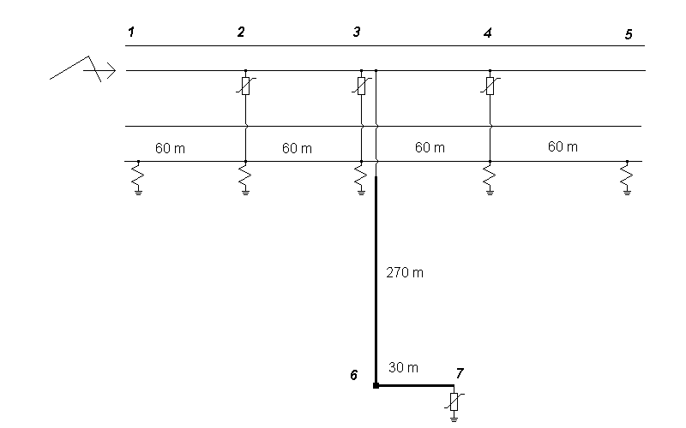
Figure 12 Scout and Cable Arrester Application

Table 6 Example Program Input for Scout Arrester Scheme

time 4 0.01e-6 15.0e-6

* overhead line geometry
span 1
conductor 1 10.0 -1.5 0.00715 3854.0
conductor 2 10.5 0.0 0.00715 -11097.0
conductor 3 10.0 1.5 0.00715 7243.0
conductor 4 8.0 0.0 0.00715 0.0

* single-phase underground attached to upper phase
span 2
cable 2 30.0 1.5e8 -11097.0
end
end

* overhead line spans
line 1 2 1 60.0 1 0
line 2 3 1 60.0 0 0
line 3 4 1 60.0 0 0
line 4 5 1 60.0 0 1
*underground spans
line 3 6 2 270.0 0 0
line 6 7 2 30.0 0 0
end

labelphase 0 G
labelphase 1 A
labelphase 2 B
labelphase 3 C
labelphase 4 N

labelpole 3 riser
labelpole 6 xfmr
labelpole 7 opntie

ground 85.0 250.0 400.0e3 0.5e-6 10.0
pairs 4 0
poles 1 2 3 4 5

* riser pole, scout, and open tie arresters
arrbez 0.0e3 40.0e3 0.0 0.0 0.0 0
pairs 2 0
poles 2 3 4 7

surge -10.0e3 1.0e-6 50.0e-6 0.0e-6
pairs 2 0
poles 1

meter
pairs 2 0
poles 3 6 7

Table 7 Example Program Input for 138-kV Substation
* incoming backflash for the EPRI 138-kV training example

time 1 6e-9 10e-6

* network definition

span 1
cable 1 472.0 3.0e8 -93.0e3
end

line 1 2 1 10.67 0 0
line 2 3 1 15.24 0 0
line 2 4 1 9.14 0 0
line 2 5 1 9.14 0 0
line 5 7 1 9.14 0 0
line 7 8 1 9.14 0 0
line 6 7 1 10.67 1 0
line 7 9 1 15.24 0 0
end

labelphase 0 G
labelphase 1 A

labelpole 1 ln1
labelpole 2 cb1
labelpole 3 xf1
labelpole 4 top
labelpole 5 tiebrk
labelpole 6 ln2
labelpole 7 cb2
labelpole 8 bot
labelpole 9 xf2

meter
pairs 1 0
poles all

* source equivalent

resistor 472.0
pairs 1 0
poles 1

steepfront 2.54e3 1.82e-6 9.7e-6 1.0e-7 1.0
pairs 1 0
poles 1

* transformers and arresters

capacitor 2e-9
pairs 1 0
poles 3 9

arrbez 0.0 296.0e3 0.051 1.57e-6 1.83 1
pairs 1 0
poles 3 9

* insulators

lpm 650.0e3 535.0e3 7.785e-7
* lpm 650.0e3 551.3e3 1.831e-6
pairs 1 0
poles all

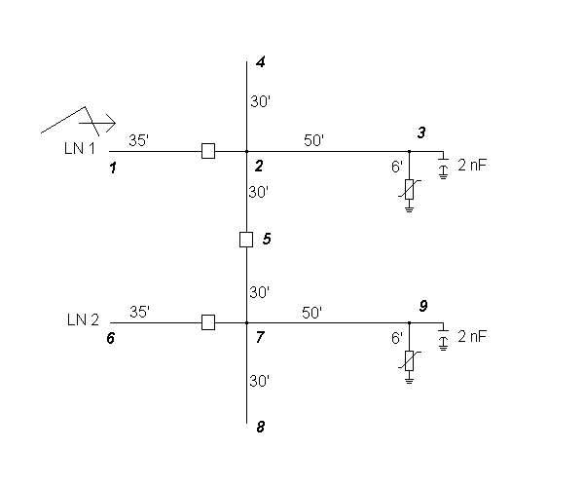
Figure 13 138-kV Substation Application

6 REFERENCES

[1] W. S. Meyer and H. W. Dommel, "Computation of Electromagnetic Transients," Proceedings of the IEEE, Vol. 62, No. 7, July 1974, pages 983-993.

[2] G. D. Smith, Numerical Solution of Partial Differential Equations: Finite Difference Methods, Oxford University Press, 1985, pages 175-238.

[3] A. K. Agrawal, H. J. Price, S. H. Gurbaxani, "Transient Response of Multiconductor Transmission Lines Excited By a Nonuniform Electromagnetic Field," IEEE Transactions on Electromagnetic Compatibility, Vol. EMC-22, No. 2, May 1980, pages 119-129.

[4] D. R. Smith and J. L. Puri, "A Simplified Lumped Parameter Model for Finding Distribution Transformer and Secondary System Responses to Lightning," IEEE Transactions on Power Delivery, Vol. 4, No. 3, July 1989, pages 1927-1936.

[5] H. B. Dwight, "Calculation of Resistance to Ground," AIEE Transactions, December 1936, pp. 1319-1328.

[6] Andrew R. Jones, "Evaluation of the Integration Method for Analysis of Nonstandard Surge Voltages," AIEE Transactions III-B, Vol. 73, August 1954, pp. 984-990.

[7] Mississippi State University, A Guide to Estimating Lightning Insulation Levels of Overhead Distribution Lines, EPRI Report EL-6911, RP2874-1, Electric Power Research Institute, May 1989.

[8] C. F. Wagner and A. R. Hileman, "Effect of Predischarge Currents Upon Line Performance," AIEE Transactions on Power Apparatus and Systems, 1963, pp. 117-128.

[9] Cigre Working Group 01, Study Committee 33, Guide to Procedures for Estimating the Lightning Performance of Transmission Lines, October 1991.

[10] A. R. Hileman, J. Roguin, and K. H. Weck, “Metal Oxide Surge Arresters in AC Systems – Part V: Protection Performance of Metal Oxide Surge Arresters”, Electra, no. 133, December 1990, pp. 133-144.

[11] IEEE Working Group, “Modeling of Metal Oxide Surge Arresters”, IEEE Transactions on Power Delivery, January 1992, pp. 302-309.

