# Description

During the period from 1990 through 2002, EPRI funded the development of a Lightning Protection Design Workstation (LPDW), which was used by many utilities to assess the lightning performance of distribution lines. Since about 2002, this program has not been available. EPRI decided to release the simulation kernel of LPDW under the name ***OpenETran***, with an open-source license (GPL v3), so it may be incorporated into IEEE Flash and other projects.

OpenETran can presently simulate multi-conductor power lines, insulators, surge arresters, non-linear grounds, and lightning strokes. It efficiently calculates energy and charge duty on surge arresters, and iterates to find the critical lightning current causing flashover on one or more phases. It is also suitable for use in substation insulation coordination. Capacitor switching, TRV, and other applications may be added.

EPRI originally had permission to use code from the Numerical Recipes book in LPDW. These routines have been removed in favor of the GNU Scientific Library (GSL), which also uses the GPL v3 license. As a result, the OpenETran package can be freely used and modified, but not commercialized.

# Models

Figure 1 shows the circuit structure analyzed for overhead lines. It includes a series of one or more poles, with each pole connected by a section of line with one or more conductors. One conductor, typically the neutral, may be grounded at selected poles or at all poles. Each line section must have the same span length and conductor configuration. Figure 1 also shows optional features, connected to some of the poles. These include:

1. Insulators
2. Surge arresters
3. Terminations, with optional D.C. voltage bias
4. Meters for plotted voltage output
5. Meters for arrester, pole ground, and service drop currents
6. Surge current to represent a direct flash to a conductor
7. The program can also simulate lumped resistors, inductors, and capacitors.

Figure 2 illustrates the performance of a non-linear and frequency-dependent surge arrester model, using Bezier splines for the discharge characteristic, and Cigre’s conductance model for turn-on delay and inductive effects. OpenETran also includes time-dependent insulator models. All of the model and engineering assumptions are documented in the user manual.

For lightning analysis, OpenETran is more efficient than other electromagnetic transient (EMT) programs. Each pole is considered to be a separate subsystem, so the system admittance matrix is inherently block diagonal (i.e. sparse). For efficient arrester duty calculations, the time step automatically increases after the time window of interest for flashover evaluations.



Figure - Distribution line model components in OpenETran



Figure - Frequency-dependent arrester characteristics using the Cigre model

# Examples

Figure 3 illustrates the simplified program input for simulating a direct stroke to one conductor of a four-wire multi-grounded neutral feeder. Thirty pole spans are included in the model. Figure 4 shows a sample resulting voltage waveform from this case. Figures 4 and 5 illustrate other program applications for cable and substation lightning protection, based on use in earlier EPRI projects (CFlash and SDWorkstation).

The test cases distributed with OpenETran include:

ABCIGLD discharge test for Bezier spline arrester with turn-on conductance and lead inductance

ABCIGRE discharge test for Bezier spline arrester with turn-on conductance

ABEZGAP discharge test for Bezier spline arrester with series gap

ABEZLEAD discharge test for Bezier spline arrester with lead inductance

ABGAPLD discharge test for Bezier spline arrester with series gap and inductance

ARRBEZ discharge test for Bezier spline arrester model

ARRESTER discharge test for arrester switch model

ARRLIN discharge test for piecewise linear arrester model

ARRLEAD discharge test for arrester switch model with lead inductance

DESTEEP destructive effect insulator model, 100 kV CFO, concave surge front

DESURGE destructive effect insulator model, 100 kV CFO, 1-cosine surge front

EPRI138 incoming surge for the 138-kV substation example from the ICWorkstation training course (see Figure 13 and Table 7)

EPRI500 incoming surge for the 500-kV substation example from the ICWorkstation training course

HOUSE single-phase overhead with transformer secondary model

LPMSTEEP leader progression insulator model, 100 kV CFO, concave surge front

LPMSURGE leader progression insulator model, 100 kV CFO, 1-cosine surge front

NO_FLASH leader progression insulator model, 100 kV CFO, flashover disabled and severity index greater than one

OVERBEZ 4-conductor overhead line with Bezier spline arresters

OVERHEAD 4-conductor overhead line with arrester switch models (see Figure 1 and Table 5)

PIPEGAPS single-phase lateral with predischarge currents

PAPERGAP three-phase line with predischarge currents

PAPERARR add arresters and insulators to a three-phase line

RISER single-phase cable with riser pole arrester

SCOUT 4-conductor line with arresters feeding a single-phase cable with open-point arrester (see Figure 12 and Table 6)

STEEP typical first-stroke current parameters, concave surge front

SURGE typical first-stroke current parameters, 1-cosine surge front

THREEWIRE three-wire line with top-phase arrester, using a pole node for ground

All of these test cases have been verified to produce the same results in OpenETran, as in the EPRI LPDW version, which was previously validated through EPRI’s SQA process.

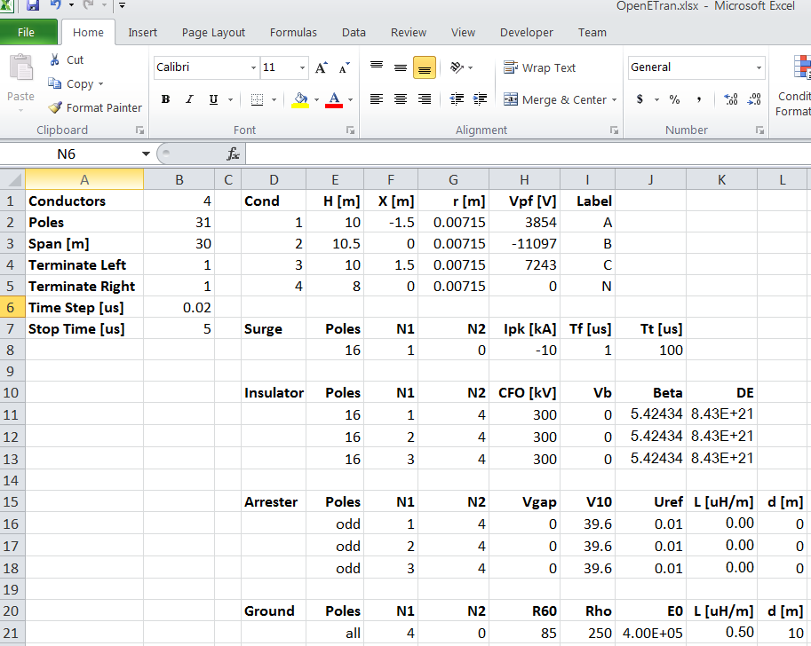

Figure - Spreadsheet Interface to OpenETran



Figure - Adjacent Pole Voltages with Surge Arresters

# scout.bmp

Figure - Riser pole and scout arresters protecting a distribution cable in OpenETran

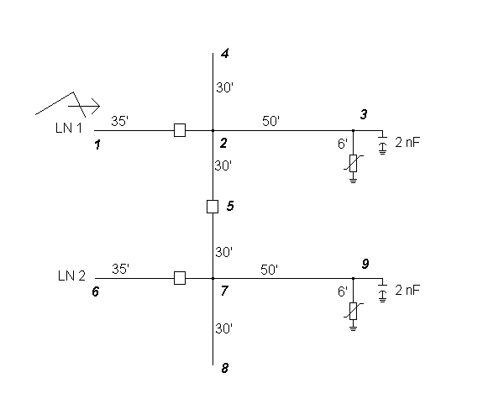

Figure - Incoming surge modeled in OpenETran

# Software Quality Assurance Requirements

This effort falls under EPRI’s Software Quality Assurance (SQA) process, with requirements listed below. To date, requirements 1-8 and 11 have been completed. The remainder will be finished by the end of 2011.

**Objectives**: Prepare the OpenETran program for release under an open-source license, archived in a public source code repository. Update OpenETran and interface it with IEEE Flash, so that other developers may contribute and anyone may use the program.

1. The OpenETran software shall run in both 32-bit and 64-bit versions on Windows XP or later.
2. The OpenETran software shall not use any commercial third-party components.
3. Microsoft Visual Studio 2010 shall be used for development.
4. The open source license type shall be GPL version 3.
5. The open source GNU Scientific Library (GSL) version 1.15 shall be used for linear matrix solutions and eigensystem solutions.
6. The software shall write waveforms in comma-delimited text, tab-delimited text, and the existing binary ELT formats.
7. The software shall support a text-based console execution mode.
8. The software shall support execution from Microsoft Excel Visual Basic for Applications, version 2007 or later. In particular, IEEE Flash shall be modified to invoke OpenETran simulations.
9. IEEE Flash shall be modified to produce OpenETran models from user inputs on pole/tower, surge arrester, grounding, conductor, span, and environment worksheets in Excel.
10. IEEE Flash shall be modified to accept critical current, arrester duty, phases flashing over, and other numerical outputs from OpenETran.
11. The OpenETran software shall be tested and verified to produce matching outputs in console mode, for 27 existing test cases from the EPRI LPDW project.
12. The OpenETran / IEEE Flash package shall be tested on 3 cases:
    1. 15-kV wood crossarm line, from IEEE Std. 1410
    2. 35-kV wood pole structure with overhead shield wire, from IEEE Std. 1410
    3. 13.8-kV line with line arresters, from Chapter 14 of “Insulation Coordination for Power Systems” by A. R. Hileman, which contains both analytical results and ATP simulation results.
13. OpenETran shall be incorporated into the IEEE Flash installer.
14. A separate installer shall be provided for a standalone version of OpenETran.
15. The software documentation shall include:
    1. Updated software requirements
    2. Design documentation with UML package diagram, UML class diagrams, a UML sequence diagram for critical current estimates, and supporting narrative
    3. Build instructions and make files
    4. Change log, which is derived from Subversion file check-in comments
    5. Updated license file, release notes, and OpenETran user manual as needed
    6. Test case document, including instructions to run the test cases and expected results