CTM2SCICHEM
User’s Guide

Contents
Purpose 3
Requirements 3
Installation 4
Configuring and Running CTM2SCICHEM 5
Input files 5
Running the tool 14

Purpose
CTM2SCICHEM converts hourly 3D concentration files generated by CAMx or CMAQ into ambient background concentration files for SCICHEM. The tool is comprised of a .csh run script that calls various fortran, ncl, and perl scripts that perform the conversion.
The processing steps are:
- CAMx2IOAPI
Converts CAMx 3D output to I/O-API format and is only required for CAMx files as CMAQ output files are already in I/O-API format.
- diurnal_prof
Calculates diurnal averages across each month of the user selected year from hourly 3D concentration files.
- spcmap
Maps CAMx model species to SCICHEM CB6r4 species and is only required for CAMx output files or CMAQ files using a different mechanism.
- NCL
Calculates the regional average diurnal concentrations for each month using shapefile masking.
- reformat
Reformats ascii output from NCL into SCICHEM ambient concentration file input format.

Requirements
The following software and libraries are required to run CTM2SCICHEM:
- csh/tsch
- I/O-API 3.1 (https://www.cmascenter.org/ioapi/)
  - Specifically, m3tools program latlon.
- NetCDF4.0
- NCAR Command Language (NCL)
- Perl (https://www.perl.org/)
- A Fortran compiler
  - One of Portland Group (pgf90), Intel Fortran (ifort), or GNU Fortran (gfortran)

Installation
- Unzip CTM2SCICHEM.tgz
- Compile camx2ioapi_v6, diurnal_prof, and spcmap
  - camx2ioapi_v6 and spcmap are only required for CAMx output files. If you plan to use CMAQ model output files as input, then you only need to compile diurnal_prof.
  - The makefiles are located in the ‘src’ directory of each of the tool directories listed above.
    - ./CTM2SCICHEM/camx2ioapi_v6/src
    - ./CTM2SCICHEM/diurnal_prof/src
    - ./CTM2SCICHEM/spcmap/src
  - Edit the makefiles and specify the following:
    - Paths to your I/O-API include file directory, I/O-API library file directory, and the NetCDF library file directory
Example:
IOAPI_INC = /usr/local/ioapi-3.1/ioapi/fixed_src
IOAPI_LIB = /usr/local/ioapi-3.1/Linux2_x86_64
NETCDF_LIB = /usr/local/netcdf-4.0/lib
    - Uncomment the section corresponding to the Fortran compiler you will use. The makefiles contain templates for pgf90, ifort, and gfortran. Comment out the sections for compilers you will not use (only one section should be uncommented).
Example set up for pgf90:
FC = pgf90
OPT = -mcmodel=medium -O2 -Mdalign -Mnoframe -byteswapio - Bstatic_pgi
LIB = -L$(IOAPI_LIB) -lioapi -L$(NETCDF_LIB) -lnetcdf
INC = -I$(IOAPI_INC)
EXE = camx2ioapi_test
###FC = ifort
###OPT = -mcmodel=medium -O2 -align dcommons -extend_source - convert big_endian
###LIB = -L$(IOAPI_LIB) -lioapi -L$(NETCDF_LIB) -lnetcdf
###INC = -I$(IOAPI_INC)
###EXE = camx2ioapi
###FC = gfortran
###OPT = -mcmodel=medium -O2 -fno-align-commons -fconvert=big-endian -frecord-marker=4 -ffixed-line-length-0
###LIB = -L$(IOAPI_LIB) -lioapi -L$(NETCDF_LIB) -lnetcdf
###INC = -I$(IOAPI_INC)
###EXE = camx2ioapi
  - Type ‘make clean’ and then ‘make’ while in each src directory to compile the Fortran code into an executable.

Configuring and Running CTM2SCICHEM

Input files
- Hourly, 3D concentration files from CMAQ or CAMx
- GRIDDESC file
  - ascii file providing modeling grid definition following the CMAQ format. An example file a 12 km CONUS grid is provided in the ncl input directory (./CTM2SCICHEM/ncl/input/GRIDDESC.CONUS12km)
- SCICHEM Domain definition
  - Shapefile containing the desired domains as polygons.
    - Requires a field named ‘Domain’ that lists the name of each domain in the shapefile.
    - US-state based domains are provided with the tool here: ./CTM2SCICHEM/ncl/input/shp/SCICHEM_Regions.shp
  - A list containing the regions corresponding to the shapefile provided.
    - An example list is provided with the tool corresponding to the shapefile listed above. The example file is stored here: ./CTM2SCICHEM/input/reg_list.txt
    - Format:
      - No header, comma delimited
      - Short name, Long name, SW corner latitude, SW corner longitude
    - The long name must match the name provided in the ‘Domain’ field of the domain definition shapefile.
    - Example:
AL,Alabama,29.96070063,-88.83207441
AR,Arkansas,33.15685396,-94.68136726
AZ,Arizona,30.41516839,-114.63781229
CEN_CA,Cen_CA,34.64198311,-121.73735125
CO,Colorado,36.46407674,-108.74618031
FL,Florida,25.11014925,-88.25901576
GA,Georgia,31.00426789,-86.07716121
IA,Iowa,40.64942834,-96.57156893
ID,Idaho,41.33973662,-116.62655517
IL,Illinois,37.27533052,-91.68717225
IN,Indiana,38.01598327,-87.90604079
KS,Kansas,36.96907600,-101.88303306
KY,Kentucky,36.48773919,-89.31399180
LA,Louisiana,28.95357546,-94.07084934
MD_DE,MD_DE,38.41567450,-79.88445322
ME,Maine,43.38867546,-72.15197028
MI,Michigan,42.12114324,-90.86644933
MN,Minnesota,43.57230148,-97.00000000
MO,Missouri,36.09280770,-95.79434848
MS,Mississippi,30.14969530,-91.79389022
MT,Montana,43.96046066,-114.66383592
NC,North Carolina,34.40437746,-84.38894454
N_CA,North_CA,34.46506404,-122.49470826
ND,North Dakota,45.65215426,-103.93731586
NE,Nebraska,31.07339629,-103.02163935
NE_TX,NE_TX,31.24424210,-97.00000000
NJ,New Jersey,39.07647552,-75.86622534
NM,New Mexico,31.20179287,-109.08998086
NV,Nevada,34.35179543,-118.39515168
NW_TX,NW_TX,30.47413181,-106.72177865
NY,New York,41.41154624,-80.00557913
OH,Ohio,38.76232104,-85.29110036
OK,Oklahoma,33.67285490,-102.83953203
OR,Oregon,40.56829141,-123.92354045
PA,Pennsylvania,39.92918332,-81.23297900
SC,South Carolina,32.34412288,-83.57033006
S_CA,South_CA,31.60476371,-120.35451891
SD,South Dakota,42.39793857,-104.04037748
SE_TX,SE_TX,25.75784742,-100.16744034
SW_TX,SW_TX,27.72807424,-104.94141182
TN,Tennessee,34.92121899,-90.26937091
UT,Utah,36.49906494,-113.66158732
VA,Virginia,36.55815136,-83.19621089
VT_NH_MA_RI_CT,VT_NH_MA_RI_CT,41.21082884,-74.74904098
WA,Washington,44.67116543,-123.77686774
WI,Wisconsin,42.53546635,-93.03436479
WV,West Virginia,37.47111818,-82.60545513
WY,Wyoming,40.51275521,-110.73485218

- Variable list
  - List of variables that will be included in the SCICHEM ambient concentration output files. This list may only include variables that are available in the CTM 3D concentration files (after spcmap if CAMx files). An example list is provided with the tool: ./CTM2SCICHEM/input/var_list.txt
  - Format:
    - No header, comma delimited
    - VAR,UNITS

  - Example (first few rows):
AACD,ppm
ALD2,ppm
ASO4J,ugm-3
- SCICHEM vertical layer heights (top)
  - Format:
    - No header, comma delimited
    - LAYNUM, TOPHEIGHT (meters)
  - Example (./CTM2SCICHEM/inputs/topht_CONUS12km_CAMx2011.txt)

1,20.0
2,40.0
3,80.0
4,160.0
5,245.0
6,325.0
7,490.0
8,660.0
9,835.0
10,1010.0
11,1190.0
12,1370.0
13,1555.0
14,1740.0
15,2030.0
16,2330.0
17,2740.0
18,3280.0

Creating a SCICHEM Domain Shapefile
CTM2SCICHEM uses a shapefile containing each of the SCICHEM domains of interest to calculate the spatial average of the monthly diurnal concentrations in each domain. A sample shapefile is provided with the tool that contains state-based SCICHEM domains (./CTM2SCICHEM/ncl/inputs/shp).
New SCICHEM domain shapefiles can be created using GIS software. A step-by-step explanation of creating a shapefile of the Northeast domain (shown in the table below) in ESRI’s ArcMAP (v10.3) is provided here.
 | LOWER LEFT CORNER |  | UPPER RIGHT CORNER
SUBDOMAIN | Longitude | Latitude | Longitude | Latitude
NORTHEAST | -72.00 | 43.00 | -67.50 | 46.00

- Create a .csv file containing the corners of the rectangular domain.
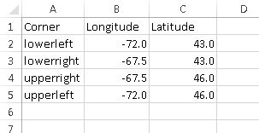
  - To make a square domain start with one corner then move around the domain in order. These points will be used to make a polyline box, and then a rectangular polygon in ArcMap.

- Open ArcMap.
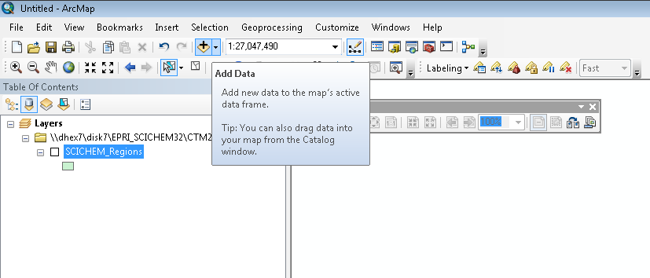
- Import the SCICHEM regions shapefile provided with the tool (./CTM2SCICHEM/ncl/input/shp/SCICHEM_Regions.shp) using the ‘Add Data’ button.
  - This will set the dataframe coordinate system to Lambert Conformal Conic, and provide spatial reference for the newly specified domain.
- Import the domain .csv file created in Step 1 into ArcMAP using ‘Add Data.’
- Right click on the imported dataset and select ‘Display X,Y data’
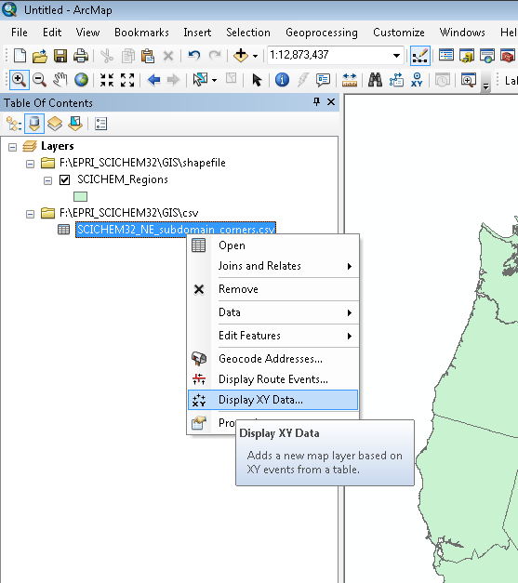

- Click ‘Edit’ and select the coordinate system corresponding with the latitude, longitude of the domain corners provided in the loaded csv file. Then, click ‘Ok’.
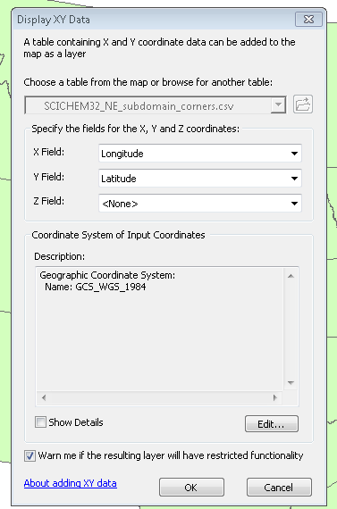
- Export the newly created point events layer (from Step 6) to a shapefile.
  - Right click on the Events layer created in Step 6.
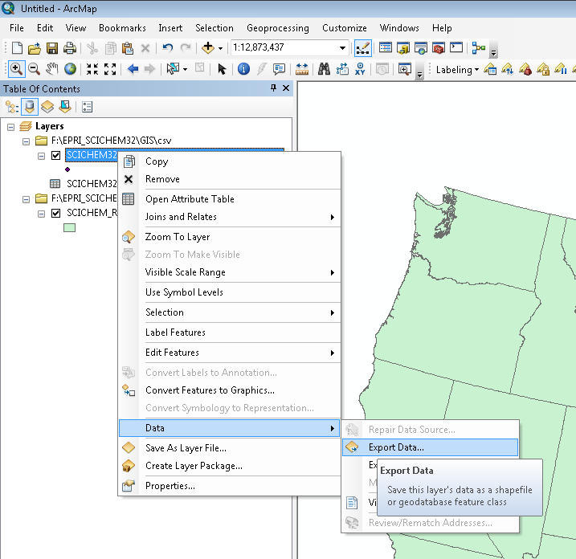
  - Click ‘Data’ -> ‘Export Data’
  - Select the option to use the same coordinate system as the dataframe.
  - Specify the output location and press ‘OK’.
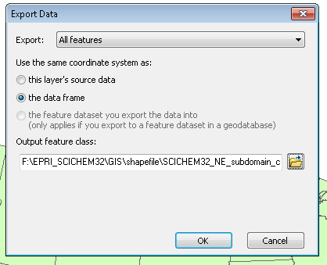
  - Add this shapefile to the map.

- Convert the point shapefile from Step 7 into lines with the ‘Points to Line’ tool.
  - Under the ‘Geoprocessing’ menu select ‘Search For Tools.’
  - In the search bar enter ‘Points to Line’
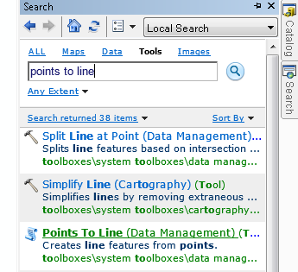
  - Select ‘Points to Line (Data Management)
  - Select the point events layer you created in step 4 as ‘Input’ and select an output location.
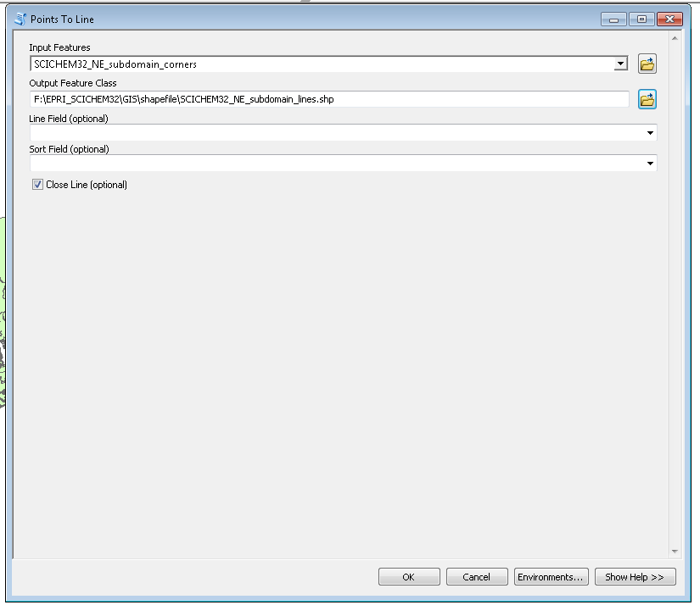
  - Select ‘Close Line’. Press ‘OK.’

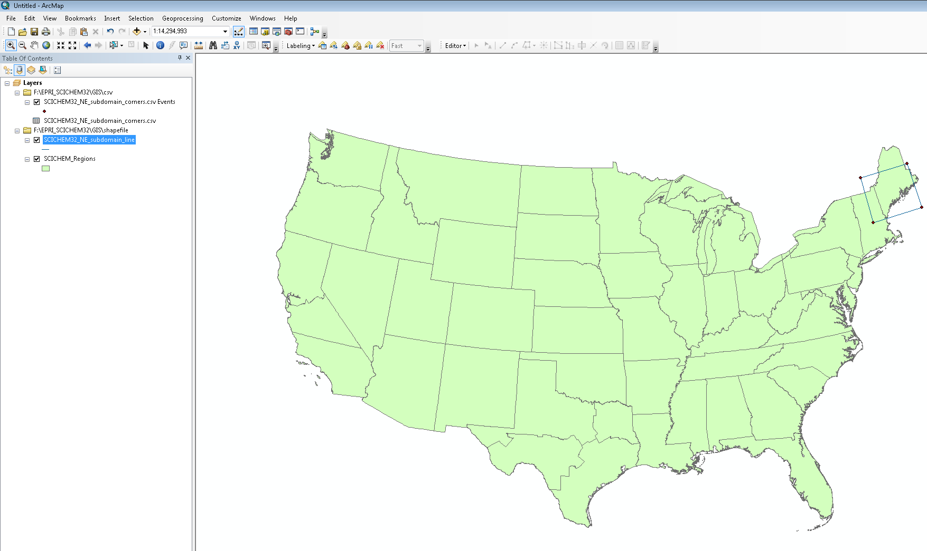
  - A line shapefile will be created connecting the 4 points entered.

- Create a polygon from your line feature.
  - Search in the geoprocessing menu (following the process in Step 8) for the ‘Feature to Polygon’ tool.
  - Select the lines feature from step 8 as input, and specify the output shapefile name. Press ‘OK’
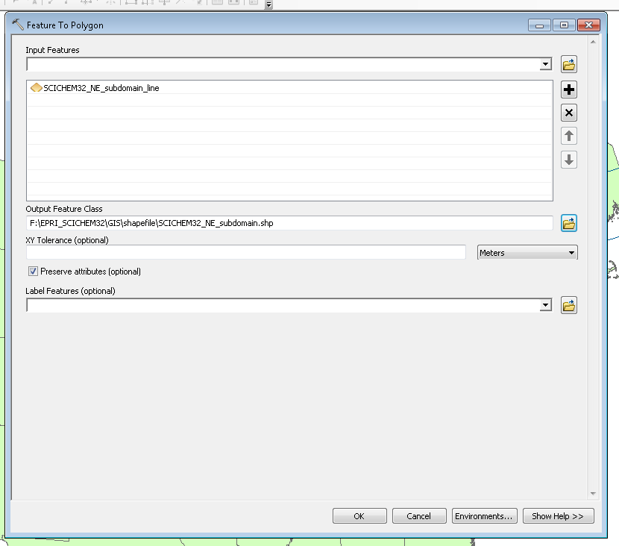
- Add a ‘Domain’ field to the created polygon shapefile.
  - Open the attribute table by right clicking on the created polygon layer and selecting ‘Open Attribute Table’.
  - Add a field to the attribute table using ‘Add Field’ in the menu.
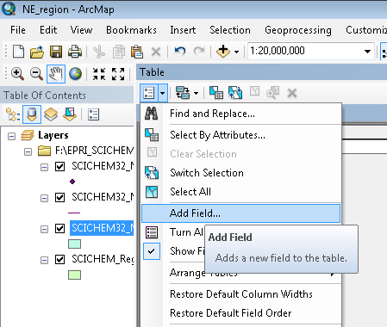
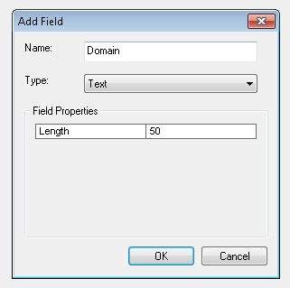
  - Name this field ‘Domain’ with type ‘Text.’

- Add the domain name to the created ‘Domain’ field.
  - Open the editor menu, and click ‘Start Editing.’
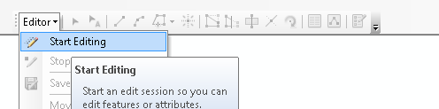
  - Open the attribute table of the domain polygon layer.
  - Click on the cell in the ‘Domain’ field and enter the domain name.
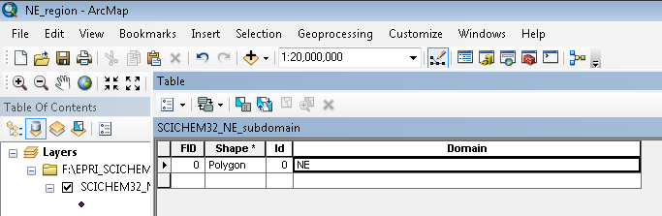
  - On the editor toolbar, click ‘Save Edits’ and then ‘Stop Editing.’
- This shapefile can be used in CTM2SCICHEM (REGION_SHP).

Running the tool
Run scripts are stored in ./CTM2SCICHEM/runfiles. An example runscript is provided with the tool (‘./CTM2SCICHEM/runfiles/CTM2SCICHEM_CONUS12km_cb6r4_CAMx2011.csh’), and is also copied below with all user required configuration input shown in red. Additional notes/comments are shown in blue.
The required steps for running the tool are as follows:
- Create a run script by creating a copy of the run script provided with the tool.
- Updated the required user configuration for the run of interest in the ‘User Inputs’ section of the run script (marked with red in the run script template below).
- Execute the run script
Each step of the CTM2SCICHEM tool can be skipped (if unnecessary or already completed) by setting the SKIP environmental variable in each step.
Run Script Template (user input shown in red, notes in blue)
#!/bin/csh

## Tool to create SCICHEM inputs from 3D CTM Model Outputs (CAMx or CMAQ)
# -----------------------------------------------------------------------

### Steps:
## 1. CAMx2IOAPI (only required for CAMx output files)
# - Converts CAMx 3D output to I/O-API format
# - Only required for CAMX files as CMAQ output files are already in I/O-API format
# - Sigma levels of CAMx output are specified under the CAMx2IOAPI section
## 2. diurnal_prof
# - Calculate diurnal averages across each month
# - Calculated for all months in the date range provided
# - If full months data not provided, diurnal average calculated for available days
## 3. spcmap (only required for CAMx files, skipped if CMAQ specified as input model)
# - Map CTM model species to SCICHEM CB6r2 species
## 4. NCL
# - Calculate regional average using shapefile masking (e.g. states)
## 5. reformat
# - Reformat NCL ascii output to SCICHEM input format

########## User Inputs ##############
#-----------------------------------#
echo "\n----- READING USER INPUT -----\n "
## Specify location of CTM2SCICHEM Directory
set DIR_CTM2SCICHEM = /disk7/EPRI_SCICHEM32/CTM2SCICHEM/dev

## Specify whether CAMx or CMAQ model were used to generated hourly 3D Input files (not case sensitive)
set MODEL = CAMx

## Specify year of model run
set YYYY = 2011

## Provide unique runname for intermediate output directory and file labels
set RUNNAME = CONUS12km_CAMx2011_cb6r4

##Provide directory containing 3D CAMx or CMAQ outputs
# assumes all output files are in the same directory (if not create symbolic links)
set DIR_CTM_3DOUT = /disk7/EPRI_SCICHEM32/CTM2SCICHEM/input/

## Specify daily CTM (CMAQ or CAMx) output filenames format using $JDATE for the julian date
# MUST USE SINGLE QUOTES
set CTM_3DOUT_FILE = 'camx64_cb6r4.$JDATE.CONUS12km.avrg.grd01'

## Specify NCARG_ROOT environment variable for NCL and m3 tools directory that contains latlon
# NCARG_ROOT - specify if not already included in .cshrc
setenv NCARG_ROOT /usr/local/ncarg
# directory containing m3tools latlon
set DIR_M3LATLON = /models/CMAQ/lib64/ioapi-3.1/Linux2_x86_64pg

## Region list and shapefile
# Full name must match Domains field in shapefile specified below
set REGLIST = $DIR_CTM2SCICHEM/inputs/reg_list.txt
# Region Shapefile, used to create regional mask
set REGION_SHP = $DIR_CTM2SCICHEM/ncl/input/shp/SCICHEM_Regions.shp

## Variable list
# list of variables that be included in created SCICHEM background files
set VARLIST = $DIR_CTM2SCICHEM/inputs/var_list.txt

## SCICHEM layer heights (top)
set TOP_HT = $DIR_CTM2SCICHEM/inputs/vertlayer_height.txt

## Directory Locations associated with steps listed above, associated output directories, and option to skip steps
# 1. CAMx2IOAPI (only required for CAMx output files)
set DIR_CAMx2IOAPI = $DIR_CTM2SCICHEM/camx2ioapi_v6
# output directory
set DIR_CAMx2IOAPI_OUT = $DIR_CTM_3DOUT
set SIGMA_LEVELS = '0.9975,0.995,0.99,0.98,0.97,0.96,0.94,0.92,0.9,0.88,0.86,0.84,0.82,0.8,0.77,0.74,0.7,0.65,0.6,0.5,0.45,0.3,0.2,0.1,0'
# Option to skip step (if already completed). If True, IOAPI files are assumed to be in DIR_CAMx2IOAPI_OUT
set SKIP_CAMx2IOAPI = False

# 2. diurnal_prof
# main diurnal_prof directory
set DIR_DIURNAL_PROF = $DIR_CTM2SCICHEM/diurnal_prof
# output directory
set DIR_DIURNAL_PROF_OUT = /dhex7c/EPRI_SCICHEM32/CTM2SCICHEM/diurnal_prof/output/${RUNNAME}
# option to skip step (if already completed)
set SKIP_DIURNAL_PROF = False

# 3. spcmap
# main spcmap directory
set DIR_SPCMAP = $DIR_CTM2SCICHEM/spcmap
# spcmap output directory
set DIR_SPCMAP_OUT = $DIR_SPCMAP/output/$RUNNAME
# mapping tables from CTM chemical mechanism to SCICHEM species
set SPCMAP_MAPTBL = $DIR_SPCMAP/Species_Mapping_Tables/MAPTBL.CAMx-CB6-CF_to_CB6r4.scichem
# option to skip (if already completed), if True assumes ioapi files for spatial averaging are in $DIR_specmap_out
set SKIP_SPCMAP = False

# 5. NCL (and getlatlon)
set DIR_NCL = $DIR_CTM2SCICHEM/ncl
set DIR_NCL_INPUT = $DIR_NCL/input
set DIR_NCL_OUT = $DIR_NCL/output/$RUNNAME
set DIR_NCL_NCDF_OUT = ${DIR_NCL}/ncf

# GRIDDESC file containing grid definition.
set CTM_GRIDDESC = $DIR_NCL_INPUT/GRIDDESC.CONUS12km
set CTM_GRIDNAME = CONUS12km
set DIR_GETLATLON_OUT = $DIR_NCL_INPUT
## Name of output file for LATLON tool
# For CMAQ runs, a GRIDCRO2D file can be provided instead.
# If specifying an exiting GRIDCRO2D file LATLON_OUTFILE, set SKIP_GETLATLON to 'True'
set LATLON_OUTFILE = $DIR_GETLATLON_OUT/LATLON.CONUS12km.nc
# If SKIP_GETLATLON set to True, assumes latlon outfile above exists, only needs to be run once for each grid
set SKIP_GETLATLON = False
set SKIP_NCL = False

# 6. reformat
set DIR_REFORMAT = $DIR_CTM2SCICHEM/reformat
set DIR_REFORMAT_OUT = $DIR_REFORMAT/output/$RUNNAME/
set REFORMAT_VARLIST = $VARLIST
set REFORMAT_REGIONLIST = $REGLIST
set SKIP_REFORMAT = False
#-----------------------------------#
#####################################

## Alias to provide 3D CTM output file name within JDATE loop
# Used in CAMx2IOAPI for CAMx files, and in diurnal_prof for CMAQ files
alias CTM_DAILYFILE echo "$CTM_3DOUT_FILE"

# Beginning and ending julian dates based on user specied Year.
set BEGJDATE = ${YYYY}001
set ENDJDATE = `date -d "1/1/$YYYY + 1 year - 1 day" +%Y%j`
# Months
set MONTHS = '01 02 03 04 05 06 07 08 09 10 11 12'

echo "\nUSER INPUT: "

echo " CTM MODEL: $MODEL"
echo " CTM Grid Name: $CTM_GRIDNAME"
echo " CTM GRIDDESC File: $CTM_GRIDDESC"
echo " RUN YEAR: $YYYY"
echo " RUN NAME: $RUNNAME"
echo " Variable List: $VARLIST"
echo " Regions List: $REGLIST"
echo " Regions Shapefile: $REGION_SHP"
echo " Species Mapping: $SPCMAP_MAPTBL"
echo " Final SCICHEM Out: $DIR_REFORMAT_OUT\n"

####################################
######## Begin CTM2SCICHEM #########
####################################

echo "----- BEGINNING PROCESSING -----\n "

#################
# CAMx2IOAPI
#################
echo "# START CAMx2IOAPI #\n"
# covert user specified model to lower case
set MODEL_LC = `echo $MODEL | tr "[:upper:]" "[:lower:]"`

# If CMAQ skip CAMx2IOAPI
if($MODEL_LC == "cmaq") then
echo "User specified CMAQ model as source of hourly 3D input files"
echo "Skipping CAMx2IOAPI (not required as CMAQ files are already I/O-API format)\n"

else if($MODEL_LC == "camx") then
# Convert SKIP option to lower case
set SKIP_CAMx2IOAPI_LC = `echo $SKIP_CAMx2IOAPI | tr "[:upper:]" "[:lower:]"`

# SKIP_CAMX2IOAPI set to True, skip.
if($SKIP_CAMx2IOAPI_LC == "true" || $SKIP_CAMx2IOAPI_LC == "t") then
echo "Skipping CAMx2IOAPI even though CAMx was selected as user specified SKIP_CAMx2IOAPI as True"
echo "Setting IOAPI directory (Hourly 3D IO-API model files) to $DIR_CAMx2IOAPI_OUT"
set DIR_IOAPI = $DIR_CAMx2IOAPI_OUT

# SKIP_CAMx2IOAPI set to False, continue.
else
echo "User specified CAMx model as source of hourly 3D input files, running CAMx2IOAPI"
# create output directory
mkdir -p $DIR_CAMx2IOAPI_OUT
set DIR_IOAPI = $DIR_CAMx2IOAPI_OUT

set JDATE = $BEGJDATE
echo "CAMx2IOAPI - Beginning JDATE: $JDATE; End JDATE: $ENDJDATE"
while ($JDATE <= $ENDJDATE)
##!! SPECIFY CAMx daily output file names using $JDATE
set INFILE_3DCAMxOUT = $DIR_CTM_3DOUT/`CTM_DAILYFILE`
set INBASE = `basename $INFILE_3DCAMxOUT`
# IOAPI output file name specified using CAMx output file names
set OUTFILE_IOAPI = ${INBASE}.ioapi.nc
setenv IOAPI_OUT $DIR_IOAPI/$OUTFILE_IOAPI
rm -f $IOAPI_OUT
$DIR_CAMx2IOAPI/src/camx2ioapi << EOF
Input CAMx |$INFILE_3DCAMxOUT
Data Type |AVRG
Sigma Levels |$SIGMA_LEVELS
EOF
echo "finished running CAMx2IOAPI for JDATE: $JDATE"
@ JDATE++
end # jdate loop
endif # SKIP_CAMx2IOAPI option
else
echo "Selected CTM model '$MODEL' not recognized. Please choose CAMx or CMAQ."
echo "Exiting"
exit
endif # Model selection

################
# diurnal_prof
#################
echo "# START diurnal_prof #\n"

# Convert user specified SKIP_DIURNAL_PROF option to lowercase
set SKIP_DIURNAL_PROF_LC = `echo $SKIP_DIURNAL_PROF | tr "[:upper:]" "[:lower:]"`

# SKIP_DIURNAL_PROF set to True, skip.
if($SKIP_DIURNAL_PROF_LC == "true" || $SKIP_DIURNAL_PROF_LC == "t") then
echo "Skipping diurnal_prof (monthly diurnal average) as user specified SKIP_DIURNAL_PROF as True"
echo "Assuming monthly diurnal average files are in $DIR_DIURNAL_PROF_OUT\n"

# SKIP_DIURNAL_PROF set to False, continue.
else
echo "Starting diurnal_prof to calculate monthly diurnal averages."
setenv ALL_LAYERS T
setenv GET_SUM F
# make output directory
mkdir -p ${DIR_DIURNAL_PROF_OUT}

foreach MM ($MONTHS)
set ndays = `cal $MM $YYYY | awk 'FNR>2{d+=NF}END{print d}'`
setenv NFILE $ndays
set JDATE = `date -d "$MM/1/$YYYY" +%Y%j`
set i = 1
while($i <= $NFILE) # read input files for each month
set INUM = `echo $i | awk '{printf("%3.3d",$1)}'`
if($MODEL_LC == "camx") then
set IOAPI_FILE = `CTM_DAILYFILE`.ioapi.nc
setenv INFILE${INUM} "${DIR_IOAPI}/${IOAPI_FILE}"
else if($MODEL_LC == "cmaq") then
setenv INFILE${INUM} "${DIR_CTM_3DOUT}/`CTM_DAILYFILE`"
else
echo "Selected CTM model '$MODEL' not recognized. Please choose CAMx or CMAQ."
echo "Exiting"
exit
endif
@ i++
@ JDATE++
end # read input files for each month
setenv OUTFILE ${DIR_DIURNAL_PROF_OUT}/${RUNNAME}.${YYYY}${MM}.hrly_prof.ioapi.nc
rm -f $OUTFILE
echo "Running diurnal_prof for month $MM of $YYYY with $ndays days of input"
$DIR_DIURNAL_PROF/src/diurnal_prof
end # foreach MM
endif # SKIP_DIURNAL_PROF

#################
# spcmap
#################
echo "# START spcmap #\n"
echo test

# If CMAQ skip spcmap
if($MODEL_LC == "cmaq") then
echo "User specified CMAQ model as source of hourly 3D input files"
echo "Skipping spcmap\n"
echo "Setting ncl input as diurnal prof output files: $DIR_DIURNAL_PROF_OUT”
set DIR_SPCMAP_OUT = $DIR_DIURNAL_PROF_OUT

else if($MODEL_LC == "camx") then

# Convert user specified SKIP_SPCMAP option to lowercase
set SKIP_SPCMAP_LC = `echo $SKIP_SPCMAP | tr "[:upper:]" "[:lower:]"`

if($SKIP_SPCMAP_LC == "true" || $SKIP_SPCMAP_LC == "t") then
echo "Skipping spcmap (mapping model species to SCICHEM species) as user specified SKIP_SPCMAP as True"
echo "Assuming monthly files with SCICHEM species are in $DIR_SPCMAP_OUT\n"
else
setenv MAPTBL $SPCMAP_MAPTBL
echo "Mapping CTM species to SCICHEM species using $MAPTBL."
mkdir -p $DIR_SPCMAP_OUT
foreach MM ($MONTHS)

setenv INFILE ${DIR_DIURNAL_PROF_OUT}/${RUNNAME}.${YYYY}${MM}.hrly_prof.ioapi.nc
setenv OUTFILE ${DIR_SPCMAP_OUT}/${RUNNAME}.${YYYY}${MM}.hrly_prof.ioapi.nc

rm -f $OUTFILE
echo "Running spcmap on diurnal average file of month: $MM"
$DIR_SPCMAP/src/spcmap
end # foreach MM
endif # skip spcmap
endif # CAMx or CMAQ
###################
# NCL and getlatlon
###################
echo "# START NCL FOR REGION MAPPING #\n"

## getlatlon
## ------------
# Use latlon tool of IO-API to generate a 1-layer time-indepedent gridded lat, lon file
# latlon uses the grid defifition in the $CTM_GRIDDESC file
# The grid name used in GRIDDESC and in the latlon program should be exactly the same (specified between laton <<EOF and EOF)
## ------------

# Convert user specified SKIP_DIURNAL_PROF option to lowercase
set SKIP_GETLATLON_LC = `echo $SKIP_GETLATLON | tr "[:upper:]" "[:lower:]"`

if($SKIP_GETLATLON_LC == "true" || $SKIP_GETLATLON_LC == "t") then
echo "Skipping getlatlon as user specified SKIP_GETLATLON as True"
echo "Assuming that the latlon netcdf file for the domain, $LATLON_OUTFILE, available in ncl dir\n"
else
setenv IOAPI_ISPH 20
setenv GRIDDESC $CTM_GRIDDESC
setenv GRDFILE $LATLON_OUTFILE

echo "Creating a time-indepedent gridded latlon file based on $CTM_GRIDDESC for grid: $CTM_GRIDNAME"

$DIR_M3LATLON/latlon <<EOF
Y

NONE

$CTM_GRIDNAME

EOF
endif

## NCL
## ----------
# Convert user specified SKIP_NCL option to lowercase
set SKIP_NCL_LC = `echo $SKIP_NCL | tr "[:upper:]" "[:lower:]"`

if($SKIP_NCL_LC == "true" || $SKIP_NCL_LC == "t") then
echo "Skipping ncl as user specified SKIP_NCL as True"
echo "Assuming monthly, regional output files for SCICHEM species are in $DIR_NCL_OUT\n"
else
## First ncl script generates netcdf files with region mask
##Second ncl script applies the region mask and calculates the conc values for each variable
#*********** ncl script 1 **************

set NCLMASK_INFILE = `echo "${DIR_SPCMAP_OUT}/${RUNNAME}.${YYYY}01.hrly_prof.ioapi.nc" | sed 's:/:\\\/:g'`
set GRIDCRO_FILE = `echo "$LATLON_OUTFILE" | sed 's:/:\\\/:g'`
set SHAPEFILE = `echo "$REGION_SHP" | sed 's:/:\\\/:g'`
set OUT_NCF_PATH = `echo "$DIR_NCL_NCDF_OUT" | sed 's:/:\\\/:g'`
set SHPFILE_UTILS = `echo "${DIR_NCL}/shapefile_utils.ncl" | sed 's:/:\\\/:g'`

mkdir -p $DIR_NCL_OUT
mkdir -p $DIR_NCL_NCDF_OUT

#create region csv file for NCL from user specified $REGLIST
echo "Create region csv for NCL from $REGLIST"
# remove existing region list
rm -f $DIR_NCL_INPUT/${RUNNAME}.ireg_xref.csv
set k = 1
foreach line("`cat $REGLIST`")
set reg_long = `echo $line | awk -F, '{print $2}'`
printf {{"%6s,$reg_long\n"}} {{$k}} >> $DIR_NCL_INPUT/${RUNNAME}.ireg_xref.csv
@ k++
end

set NUM_REGIONS = `wc -l < $REGLIST`
echo "Number of regions: $NUM_REGIONS"
set NCLREGION_CSV = `echo "$DIR_NCL_INPUT/${RUNNAME}.ireg_xref.csv" | sed 's:/:\\\/:g'`

cat ${DIR_NCL}/mk_regn_nc.ncl \
| sed "s/SHPUTIL/${SHPFILE_UTILS}/g" \
| sed "s/INF/${NCLMASK_INFILE}/g" \
| sed "s/GRIDNAME/${CTM_GRIDNAME}/g" \
| sed "s/GRID/${GRIDCRO_FILE}/g" \
| sed "s/SHP/${SHAPEFILE}/g" \
| sed "s/SHAPEUTIL/${SHPFILE_UTILS}/g" \
| sed "s/IREGXREF/${NCLREGION_CSV}/g" \
| sed "s/NREG/${NUM_REGIONS}/g" \
| sed "s/NCDF/${OUT_NCF_PATH}/g" \
>! ${DIR_NCL}/tmp_ncl1.ncl

ncl ${DIR_NCL}/tmp_ncl1.ncl
rm -f ${DIR_NCL}/tmp_ncl1.ncl

#******* ncl script 2 **********************

set VARS = `cat $VARLIST | awk -F, '{print $1}'`

foreach MM ($MONTHS)
foreach VAR ($VARS)

echo "$MM --- $VAR"

set INFILE = `echo "${DIR_SPCMAP_OUT}/${RUNNAME}.${YYYY}${MM}.hrly_prof.ioapi.nc" | sed 's:/:\\\/:g'`
set OUTFILE = `echo "${DIR_NCL_OUT}/${RUNNAME}.${YYYY}${MM}.${VAR}.no_laymap.txt" | sed 's:/:\\\/:g'`

cat ${DIR_NCL}/prep_scichem_bgk.all_lays.ncl \
| sed s/INF/$INFILE/g \
| sed s/OUTF/$OUTFILE/g \
| sed s/VAR/$VAR/g \
| sed s/SHP/$SHAPEFILE/g \
| sed s/SHAPEUTIL/$SHPFILE_UTILS/g \
| sed s/GRIDNAME/$CTM_GRIDNAME/g \
| sed s/IREGXREF/$NCLREGION_CSV/g \
| sed s/NREG/$NUM_REGIONS/g \
| sed s/NCDF/$OUT_NCF_PATH/g \
>! ${DIR_NCL}/tmp_ncl2.ncl

ncl ${DIR_NCL}/tmp_ncl2.ncl
rm -f ${DIR_NCL}/tmp_ncl2.ncl

end # End foreach VAR
end # foreach MM
endif # skip_ncl

#################
# reformat
#################

echo "# START reformat #\n"

# Convert user specified SKIP_DIURNAL_PROF option to lowercase
set SKIP_REFORMAT_LC = `echo $SKIP_REFORMAT | tr "[:upper:]" "[:lower:]"`

if($SKIP_REFORMAT_LC == "true" || $SKIP_REFORMAT_LC == "t") then
echo "Skipping reformat as user specified SKIP_REFORMAT as True\n"
else
mkdir -p ${DIR_REFORMAT_OUT}
perl $DIR_REFORMAT/reformat.pl $DIR_NCL_OUT $DIR_REFORMAT_OUT $REFORMAT_VARLIST $REFORMAT_REGIONLIST $YYYY $RUNNAME $TOP_HT
endif #skip_reformat

