Connect RPi /GrovePi+ running DHT11 to Adafruit IO

Create Adafruit IO account- <https://io.adafruit.com/>

My Adafruit IO dashboard: <https://io.adafruit.com/eprof1/dashboards/welcome-dashboard>

Make sure pip installed on RPi: sudo apt-get install python3-pip

Install Adafruit IO:

pip3 install adafruit-io

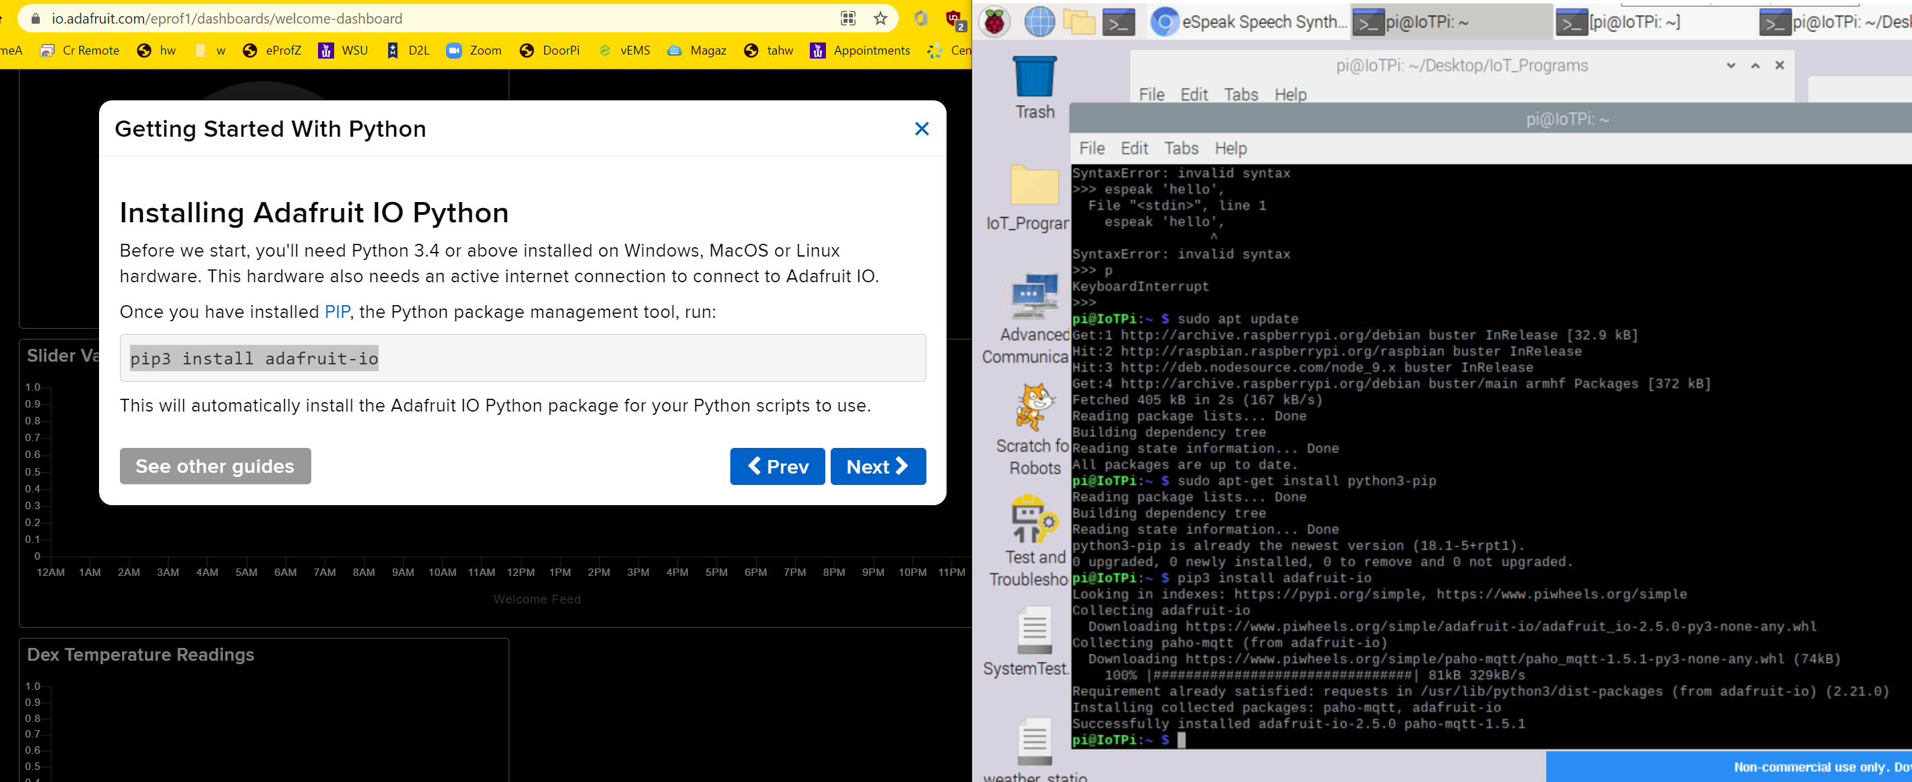

Setup dashboard-need Adafruit account ‘user’ and ‘key’ to connect to Data Feed.

Ref:

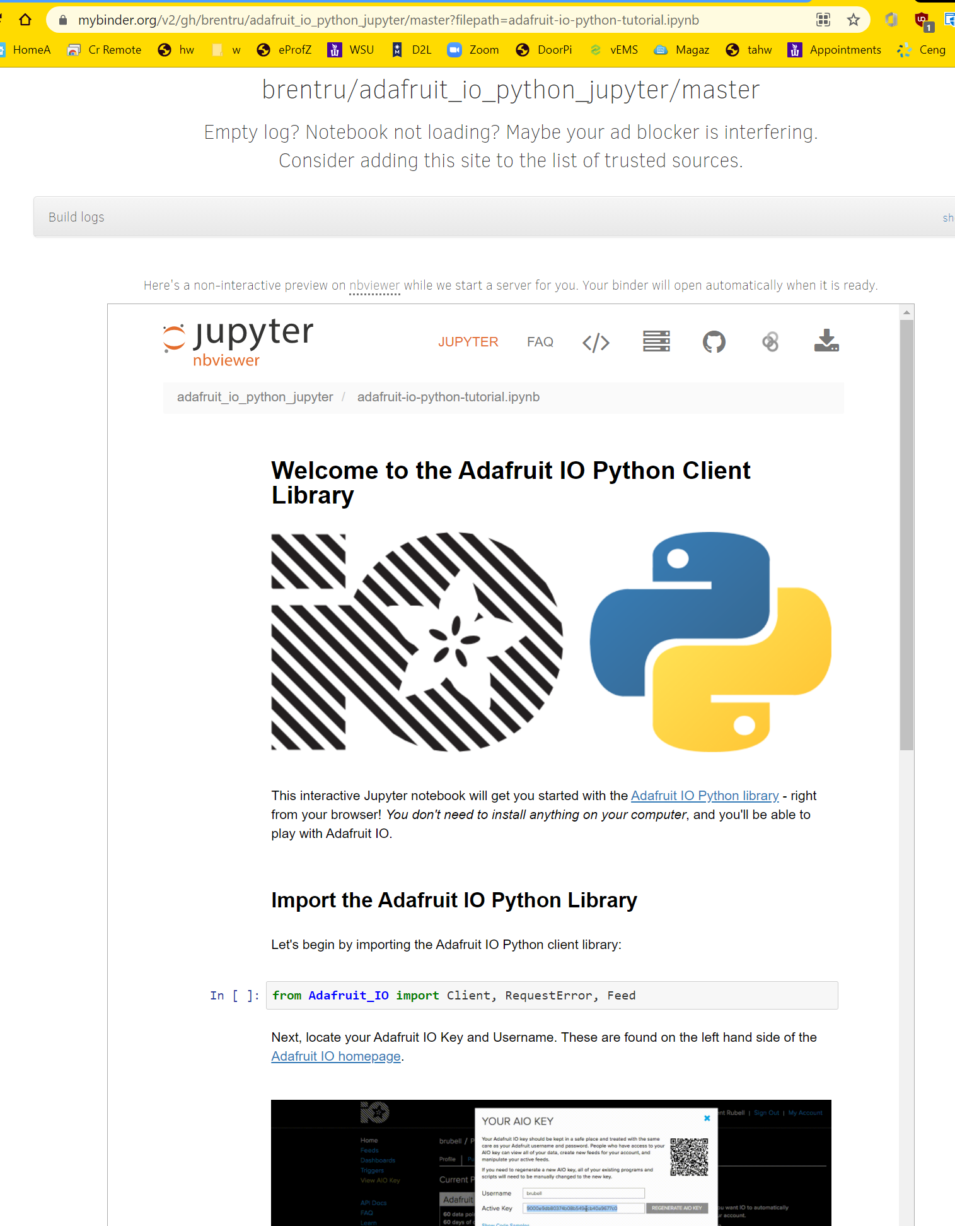

from Adafruit website can got this Github page which contains information.

<https://github.com/adafruit/Adafruit_IO_Python/tree/839e41b494aaefcca047705b3bcbc384f23322de>

which took me to: <https://adafruit-io-python-client.readthedocs.io/en/latest/quickstart.html>

10/15/2021 Note: previously created python program to push DHT to adafruit.io, worked okay. Need to add that script below. Put on Somsen 301 Teaching Station RPi/Grovpi, and push to eprofessor home page.

Here is the code from the Adafruit Quickstart, above, modified for my account, 10/20/21

*# Import library and create instance of REST client.*

**from** **Adafruit_IO** **import** Client

aio = Client('YOUR ADAFRUIT USER', 'YOUR ADAFRUIT IO KEY')

*# Send the value 100 to a feed called 'Foo'.*

aio.send('Foo', 100)

*# Retrieve the most recent value from the feed 'Foo'.*

*# Access the value by reading the `value` property on the returned Data object.*

*# Note that all values retrieved from IO are strings so you might need to convert*

*# them to an int or numeric type if you expect a number.*

data = aio.receive('Foo')

print('Received value: *{0}*'.format(data.value))

Here is python code for DHT sensor, worked okay 10/20/2021

# Import library and create instance of REST client  
from Adafruit_IO import Client  
from grovepi import *  
  
aio = Client('xxx', 'yyy') #signup for Adafruit.io account, get username and key  
dht_sensor_port = 5

while True:

try:

[temp,hum ] = dht(dht_sensor_port,0) #Get the temperature and Humidity from the DHT sensor

print("temp =", temp, "C\thumidity =", hum,"%")

t = str(temp)

h = str(hum)

# Send the value 100 to a feed called 'Foo'.

aio.send('temperature', t)

aio.send('humidity', h)

time.sleep(10)

# Retrieve the most recent value from the feeds.  
 # Access the value by reading the `value` property on the returned Data object.  
 # Note that all values retrieved from IO are strings so you might need to convert  
 # them to an int or numeric type if you expect a number.  
   
 # Troubleshooting-uncomment to try and retrieve recent data  
 #data = aio.receive('temperature')  
 #print('Received value: {0}'.format(data.value))  
 #data = aio.receive('humidity')  
 #print('Received value: {0}'.format(data.value))  
   
 except (IOError,TypeError) as e:  
 print("Error")