Sudo nano ifconfig.sh # to create file in /home/pi

#!/bin/bash

Ifconfig wlan0

Ifconfig eth0

Sudo chmod +x ifconfig.sh #makes file executable

Sudo nano ./bashrc # edit this file

Sudo /home/pi/ifconfig.sh # add this as last line of ./bashrc, it will display ip addresses if you boot to command line

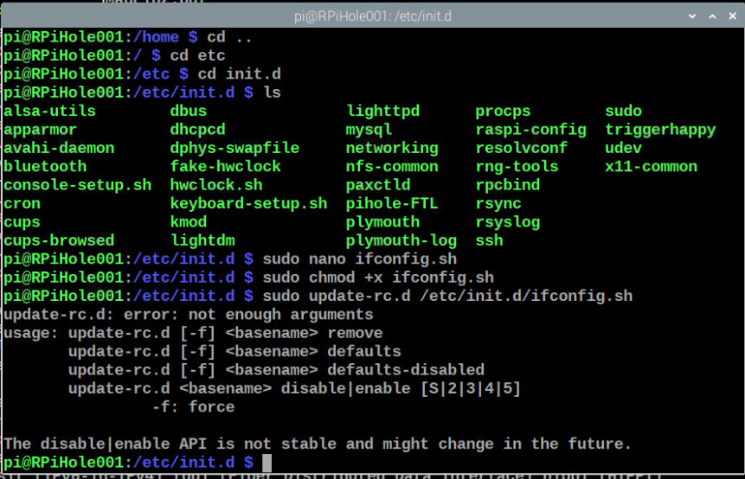sudo