Official EPSA07 Conference Hotels (to be booked by the organisers through registration form)

1. NH ALBERTO AGUILERA 3*** HOTEL
Alberto Aguilera, 18 (metro: Argüelles, phone: +34 914 460 900)

This attractive and nice hotel is located in the tourist area in Madrid, very close to Plaza España. From 20 metres you will find public transport service and from 10 minutes walking you can arrive to the city centre where you will find a large number of restaurants, shops and pubs to go out by the night.
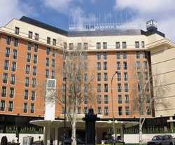
This hotel was inaugurated in 1999, has eight floors and 148 double rooms. To disposal of all the guests, there is bar and a air-conditioned restaurant. Beside, the hotel has provided with Internet service, Service Room, laundry, parking and a garage. The rooms are provided with a hairdryer in the bathroom, Phone, Internet Conection, Mini-Bar and central heating.
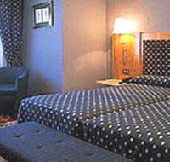
Prices

ACCOMODATION | PER NIGHT AND PER ROOM
A Double room for single occupancy , Bed and Breakfast | 133.75 €
A Double Room, Bed and Breakfast | 144.45 €

This hotel has an availability of 85 Rooms.

2. NH ARGÜELLES 3* HOTEL
C/ Vallehermoso, 65 (metro: Canal; phone: +34 915 939 777)

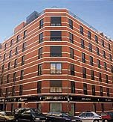
This hotel is located close to Bravo Murillo Street and Vallehermoso Stadium. There is shuttle service by bus to Barajas Airport.
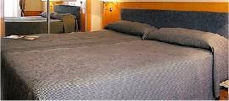
This urban hotel has 75 rooms, 24 hours - Reception, Safe deposit box in rooms, cloakroom. Regarding the meals, the hotel offers a restaurant and a bar for all the guests. There is an Internet Connection and Rental Car at Reception. Also the hotel offers a babysitter for parents who want to leave in good hands to their children. There is a Room Service, Laundry and medical attention. You will park your car in the garage or parking. The rooms are equipped with air-conditioned, hairdryer. In the bathroom, telephone, Satellite/Cable Colour TV and minibar. Every morning the hotel offers buffet service in order the guest could serve whatever you wish.
Prices

ACCOMODATION | PRICE PER NIGHT AND ROOM
A Double room for single occupancy , Bed and Breakfast | 111.30 €
A Double Room, Bed and Breakfast | 126.30 €

This hotel has an availability of 40 Rooms.

3. MELIÁ MADRID 5***** HOTEL
C/ Princesa, 27 (metro: Ventura Rodríguez; phone: +34 915 418 200)

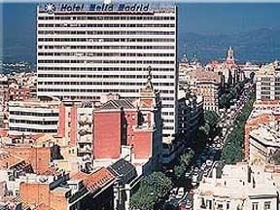
This hotel is located in one of the most important area in Madrid, close to Real Palace, “Plaza España” and “Plaza Mayor”. You will arrive to tourist interesting places walking from the hotel. It is recommended visiting cities like Toledo and El Escorial from 60 Km distance.
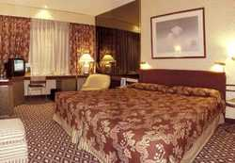
The building was built in 1967 and was renovated in 1998. The hotel has a total of 12 floors with 275 rooms, which 252 double rooms and 23 Suites Rooms. It offers the guests a large hall, Safe deposit box in room, cloakroom, foreign currency, and a 24hours reception. There are some shops, a disco, a bar, a hairdresser’s, and air-conditioned restaurant with non-smoking area. There is a Conference Room and an Internet Connection, Laundry Service, Medical Attention and a parking and garage. The luxe rooms are equipped with hairdryer in the bathroom, Satellite Television, Radio and Internet Connection, Minibar, King-Bed and central heating. Also there is Spa area, Solarium, swimming pool, Jacuzzi and massage service. The breakfast and the lunch is buffet service.
Prices

ACCOMODATION | PRICE PER NIGHT AND ROOM
A Double room for single occupancy , Bed and Breakfast | 176.55 €
A Double Room, Bed and Breakfast | 187.25 €

This hotel has an availability of 50 Rooms.

4. ABBA ATOCHA 3*** HOTEL
Pº Santa María de la Cabeza, 73 (metro: Delicias; phone: +34 914 739 111)

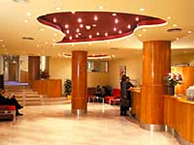
Located in the City centre, near to Prado, Reina Sofía and Thyssen- Bornemisza Museum, and 10 minutes walk from Atocha Station.
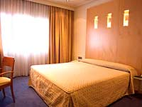
The hotel offers modern rooms 108, 7 Junior Suite, non-smoking floor, garage and a large rooms to celebrate any event. In its restaurant “Las Brasas”, you will enjoy of a delicious “castellana cuisine” plenty of tradicional tastes.

Prices

ALOJAMIENTO | PRECIO POR HABITACIÓN Y NOCHE
A Double room for single occupancy , Bed and Breakfast | 81.35 €
A Double Room , Bed and breakfast | 88.85 €

This hotel has an availability of 40 Rooms.

5. TRYP ATOCHA 4**** HOTEL
C/ Atocha, 83 (metro: Atocha; phone: +34 913 300 500)

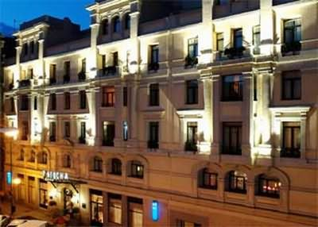
The hotel is located in the centre area of Madrid, close to Prado Museum, Atocha Station, and of another important places of the city.
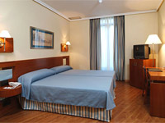
The building was built in 1913 and was fully renovated in 2002. It offers to their guests 150 rooms, a large hall, 24 hours reception, foreign currency, Safe Deposit Box and a cloakroom. Also there is a bar and a air-conditioned restaurant, a Conference Room, Internet Connection, laundry, garage. Rooms are equipped with telephone, Internet Connection, Satellite Television, Minibar, Central Heating, King-Bed.
Breakfast is buffet service.
Prices

ACCOMODATION | PRICE PER NIGHT AND ROOM
A Double room for single occupancy , Bed and Breakfast | 144.45 €
A Double Room , Bed and breakfast | 155.15 €

This hotel has an availability of 50 Rooms.

NH SUITES PRISMA 4**** HOTEL
Santa Engracia, 120

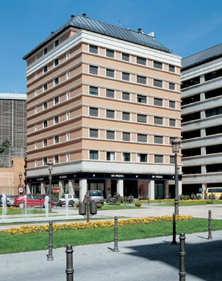

Located in the Nuevos Ministerios and Azca area, very close to the Paseo de la Castellana.

Hotel services
24 hours room service
Car rental
Babysitting service
Breakfast buffet
Café Bar
Cloakroom service
Early riser breakfast

Front desk safety deposit box
Internet connectivity
Laundry
Medical service
Meeting rooms
Restaurant
Shuttle service
Video games

In-room services
Air-conditioning
Canal+
Choice of pillows
Direct-dial telephone
Hairdryer
Mini-bar
Pay per view films
Satelite TV Radio
Toiletries kit
Wireless internet access

