Team Granite · App team · working draft with pictures

Script sequence with pictures
This is the 5-minute order: spoken lines, then the picture that sits under them. Eddie’s grabs are in. Wilmer’s plan + list shots are still empty orange boxes. Version 1 film (silent): https://granite-plan09.pages.dev/demo-5min
Working Google Doc for the team: https://docs.google.com/document/d/1YIlnHycgLJT_yIp2MM2VxnZXQ1ny6UzBjGMYsE10P34/edit?usp=sharing
To drop this into that Google Doc: File → Open → Upload this Word file, or copy the pictures across. Spoken is what a person reads. No voice on the film yet.

01. The case · 0:00–0:45
Spoken
Ahlsell gets asked to price the fittings on a building that does not exist yet. A contractor sends a pack of drawings and wants a number. That number is how Ahlsell wins the job — or loses it.
Today a specialist still does that by hand. They sit with the drawings, sometimes in Bluebeam, sometimes with a highlighter on an A2 print, and they count. It takes hours. If they miss a room, the quote is wrong. And when it goes out, their name is on it.
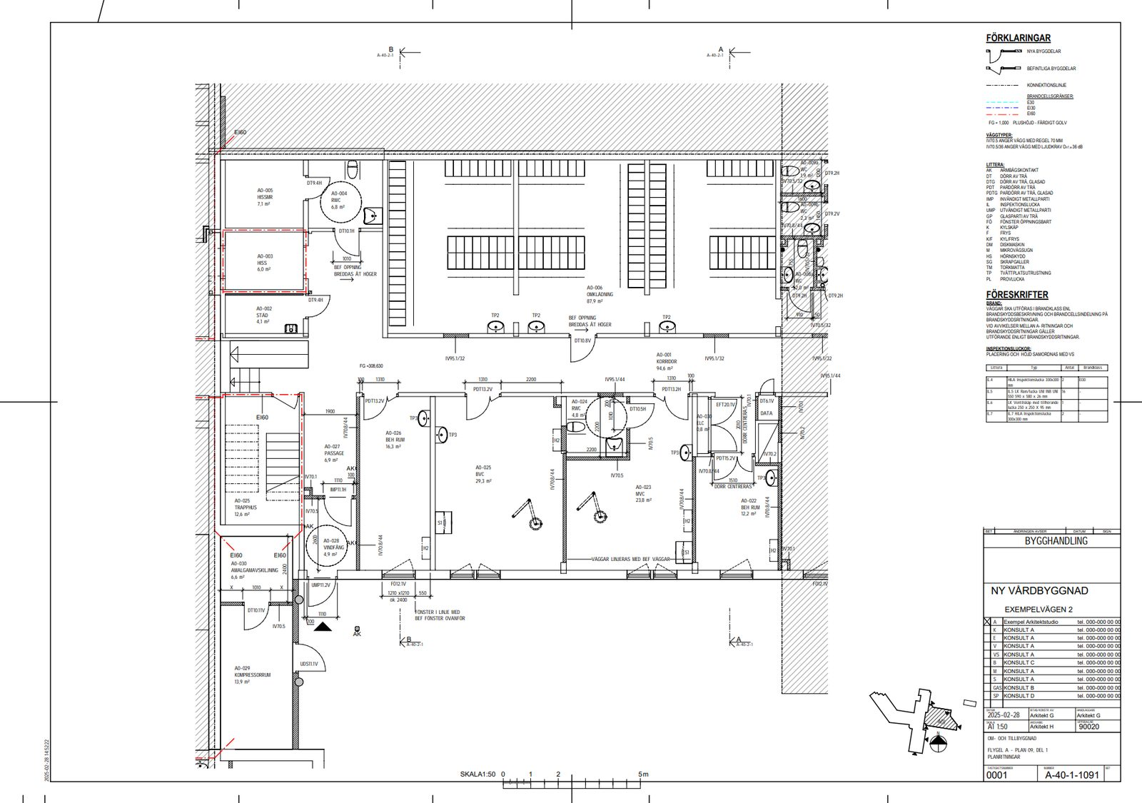
01-empty-plan.png · Raw A-40-1-1091. A room. No our boxes.

02. The promise · 0:45–1:15
Spoken
We are an app team. We did not try to replace that person, and we did not try to rebuild Bluebeam.
We asked a smaller question: once a machine has had a first pass at the PDFs, is that result reviewable? Can they open it in Bluebeam and see the draft already in the Markups List, see what is solid and what still needs a person, and still be the one who signs?
That is what we are going to show.
WAITING — Wilmer’s grab
02-wilmer-plan-list.png
Wilmer UI. Plan with marks + 69-line list. Don’t click yet.

03. Proof — in their tool · 1:15–2:05
Spoken
Here is a floor. Empty. This is where they start today — a blank page.
01-empty-plan.png (again) · Same empty drawing. Then cut to the filled one.

Here is the same floor after the API has had a go. The list is already there, next to the drawing.
WAITING — Wilmer’s grab
02-wilmer-plan-list.png (again)
Wilmer: filled plan + list.

And here it is in Bluebeam: the Markups List is filled. The real codes are still the real codes. They do not re-type sixty-nine lines.
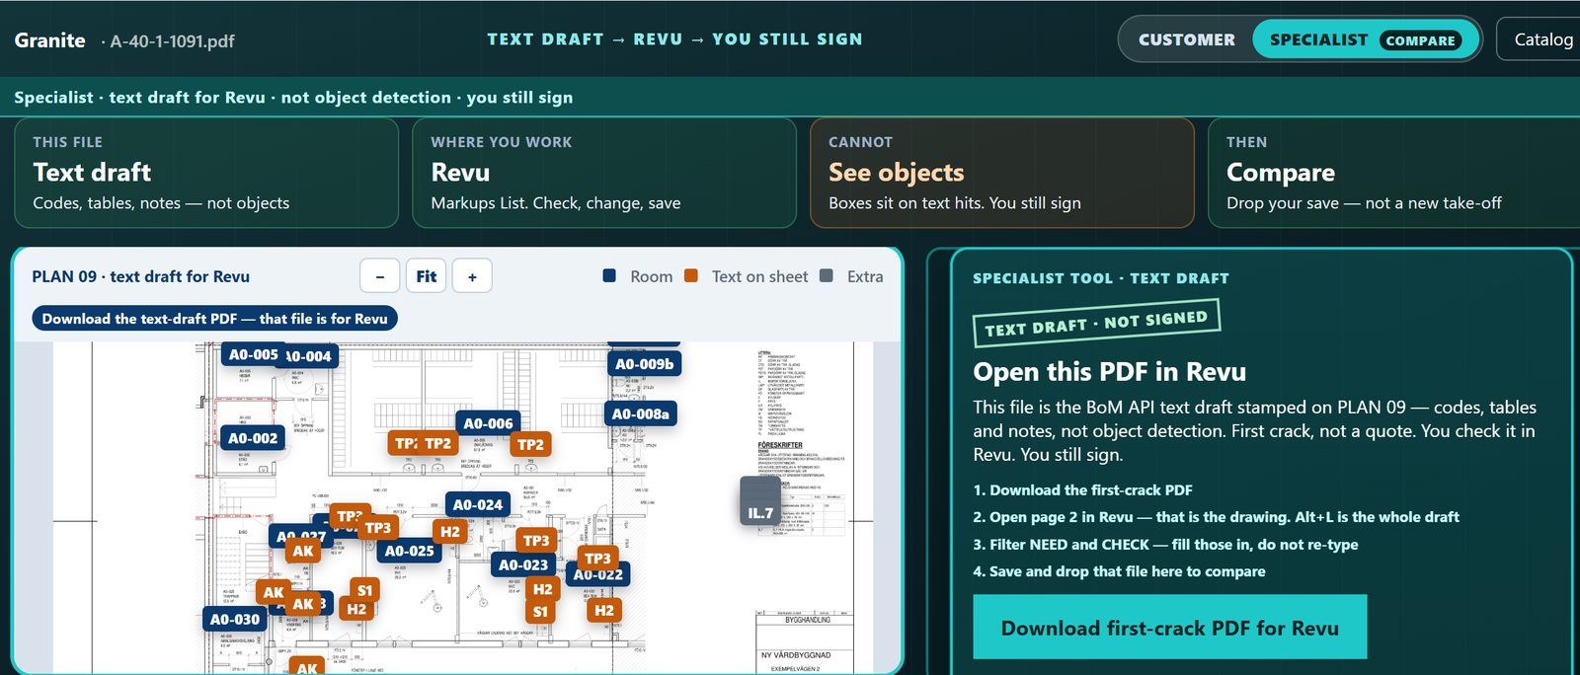
05-eddie-download-pdf.png · Specialist screen. Download first-crack PDF for Revu.

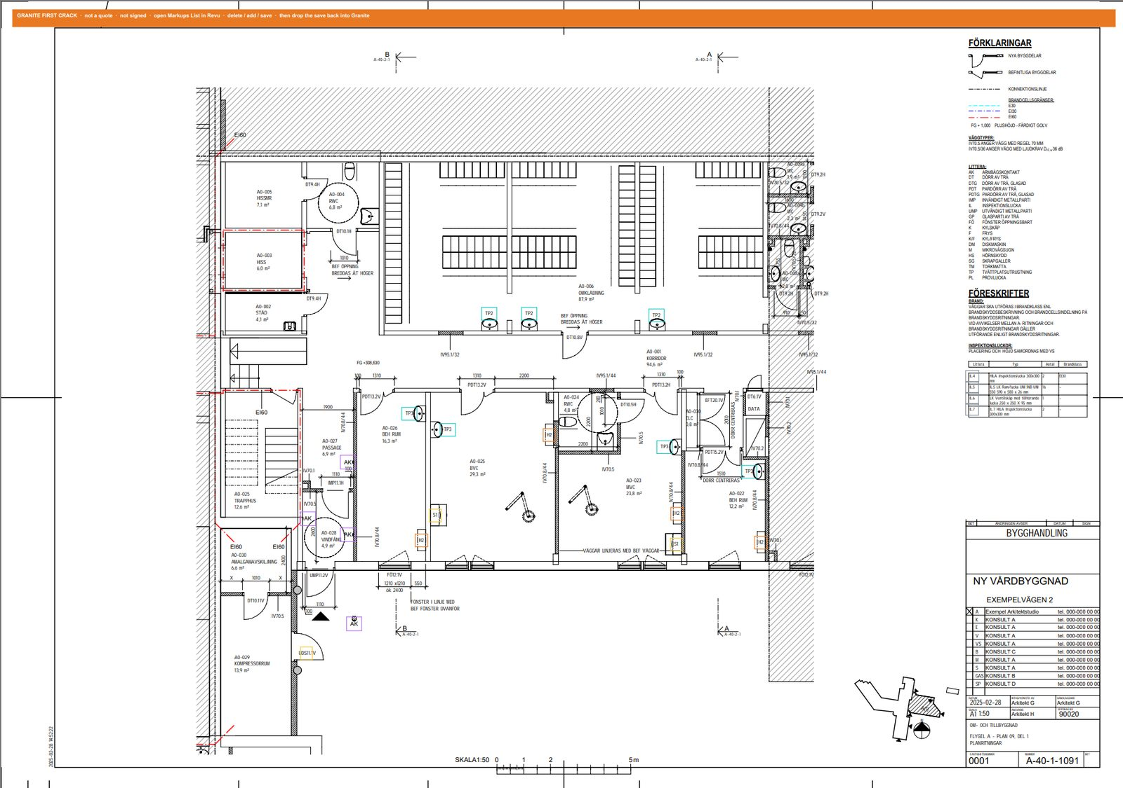
06-pdf-page2-boxes.png · First-crack PDF, page 2. Coloured boxes on the drawing.

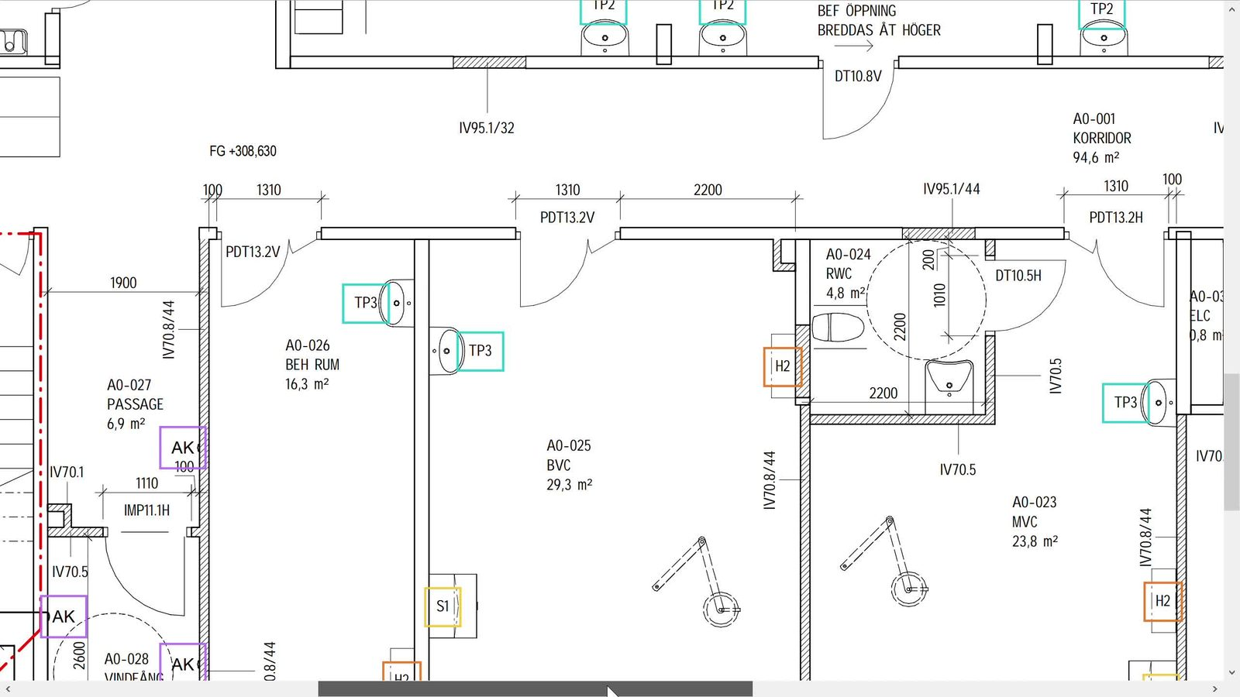
06-pdf-page2-boxes.mp4 (clip still) · Same sheet moving. Marks already on the page.

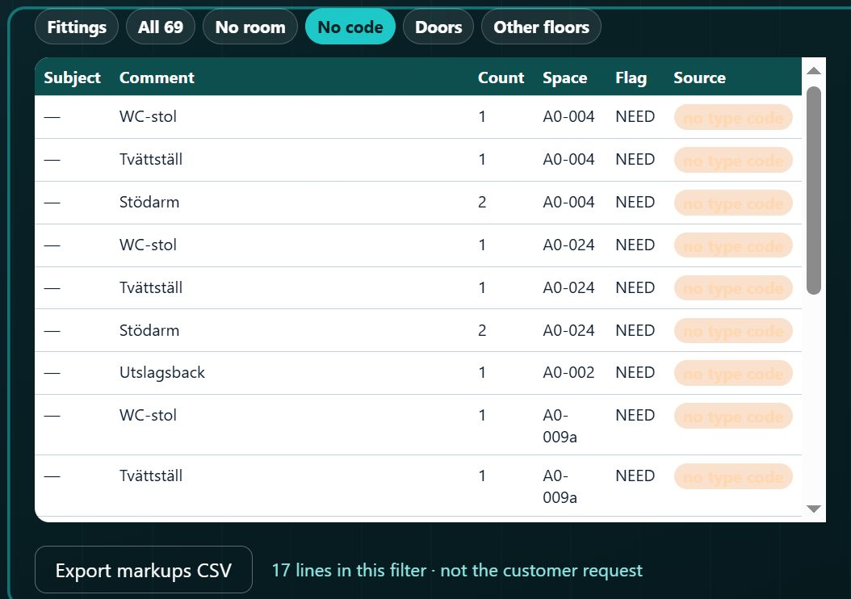
08-revu-markups-need.png · Demo-site Full draft list after scroll. NEED rows. Not Revu itself.

03. Proof — what still needs a person · 2:05–2:50
Spoken
They can see which lines still need a person: missing info, things that are another trade, a shelf that is not even on this sheet. The gaps stay visible. That is the point.
WAITING — Wilmer’s grab
03-wilmer-click-mark.mp4 / .png
Click H2 or TP3 on Wilmer’s plan.

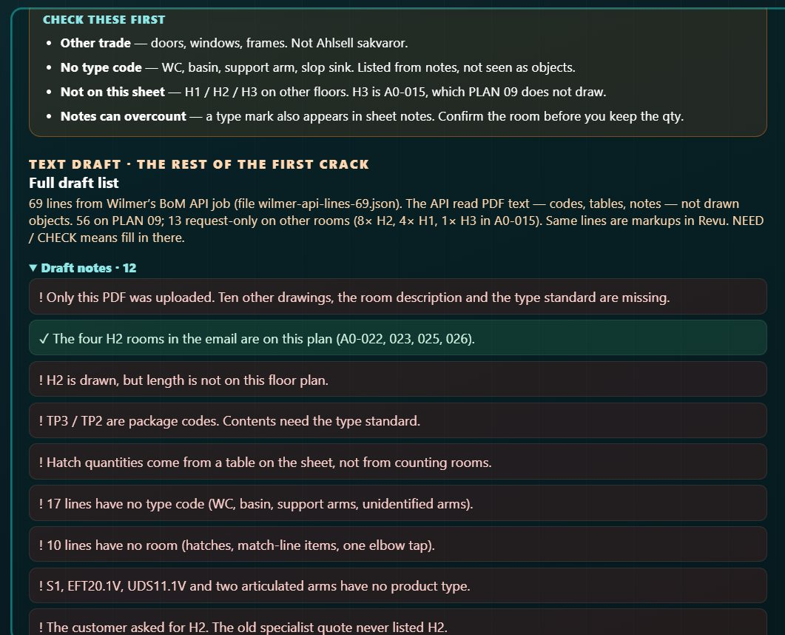
09-eddie-check-first.png · Eddie specialist: Check these first.

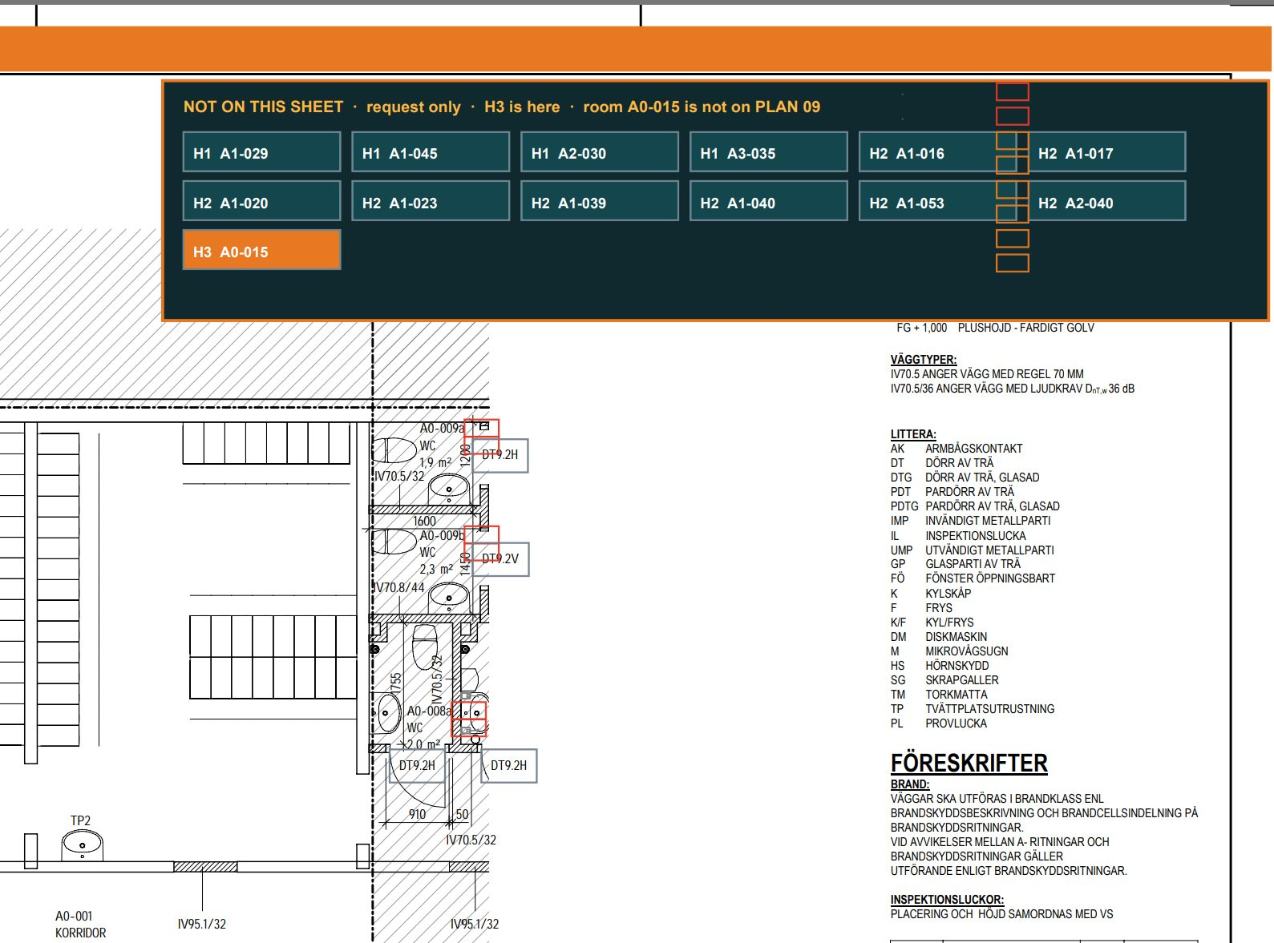
07-pdf-h3-offsheet.png · PDF: NOT ON THIS SHEET / H3.

WAITING — Wilmer’s grab
04-wilmer-notes.png
Wilmer Notes (12). A gap must be readable.

03. Proof — they still sign · 2:50–3:35
Spoken
They check. They change what is wrong. They save. We can show them what changed. We do not send the quote. They do.
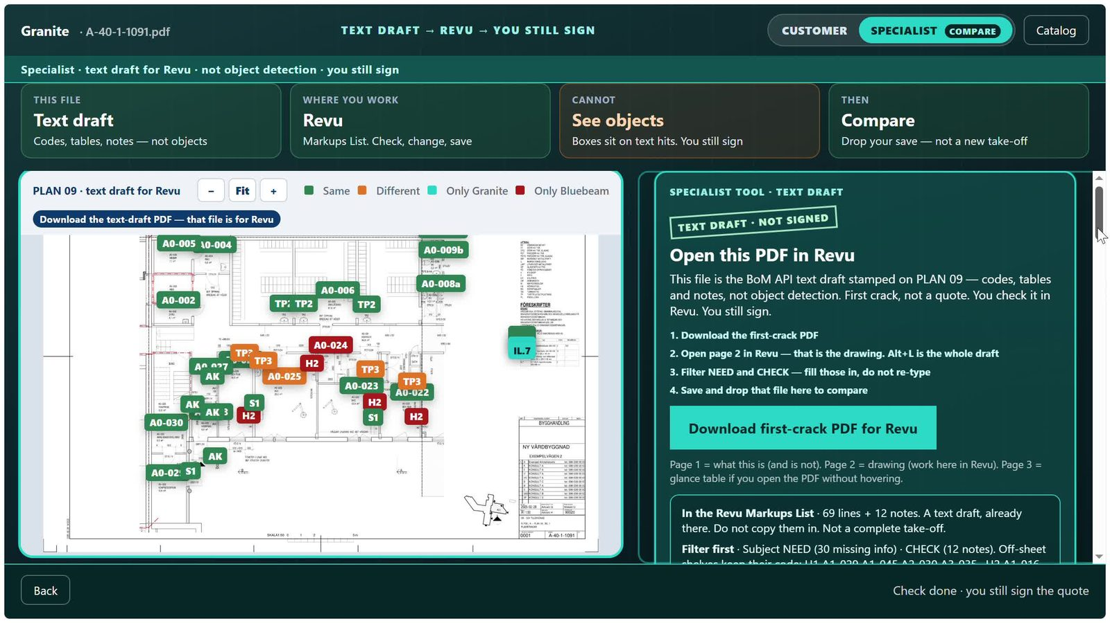
10a-eddie-compare-drop.mp4 (clip still) · Drop the save / sample check.

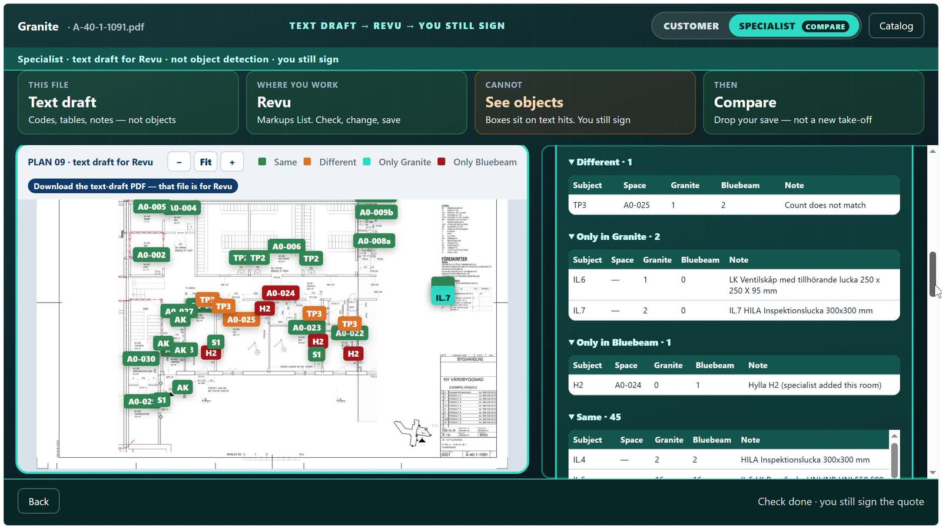
10b-eddie-compare-result.mp4 (clip still) · Same / Different / Only in Granite / Only in Bluebeam.


11a-not-signed-stamp.png · Stamp: TEXT DRAFT · NOT SIGNED. 11b was a duplicate of 09, so this is the sign-off grab.

03. Extra — catalogue · 3:35–3:50 (cut first if long)
Spoken
When they need an article number, they look it up in the assortment. The API did not invent those numbers.
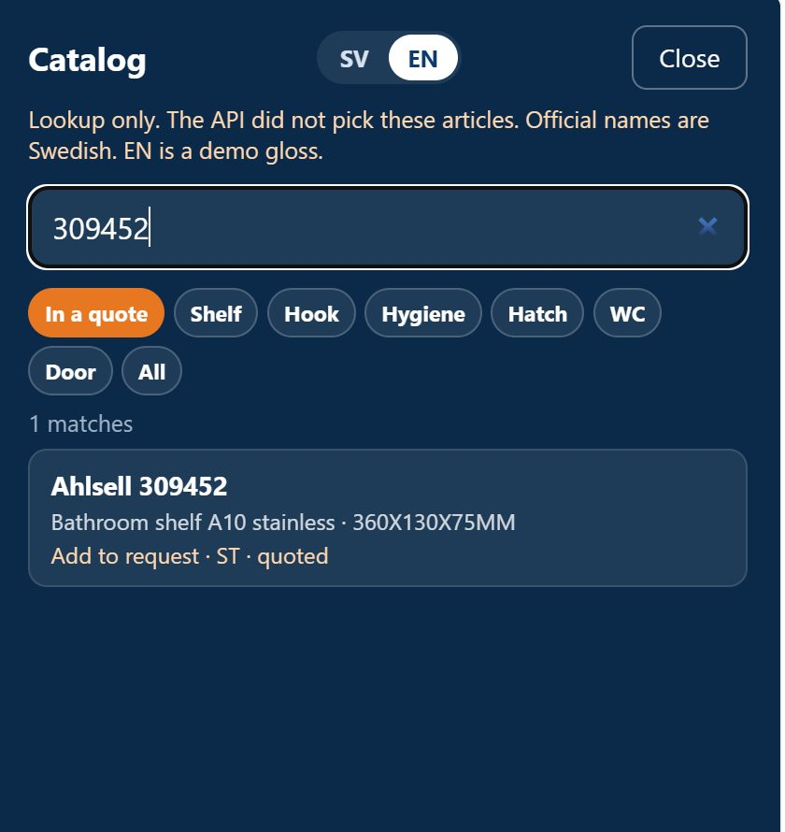
12-eddie-catalog.png · Catalog search. One real Ahlsell number. Optional.

04. The insight · 3:50–5:00
Spoken
We should tell you what the machine actually did. It did not count the fittings the way a person counts objects on a sheet. It read the text — the codes, the tables, the notes.
WAITING — Wilmer’s grab
04-wilmer-notes.png (again)
The notes are the proof the API is guessing from text, not seeing objects.

Ahlsell already wondered if the answer might be in the text rather than the drawing. For this API, that is what we got. The hope that the machine looked at the plan and counted the fittings is a dead end. The jury asked for dead ends. That is ours.
It is allowed to be a bit disappointing. A well-argued “we tried that and it cannot work” is still a result. And a filled list is still not nothing. Starting from a draft you can reject is a different job from starting from zero.
06-pdf-page2-boxes.png (filled list) · Filled marks. The plus. Swap for Wilmer’s list when we have it.

So the useful thing, for us, is not a smarter pair of eyes tonight. It is a review surface: the PDF comes out, a person can work it in Bluebeam, and a person still signs.
11a-not-signed-stamp.png (again) · End here. They still sign.

Wilmer still to drop in: 02 plan+list, 03 click a mark, 04 notes. Everything else is Eddie’s grab.

