{{phone}}

{{factor_date}}

{{factor_addons}}

{{factor_id}}

{{location}}

{{title}}

{{sby}}

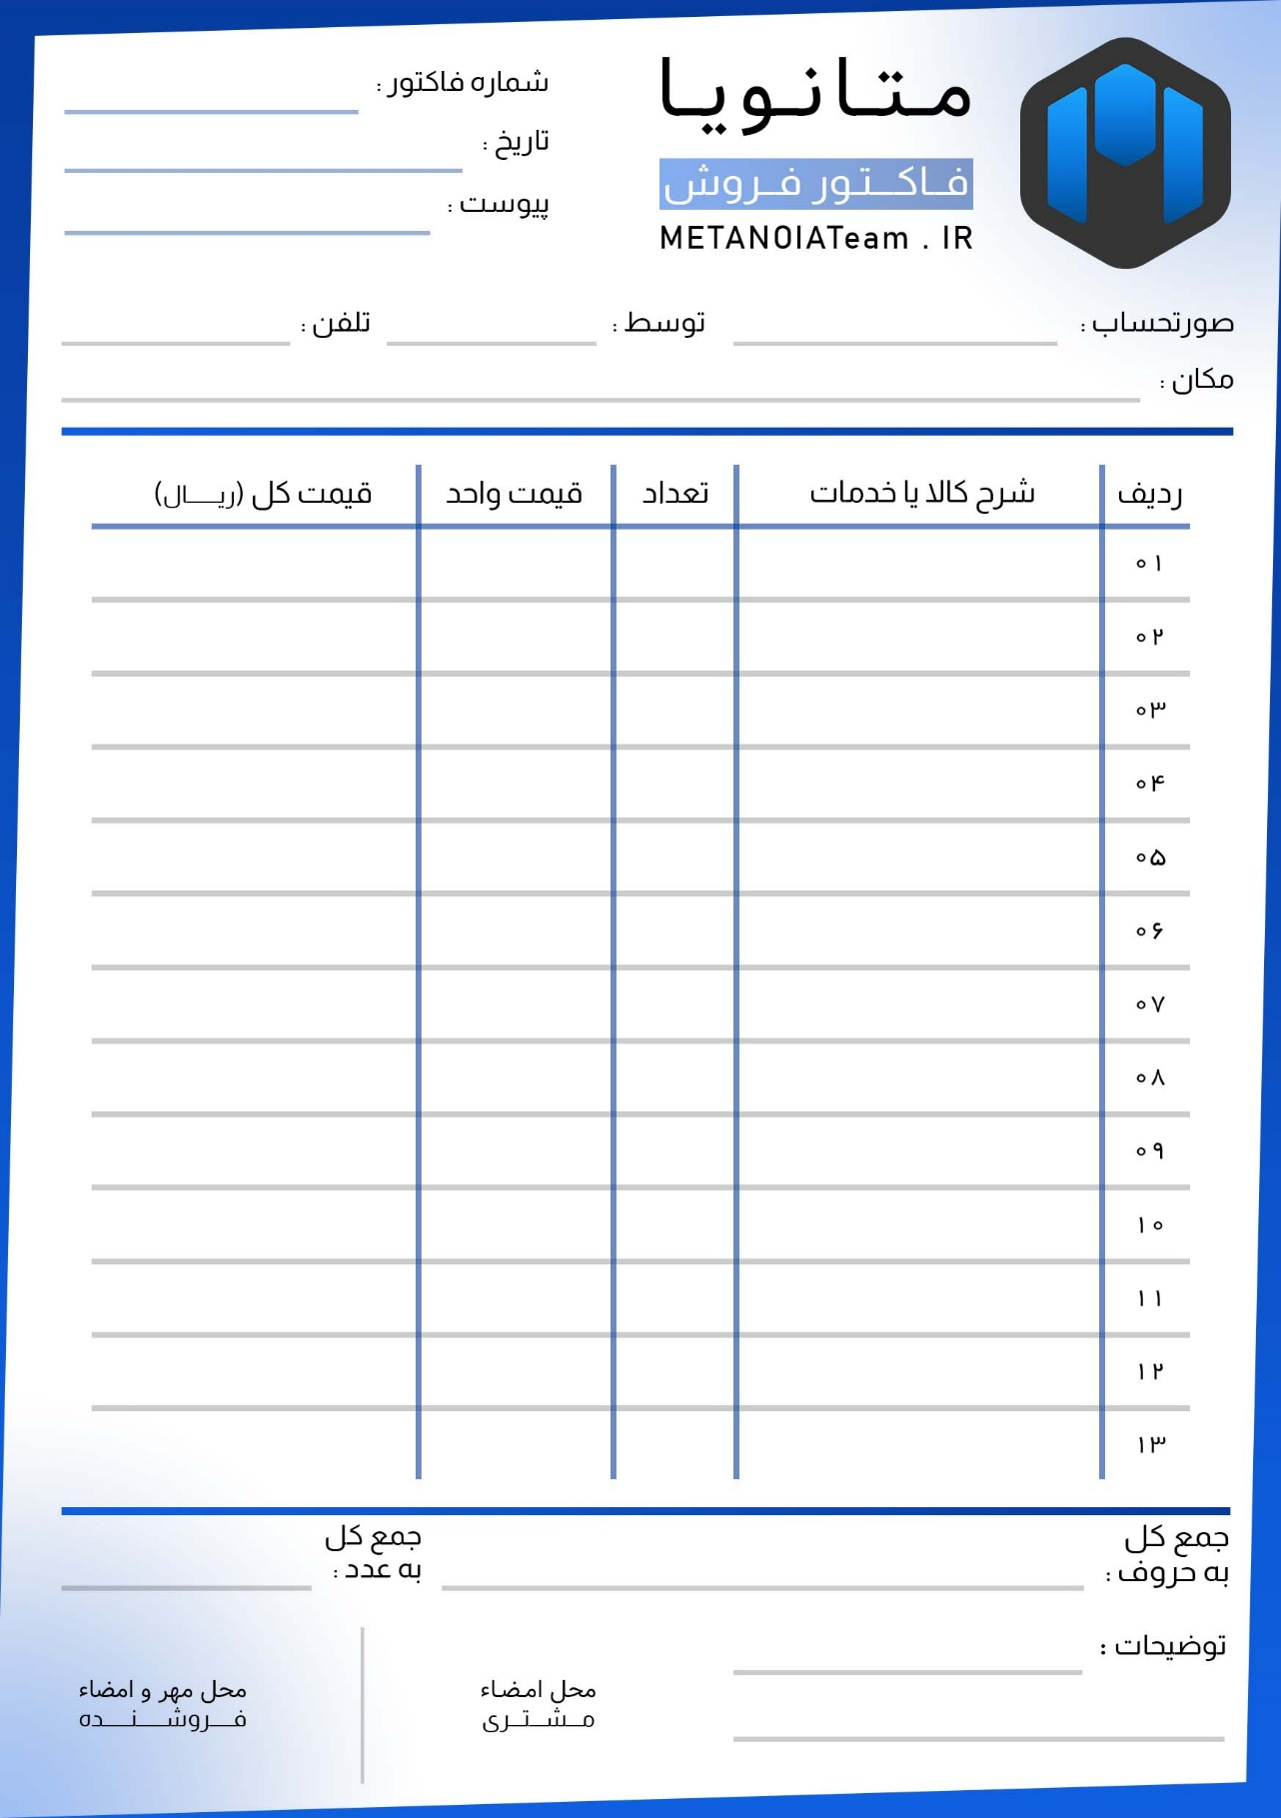

|  |  |  |  |
| --- | --- | --- | --- |
|  |  |  |  |
|  |  |  |  |
|  |  |  |  |
|  |  |  |  |
|  |  |  |  |
|  |  |  |  |
|  |  |  |  |
|  |  |  |  |
|  |  |  |  |
|  |  |  |  |
|  |  |  |  |
|  |  |  |  |
|  |  |  |  |

{{factor_price_name}}

{{factor_price_number}}

{{factor_disc_2}}

{{factor_disc_1}}