Introduction to .NET Framework
Last Updated : 31 Jan, 2025

The .NET Framework is a software development framework developed by Microsoft that provides a runtime environment and a set of libraries and tools for building and running applications on Windows operating systems. The .NET framework is primarily used on Windows, while .NET Core (which evolved into just .NET starting from version 5) is cross-platform. The framework supports multiple programming languages, such as C#, F#, and VB.NET, and supports a range of application types, including desktop, web, mobile, cloud, and gaming applications.

Main Components of .NET Framework
- Common Language Runtime(CLR):
  - The CLR is the heart of the .NET Framework, acting as a virtual machine that runs the code and manages various services such as memory management, security, and thread management. Code that is compiled and executed within the CLR is called "Managed Code," while code that the CLR does not manage is known as "Unmanaged Code."
- .NET Framework Class Library (FCL):
  - The FCL provides a large set of reusable classes and methods for application development.
  - This includes libraries for input/output operations, networking, data access, UI controls, and more.
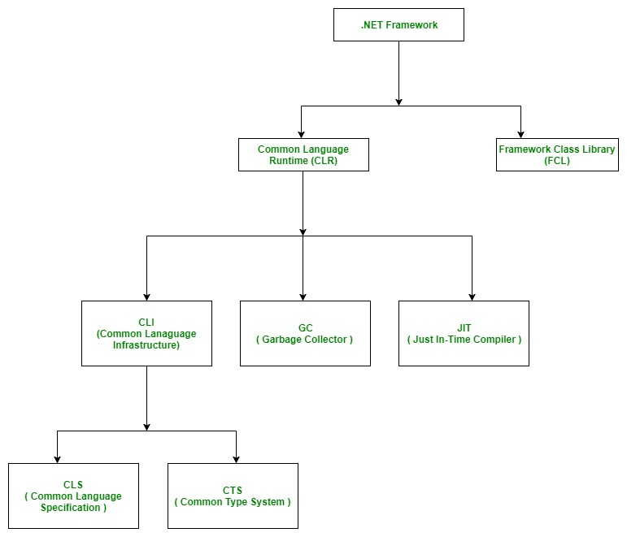
Overall, the .NET Framework is a powerful and versatile development platform that provides a wide range of tools and libraries for building and running applications on Windows operating systems.
- .NET is a software framework that is designed and developed by Microsoft. The first version of the .Net framework was 1.0 which came in the year 2002. In easy words, it is a virtual machine for compiling and executing programs written in different languages like C#, VB.Net, etc.
- It is used to develop Form-based applications, Web-based applications, and Web services. There is a variety of programming languages available on the .Net platform, VB.Net and C# being the most common ones. It is used to build applications for Windows, phones, web, etc. It provides a lot of functionalities and also supports industry standards.
- .NET Framework supports more than 60 programming languages of which 11 programming languages are designed and developed by Microsoft. The remaining Non-Microsoft Languages are supported by .NET Framework but not designed and developed by Microsoft.

Evolution of .NET Technology
There are three significant phases of the development of .NET technology.
- OLE Technology
- COM Technology
- .NET Technology
- OLE Technology: OLE (Object Linking and Embedding) is one of the technologies of Microsoft's component document. Basically, its main purpose is to link elements from different applications with each other.
- COM Technology: The technology of the Microsoft Windows family of the operating system, Microsoft COM (Common Object Model) enables various software components to communicate. COM is mostly used by developers for various purposes like creating reusable software components, linking components together to build applications, and also taking advantage of Windows services. The objects of COM can be created with a wide range of programming languages.
- .NET Technology: .NET technology of collection or set of technologies to develop windows and web applications. The technology of .Net is developed by Microsoft and was launched in Feb. 2002, by basic definition, Microsoft's new Internet Strategy. It was originally called NGWS (Next Generation Web Services). It is considered to be one of the most powerful, popular, and very useful Internet Technology available today.

.NET Programming Languages
The .NET ecosystem supports various programming languages developed by Microsoft and third-party contributors. Some of the most widely used languages are:
- C# .NET: A modern, object-oriented language used for a wide range of application types.
- VB.NET: A language designed for ease of use, with syntax similar to traditional Basic.
- F# .NET: A functional-first programming language, well-suited for complex algorithms and data processing.
- C++ .NET: An extension of C++ designed for managed code applications.
- J# .NET: A language that provides .NET compatibility for Java developers.
- IronRuby, IronPython: .NET implementations of the Ruby and Python languages.
- Other Languages: JScript.NET, C Omega, ASML, and more.

Is the .NET Application Platform Dependent or Platform Independent?
By default, .NET applications were designed to be platform-dependent, primarily running on Windows. But because of Mono (a cross-platform framework), and .NET Core, developers can now run .NET applications on Linux, macOS, and even mobile platforms.
Mono Framework:
- The Mono framework, developed by Novell (now part of Micro Focus), allows .NET applications to run across different operating systems.
- Though it is cross-platform, Mono is a paid framework.

.NET Version Compatibility Table
Release History of .NET Framework and its compatibility with the different Windows version are below:
.NET Version | CLR Version | Development tool | Windows Support
1.0 | 1.0 | Visual Studio .NET | XP SP1
1.1 | 1.1 | Visual Studio .NET 2003 | XP SP2, SP3
2.0 | 2.0 | Visual Studio 2005 | N/A
3.0 | 2.0 | Expression Blend | Vista
3.5 | 2.0 | Visual Studio 2008 | 7, 8, 8.1, 10
4.0 | 4 | Visual Studio 2010 | N/A
4.5 | 4 | Visual Studio 2012 | N/A
4.5.1 | 4 | Visual Studio 2013 | N/A
4.5.2 | 4 | N/A | N/A
4.6 | 4 | Visual Studio 2015 | N/A
4.6.1 | 4 | Visual Studio 2015 Update 1 | N/A
4.6.2 | 4 | N/A | 10 v1607
4.7 | 4 | Visual Studio 2017 | 10 v1703
4.7.1 | 4 | Visual Studio 2017 | 10 v1709
4.7.2 | 4 | Visual Studio 2017 | 10v 1803
4.8 | 4 | Visual Studio 2019 | 11
4.8.1 | 4 | Visual Studio 2019 | 10v 20H2
6 | - | Visual Studio 2022 | 11
8.0 (2024) | - | Visual Studio 2024 | 10
9.0 (2025) | - | Visual Studio 2025 | 11

Important Points:
- Visual Studio is the development tool that is used to design and develop .NET applications. For using Visual Studio, the user has to first install the .NET framework on the system.
- In the older version of Windows OS like XP SP1, SP2, or SP3, the .NET framework was integrated with the installation media.
- Windows 8, 8.1, or 10 do not provide a pre-installed version 3.5 or later of .NET Framework. Therefore, a version higher than 3.5 must be installed either from a Windows installation media or from the Internet on demand. Windows update will give recommendations to install the .NET framework.

Advantages of .NET Framework
- Multi-Language Support: The .NET Framework supports several programming languages, including C#, F#, and Visual Basic, allowing developers to choose the language that best suits their needs while still benefiting from the same set of libraries and tools.
- Cross-Platform Compatibility (via .NET Core and Mono): Although initially designed for Windows, the .NET Framework can now run on various operating systems through .NET Core and Mono, making it a versatile solution for cross-platform development.
- Large and Active Developer Community: The .NET Framework benefits from a broad developer base, creating a rich ecosystem of libraries, tools, and resources. This helps developers solve problems more easily and share solutions across the community.
- Security Features: The framework includes various security features such as code access security and digital signatures, helping protect applications from malicious threats and vulnerabilities.
- Productivity: The set of pre-built libraries and tools offered by .NET accelerates development time, enabling developers to focus on business logic rather than reinventing common functionalities.

Disadvantages of .NET Framework
- Windows Dependency: Though it supports on cross-platform, the .NET Framework was originally built for Windows, and certain features may still be optimized primarily for the Windows operating system.
- Large Footprint: The .NET Framework installation is relatively large, which can be a concern for applications running on devices with limited storage or bandwidth.
- Licensing Costs: Some versions of the .NET Framework may require a paid license, adding costs to development and deployment.
- Performance Considerations: Although .NET provides excellent performance for most applications, it may not be the ideal choice for high-performance scenarios where low-level hardware interaction or complex algorithms are required.
- Learning Curve: Although .NET is designed to be easy to use, developers new to the platform may face a learning curve specially with the object-oriented programming.

