PROPUESTAS PARA EL SISTEMA DE TV EDUCATIVA

Componente visual

http://eliteadmin.themedesigner.in/demos/bootstrap4/elite-hospital/timeline-horizontal.html

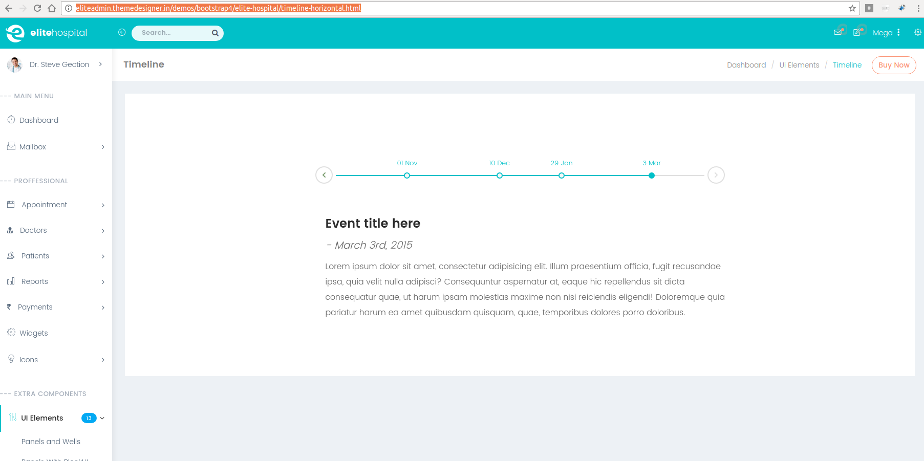

http://eliteadmin.themedesigner.in/demos/bootstrap4/elite-hospital/date-paginator.html

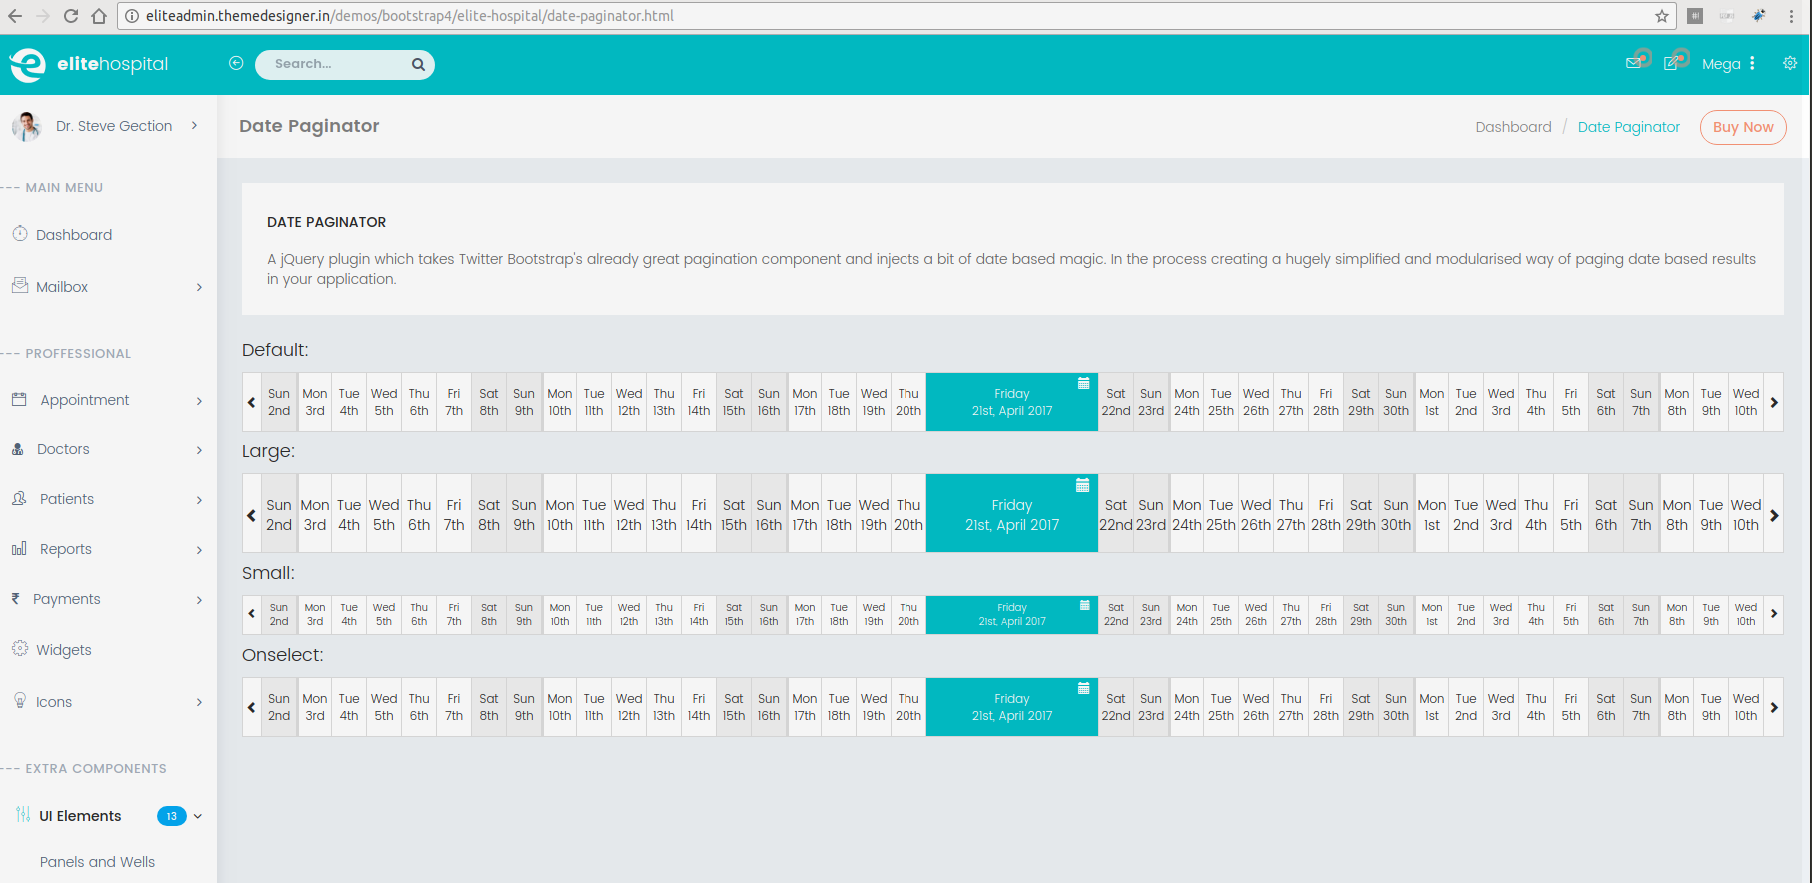

Fin de sesión

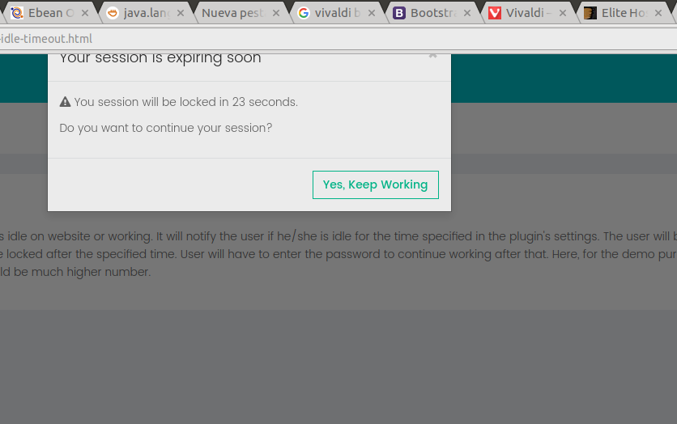

Uso swl control de hora
http://eliteadmin.themedesigner.in/demos/bootstrap4/elite-hospital/form-pickers.html

Checar las funcionalidades extras que provee jasny sobre bootstrap

http://www.jasny.net/bootstrap/

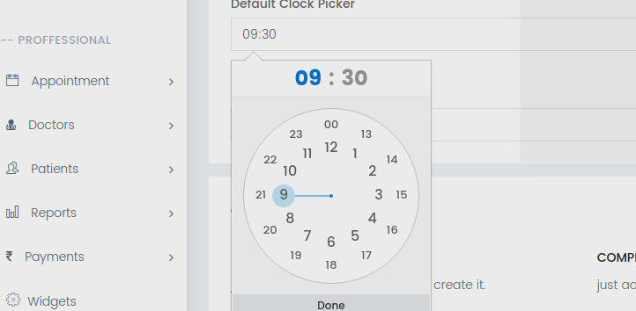

Notificaciones tipo growl

http://goodybag.github.io/bootstrap-notify/

https://github.com/ifightcrime/bootstrap-growl

Valida length de campos text y textarea
http://mimo84.github.io/bootstrap-maxlength/

Selects
http://silviomoreto.github.io/bootstrap-select/examples/

checar el slider en timeline

https://www.sitepoint.com/community/t/load-url-with-javascript/1285

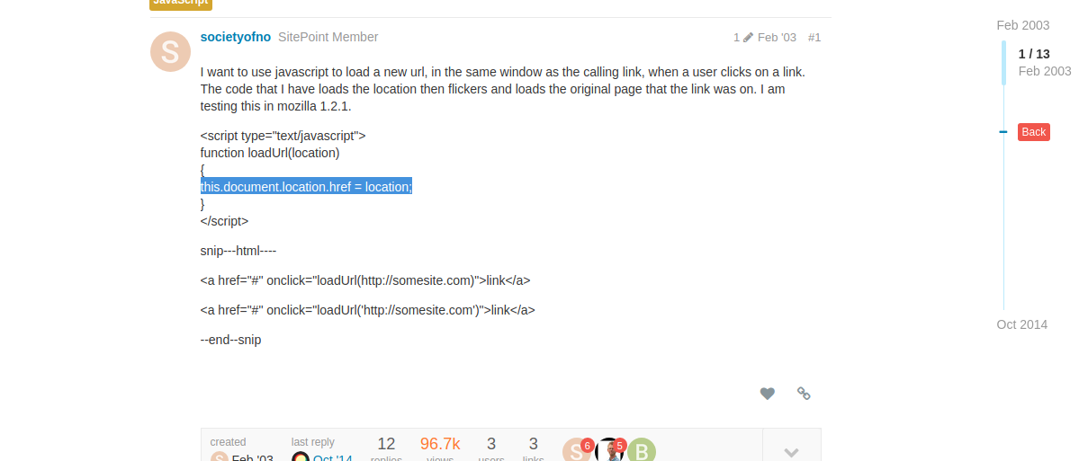

http://mrlopez.me/bootstrap-floating-labels/

http://wenzhixin.net.cn/p/bootstrap-show-password/

https://neofusion.github.io/hierarchy-select/

http://bootstraptour.com/

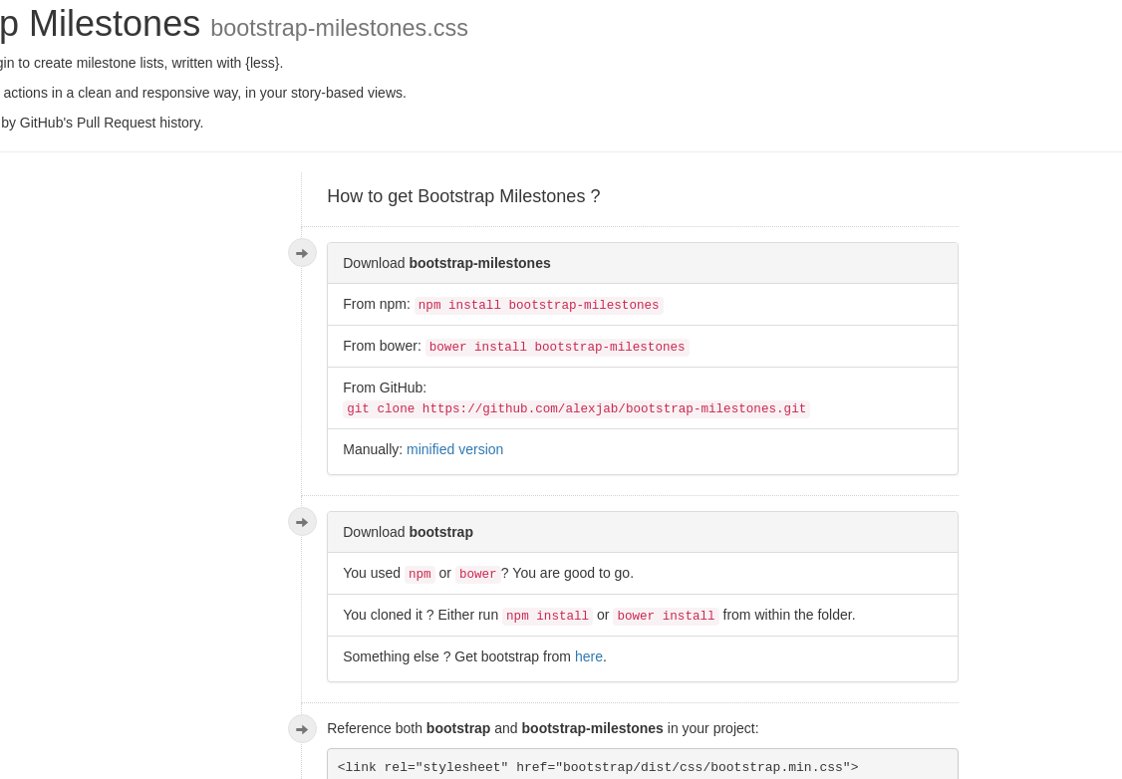

https://jablon.me/bootstrap-milestones/

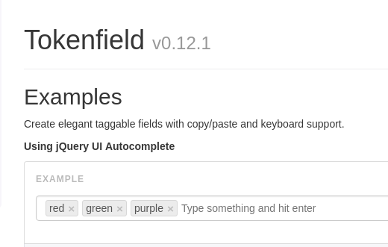

http://sliptree.github.io/bootstrap-tokenfield/

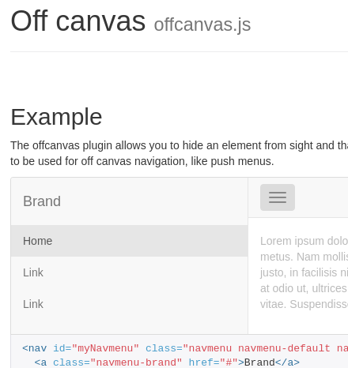

http://www.jasny.net/bootstrap/javascript/#offcanvas

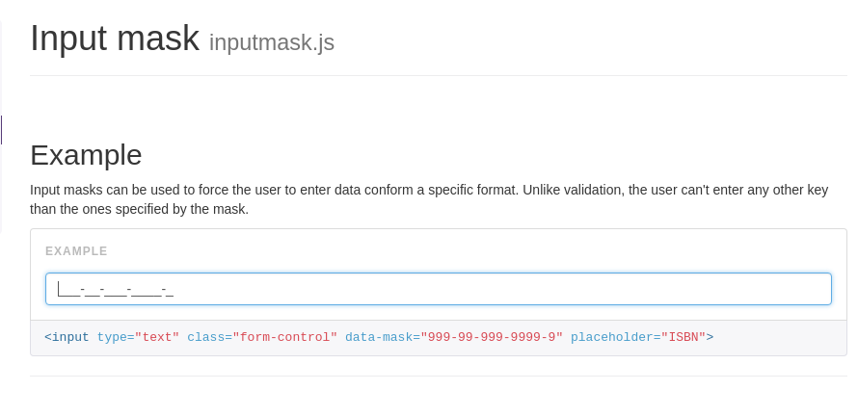
http://www.jasny.net/bootstrap/javascript/#inputmask

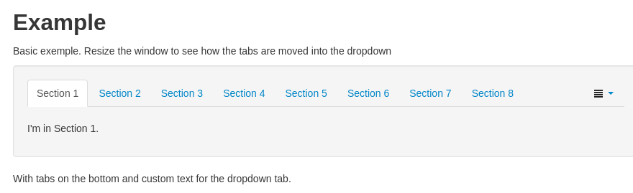

http://www.eyecon.ro/bootstrap-tabdrop/

https://bootstrapious.com/p/bootstrap-sidebar

http://bootboxjs.com/examples.html

Date picker

https://felicegattuso.com/projects/datedropper/

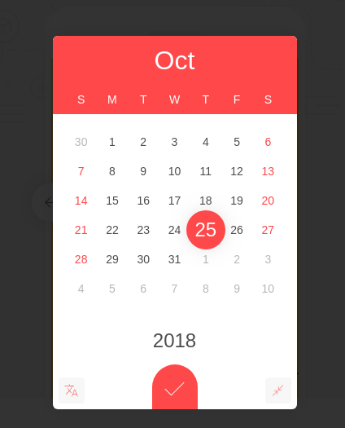

https://www.jqueryscript.net/demo/Pretty-Persian-Date-Time-Picker-with-jQuery-Bootstrap/

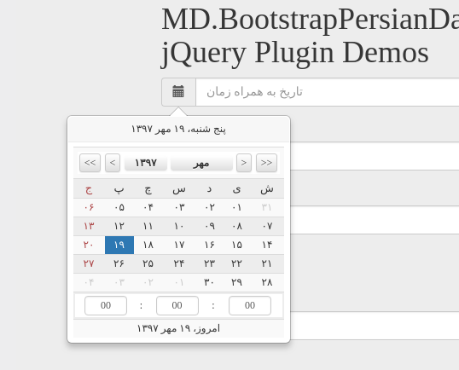

https://www.jqueryscript.net/demo/Cross-browser-Date-Time-Selector-For-jQuery-dateTimePicker/

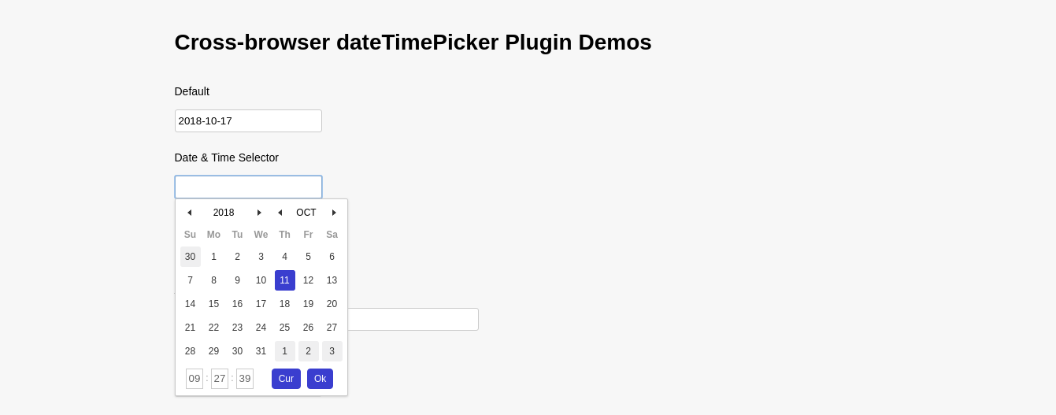

https://www.jqueryscript.net/demo/Easy-Datetime-Picker-Bootstrap/
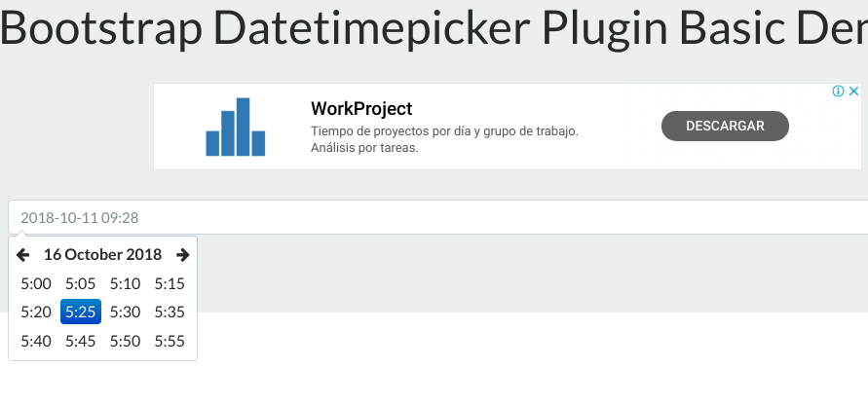

Time picker

http://weareoutman.github.io/clockpicker/

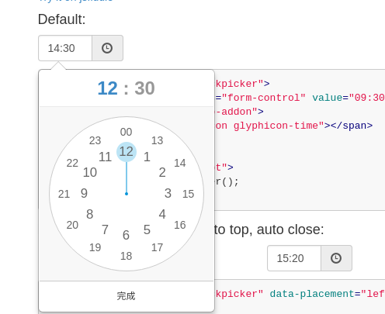

https://www.jqueryscript.net/time-clock/Mobile-Datetime-Picker-jQuery-CSS3.html
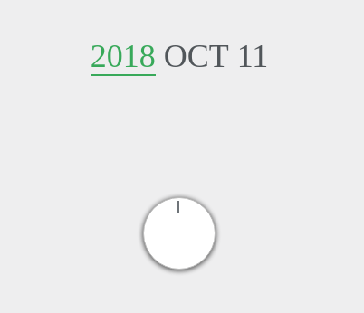

Time range

https://www.jqueryscript.net/demo/Konb-Time-Range-Selector-timeRangeWheelSlider/

https://www.jqueryscript.net/time-clock/Pretty-Date-Time-Picker-Plugin-For-Bootstrap-Material.html
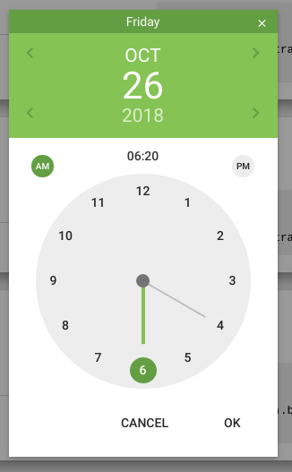

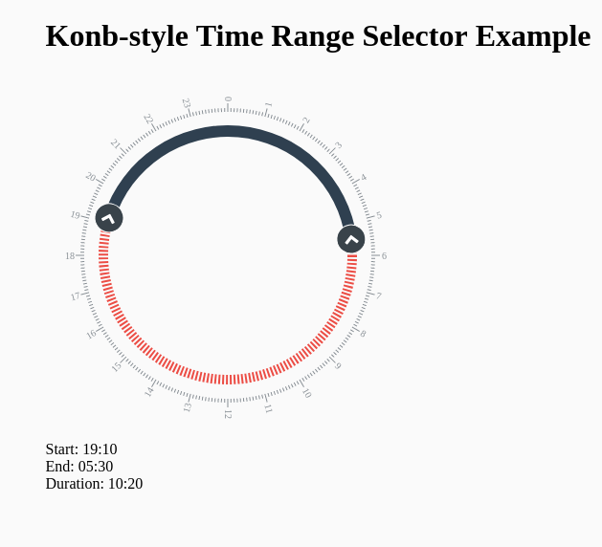

https://www.jqueryscript.net/demo/Dynamic-Scrolling-Timeline-Plugin-jQuery-jTLine/

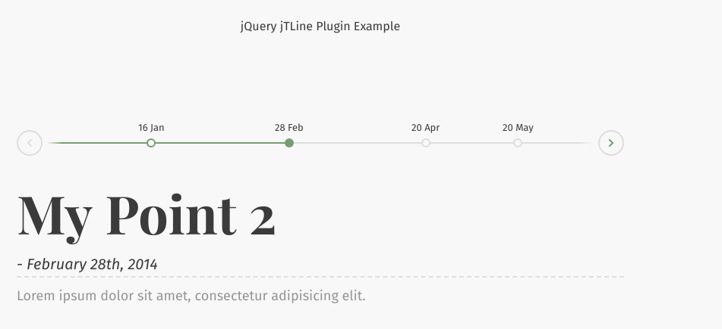

https://www.jqueryscript.net/time-clock/Minimal-jQuery-Count-Up-Plugin-CoutUpCircle.html
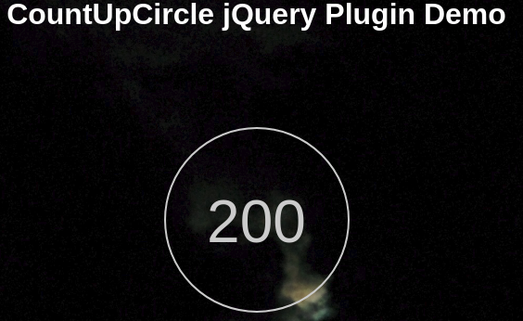

https://bootsnipp.com/snippets/VgzeR

