
SKS-16951
SLDC GENERATOR ELECTRIC
AIR COMPRESSOR TRIP UNIT
UPGRADE

11 June 2026

Quote Number: SKS-16951

Attn: Jacob
Address: Herbert St, St Leonards, NSW, 2065

Email: Jacob.Brennan@team.telstra.com

Re: SLDC Generator electric air compressor trip unit upgrade

Dear Brennan,

It is with much pleasure that we provide the following quotation for the works at the above address.

SKS Technologies has a client focused business model that provides a single point of contact and consistent level of delivery of service, that we often refer to as being ‘small enough to listen and big enough to deliver.’ At a management level we provide a structure that inspires development, resilience and support and we convey this very same philosophy to our site teams. In doing this we provide our clients with the security that we can quickly scale up or down to support key milestones and expectations.
We anticipate that the information provided within this response will be sufficient for you to gain an understanding of SKS Technologies intended approach towards this project. However, if you do require any further clarification regarding this tender response, please do not hesitate to contact us as we would be pleased to offer our assistance in any way possible to enable you to achieve your project goals.

If successful in being awarded this work we look forward to demonstrating our positive attitude and tending to you the best possible level of service in order to build a long-term professional relationship between BGIS Pty Ltd and SKS Technologies and assure you of our utmost attention at all times.

Kind Regards

Royce Milmlow
NSW Operations Manager
0432944014
royce.milmlow@sks.com.au

Company Overview

SKS Technologies Group Limited (ASX:SKS) is focused on building a leading integrated technology solutions business with nationwide operations.
The company specialises in delivering advanced technology via creative design and installation of converged Audio Visual (AV) / Information Technology (IT), electrical and communication networking solutions nationally.
Scope of projects include the design, supply and installation of boardrooms, stadiums, commercial buildings, retail outlets, airport lounges, lecture halls and hospitals for clients across Australia.
SKS Technologies’ offerings are unique in that we combine AV, electrical and communications networks whilst maintaining the agility to capitalise on industry technology advancements as the company turns its current focus to the convergence with IT. There are very few who have the ability to provide a truly end to end technology solution and who can do it nationally.

Scope of Works

Replace TM63D trip unit with Micrologic 2.2M to provide a more adjustable curve to suit the dynamic load.
The breaker will require an upstream isolation for the duration of the works.
Suggested settings for M class micro
Ir=50, Class=5, Isd=11

Our Price for the above works shall be:

One thousand five hundred and twelve dollars exactly $1,512.00 (excluding GST)

Description | Qty | Unit | Sell Price | Total
LABOUR
Equinix - Normal Hours | 4 | hrs | $125.00 | $500.00
Labour Subtotal |  |  |  | $500.00
MATERIALS
NSX100 2.2M micrologic | 1 | ea | $1,012.00 | $1,012.00
Materials Subtotal |  |  |  | $1,012.00
Subtotal (ex GST) |  |  |  | $1,512.00
GST (10%) |  |  |  | $151.20
TOTAL (inc GST) |  |  |  | $1,663.20

Clarifications
The following is a list of Clarifications that we have identified on this project.
- Nil

Defects Liability Period and Service Level Agreement

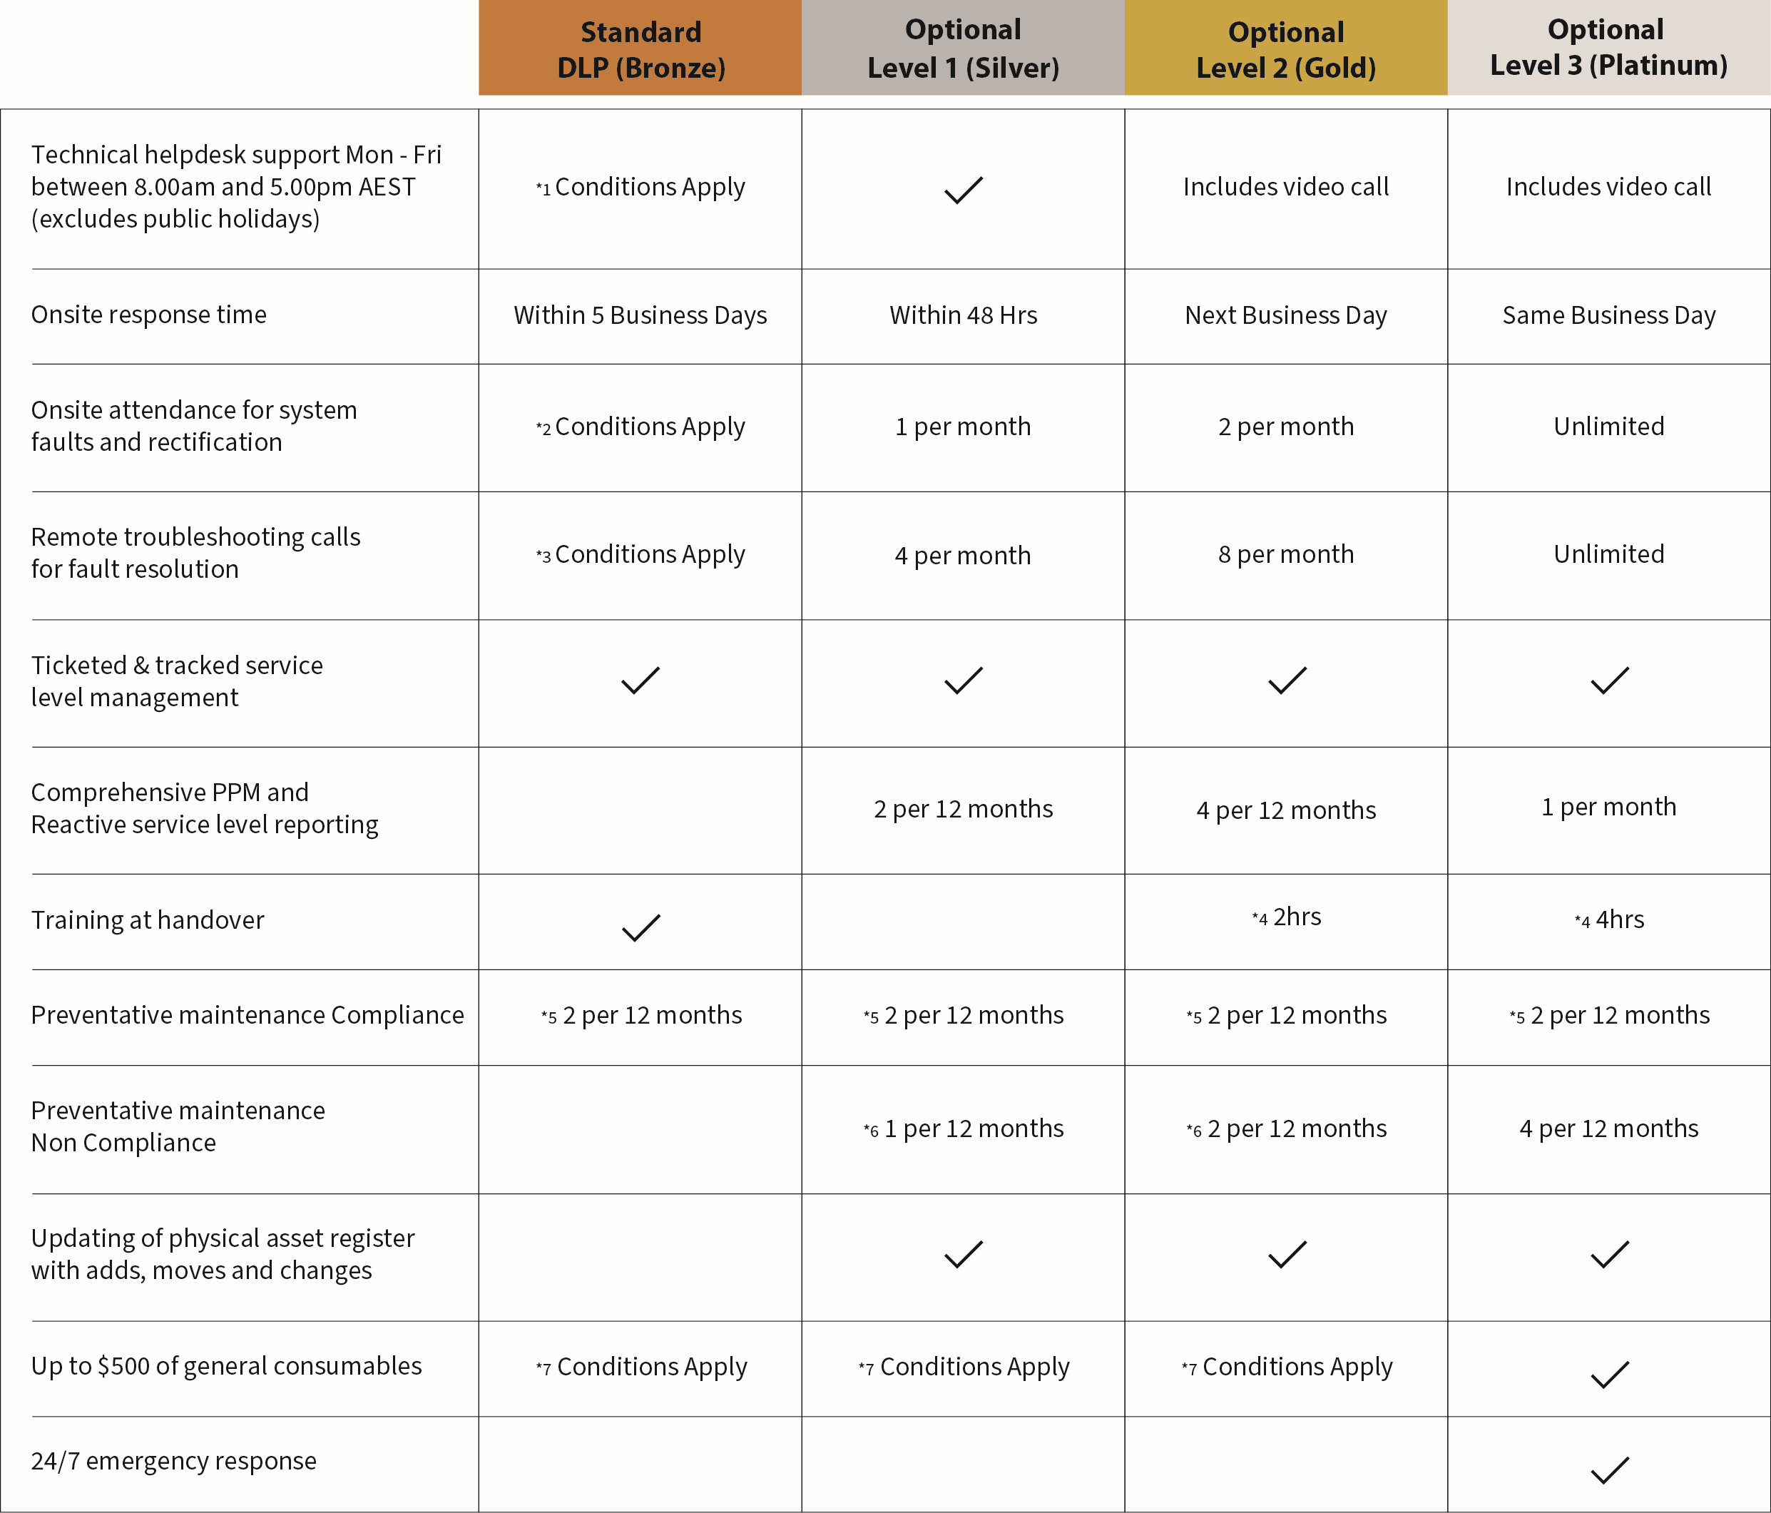
*Conditions
1. May be chargeable under DLP
2. Excludes labour costs as per warranty and manufacturers terms and conditions
3. Excluded under DLP as per warranty terms and conditions
4. Training time includes travel to and from location
5. Compliance testing during business hours
6. Excludes the use of customer portals
7. Includes lamps and drivers. (storage must be on customer premise)
8. Loan stock and storage on customer premise to be discussed and confirmed?
Note: SKS Technologies will only provide services to software and systems that SKS Technologies has provided and installed. Any additions or amendments to the original installation, will void this service level agreement unless agreed by both parties in writing as it may require additional fees.
SKS General and DLP Terms and Conditions can be viewed here https://sks.com.au/terms-and-conditions/

https://sks.com.au/sks-escalation-procedure/
SKS Technologies support contact details
E: support@sks.com.au T: 1300 908 689

SKS Warranty Statement

SKS Technologies can provide an optional support and maintenance agreement as an extra support feature for new and existing installations. Each agreement can be tailored to suit the requirements of the client and their users.
Some example features/benefits of these agreements are listed below:
- Scheduled service and preventative maintenance visits
- Extended out-of-hours phone support
- Discounts on upgrades and non-warranty repairs
- Onsite fault rectification with response times as low as 4 hours
- Additional user training

https://sks.com.au/warranty-documents/

Terms & Conditions

https://sks.com.au/terms-and-conditions/

National Presence
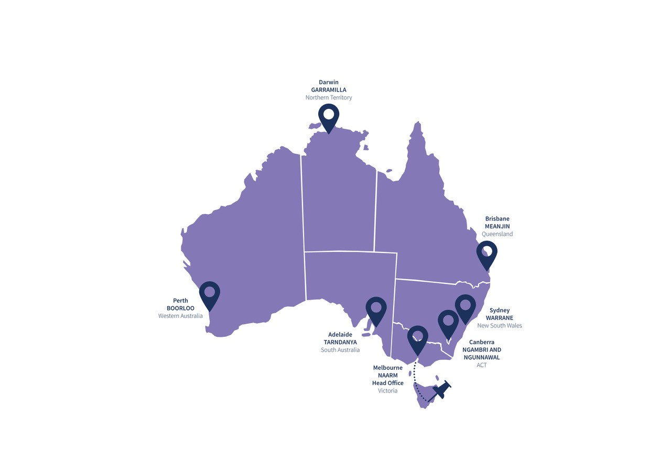

Additional Services

Our complete range of services and solutions which may be above those being provided as part of this submission include –
Electrical Infrastructure |  |  | Communication Networks |  |  | Audio visual
 |  |  | 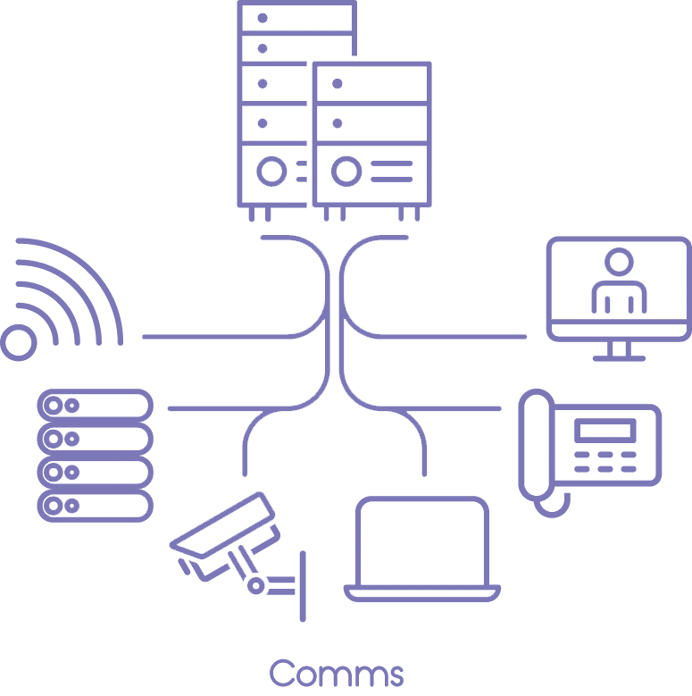 |  |  | 

Data Centres |  |  | Service Support |  |  | Maintained Essential Service
 |  |  | 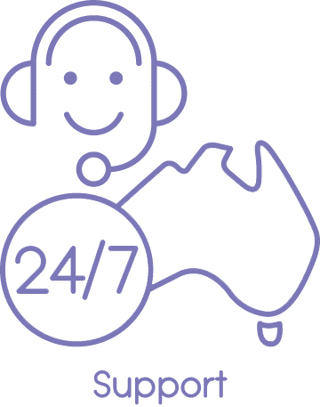 |  |  | 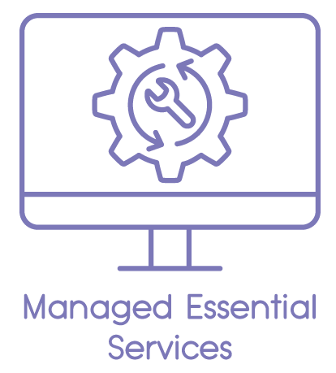
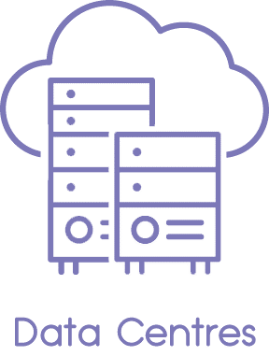
National Rollouts |  |  | Projects |  |  | Smart Buildings
 |  |  |  |  |  | 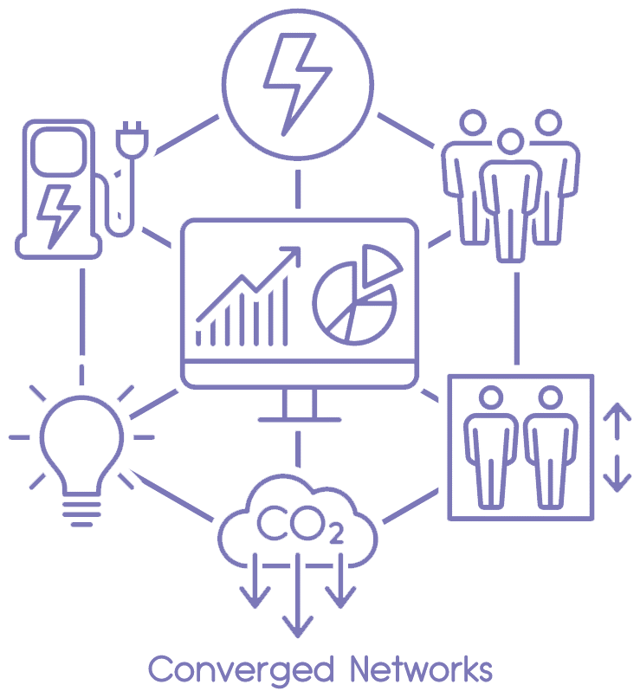
High Speed Internet |  |  | Managed Cloud |  |  | Wi-Fi
 |  |  | 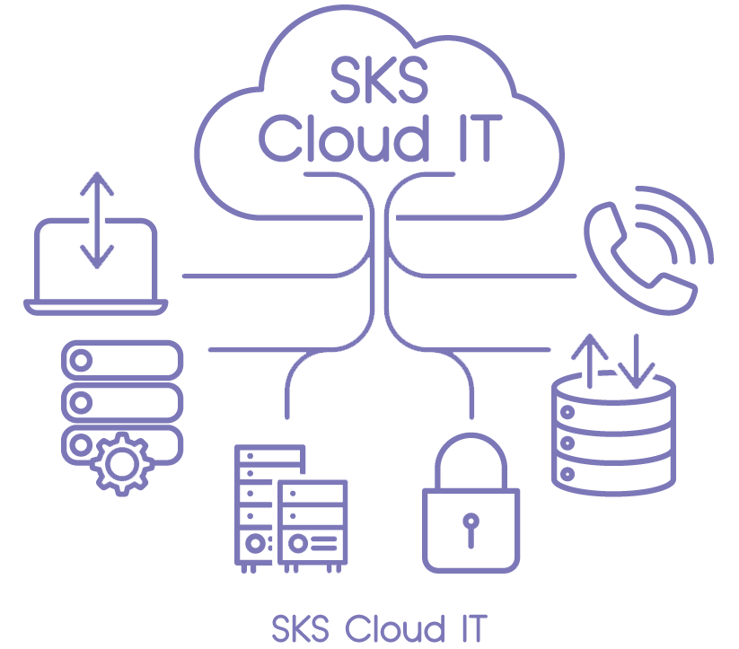 |  |  | 
WiredScore Building Audits |  |  | SmartScore Building Audits
 |  |  | 

