Hey I want to create an indicator that automatically highlights the candlesticks that fall into the criteria.

indicator parameters

3 Types of Candles in a momentum move are: (All candles must close past the previous candle to be considered)

1. Above average candle ( a candle that from wick to close is more than the 21 period ATR by atleast 1 pip )

2. Average Candle ( a candle that from wick to close is atleast 80% of the 21 period ATR but not up to 1 pip more.)

3. Below average candle ( a candle that from wick to close is less than 80% of the 21 period ATR)

Samples are given below, but do not program it, as client has not mentioned their programming.

What Makes a Momentum Move: (All examples are for Bullish moves but the opposite applies for bearish moves.)

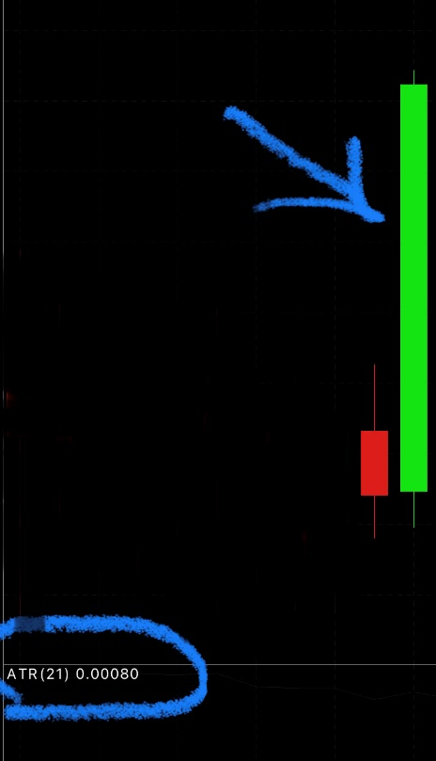1. If the first candle to close above the previous candle is an "above average candle"

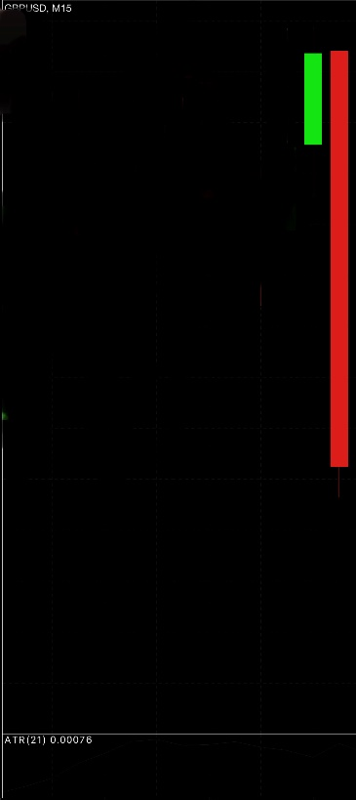

2. After consecutive bullish candles fail to close above the previous, the first candle to close above in at least an "average candle" is a momentum move. (There can be no bearish candles in between

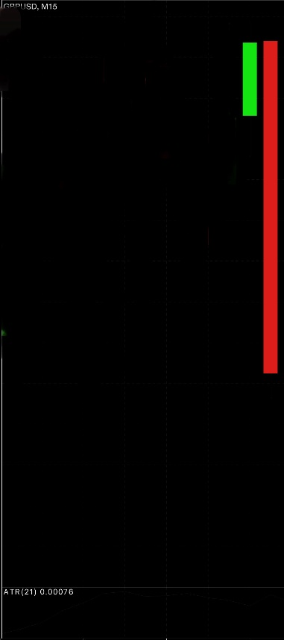 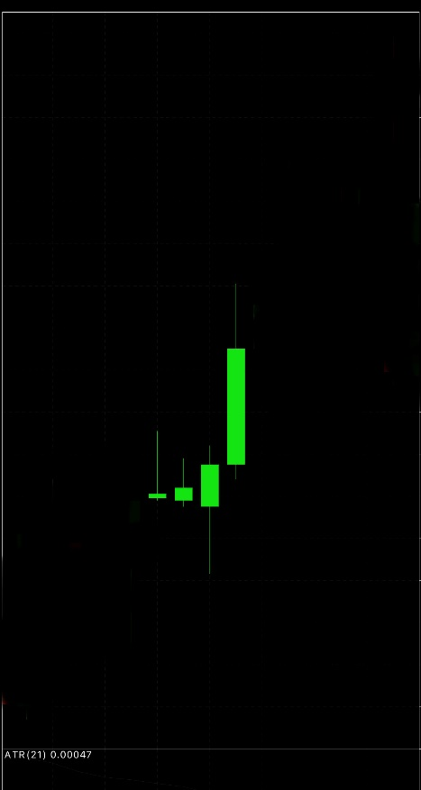

3. Two consecutive average candles

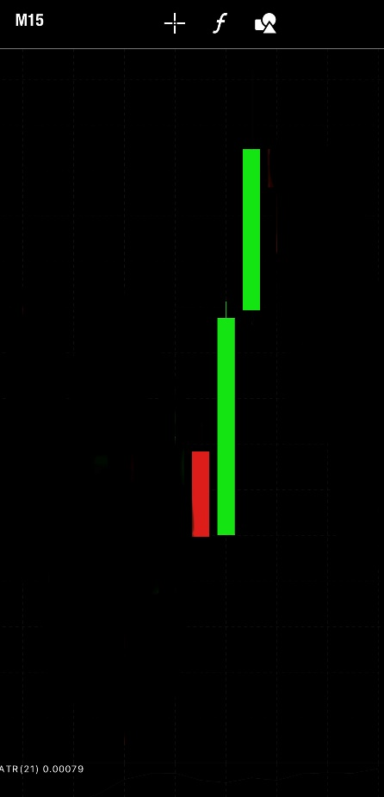 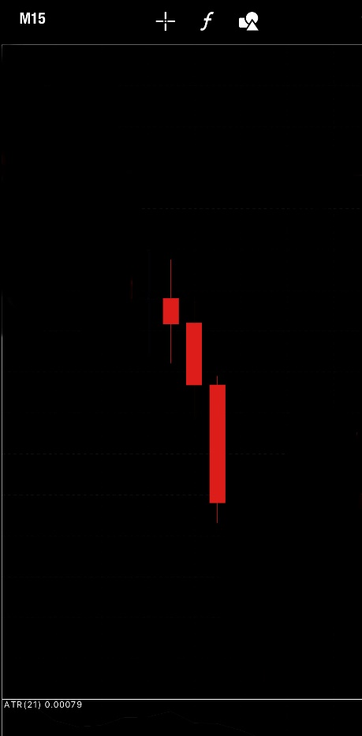

4. A below average candle followed by an average or above average candle

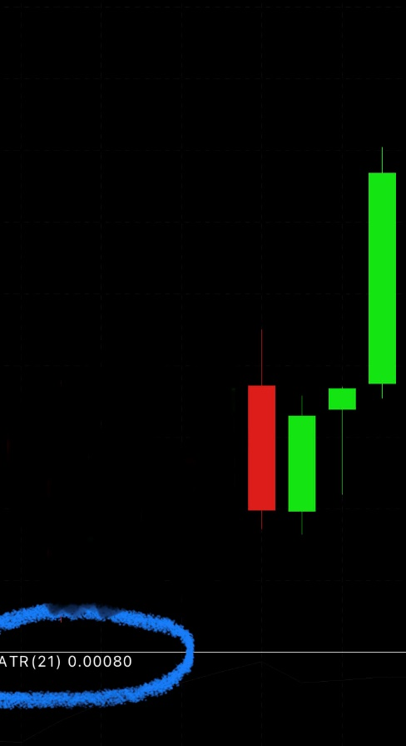

5. Three consecutive below average candles

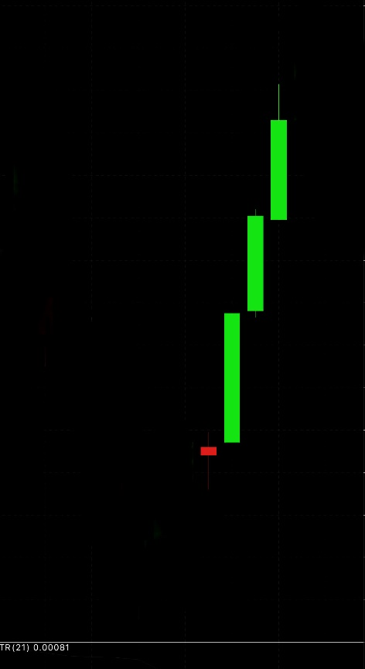

6. An average candle followed by a below average candle, then any other candle closing above the previous two.

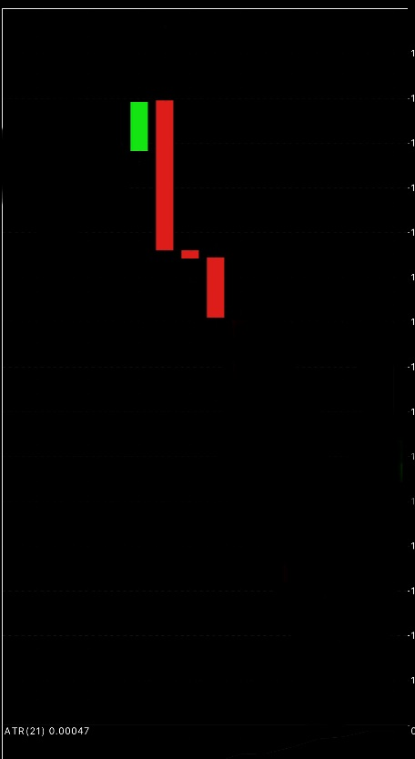

7. Two consecutive below average candles followed by any other candle closing above the previous candle

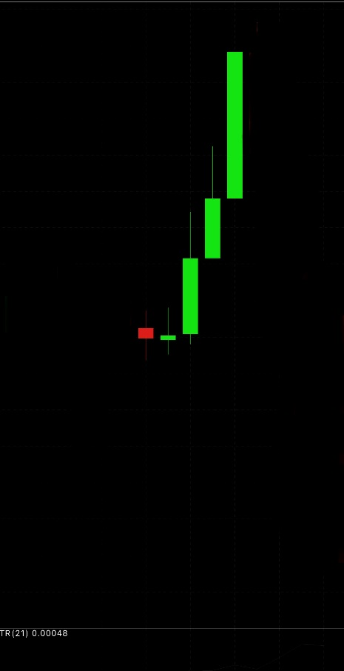

***Also sorry the bearish example for 3. Is actually an example for 4.***

**Highlighting specific candles in Gold color**

**Display a rectangular box around candles and put label on it.**