**Assignment 5**

**CS 302 – Design and Analysis of Algorithm Spring 2021**

**Deadline: 5th June 2021 (11:55PM)**

**Slate Deadline: 6th June 2021 (11:55PM)**

**(This assignment is for All Sections)**

**This is a group Assignment.**

**Cross Section group strictly NOT allowed.**

**Total Member allowed = Max: 3**

**Work Division is your responsibility in any case.**



1. A single violation of guideline will lead to Zero mark in your assignment.
2. Slate address:

|  |  |  |
| --- | --- | --- |
| http://slate.nu.edu.pk/portal | |  |
| **OR** |  |
| http://203.124.42.218:8080/portal | | |

1. You have been given whole **1 day for only submission** purpose so **NO email submission** will be accepted.
2. You are encouraged to take help from Internet and books but clearly mention the source.
3. This is a group Assignment, make groups on your own responsibility. Excuses will not be entertained like a member didn’t attempt his/her part.
4. Cross Section group strictly NOT allowed.
5. **Total Member allowed = 3, Assignment will be checked as a whole work, not individual work will be marked as full work, so work division is your responsibility.**
6. Work Division is your responsibility if members are less than 3.
7. Only one member must Submit all members work in a zip file contains this report and your project.
8. Zip file must be named as:

Rollnumber1_Rollnumber2_Rollnumber3_Section_Assignment5 For example: 19f0123_19f0345_19f0567_A_Assignment5

**Question: 1** Menu base GUI Application is the requirement. Implement Brute Force, RK and KMP algorithm for String Matching. Details are:

Create a word search program. Where user can search a specific word or sequence of words from the given list of files (Attached). It should work as following (GUI Application)

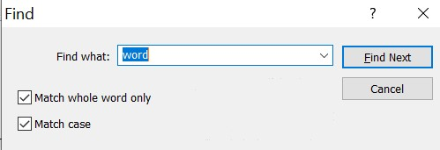

**Functionalities**

1. Program must find the position of search word or sequence of words from **given files** and return name of file, row number and column number.

1. Match whole word only [**Unchecked**]
   1. Program should return Pakistan, adampak, abnopakis, and pak against ‘pak’ searched word because ‘pak’ is present in all of them. The length of return word and search word may differ.
2. Match whole word only [**Checked**]
   1. Program should return only pak against ‘pak’ searched word. The length of return word and search word should be same.

1. Match case [**Unchecked**]
   1. Program should return Bilal, bilaL, bIlaL against ‘bilal’. The upper and lower case should not be checked
2. Match case [**Checked**]
   1. Program should only return bilal against bilal and BilaL against BilaL. The upper and lower case should be checked against each character.

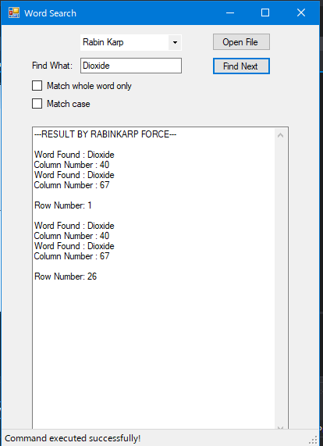

*The rest of the algorithms/features can be tested out in live environment* 😊

**Question 2:** Write a detail comparison on Brute force, Rk and KMP algorithm of String Matching. Max 2 pages.

|  |  |  |  |  |  |
| --- | --- | --- | --- | --- | --- |
| **Algorithm** | **Time Complexity** | **Pattern Preprocessing** | **Search Type** | **Key Ideas** | **Approach** |
| Brute Force | Best: O(n)  Average & Worst: O(nm) | No | Prefix | Searches all alphabets | Linear Search |
| Rabin Karp | Best & Average: O(n + m)  Worst: O(nm) | Yes | Prefix | Compares the text and pattern from hash function | Hashing Based |
| KMP | All Cases: O(m + n) | Yes | Prefix | Constructs an automation from the pattern | Heuristics based |

*\* m = length of pattern, n = length of text*