Docker
Complete Guide: From Scratch to Advanced
Containers • Images • Networking • Compose • Swarm • Security

Chapter 1: Introduction to Docker

1.1 What is Docker?
Docker is an open-source platform for developing, shipping, and running applications inside containers. Released in 2013, it has transformed software delivery by packaging applications with all their dependencies into portable, self-sufficient units that run identically anywhere Docker is installed.

KEY IDEA | Docker packages your application and all its dependencies into a container image. The same image runs identically on a developer laptop, CI server, or production cloud — eliminating "works on my machine" problems.

1.2 Containers vs Virtual Machines
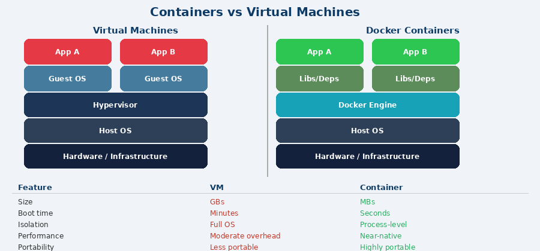
Virtual machines emulate an entire OS on top of a hypervisor, consuming GBs of disk and taking minutes to boot. Docker containers share the host OS kernel — they start in seconds and consume only MBs.

1.3 Docker Architecture
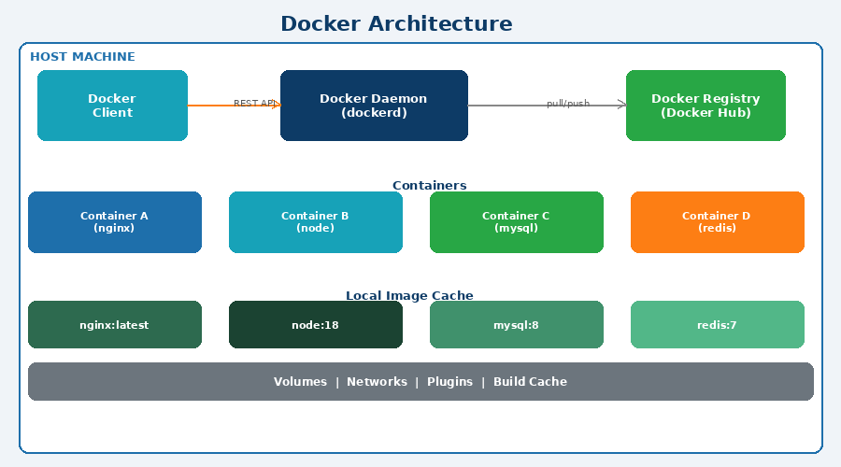
Docker uses a client-server architecture. The CLI client communicates with the Docker Daemon (dockerd) via REST API. The daemon manages images, containers, volumes, and networks. Docker Hub is the default public image registry.

INTERNALS | Docker Client → dockerd (daemon) → containerd → runc → Linux kernel (namespaces + cgroups)

Chapter 2: Installation & First Steps

2.1 Installing Docker

Ubuntu / Debian (quick install)
sudo apt-get update && sudo apt-get install -y curl
curl -fsSL https://get.docker.com | sh
sudo usermod -aG docker $USER # Avoid needing sudo
newgrp docker # Reload group

macOS / Windows
Download Docker Desktop from https://www.docker.com/products/docker-desktop — it includes Docker Engine, Docker CLI, Docker Compose, and Kubernetes in a single installer.

2.2 Verify Installation
docker --version
docker run hello-world

2.3 Essential Commands Reference
Command | Description
docker version | Show Docker client & daemon version
docker info | System-wide information and config
docker ps | List running containers
docker ps -a | List all containers (including stopped)
docker images | List locally available images
docker pull nginx | Download image from registry
docker run nginx | Create and start a container
docker stop <id> | Stop a container gracefully (SIGTERM)
docker rm <id> | Remove a stopped container
docker rmi <image> | Remove a local image
docker logs <id> | View container output logs
docker exec -it <id> bash | Open interactive shell in container
docker system prune | Remove all unused resources
docker system df | Show disk usage by Docker

Chapter 3: Docker Images

3.1 Understanding Images & Layers
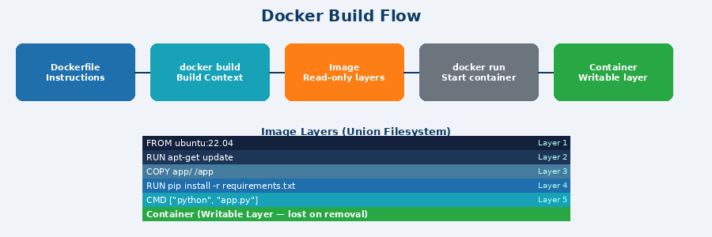
A Docker image is a read-only template containing your application and all its dependencies. Images are built from layers — each Dockerfile instruction creates one layer. Layers are cached and shared, so rebuilds only process changed layers.

3.2 Writing a Dockerfile
EXAMPLE | Complete Dockerfile for a Python Flask application
# Start from an official slim Python image
FROM python:3.11-slim

# Set working directory inside the container
WORKDIR /app

# Copy requirements first (improves layer caching)
COPY requirements.txt .

# Install Python dependencies
RUN pip install --no-cache-dir -r requirements.txt

# Copy the rest of the application
COPY . .

# Expose the port Flask listens on
EXPOSE 5000

# Set production environment
ENV FLASK_ENV=production

# Run as a non-root user for security
USER nobody

# Default startup command
CMD ["python", "app.py"]

3.3 Dockerfile Instructions
Instruction | Description
FROM | Base image — must be the first instruction
WORKDIR | Set working directory for all subsequent commands
COPY | Copy files/directories from host build context
ADD | Like COPY but also handles URLs and extracts archives
RUN | Execute a command and commit result as a new layer
CMD | Default command when container starts (overridable)
ENTRYPOINT | Fixed executable; CMD provides default arguments
EXPOSE | Documents which port the container listens on
ENV | Set environment variables (persisted in image)
ARG | Build-time variables — not persisted in final image
VOLUME | Declare a mount point for external storage
USER | Switch to a different user for security
LABEL | Add metadata as key=value pairs
HEALTHCHECK | Command Docker uses to check container health

3.4 Building & Publishing Images
docker build -t myapp:1.0 . # Build with tag
docker build -f Dockerfile.prod -t myapp:prod . # Custom Dockerfile
docker build --no-cache -t myapp:fresh . # Skip cache
docker tag myapp:1.0 username/myapp:1.0 # Tag for Docker Hub
docker login # Authenticate
docker push username/myapp:1.0 # Publish to registry

3.5 Multi-Stage Builds (Best Practice)
Multi-stage builds use multiple FROM instructions to keep final images small by discarding build-time tools.
# ── Stage 1: Build ─────────────────────────────────
FROM node:18 AS builder
WORKDIR /app
COPY package*.json ./
RUN npm ci
COPY . .
RUN npm run build

# ── Stage 2: Production (only nginx + built files) ─
FROM nginx:alpine
COPY --from=builder /app/dist /usr/share/nginx/html
EXPOSE 80
CMD ["nginx", "-g", "daemon off;"]

Chapter 4: Containers — Deep Dive

4.1 Running Containers
Command | Description
docker run nginx | Run nginx in foreground
docker run -d nginx | Run in background (detached)
docker run -p 8080:80 nginx | Map host:container port
docker run --name web nginx | Assign a custom name
docker run -e VAR=value nginx | Set environment variable
docker run -v mydata:/data nginx | Mount a named volume
docker run --rm nginx | Auto-remove on stop
docker run -it ubuntu bash | Interactive terminal session
docker run --memory=512m nginx | Limit RAM to 512 MB
docker run --cpus=2 nginx | Limit to 2 CPU cores
docker run --restart=always nginx | Auto-restart on crash/reboot
docker run --read-only nginx | Read-only root filesystem
docker run --network host nginx | Share host network stack
docker run --cap-drop=ALL nginx | Drop all Linux capabilities

4.2 Container Lifecycle
docker create nginx # Create without starting
docker start <id> # Start a stopped container
docker pause <id> # Pause all processes (SIGSTOP)
docker unpause <id> # Resume paused container
docker stop <id> # Graceful shutdown (SIGTERM + 10s)
docker kill <id> # Immediate kill (SIGKILL)
docker restart <id> # Stop then start
docker rm -f <id> # Force-remove running container

4.3 Inspecting & Monitoring
docker inspect <id> # Full JSON configuration
docker stats # Live CPU / RAM / network
docker stats --no-stream # One-time snapshot
docker top <id> # Processes running inside
docker diff <id> # Filesystem changes since start
docker logs -f --tail=100 <id> # Stream last 100 log lines
docker port <id> # Show port mappings

Chapter 5: Volumes & Data Persistence

5.1 Why Volumes?
Containers are ephemeral — data written inside is lost when the container is removed. Docker provides three storage options to persist data outside the container lifecycle.

Storage Type | Use Case
Named Volumes | Docker-managed storage in /var/lib/docker/volumes/. Best for persistent databases and application data
Bind Mounts | Map a specific host directory into the container. Best for development with live code reloading
tmpfs Mounts | Stored only in host memory (Linux). Best for short-lived secrets or sensitive data

5.2 Volume Commands
docker volume create mydata # Create named volume
docker volume ls # List all volumes
docker volume inspect mydata # Inspect a volume
docker volume rm mydata # Remove a volume
docker volume prune # Remove unused volumes

5.3 Mounting Storage
# Named volume (persistent database)
docker run -v mydata:/var/lib/postgresql/data postgres

# Bind mount (development live reload)
docker run -v $(pwd):/app -p 3000:3000 node:18

# Read-only bind mount (config files)
docker run -v $(pwd)/nginx.conf:/etc/nginx/nginx.conf:ro nginx

# tmpfs (in-memory, ephemeral)
docker run --tmpfs /tmp:size=100m myapp

Chapter 6: Docker Networking
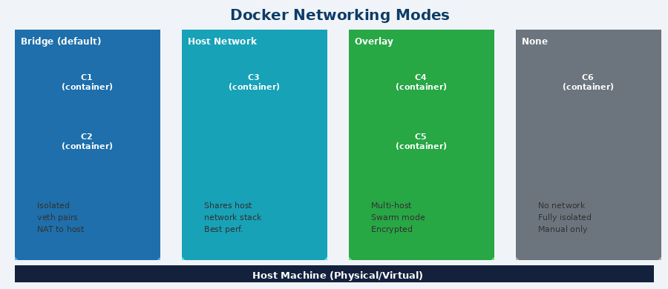

6.1 Network Drivers
Driver | Description
bridge | Default driver for standalone containers. Creates an isolated network; containers communicate by container name on user-defined bridges
host | Container shares the host network stack. No port mapping needed. Maximum performance. Linux only
none | Disables all networking. Container is completely isolated from all networks
overlay | Connects multiple Docker hosts. Required for Docker Swarm multi-node deployments
macvlan | Assigns a real MAC/IP address to container. It appears as a physical device on your network
ipvlan | Similar to macvlan but shares MAC address. Suitable for layer 2/3 networks with strict MAC limits

6.2 Networking Commands
docker network ls # List all networks
docker network create appnet # Create bridge network
docker network create --driver overlay swarm_net
docker network inspect appnet # Show network details
docker network connect appnet <container> # Connect container
docker network disconnect appnet <container> # Disconnect
docker network rm appnet # Remove a network
docker network prune # Remove unused networks

6.3 Container DNS Resolution
On user-defined bridge networks, Docker provides automatic DNS. Containers reach each other by name — no need to know IP addresses.
docker network create appnet
docker run -d --name postgres --network appnet postgres:15
docker run -d --name api --network appnet myapi
# Inside "api" container, connect to postgres by name:
psql -h postgres -U appuser mydb

Chapter 7: Docker Compose
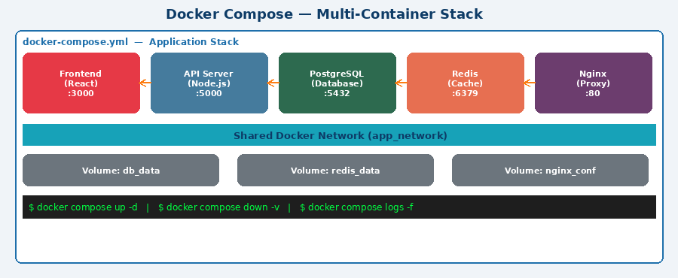

7.1 What is Docker Compose?
Docker Compose is a tool for defining and running multi-container Docker applications. You describe the entire application stack in a single docker-compose.yml file and manage it with simple commands.

ONE COMMAND | "docker compose up -d" starts your entire application stack — all services, networks, and volumes — in the right order.

7.2 Full docker-compose.yml Example
version: "3.9"

services:
frontend:
build: ./frontend
ports: ["3000:3000"]
environment:
- REACT_APP_API_URL=http://api:5000
depends_on: [api]
networks: [appnet]

api:
build: ./backend
ports: ["5000:5000"]
environment:
DATABASE_URL: postgresql://user:pass@db:5432/mydb
REDIS_URL: redis://cache:6379
depends_on:
db:
condition: service_healthy
volumes: [./backend:/app] # Dev live reload
networks: [appnet]

db:
image: postgres:15
environment:
POSTGRES_USER: user
POSTGRES_PASSWORD: pass
POSTGRES_DB: mydb
volumes: [db_data:/var/lib/postgresql/data]
healthcheck:
test: ["CMD-SHELL", "pg_isready -U user"]
interval: 10s
retries: 5
networks: [appnet]

cache:
image: redis:7-alpine
volumes: [redis_data:/data]
networks: [appnet]

volumes:
db_data:
redis_data:

networks:
appnet:
driver: bridge

7.3 Compose Commands
Command | Description
docker compose up | Start all services (foreground)
docker compose up -d | Start all services in detached mode
docker compose up --build | Rebuild images then start
docker compose down | Stop and remove containers/networks
docker compose down -v | Also remove volumes
docker compose logs -f | Stream all service logs
docker compose ps | List service containers and status
docker compose restart api | Restart a specific service
docker compose exec db bash | Open shell in a running service
docker compose run api pytest | Run one-off command in new container
docker compose scale api=3 | Scale service to 3 replicas
docker compose config | Validate and view merged compose file
docker compose pull | Pull latest images for all services
docker compose build | Build or rebuild service images

Chapter 8: Docker Registry

8.1 Docker Hub
Docker Hub is the world's largest container image registry with over 8 million public images. It is the default registry for docker pull and docker push commands.
docker login # Authenticate
docker push username/myapp:1.0 # Publish image
docker pull username/myapp:1.0 # Download image
docker search nginx # Search registry

8.2 Private / Self-Hosted Registry
# Run an official registry server locally
docker run -d -p 5000:5000 --restart=always \
--name registry registry:2

# Tag for local registry
docker tag myapp:latest localhost:5000/myapp:latest

# Push to local registry
docker push localhost:5000/myapp:latest

# Pull from local registry
docker pull localhost:5000/myapp:latest

8.3 Other Popular Registries
Registry | Notes
GitHub Container Registry | ghcr.io — free with GitHub Actions
AWS ECR | Managed registry for AWS ECS/EKS
Google Artifact Registry | GCP-native, supports multiple artifact types
Azure Container Registry | ACR — integrated with Azure services
Harbor | Open-source enterprise registry with vulnerability scanning
Nexus Repository | Universal artifact manager with Docker support

Chapter 9: Docker Security

9.1 Security Best Practices
- Use minimal base images — alpine, distroless, or slim variants reduce attack surface
- Run containers as a non-root user — add USER instruction in Dockerfile
- Scan images for CVEs — use docker scout cves or trivy image
- Use read-only filesystems where possible — --read-only flag on docker run
- Drop unnecessary Linux capabilities — --cap-drop=ALL --cap-add=<needed>
- Never hardcode secrets — use Docker secrets or environment variable injection
- Keep Docker Engine and images updated to latest stable versions
- Enable Docker Content Trust (DCT) for cryptographic image signing
- Use network segmentation — separate frontend, backend, and database networks
- Limit container resources — prevents a single container from exhausting the host

9.2 Scanning for Vulnerabilities
# Docker Scout (built-in, requires Docker Hub account)
docker scout cves myapp:latest
docker scout recommendations myapp:latest

# Trivy (open source)
trivy image myapp:latest
trivy image --severity HIGH,CRITICAL myapp:latest

9.3 Linux Security Features Docker Uses
Feature | Purpose
Namespaces | Isolates PID, network, mount, UTS, IPC, user per container
cgroups | Limits CPU, memory, I/O, and network bandwidth
Capabilities | Fine-grained privileges — drop ALL, add only what is needed
Seccomp | Filters which system calls a container may invoke
AppArmor / SELinux | Mandatory access control profiles for container processes

9.4 Secrets Management
# Create a Docker secret (Swarm mode)
echo "my_db_password" | docker secret create db_pass -

# Use secrets in compose (Swarm only)
services:
api:
secrets:
- db_pass
secrets:
db_pass:
external: true

Chapter 10: Docker Swarm (Orchestration)

10.1 What is Docker Swarm?
Docker Swarm is Docker's native container orchestration tool. It converts a pool of Docker hosts into a single, virtual Docker host — providing load balancing, service discovery, scaling, and rolling updates out of the box.

10.2 Swarm Concepts
Term | Definition
Node | A Docker host in the Swarm. Can be Manager or Worker
Manager Node | Manages cluster state, schedules tasks, exposes Swarm API
Worker Node | Runs tasks (containers) assigned by the manager
Service | Declarative desired state for running containers (replicas, ports)
Task | A single container instance assigned to a node
Stack | A group of services sharing networks and volumes, defined in compose file
Routing Mesh | Built-in load balancer — any node routes traffic to correct container

10.3 Setting Up a Swarm
# On the manager node
docker swarm init --advertise-addr <MANAGER_IP>

# Get join token for workers
docker swarm join-token worker

# On each worker node
docker swarm join --token <TOKEN> <MANAGER_IP>:2377

# List all nodes
docker node ls

10.4 Managing Services
# Create a service with 3 replicas
docker service create --name webapp --replicas 3 -p 80:80 nginx

# Scale the service
docker service scale webapp=5

# Rolling update with zero downtime
docker service update --image nginx:1.25 webapp

# Deploy a full stack
docker stack deploy -c docker-compose.yml mystack
docker stack services mystack
docker stack rm mystack

10.5 Swarm vs Kubernetes
Aspect | Comparison
Setup complexity | Swarm: Minutes (built-in) vs K8s: Hours/days
Learning curve | Swarm: Gentle vs K8s: Steep
Scalability | Swarm: Hundreds of nodes vs K8s: Thousands
Auto-healing | Both support automatic container replacement
Load balancing | Swarm: Built-in routing mesh vs K8s: Ingress controllers
Ecosystem | Swarm: Smaller vs K8s: Massive (CNCF)
Best for | Swarm: Small-medium teams vs K8s: Enterprise scale

Chapter 11: Advanced Topics

11.1 BuildKit (Modern Build Engine)
BuildKit is Docker's next-generation build engine, enabled by default in Docker 23+. It offers parallel execution of independent stages, better caching, and secure secret handling.
# Enable BuildKit on older Docker versions
export DOCKER_BUILDKIT=1

# Mount secrets without leaking into image layers
RUN --mount=type=secret,id=gh_token \
pip install --extra-index-url $(cat /run/secrets/gh_token) mypackage
docker build --secret id=gh_token,src=./token.txt .

# SSH forwarding for private Git repos
RUN --mount=type=ssh git clone git@github.com:org/private-repo.git
docker build --ssh default .

# Inspect build cache
docker buildx du
docker builder prune --keep-storage 10GB

11.2 .dockerignore (Critical for Performance)
The .dockerignore file excludes files from the build context, keeping images small and builds fast.
.git
node_modules
**/__pycache__
**/*.pyc
.env
*.log
dist/
coverage/

11.3 Resource Constraints
# Memory constraints
docker run --memory=512m --memory-swap=1g myapp

# CPU constraints
docker run --cpus=1.5 --cpu-shares=512 myapp

# I/O constraints
docker run --device-write-bps /dev/sda:10mb myapp

11.4 Health Checks
# In Dockerfile
HEALTHCHECK --interval=30s --timeout=10s --start-period=5s --retries=3 \
CMD curl -f http://localhost/health || exit 1

# Check health status
docker inspect --format="{{.State.Health.Status}}" <container>

11.5 Docker Contexts (Multi-Environment)
Docker contexts let you manage connections to multiple Docker endpoints — local, remote SSH, Swarm, or Kubernetes — from a single CLI.
docker context ls # List contexts
docker context create prod --docker "host=ssh://user@prod.server.com"
docker context use prod # Switch to prod
docker ps # Now runs on prod
docker context use default # Switch back

11.6 System Cleanup
Command | Description
docker system df | Show disk usage by images, containers, volumes
docker system prune | Remove stopped containers, unused networks/images
docker system prune -a | Also remove unused images (not just dangling)
docker container prune | Remove all stopped containers
docker image prune -a | Remove dangling and unused images
docker volume prune | Remove volumes not used by any container
docker network prune | Remove networks not used by any container
docker builder prune | Clear build cache

Chapter 12: CI/CD with Docker

12.1 GitHub Actions Pipeline
name: Build, Test & Deploy
on:
push:
branches: [main]

jobs:
build-and-push:
runs-on: ubuntu-latest
steps:
- uses: actions/checkout@v4

- name: Set up Docker Buildx
uses: docker/setup-buildx-action@v3

- name: Log in to Docker Hub
uses: docker/login-action@v3
with:
username: ${{ secrets.DOCKER_USERNAME }}
password: ${{ secrets.DOCKER_TOKEN }}

- name: Build and push image
uses: docker/build-push-action@v5
with:
push: true
tags: |
username/myapp:latest
username/myapp:${{ github.sha }}
cache-from: type=gha
cache-to: type=gha,mode=max

12.2 Best Practices Summary
Command | Description
Image Size | Use slim/alpine bases, multi-stage builds, .dockerignore
Layer Caching | Order Dockerfile: rarely-changed → frequently-changed
Security | Non-root user, no secrets in image layers, regular scans
Tagging | Use semantic versioning; never rely only on :latest in prod
One Process | One main process per container for proper signal handling
Immutability | Never modify running containers — replace with new image
Logging | Log to stdout/stderr; use --log-driver for aggregation
Health Checks | Always define HEALTHCHECK so orchestrators know state
.dockerignore | Exclude .git, node_modules, secrets from build context
Local dev | Use Compose for dev; Swarm or Kubernetes for production
Resource limits | Always set memory and CPU limits to prevent noisy-neighbour
Image scanning | Integrate docker scout or trivy in every CI pipeline

Quick Reference Cheat Sheet

Most-Used Commands
Command | Description
docker run -d -p 8080:80 --name web nginx | Run nginx in background, expose on host:8080
docker exec -it web bash | Open interactive shell in running container
docker build -t app:v1 . | Build image from current directory
docker push user/app:v1 | Push image to Docker Hub
docker compose up -d --build | Build and start Compose stack
docker compose down -v | Tear down stack and remove volumes
docker system prune -a --volumes | Full cleanup of unused resources
docker stats --no-stream | One-shot resource usage for all containers
docker logs -f --since=1h web | Stream logs from last 1 hour
docker inspect -f "{{.NetworkSettings.IPAddress}}" web | Get container IP address
docker save app:v1 | gzip > app.tar.gz | Export image to tarball
docker load < app.tar.gz | Import image from tarball

— End of Docker Complete Guide —

