**CRPF – Cross Site Request Forgery**

When you want to post, put, delete through the api then you need to send CRPF token in spring security.

crpf-token can be get as below:

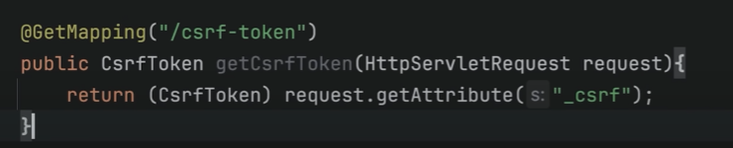

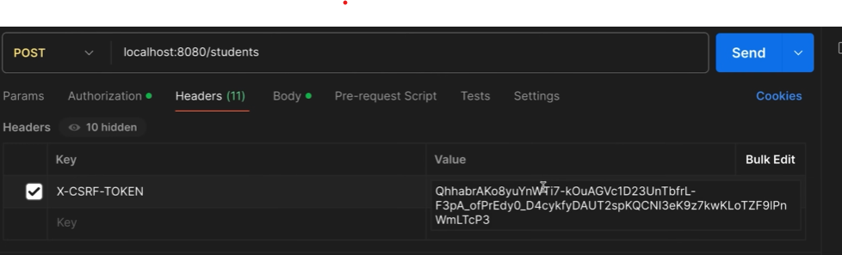

**We can configure web security by putting configuration.**

If we add @EnableWebSecurity then it will enable custom filter configuration and the filter we add only work. The below configuration has no any filter , so even the login form will not shown and we not need to pass any authorization.

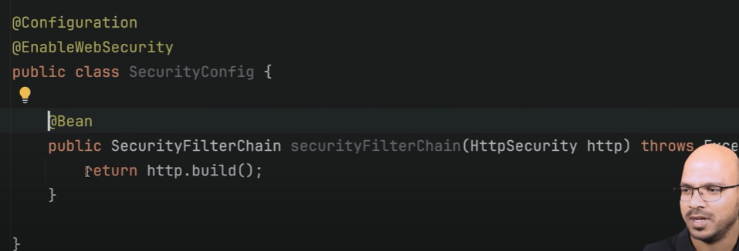

By below configuration authorization will start work

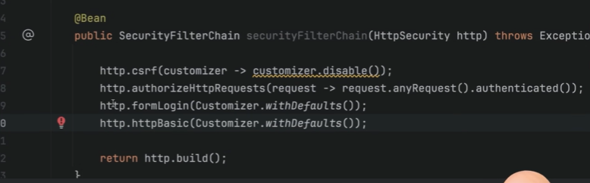

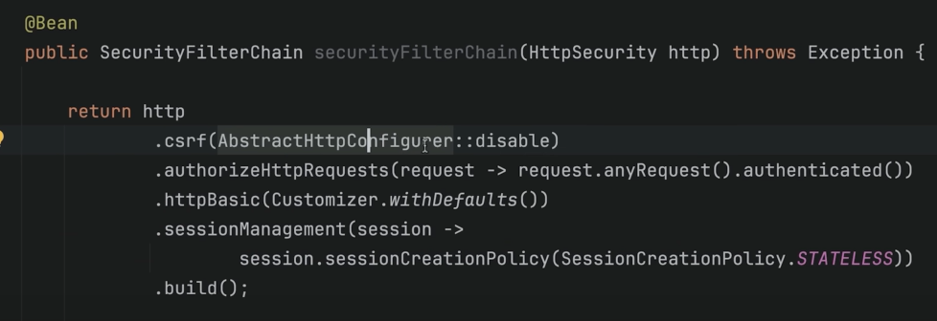

As above crpf is disable. It will work without authorization.

Now, If I want to create login user and password for different user and save to database rather than application.properties file.

Below is hardcoded user and password.

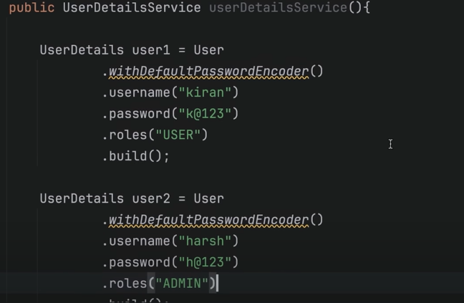



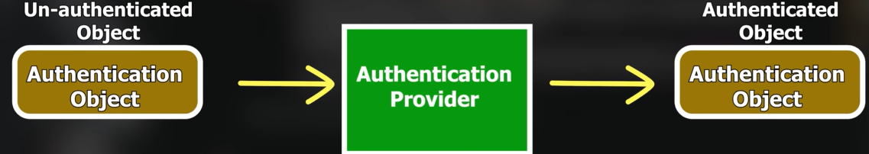

Security with database:

Add AuthenticationProvider

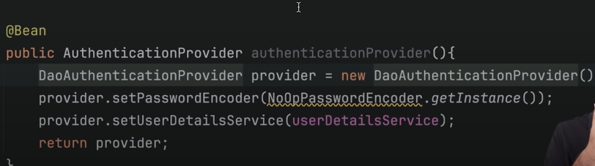

Then create a service

