**Help For FlowWorks App**

### Product of Equalize Health

Revision 1.1  
May 28, 2021

## 1. Introduction

The FlowWorks application is a Windows application designed to interface with the Equalize Health CPAP product FlowLite. The interface is done through a USB connection between the Windows PC and the micro-USB port on the FlowLite device.

## 2. Setup

The application is installed with the .msi file called “FlowWorks.msi”. For Equalize Health employees, this is located by following this link: [FlowWorks.msi](https://drive.google.com/drive/folders/1fNk19hf9SiyK0Slz2joQAa4Escwhsdzl?usp=sharing). The .msi file must be downloaded to the Windows machine, then open this file and follow the prompts. Once installed, the FlowWorks can be launched either from the installer or from the Windows search for “FlowWorks.exe”.

## 3. Getting Started

On launching the app FlowWorks.exe, the following screen appears. Some details may change as the revision of the app changes. This diagram shows the pneumatic schematic of the FlowLite product.

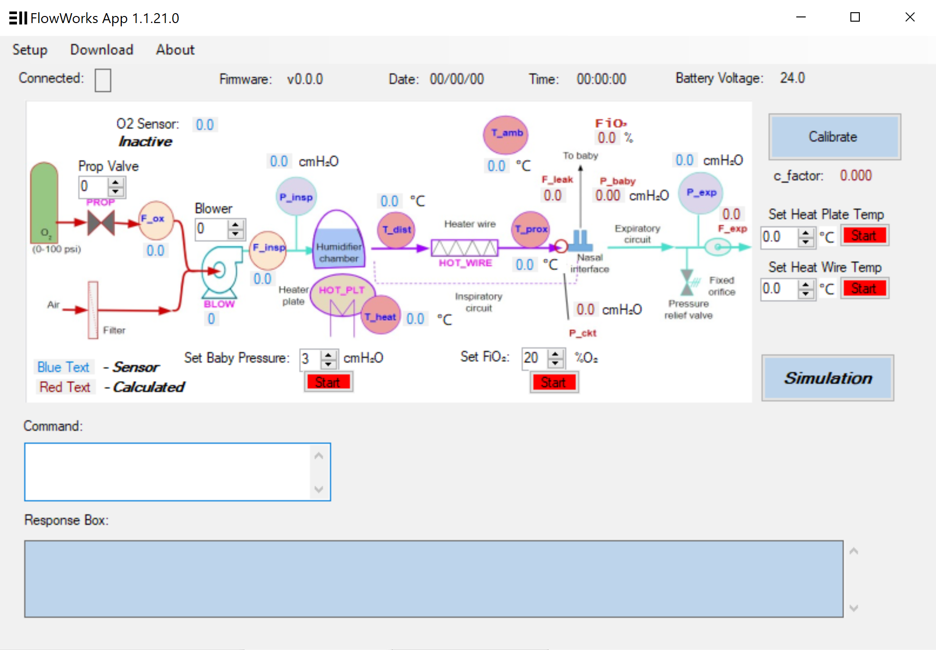

The first thing is to connect the USB cable from the FlowLite product micro-USB port to the Windows machine, and be sure the FlowLite is powered on. Next, select the correct serial port by clicking “Setup” and “COM Port”. All connected ports will appear when the mouse hovers over “COM Port”. If no ports appear, a Windows driver is probably missing.

Notice certain things can be controlled from this screen:

1. the Prop Valve to control Oxygen,
2. the Blower to control the flow of room air,
3. the “Set Baby Pressure” to set the pressure at the nasal interface,
4. “FiO2” to change the concentration of Oxygen going to the baby
5. “Set Heat Plate Temp” to control the temperature of the air coming out of the humidifier chamber
6. “Set Heat Wire Temp” to control the temperature of the heating wire running inside the tube going to the baby

## **4. Downloading Firmware to FlowLite product**

The FlowWorks app can download Firmware to the FlowLite product from the main screen. Before starting this process, an Atmel ICE (link: [Atmel ICE](https://www.microchipdirect.com/product/search/all/ATATMEL-ICE)) must be connected between the Windows machine and the special port on the FlowLite product (not the USB port). The FlowLite should be powered ON and the Atmel ICE disconnected, before connecting the cable from the ICE to the FlowLite. Once connected, then connect the ICE to the Windows machine.

Once the ICE is connected, Click on the “Download” button and “Start Firmware Download”. If the FlowLite is powered on and the Atmel ICE is connected, the firmware download should start. It takes less than 3 minutes, and should show “Successful” when complete.

To view the release notes for the Firmware Release, go to “Download” and “About Firmware” and the Release Note document will open as a .PDF document.

## **5. Calibrate**

The Calibrate button on the main screen calibrates the disposable circuit connecting the FlowLite product to the nasal prongs for the patient. There are many types of circuits, and each time a new circuit is installed, “Calibrate” should be performed. Calibration assures that the equations which estimate the pressure at the baby’s nose will be accurate. NOTE: that “Calibrate” must be done with no patient connected to the tubes, and the nasal prongs in free air. All tubes and connections, other than the patient, should be present before starting a “Calibrate”.

## **6. Simulation**

The Simulation button brings up a simulation of the Screens that appear on the FlowLite during operation.

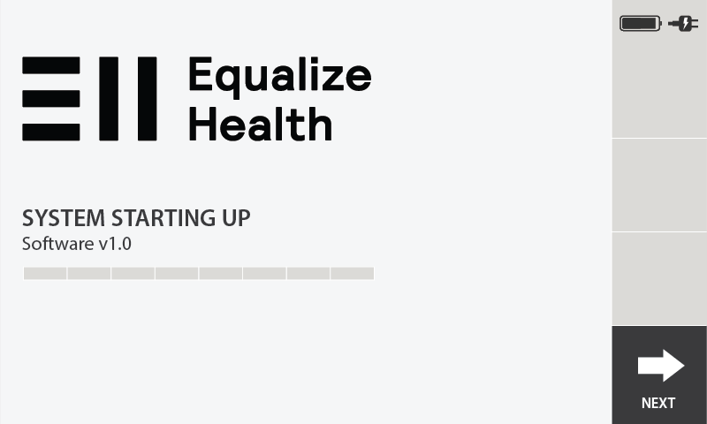

Note that although the screens are only replicas of the actual FlowLite screens, all the buttons and controls are ACTIVE on the simulation, as long as the FlowLite machine is connected by USB. The Simulation can be used when the FlowLite screen is unavailable and for testing. All the controls on the Simulation screens should exactly replicate the actions taken when pushing buttons on the actual FlowLite screen. The rotary knobs to control FiO2 and Baby Pressure are not replicated in the “Simulation” screens.