La Mejor Masa de Pizza para Marcelo
  - Uso de Quarto + Typst para reportes científicos
Miguel Equihua
domingo, 26 de abril de 2026
Resumen
Lorem ipsum dolor sit amet, consectetur adipiscing elit. Duis sagittis posuere ligula sit amet lacinia. Duis dignissim pellentesque magna, rhoncus congue sapien finibus mollis. Ut eu sem laoreet, vehicula ipsum in, convallis erat. Vestibulum magna sem, blandit pulvinar augue sit amet, auctor malesuada sapien. Nullam faucibus leo eget eros hendrerit, non laoreet ipsum lacinia. Curabitur cursus diam elit, non tempus ante volutpat a. Quisque hendrerit blandit purus non fringilla. Integer sit amet elit viverra ante dapibus semper. Vestibulum viverra rutrum enim, at luctus enim posuere eu. Orci varius natoque penatibus et magnis dis parturient montes, nascetur ridiculus mus.
This document shows a practical usage of the template.
I use the Palmer penguins dataset (Horst et al. 2020) to demonstrate the features of the template. The code is available here.

Section as Heading Level 1
Section numbering can be specified in the YAML section-numbering field as other Typst templates.

Subsection as Heading Level 2
You can use LaTeX math expressions:
Yit=αi+λt+k≠−1​τh1{Ei+k=t}+εit.
I choose a mathematical font which supports the indicator function $1\{⋅\}$. Currently, I use the ?meta:mathfont font.

Subsubsection as Heading Level 3
I don’t use and don’t recommend using heading levels 3 and below but it works.

Citation
You can cite a reference like this (Katsushika 1831) or Horst et al. (2020). Typst has some built-in citation styles. Check the Typst documentation for more information.

Figures and Tables

Figures
As Figura 1 shows, the caption is displayed below the figure. As a caption of the figure (fig-cap), I use bold text for the title and use a normal text for the description.
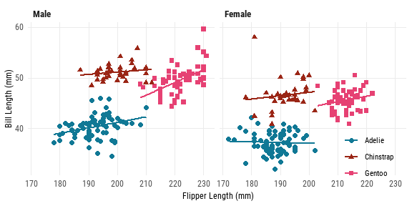
Figura 1: Flipper Length and Bill Length of Penguins. The x-axis shows the flipper length, and the y-axis shows the bill length.
When I want to show multiple figures side by side, I use the patchwork package. The reason why I don’t use the layout-col option is that the caption is also split into two parts.
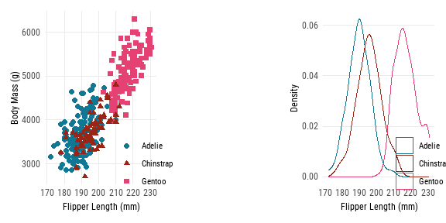
Figura 2: Characteristics of Penguins. The left panel shows the relationship between flipper length and body mass. The right panel shows the density of flipper length.

Tables
You can use tinytable for general tables and modelsummary for regression tables. As Tabla 1 shows, the caption is displayed above the table. The notes of the table can be added using the notes argument of the tinytable::tt() function.
Tabla 1: Summary Statistics of Penguins
 | Male |  |  |  | Female
 | Bill Length (mm) | Bill Depth (mm) | Flipper Length (mm) | Body Mass (g) | Bill Length (mm) | Bill Depth (mm) | Flipper Length (mm) | Body Mass (g)
Adelie | 40.39 | 19.07 | 192.4 | 4043 | 37.26 | 17.62 | 187.8 | 3369
Gentoo | 49.47 | 15.72 | 221.5 | 5485 | 45.56 | 14.24 | 212.7 | 4680
Chinstrap | 51.09 | 19.25 | 199.9 | 3939 | 46.57 | 17.59 | 191.7 | 3527
Notes: Data from Palmer penguins dataset.

Since the default backend of modelsummary is tinytable, you can use the customization options of tinytable for modelsummary. In Tabla 2, I use tinytable::group_tt() function to group the regression results by the dependent variables
Tabla 2: Regression Results of Penguins
 | Bill Length (mm) |  |  | Body Mass (g)
Chinstrap | 10.042** | 10.010** | 10.037** | 32.426 | 26.924 | 27.229
 | (0.432) | (0.341) | (0.340) | (67.512) | (46.483) | (46.587)
Gentoo | 8.713** | 8.698** | 8.693** | 1375.354** | 1377.858** | 1377.813**
 | (0.360) | (0.287) | (0.286) | (56.148) | (39.104) | (39.163)
Male |  | 3.694** | 3.694** |  | 667.555** | 667.560**
 |  | (0.255) | (0.254) |  | (34.704) | (34.755)
Year |  |  | 0.324* |  |  | 3.629
 |  |  | (0.156) |  |  | (21.428)
Observations | 342 | 333 | 333 | 342 | 333 | 333
- p < 0.1, * p < 0.05, ** p < 0.01
Notes: Data from Palmer penguins dataset.

While tinytable generates compatible tables between LaTeX and Typst, it does not support LaTeX math expressions for Typst tables. I think the compatibility between LaTeX and Typst is crucial for academic writing because it guarantees that the document can be easily converted to LaTeX for submission to journals.
A workaround is to use MiTeX, a Typst package that allows you to use LaTeX math expressions in Typst. I write a custom theme for tinytable to convert LaTeX math expressions to MiTeX expressions. The following table includes LaTeX math expressions but will be converted to MiTeX expressions in the Typst output.
Tabla 3: Math Symbols
Math
$α$
$a_{it}$
$e^{iπ}+1=0$

Last words
I made this template for my working papers, so it may not be suitable for other fields than economics. I am happy to receive feedback and suggestions for improvement.

Supplemental Figures
The section numbering will be changed to “A.1.1” in the appendix. The second section in the appendix will be “B”. On the other hand, the figure numbering will be reset to “A.1”, “A.2” so that it is clear that these figures are part of the appendix. The “A” stands for the “Appendix”, not the section numbering.
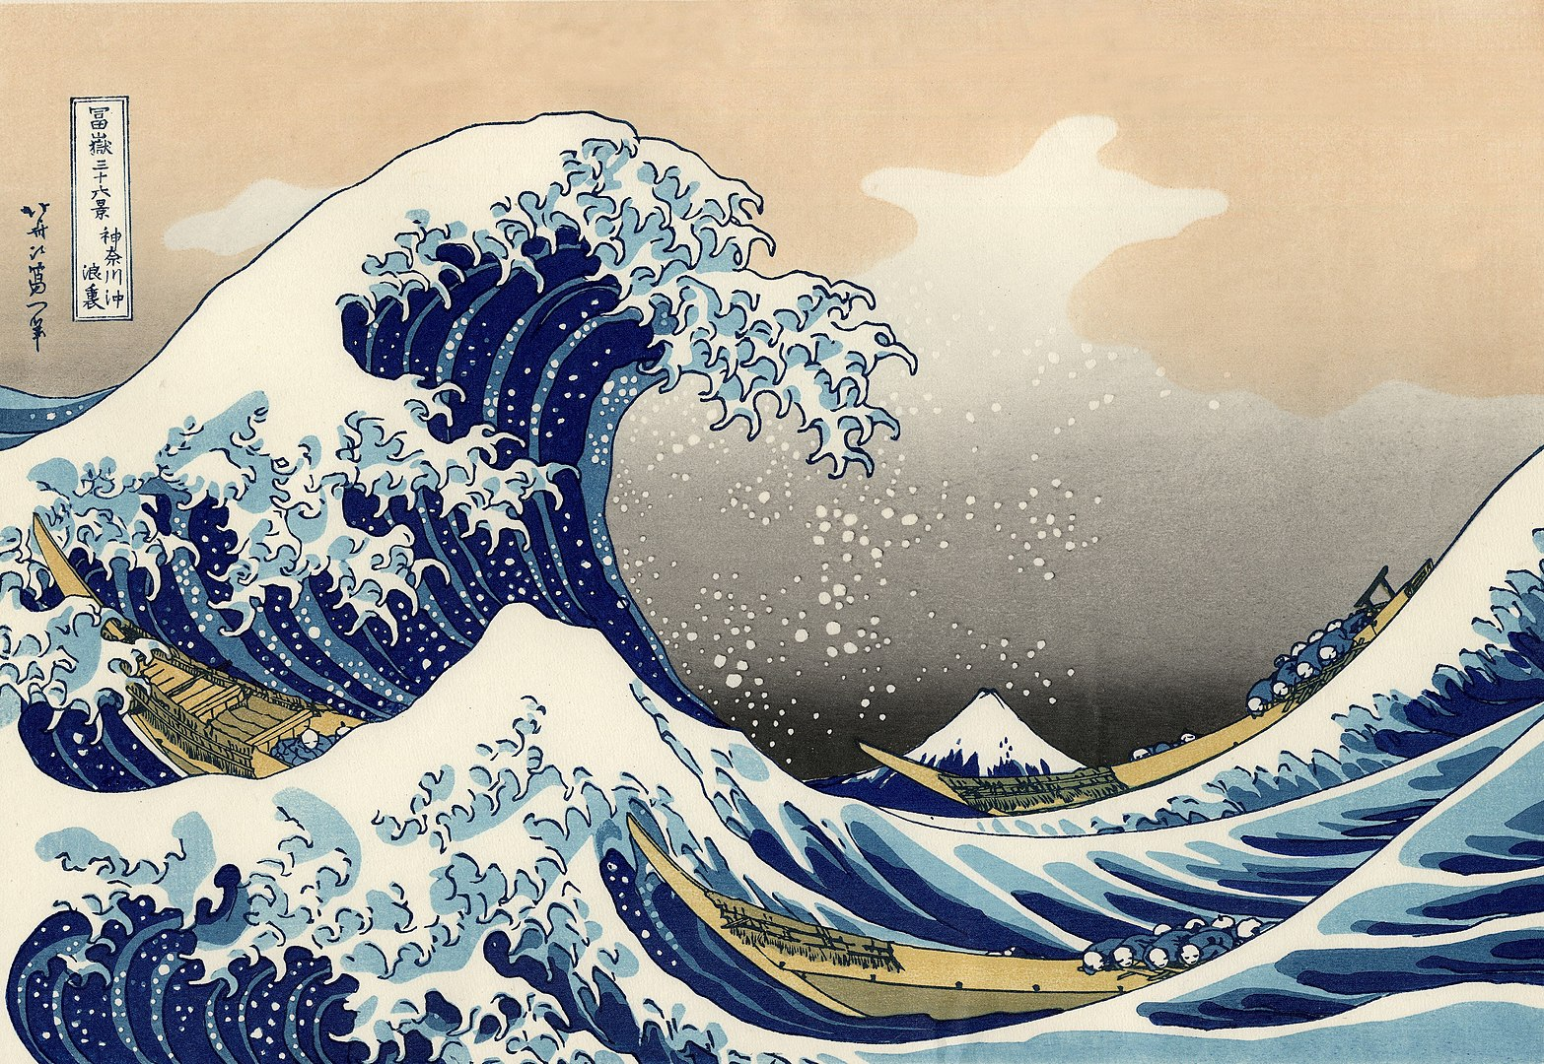
Figura 3: The Great Wave off Kanagawa. A woodblock print by Katsushika (1831).

Horst, Allison Marie, Alison Presmanes Hill, y Kristen B Gorman. 2020. palmerpenguins: Palmer Archipelago (Antarctica) penguin data. https://doi.org/10.5281/zenodo.3960218.
Katsushika, Hokusai. 1831. The Great Wave off Kanagawa. https://upload.wikimedia.org/wikipedia/commons/a/a5/Tsunami_by_hokusai_19th_century.jpg.

