1. Download Python 3.9.7 installer (64-bit) for Windows from here:

<https://www.python.org/downloads/release/python-397/>

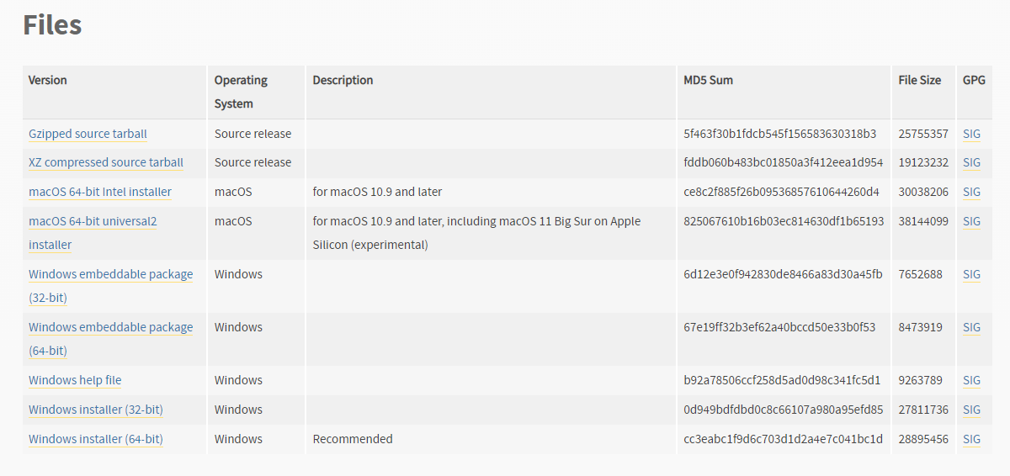

1. After the download is complete run the installation. You will see the following screen:

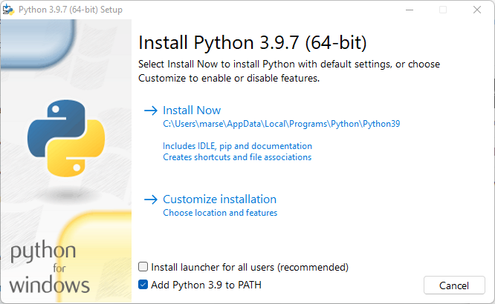

1. Choose Add Python 3.9 to PATH. Click “Customize installation”. The following screen will appear:

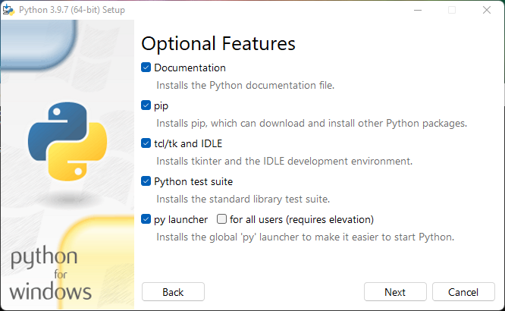

1. Make the same selections and click Next. The following screen will appear:

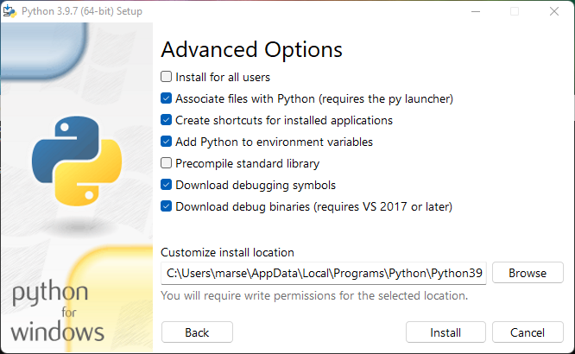

1. Again make the same selections and click “Install”. Wait until the installation is complete.
2. After the installation is complete open Windows command line.
3. After the command prompt loads type the following command to update pip and press Enter:

python -m pip install --user --upgrade pip

1. You might see a message about pip not available on the PATH or some newer versions of pip available. Ignore those messages. After pip is updated it should be a version at least 22.0.4 installed.
2. Next type the following command in command prompt and press Enter:

python -m pip install --user -r lib_reqs.txt

(Just in case, here is the content of the file lib_reqs.txt:

IPython~=7.31.1

jupyter~=1.0.0

notebook~=6.4.8

keras~=2.6.0

matplotlib~=3.5.1

numpy>=1.19.2

pandas~=1.4.1

pmw~=2.0.1

pyyaml~=6.0

scikit-learn~=1.0.2

scipy~=1.7.3

setuptools~=58.0.4

six>=1.15.0

sphinx~=4.4.0

spyder~=5.1.5

tensorboard==2.6.0

tensorflow==2.6.0

wheel~=0.35.1

1. After installation is complete and successful you can test the work of the tool by running suite of tests. Proceed to the folder “test” in the distribution of the tool and run file iam_test.py. To check the output of the test (in order to see it was successful) I recommend to run it in the command line:

python iam_test.py

1. If you follow the instructions above and installed py launcher then it’s possible to run a python file by double-clicking on it in the file browser but it’s harder to see the output after the tests are complete.
2. In similar way, you can test the run of GUI for the tool. Proceed to the folder “source/GUI” and find file NRAP_OPENIAM.py. Run it using command line or from a file browser .
3. In the case of GUI if the installation is successful, one can launch GUI by double clicking on it from a file browser.