SystemVanLaarActivitySRK Technical Report
Van Laar acid activity model with SRK carrier-phase tuning for acid solubility in high-pressure CO2

Executive Summary
SystemVanLaarActivitySRK combines a Van Laar excess-Gibbs-energy liquid model for H2O-HNO3-H2SO4 with an SRK equation-of-state carrier phase for CO2-rich systems. The liquid model reproduces the gamma-phi identity f_i = gamma_i x_i P0_i for water, nitric acid, and sulfuric acid; the CO2 extension then uses tuned SRK pure-component and binary-interaction parameters to match acid solubility data in dense/high-pressure CO2.
For the current CO2 data set, the high-priority HNO3 points are reproduced at roughly the 10-30% level for most high-pressure points, while ship-transport low-pressure points remain higher-uncertainty constraints. H2SO4 solubility is much lower in absolute terms, in the range of approximately 0.06-7.7 ppm mol over the experimental conditions.

1. Description of the Model
The implementation is a gamma-phi model. The gas or CO2-rich phase is represented by SRK, while liquid acid-water phases are represented by PhaseGEVanLaarAcid. For the acid-water liquid source, ComponentGEVanLaarAcid overrides the liquid fugacity coefficient so that phi_i = gamma_i P0_i / P. This gives f_i = x_i phi_i P = gamma_i x_i P0_i.
The Van Laar activity coefficients and pure vapour pressures are implemented in NitricSulfuricAcidVaporPressure, based on Taleb, Ponche and Mirabel (1996). Component indexing follows the reference: component 1 = H2O, component 2 = HNO3, component 3 = H2SO4. The model was originally intended for low-temperature acid-water mixtures, roughly 190-298 K, and the current CO2 solubility use extends it by coupling the acid source fugacity to an SRK CO2 carrier-phase fugacity coefficient.
The acid solubility helper calculates the liquid-source fugacity from a specified acid-water source, then divides by the trace-component fugacity coefficient and pressure of the CO2-rich SRK phase: y_i ppm = f_i,source / (phi_i,CO2 P) * 1e6.
Quantity | Model expression or value
Water P0 | log10(P0/mbar) = 8.42926609 - 1827.17843/T - 71208.271/T^2
HNO3 P0 | log10(P0/torr) = 7.57628 - 1470.385/(T - 43.0)
H2SO4 P0 | ln(P0/atm) = -10156/T + 16.259
Liquid fugacity | f_i = gamma_i x_i P0_i
CO2 solubility helper | ppm mol = f_i,source / (phi_i,CO2 P_CO2) * 1e6

2. Pure Acid-Water Model Data
The following tables and figures show the low-pressure acid-water model before the CO2 carrier-phase tuning is applied. The tables give representative liquid-source fugacity values; the added plots show the HNO3-H2O bubble/dew behaviour and the Taleb, Ponche and Mirabel paper validation curves for binary and ternary acid-water mixtures.

2.1 HNO3-H2O
Case | T [C] | wt% H2O/HNO3/H2SO4 | x H2O | x HNO3 | x H2SO4 | p H2O [Pa] | p HNO3 [Pa] | p H2SO4 [Pa]
65 wt% HNO3 source | 0.0 | 35.0/65.0/0.0 | 0.6532 | 0.3468 | 0.0000 | 108.3657 | 53.9860 | 0.000000
50 wt% HNO3 source | 0.0 | 50.0/50.0/0.0 | 0.7777 | 0.2223 | 0.0000 | 254.0422 | 6.3890 | 0.000000
20 wt% HNO3 source | 0.0 | 80.0/20.0/0.0 | 0.9333 | 0.0667 | 0.0000 | 531.3565 | 0.0683 | 0.000000
Discussion: increasing HNO3 mass fraction strongly suppresses water activity while increasing the HNO3 liquid-source fugacity. The 65 wt% HNO3 source is the source composition used for the CO2-HNO3-H2O solubility calculations later in the report.

2.2 HNO3-H2SO4-H2O
Case | T [C] | wt% H2O/HNO3/H2SO4 | x H2O | x HNO3 | x H2SO4 | p H2O [Pa] | p HNO3 [Pa] | p H2SO4 [Pa]
Ternary validation | 0.0 | 60.0/20.0/20.0 | 0.8647 | 0.0824 | 0.0529 | 371.0635 | 0.9054 | 0.000000
TPflash validation | 0.0 | 70.0/15.0/15.0 | 0.9086 | 0.0557 | 0.0358 | 470.5510 | 0.1833 | 0.000000
HNO3-rich ternary | 0.0 | 35.0/55.0/10.0 | 0.6659 | 0.2992 | 0.0349 | 101.9547 | 56.5964 | 0.000000
Discussion: the ternary model uses all three binary interaction contributions. Sulfuric acid has very low pure vapour pressure, but it can strongly affect water and nitric-acid activities through the ternary Van Laar terms.

2.3 H2SO4-H2O
Case | T [C] | wt% H2O/HNO3/H2SO4 | x H2O | x HNO3 | x H2SO4 | p H2O [Pa] | p HNO3 [Pa] | p H2SO4 [Pa]
50 wt% H2SO4 source | 0.0 | 50.0/0.0/50.0 | 0.8448 | 0.0000 | 0.1552 | 192.6673 | 0.0000 | 0.000000
80 wt% H2SO4 source | 0.0 | 20.0/0.0/80.0 | 0.5765 | 0.0000 | 0.4235 | 2.3770 | 0.0000 | 0.000000
98 wt% H2SO4 source | 25.0 | 2.0/0.0/98.0 | 0.1000 | 0.0000 | 0.9000 | 0.0055 | 0.0000 | 0.001573
Discussion: H2SO4 remains essentially non-volatile compared with water and HNO3. For the 98 wt% H2SO4 source used in the CO2-H2SO4-H2O data, predicted acid fugacity is therefore very small and the CO2-rich phase concentrations are in ppm or sub-ppm ranges.

2.4 CO2-H2O
CO2-H2O is not part of the Van Laar liquid-source activity model. In SystemVanLaarActivitySRK it enters through the SRK CO2 carrier calculation, where trace water fugacity coefficients use a temperature-dependent CO2-water binary interaction parameter.
T [C] | kij CO2-HNO3 | kij CO2-H2SO4 | kij CO2-H2O
-29.0 | 0.22893 | 0.27667 | 0.06409
-20.0 | 0.22329 | 0.26030 | 0.07847
0.0 | 0.15477 | 0.22392 | 0.10703
25.0 | 0.14071 | 0.17844 | 0.13734
40.0 | 0.07056 | 0.15116 | 0.15320
48.0 | 0.20879 | 0.13660 | 0.16106
53.0 | 0.24369 | 0.12751 | 0.16577
Discussion: water solubility in the CO2-rich phase is controlled by both the liquid source fugacity and the SRK carrier-phase fugacity coefficient. The CO2-H2O kij values are part of the carrier correction; the acid-specific fits below adjust the corresponding CO2-acid kij functions and, for HNO3, the SRK pure-component parameters.

2.5 Additional Pure Acid-Water and Paper Validation Plots
The original pure acid-water section has been expanded with figures already present in the strong-acid validation notebook folder. These plots are useful because they show the model before any high-pressure CO2 solubility tuning: pure vapour-pressure anchors, binary HNO3-H2O phase behaviour, binary H2SO4 water-activity suppression, and ternary HNO3/H2SO4 salting-out behaviour from Taleb, Ponche and Mirabel (1996).
Plot / data source | What it shows | Why it matters for this report
HNO3-H2O bubble/dew T-x-y | Bubble liquid composition and dew vapour composition at 50-760 mmHg. | Shows the non-ideal binary phase envelope that underlies nitric-acid source fugacity.
Taleb et al. Fig. 2 reproduction | P_H2O and P_HNO3 over binary H2O-HNO3 across 210-285 K. | Validates the binary nitric-acid/water activity model against the source paper.
Taleb et al. Figs. 3-5 reproduction | Water activity and water vapour pressure over H2O-H2SO4. | Explains why concentrated H2SO4 is an extreme dehydrating, low-volatility source.
Taleb et al. Figs. 6-7 reproduction | Ternary P_H2O and P_HNO3 at 273 K as H2SO4 is added. | Shows the paper-level ternary salting-out maximum and water suppression.

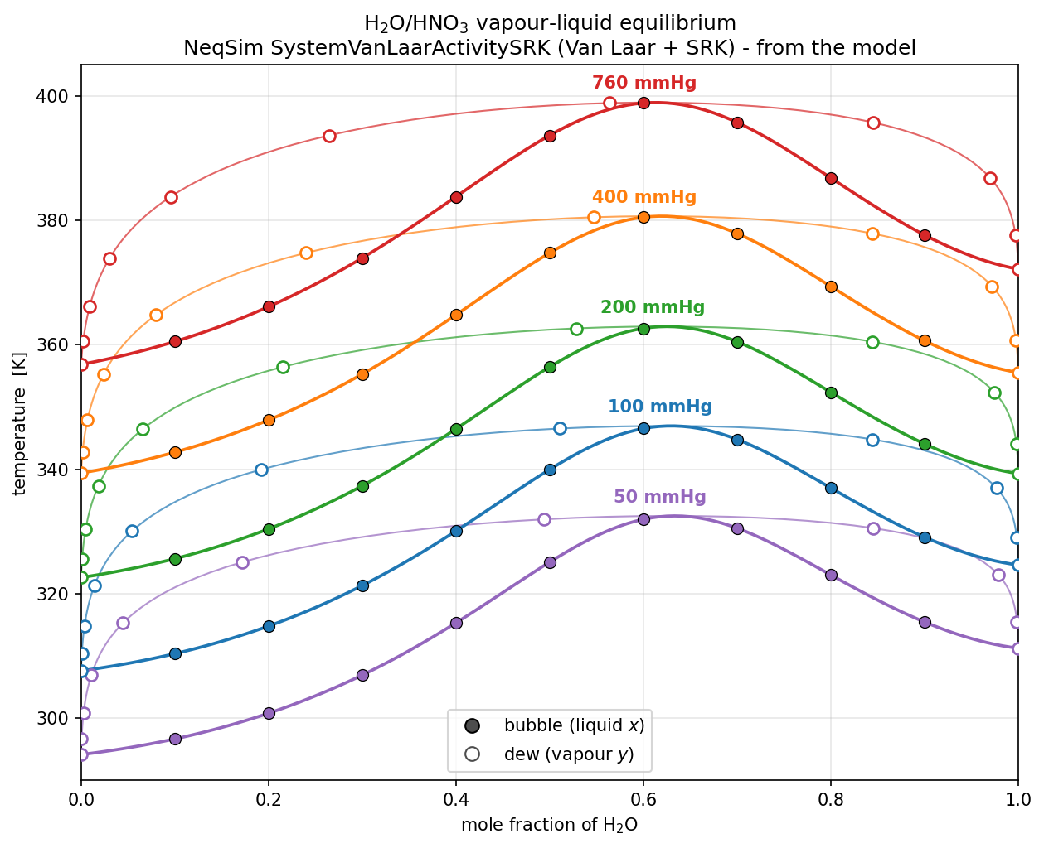
Figure 2-1. HNO3-H2O vapour-liquid equilibrium: bubble and dew lines
Discussion: The HNO3-H2O binary has a strong non-ideal vapour-liquid envelope. The bubble curves give the liquid composition and the dew curves give the corresponding vapour composition at fixed pressure. The maximum-boiling behaviour is important because it controls how nitric acid and water partition before any CO2 carrier-phase tuning is applied.

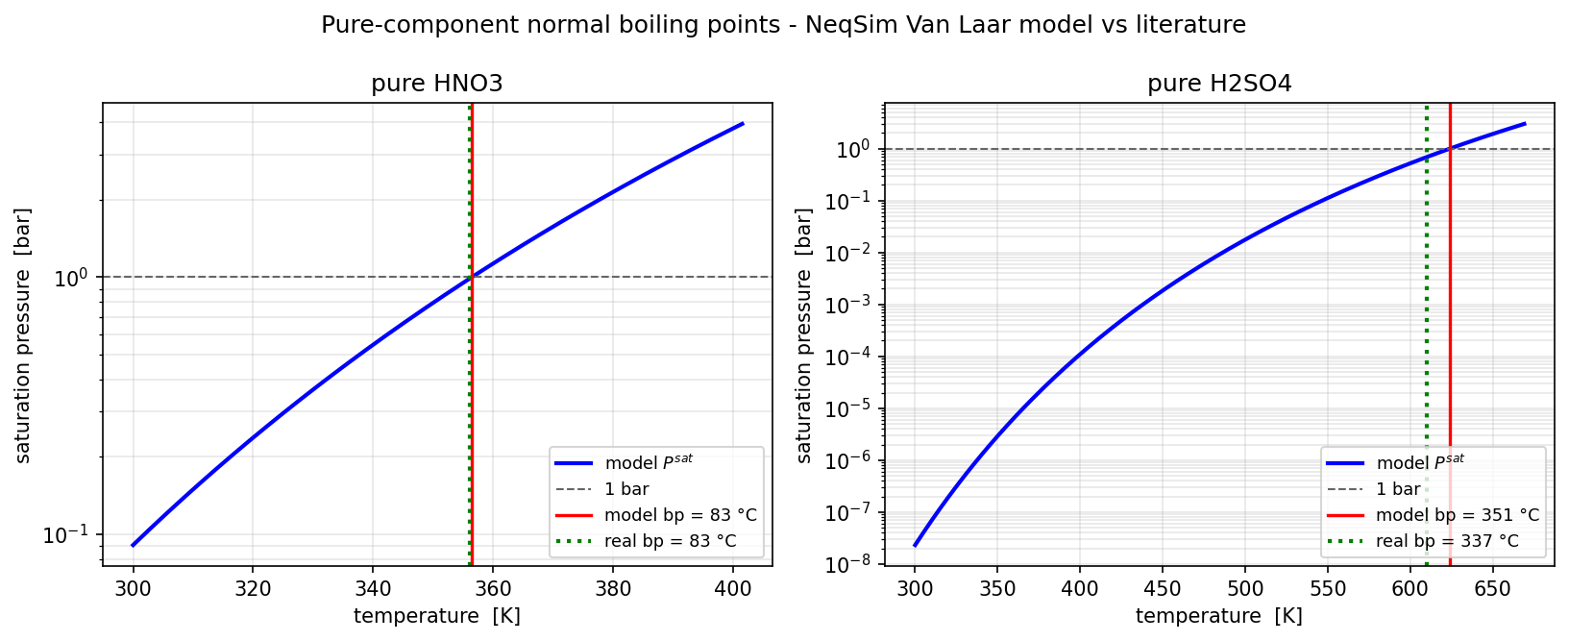
Figure 2-2. Pure-component vapour-pressure anchors
Discussion: The pure-component vapour-pressure correlations anchor the activity model. HNO3 is fitted to the normal boiling point near 83 C, while H2SO4 remains orders of magnitude less volatile than HNO3 and water over the low-temperature range.

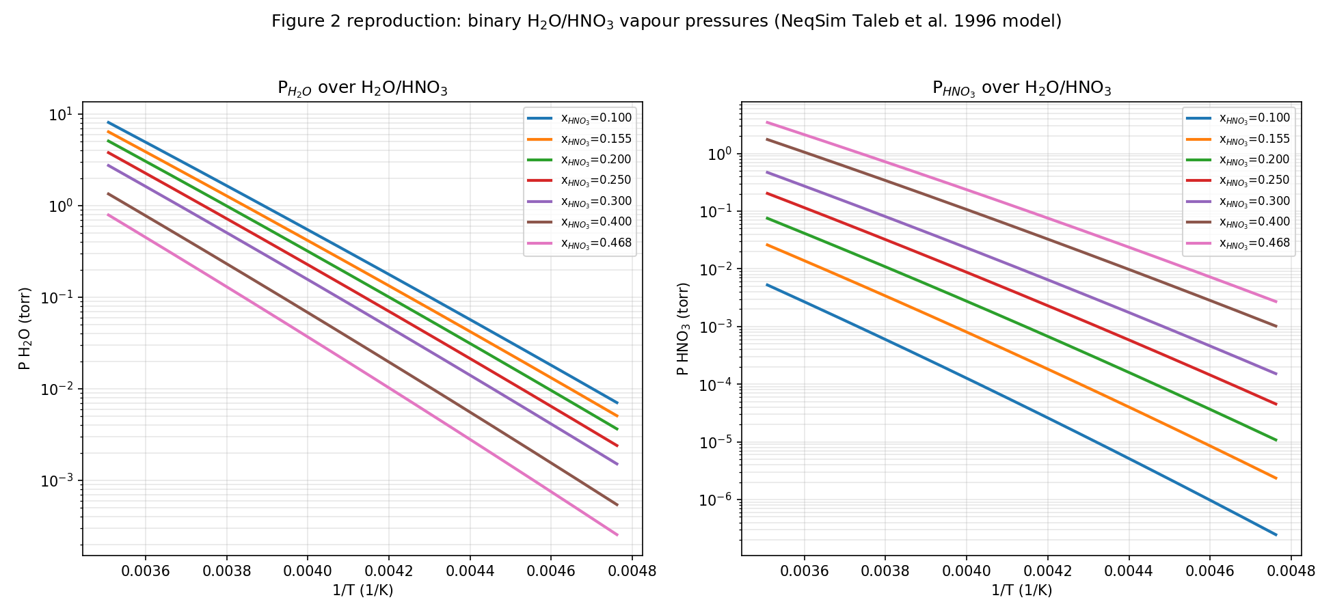
Figure 2-3. Taleb et al. Figure 2 reproduction: binary H2O-HNO3 vapour pressures
Discussion: The binary H2O-HNO3 curves show opposite composition effects: increasing HNO3 mole fraction suppresses water partial pressure but increases nitric-acid partial pressure. This is the most direct paper-level validation for the HNO3-H2O part of the model.

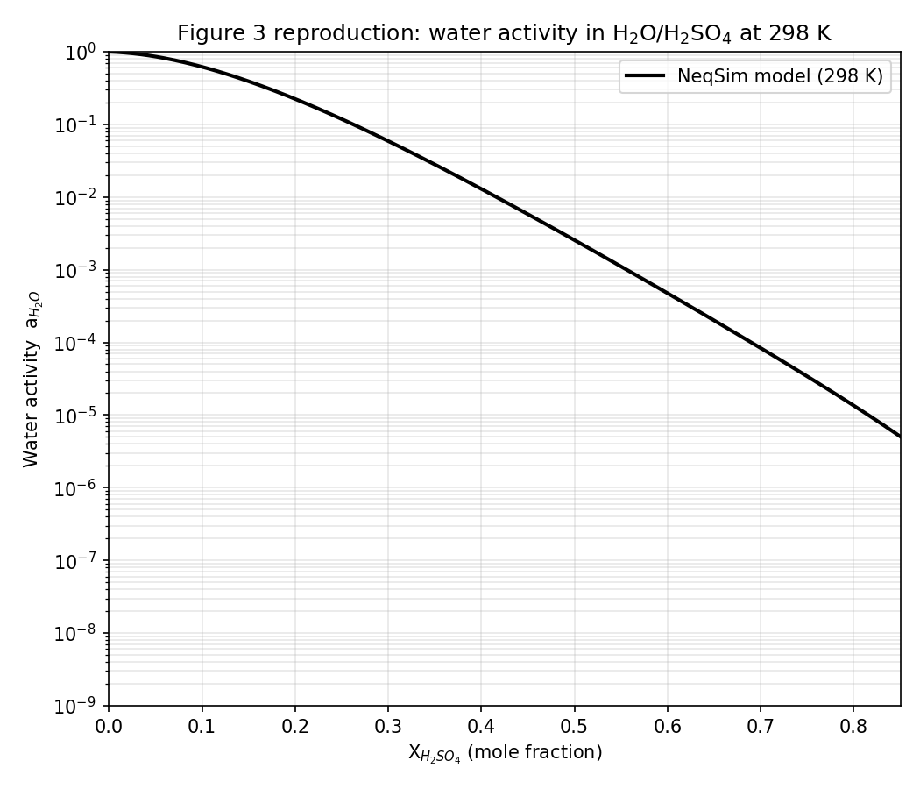
Figure 2-4. Taleb et al. Figure 3 reproduction: water activity in H2O-H2SO4
Discussion: Sulfuric acid strongly lowers water activity. By x_H2SO4 around 0.5, water activity is reduced by roughly three orders of magnitude, explaining why concentrated sulfuric acid contributes very little water vapour pressure.

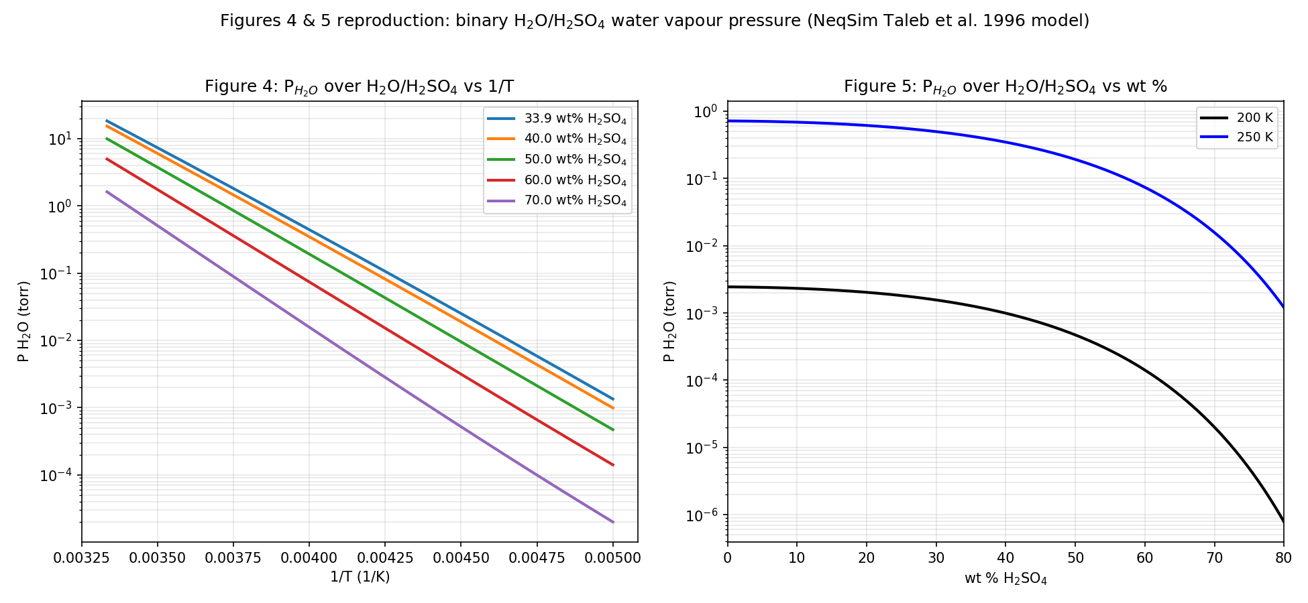
Figure 2-5. Taleb et al. Figures 4 and 5 reproduction: H2O-H2SO4 water vapour pressure
Discussion: The H2O-H2SO4 binary data show both temperature sensitivity and composition suppression of water vapour pressure. The log-scale curves make the dehydration effect of sulfuric acid visible over several orders of magnitude.

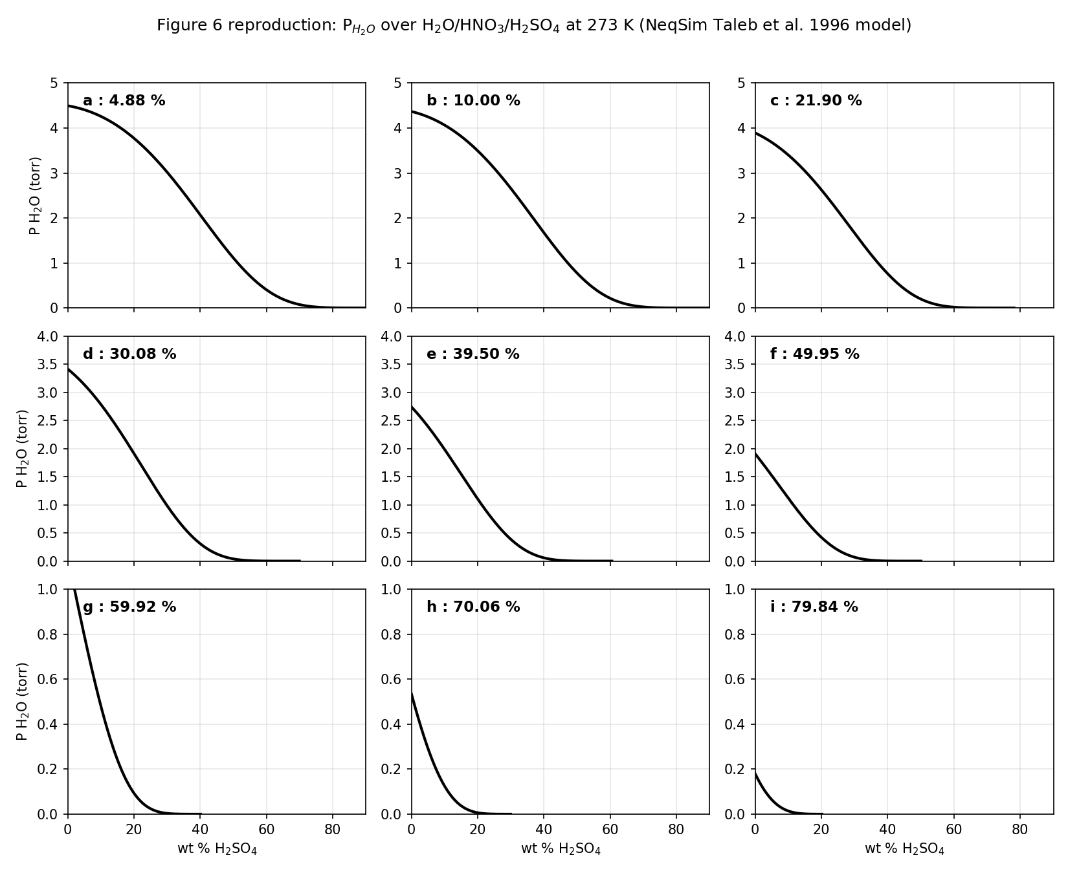
Figure 2-6. Taleb et al. Figure 6 reproduction: ternary water partial pressure at 273 K
Discussion: In ternary H2O-HNO3-H2SO4 mixtures, adding sulfuric acid reduces water partial pressure sharply. The effect strengthens as total nitric-acid content increases, because both acids lower the effective water activity.

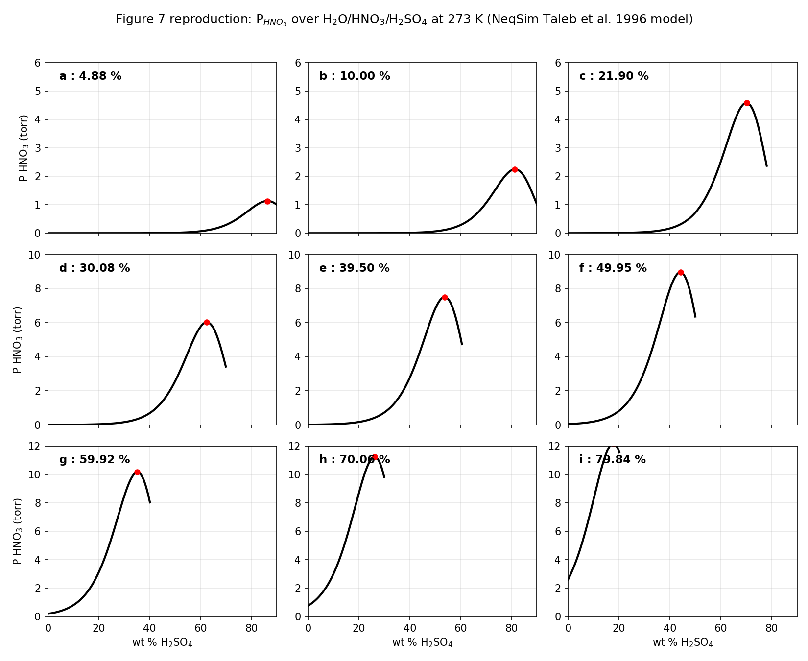
Figure 2-7. Taleb et al. Figure 7 reproduction: ternary nitric-acid salting-out at 273 K
Discussion: This is the most interesting ternary behaviour: at fixed total HNO3, adding H2SO4 first increases P_HNO3 by removing water and concentrating nitric acid, then decreases P_HNO3 after dilution by sulfuric acid dominates. The red maxima mark the salting-out peak that the Van Laar model was designed to reproduce.

3. Experimental CO2 Acid-Water Data and Tuning
The high-pressure CO2 data are represented by source-liquid compositions of 65 wt% HNO3 / 35 wt% H2O and 98 wt% H2SO4 / 2 wt% H2O. The model does not tune the Van Laar acid-water activity terms to these CO2 data; those terms come from the low-temperature acid-water reference model. The CO2 data are matched by tuning the SRK carrier-side description of trace acid components.
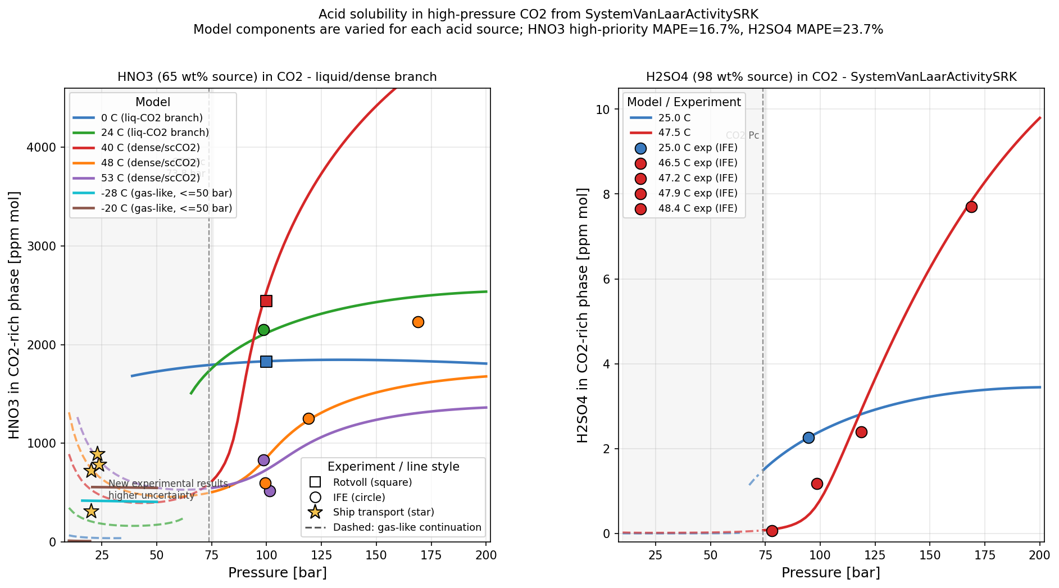
Figure 3-1. SystemVanLaarActivitySRK acid solubility in high-pressure CO2, including HNO3, H2SO4 and ship-transport HNO3 points.

3.1 CO2-HNO3-H2O Data
Source | P [bar] | T [C] | Experiment [ppm mol] | Model [ppm mol] | Deviation [%]
Rotvoll | 100.00 | 0.00 | 1828.0 | 1828.0 | 0.0
Rotvoll | 100.00 | 40.00 | 2443.0 | 2540.0 | 4.0
IFE | 98.60 | 24.00 | 2150.0 | 2100.0 | -2.3
IFE | 98.60 | 53.00 | 830.0 | 715.0 | -13.9
IFE | 101.30 | 53.00 | 520.0 | 750.0 | 44.2
IFE | 99.30 | 48.00 | 600.0 | 838.0 | 39.7
IFE | 119.00 | 48.00 | 1250.0 | 1230.0 | -1.6
IFE | 169.10 | 48.00 | 2230.0 | 1600.0 | -28.3
Ship transport | 20.00 | -21.00 | 723.0 | 519.0 | -28.2
Ship transport | 20.00 | -29.00 | 313.0 | 424.0 | 35.5
Ship transport | 23.56 | -19.19 | 787.5 | 591.0 | -25.0
Ship transport | 22.86 | -17.92 | 896.4 | 654.0 | -27.0
Discussion: the Rotvoll and IFE high-pressure points define the main dense/liquid CO2 tuning target. The ship-transport points are plotted and tabulated separately as lower-temperature low-pressure information with higher uncertainty. The fitted model captures the high-pressure trend and remains close to the main 0 C, 24 C, 40 C and 48 C data, while the 53 C data show larger scatter between 98.6 and 101.3 bar.

3.2 CO2-H2SO4-H2O Data
Source | P [bar] | T [C] | Experiment [ppm mol] | Model [ppm mol] | Deviation [%]
IFE | 94.60 | 25.00 | 2.26 | 2.26 | 0.0
IFE | 77.90 | 46.50 | 0.06 | 0.06 | -8.3
IFE | 98.40 | 47.20 | 1.18 | 1.11 | -5.9
IFE | 118.60 | 47.90 | 2.40 | 2.60 | 8.3
IFE | 168.70 | 48.40 | 7.70 | 7.65 | -0.6
Discussion: H2SO4 concentrations in the CO2-rich phase are orders of magnitude lower than HNO3, so small absolute errors can correspond to large relative differences at the lowest concentration point. The linear temperature-dependent CO2-H2SO4 kij is sufficient to reproduce the increasing pressure trend from about 100 to 170 bar.

3.3 Tuned Parameters
Parameter | Value | Purpose
HNO3 SRK critical temperature | 578.433819 K | Vapour-side trace HNO3 fugacity coefficient
HNO3 SRK critical pressure | 107.435001 bara | Vapour-side trace HNO3 fugacity coefficient
HNO3 SRK acentric factor | 0.849356 | Vapour-side trace HNO3 fugacity coefficient
CO2-HNO3 kij base | 0.15148833 | Temperature-dependent binary interaction
CO2-HNO3 kij slope | -0.00028980 per C | Linear temperature term
CO2-HNO3 low-temperature Gaussian | A=0.07478942, C=-25.0 C, W=10.0 C | Low-temperature ship-transport region
CO2-HNO3 mid-temperature Gaussian dip | A=0.08044221, C=40.0 C, W=6.0 C | 40 C Rotvoll / dense CO2 region
CO2-HNO3 high-temperature Gaussian | A=0.12485075, C=51.0 C, W=5.0 C | 48-53 C high-temperature curvature
CO2-H2SO4 kij at 47.5 C | 0.13751412 | Reference value for sulfuric acid trace fugacity
CO2-H2SO4 kij slope | -0.00181899 per C | Linear temperature correction
The CO2-HNO3 kij function is k = base + slope*T + low-temperature Gaussian - mid-temperature Gaussian dip + high-temperature Gaussian, where T is in C. The CO2-H2SO4 kij function is k = k(47.5 C) + slope*(T - 47.5 C). These parameters tune only the SRK carrier side; they do not overwrite the acid-water Van Laar liquid-source model.

3.4 Final Notebook Comparison Plot and Discussion
The final notebook plot was added to make the comparison easier to read than the pressure-temperature curve plot alone. Each condition is shown as paired experiment and VanLaar-SRK bars, followed by a deviation panel in percent. This is useful because the data combine different pressure levels, temperatures and sources; a single pressure-axis plot can hide whether the model is matching the actual measured condition.
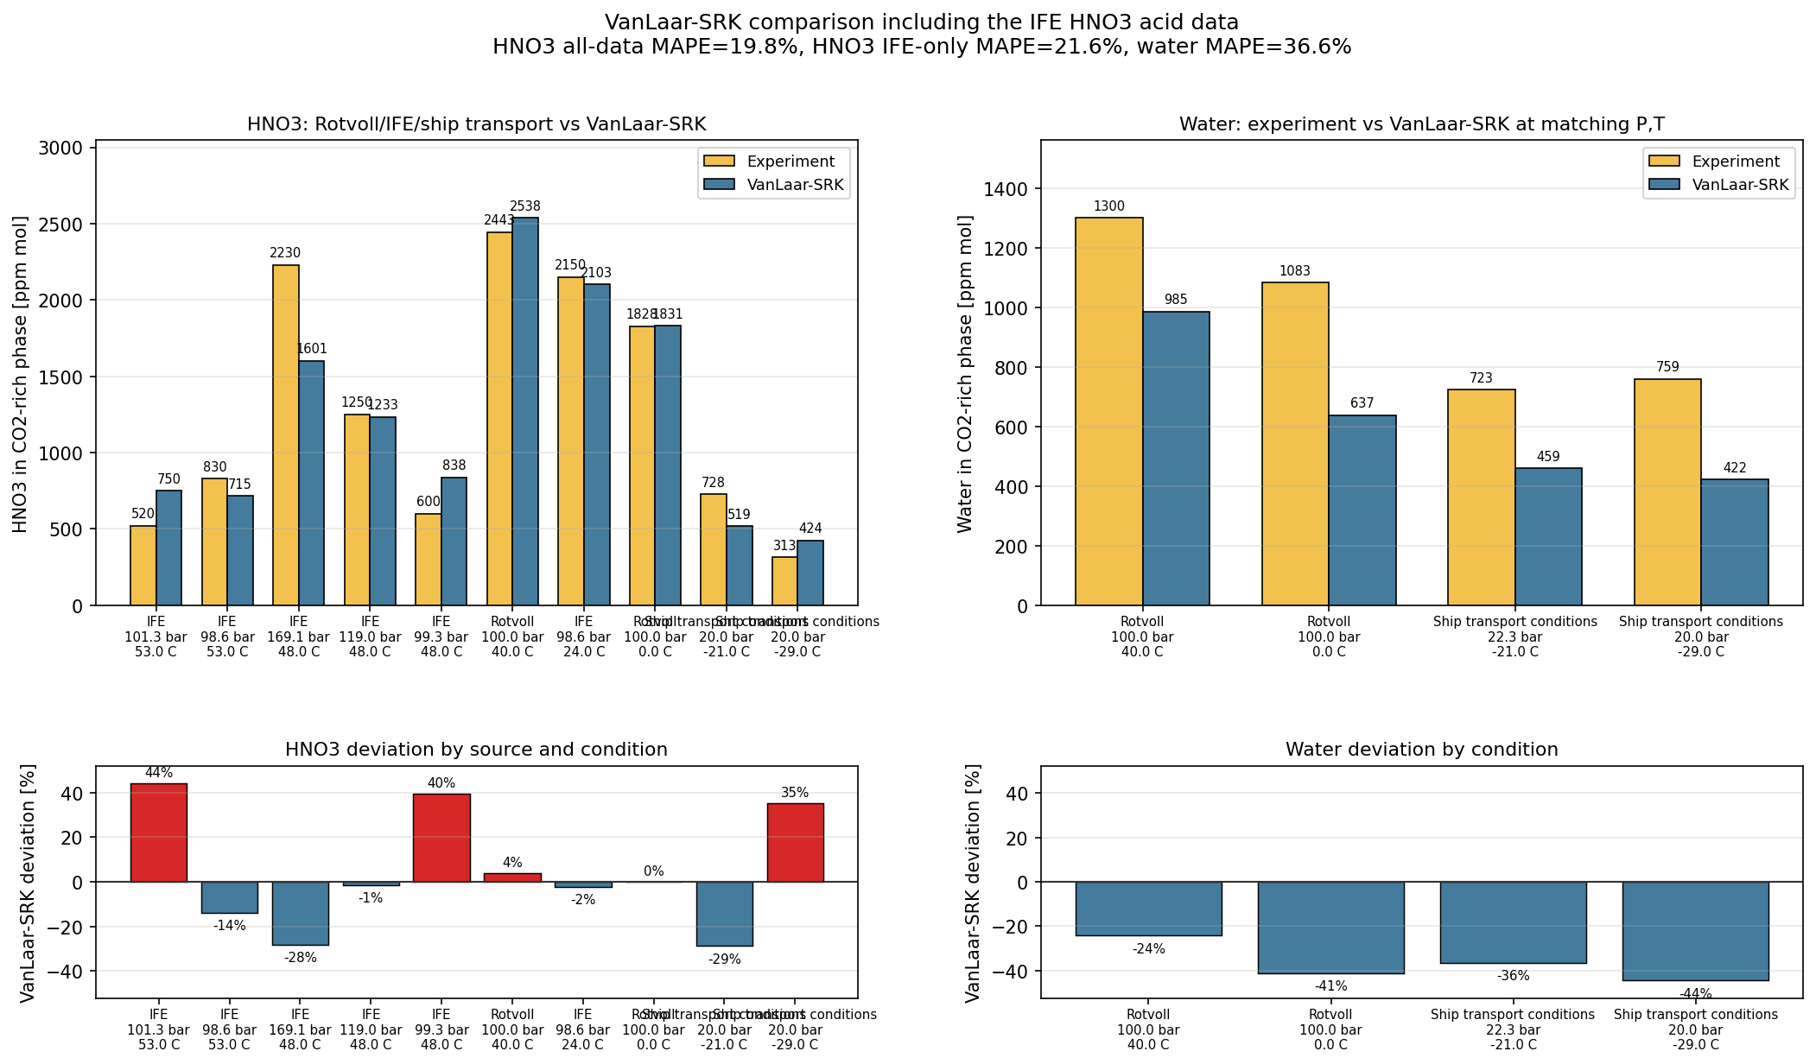
Figure 3-2. Final notebook comparison plot for the HNO3 65 wt% source. Top panels compare experiment and VanLaar-SRK values directly; bottom panels show the signed model deviation in percent for HNO3 and water.
Quantity | Comparison basis | MAPE [%] | Main observation
HNO3 | All measured rows | 19.8 | Good order-of-magnitude fit with larger deviations at 48-53 C and low pressure
HNO3 | IFE rows only | 21.6 | Scatter in the IFE data limits how closely one smooth kij curve can pass through all points
Water | Measured rows | 36.6 | Water from the nitric-acid source is systematically underpredicted in the displayed rows
For HNO3, the model follows the central trend of the Rotvoll and IFE data, especially at 0 C, 24 C and 40 C where the deviation is small. The larger deviations occur where the experiments themselves are more difficult to reconcile: the 48 C and 53 C IFE measurements span a wide range with pressure, and the low-pressure ship-transport points sit in a different CO2 phase regime. This supports using the model as an interpolation tool over the fitted data envelope, but not as a stand-alone extrapolation model.
The water comparison is less satisfactory than the acid comparison. The final notebook plot shows water underprediction for all displayed water measurements, with deviations around -24% to -44%. This suggests that the acid kij tuning mainly targeted acid solubility, while water carry-over from the HNO3-water source may need separate validation or additional tuning if water concentration is a design-critical output.
The combined interpretation of Figures 3-1 and 3-2 is therefore that the VanLaar-SRK extension captures the main acid-in-CO2 behaviour, but water and sparse low-temperature data remain the weakest parts of the model. In reporting or design use, the ship-transport rows should be kept visible and described as new experimental results with higher uncertainty.

4. SRK Binary Interaction Parameters (kij)
The kij parameters in SystemVanLaarActivitySRK belong to the SRK carrier-phase part of the model. They are not Van Laar liquid activity parameters. The acid-water liquid source still uses the Taleb/Ponche/Mirabel activity-coefficient model; kij only changes the trace-component fugacity coefficient in the CO2-rich phase.
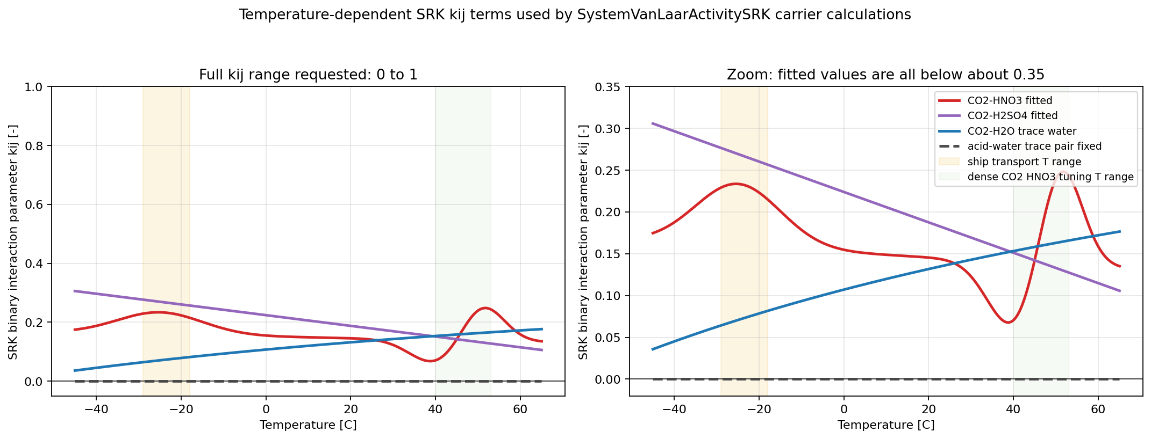
Figure 4-1. Temperature-dependent SRK binary interaction parameters used for trace-component carrier-phase calculations. Left: full 0-1 range. Right: zoomed view showing that all fitted values remain below about 0.35 over the plotted range.
T [C] | CO2-HNO3 kij | CO2-H2SO4 kij | CO2-H2O kij | acid-water trace kij
-29.00 | 0.22893 | 0.27667 | 0.06409 | 0.00000
-20.00 | 0.22329 | 0.26030 | 0.07847 | 0.00000
0.00 | 0.15477 | 0.22392 | 0.10703 | 0.00000
25.00 | 0.14071 | 0.17844 | 0.13734 | 0.00000
40.00 | 0.07056 | 0.15116 | 0.15320 | 0.00000
48.00 | 0.20879 | 0.13660 | 0.16106 | 0.00000
53.00 | 0.24369 | 0.12751 | 0.16577 | 0.00000
The HNO3 curve is deliberately more structured than a simple linear kij. It contains a low-temperature bump, a mid-temperature dip around 40 C, and a high-temperature bump around 51 C. This was introduced to match sparse data that cover different phase regimes and temperature windows: low-pressure ship-transport data, dense/liquid CO2 data near 40 C, and high-temperature IFE points around 48-53 C.
Is this type of kij normal? For highly polar trace solutes such as nitric acid, sulfuric acid and water in a nonpolar CO2-rich SRK phase, positive kij values are normal as empirical corrections. A positive kij weakens the unlike attraction term relative to the geometric mean, which is consistent with limited affinity between CO2 and strongly associating acid/water species. Temperature-dependent kij values are also common when a cubic EOS is used outside its natural comfort zone for polar trace components.
Does anything look unphysical? Within the plotted calibration range, no obvious hard unphysical behaviour appears: all kij values remain between 0 and 1, the curves are smooth, and there are no discontinuities. The values are also moderate; the largest fitted values are below about 0.30 in the relevant range. The main caution is not the magnitude, but the shape of the HNO3 curve. The Gaussian bump/dip structure is empirical and should not be interpreted as a molecular theory. It is a regression device used to fit sparse and partly scattered experimental data.
The practical implication is that interpolation inside the measured temperature-pressure range is acceptable, while extrapolation is risky. Outside the data range, the HNO3 kij may retain artificial curvature from the Gaussian terms and the linear H2SO4 term could eventually drift too high or too low. For new temperatures or different acid source strengths, the kij functions should be checked against fresh experimental or independent benchmark data.

5. Conclusion
SystemVanLaarActivitySRK is best understood as a two-layer model. The first layer is the Taleb/Ponche/Mirabel Van Laar acid-water activity model, which provides liquid-source fugacities for H2O, HNO3 and H2SO4 and is validated through exact gamma-phi identity tests. The second layer is a tuned SRK CO2 carrier model that converts those source fugacities into ppm mol solubilities in CO2-rich phases.
The current tuning gives a practical engineering correlation for trace acid carry-over into high-pressure CO2. It is strongest where direct Rotvoll/IFE high-pressure data exist and weaker where the only information is low-pressure ship-transport data or sparse H2SO4 measurements. Further work should prioritise additional controlled CO2-HNO3-H2O data below 50 bar and additional H2SO4 data between 80 and 170 bar to reduce parameter degeneracy.

References
Taleb, D., Ponche, J. L., and Mirabel, P. (1996). Vapor pressures in the ternary system water-nitric acid-sulfuric acid at low temperature. Journal of Geophysical Research, 101(D20), 25967-25977.
NeqSim source classes: SystemVanLaarActivitySRK, PhaseGEVanLaarAcid, ComponentGEVanLaarAcid, and NitricSulfuricAcidVaporPressure.
Vandoni, R. (1944). Experimental nitric-acid partial-pressure data compiled by Taleb, Ponche and Mirabel (1996) for ternary H2O-HNO3-H2SO4 salting-out validation.

