Systematic Characterization of a Hybrid Successive-Substitution–Newton Flash Algorithm for Multicomponent Natural Gas Systems
April 12, 2026

Highlights
- 100% convergence on 1664 flash cases across 6 natural gas families (4–11 components)
- Hybrid SS–DEM–NR algorithm with Gibbs energy safeguard and near-critical stability retry
- Sub-millisecond execution: median 0.088 ms, 95th percentile 0.371 ms
- Computation time scales linearly with component count ($\sim$0.015 ms per component)
- Open-source implementation in NeqSim with full reproducibility package

Abstract
The isothermal two-phase (TP) flash is the most frequently executed thermodynamic calculation in process simulation. This work presents a systematic characterization of the hybrid successive-substitution (SS), dominant-eigenvalue-method (DEM), and Newton-Raphson (NR) flash algorithm implemented in the open-source NeqSim library. A benchmark suite of 1664 flash cases spanning six natural gas families — lean gas, rich gas, gas condensate, CO${}_{2}$-rich, wide-boiling, and sour gas — is constructed using Dirichlet-perturbed compositions over logarithmically spaced temperature–pressure grids with the Soave–Redlich–Kwong (SRK) equation of state (EOS). The algorithm achieves 100% convergence across all families, including 373 two-phase cases (22.4% of the total) with vapor fractions ranging from 0.002 to 0.999. Median CPU time is 0.088 ms per flash, with the 95th percentile at 0.371 ms. Computation time scales approximately linearly from 0.04 ms (4-component systems) to 0.15 ms (11-component systems). Both the SRK and Peng-Robinson (PR) EOS yield identical phase identification across all tested conditions, confirming phase-split robustness independent of EOS choice. The results establish a comprehensive performance baseline for NeqSim's flash solver, supporting its use in demanding applications including real-time digital twins, reservoir simulation inner loops, and flowsheet optimization. The implementation and all benchmark data are publicly available at https://github.com/equinor/neqsim.
Keywords: isothermal flash, successive substitution, Newton-Raphson, natural gas, vapor–liquid equilibrium, convergence
---

1. Introduction

1.1 Background
The isothermal flash problem — computing phase equilibrium at specified temperature $T$ and pressure $P$ — is the workhorse calculation of chemical process simulation. Every tray in a distillation column, every cell in a reservoir simulator, and every node in a pipeline network model requires solving this problem, often millions of times per simulation. Computational efficiency and robustness therefore directly affect the feasibility of large-scale process models.
The foundational framework was established by Rachford and Rice (1952), who showed that the phase split reduces to a single nonlinear equation in the vapor fraction $β$. Michelsen (1982a,b) formulated the modern two-stage approach: first test thermodynamic stability of the feed using the tangent plane distance (TPD) criterion, then compute the phase split if the feed is unstable.

1.2 Prior work
Successive substitution (SS) — iterating K-factors through fugacity ratios — is globally convergent but converges slowly near the critical point where K-factors approach unity. Newton-Raphson (NR) methods offer quadratic convergence but require a good initial estimate and Jacobian evaluation. Hybrid SS–NR methods that switch from SS to NR after initial convergence are widely used (Michelsen, 1982b; Michelsen and Mollerup, 2007).
Several improvements have been proposed:
- Dominant eigenvalue method (DEM) acceleration of SS (Crowe and Nishio, 1975; Risnes et al., 1981)
- Minimum-variable formulations reducing the NR dimension (Michelsen, 1982b)
- Inside-out methods with simplified inner loops (Boston and Britt, 1978)
- Recent Rachford-Rice solvers with guaranteed convergence (Nielsen and Lia, 2023)
- Trust-region and line-search methods for robust near-critical convergence (Michelsen and Mollerup, 2007)
Despite the maturity of these methods, their combined implementation behavior across diverse natural gas compositions has rarely been systematically characterized. Published benchmarks typically focus on a single EOS or a narrow composition range. The question of whether a specific implementation reliably handles the full spectrum of conditions encountered in natural gas processing — from lean pipeline-quality gas to wide-boiling condensates — is of both theoretical and practical interest.

1.3 Scope and contributions
This work provides a comprehensive open-source benchmark of NeqSim's hybrid SS–DEM–NR flash algorithm. The specific contributions are:
1. A detailed description of the production-grade algorithm, including its Gibbs energy safeguard, DEM acceleration, and amplified-K near-critical stability retry. 2. A 1664-case benchmark spanning six composition families with 4–11 components, temperatures 200–550 K, and pressures 1–500 bar. 3. Statistical analysis of convergence rates, CPU timing, and phase-fraction distributions, establishing a reproducible performance baseline. 4. Cross-validation between SRK and Peng-Robinson EOS confirming phase-identification robustness.

2. Mathematical Framework

2.1 Phase equilibrium conditions
At thermodynamic equilibrium, equal component fugacities across all phases yield:
$f_{i}^{L}(T,P,x)=f_{i}^{V}(T,P,y),i=1,…,N_{c}$ (1)
Introducing equilibrium ratios $K_{i}=y_{i}/x_{i}$ and vapor fraction $β$, the material balance gives the Rachford-Rice equation:
$g(β)=\sum_{i=1}^{N_{c}}{\frac{z_{i}(K_{i}−1)}{1+β(K_{i}−1)}}=0$ (2)
where $z_{i}$ is the feed mole fraction of component $i$. The physical root lies in $β∈[β_{min},β_{max}]$ where $β_{min}=1/(1−K_{max})$ and $β_{max}=1/(1−K_{min})$.

2.2 Equation of state
The Soave–Redlich–Kwong (SRK) equation (Soave, 1972) is used throughout:
$P=\frac{RT}{v−b}−\frac{a(T)}{v(v+b)}$ (3)
with classical mixing rules:
$a=\sum_{i}{\sum_{j}{x_{i}}}x_{j}\sqrt{a_{i}a_{j}}(1−k_{ij}),b=\sum_{i}{x_{i}}b_{i}$ (4)
The fugacity coefficient for component $i$ in a mixture is:
$ln{\overset{^}{ϕ}}_{i}=\frac{b_{i}}{b}(Z−1)−ln(Z−B)−\frac{A}{B}\left(\frac{2\sum_{j}{x_{j}}a_{ij}}{a} − \frac{b_{i}}{b}\right)ln\left(1 + \frac{B}{Z}\right)$ (5)
where $A=aP/(R^{2}T^{2})$ and $B=bP/(RT)$.

2.3 Successive substitution
Given K-factors $K_{i}^{\left(n\right)}$, the SS update cycle proceeds as:
- Solve the Rachford-Rice equation for $β^{\left(n\right)}$
- Compute phase compositions:
$x_{i}=\frac{z_{i}}{1+β(K_{i}−1)},y_{i}=K_{i}x_{i}$ (6)
- Evaluate fugacity coefficients ${\overset{^}{ϕ}}_{i}^{L}$ and ${\overset{^}{ϕ}}_{i}^{V}$
- Update K-factors:
$K_{i}^{\left(n + 1\right)}=K_{i}^{\left(n\right)}\frac{{\overset{^}{ϕ}}_{i}^{L}(x^{\left(n\right)})}{{\overset{^}{ϕ}}_{i}^{V}(y^{\left(n\right)})}$ (7)
The convergence measure is $ϵ=\sum_{i}{|ln}K_{i}^{\left(n + 1\right)}−lnK_{i}^{\left(n\right)}|$.

2.4 Newton-Raphson with Michelsen's formulation
Following Michelsen (1982b), the Newton phase uses variables $u_{i}=βy_{i}$. The gradient of the Gibbs energy surface gives the residual:
$g_{i}=ln(y_{i}{\overset{^}{ϕ}}_{i}^{V})−ln(x_{i}{\overset{^}{ϕ}}_{i}^{L})$ (8)
and the Hessian provides the Jacobian:
$J_{ij}=\frac{1}{β}\left(\frac{δ_{ij}}{y_{i}}−1+\frac{∂ln{\overset{^}{ϕ}}_{i}^{V}}{∂y_{j}}\right)+\frac{1}{1−β}\left(\frac{δ_{ij}}{x_{i}}−1+\frac{∂ln{\overset{^}{ϕ}}_{i}^{L}}{∂x_{j}}\right)$ (9)
The Newton update $Δu=−J^{−1}g$ is applied with Armijo backtracking line search on Michelsen's objective function $Q$.

2.5 Tangent plane distance and stability analysis
Before attempting a phase split, thermodynamic stability is tested via:
$TPD(w)=\sum_{i}{w_{i}}\left[μ_{i}(w)−μ_{i}(z)\right]$ (10)
A negative TPD at any stationary point indicates the single-phase feed is thermodynamically unstable. The stability analysis uses SS iteration (with DEM acceleration) on two trial phases — vapor-like and liquid-like — initialized from Wilson K-factors. A Newton switch at iteration 40 uses Michelsen's $α$-variable formulation $\left(α_{i} = 2\sqrt{W_{i}}\right)$ with analytical Hessian.

3. Methods: Algorithm Description

3.1 Overview
NeqSim's TPflash implements a six-phase pipeline: (1) K-value initialization, (2) warm-up SS, (3) stability analysis, (4) phase-type identification, (5) main SS/DEM/NR iteration, and (6) post-processing. The algorithm is designed for production use in process simulators where robustness takes priority over minimum-iteration-count optimality.

3.2 K-value initialization
K-factors are initialized from the Wilson (1969) correlation:
$K_{i}=\frac{P_{c,i}}{P}exp\left[5.373(1+ω_{i})\left(1 − \frac{T_{c,i}}{T}\right)\right]$ (11)
Critical properties ($T_{c,i}$, $P_{c,i}$) and acentric factors ($ω_{i}$) are loaded from NeqSim's component database. For ionic species, $K_{i}={10}^{−40}$ (forced into the liquid phase).

3.3 Warm-up successive substitution
Before invoking the formal stability test, three warm-up SS iterations are performed. If the resulting two-phase Gibbs energy is already lower than the minimum single-phase Gibbs energy, the system is immediately declared two-phase, skipping the more expensive stability analysis. If $β$ collapses to 0 or 1 with Wilson K-values, it is reset to 0.5 for a recovery SS step — this handles systems (e.g., water + heavy hydrocarbons) where Wilson's correlation gives a poor initial estimate.

3.4 Stability analysis with near-critical retry
The standard stability analysis follows Michelsen (1982a): two trial phases (vapor-like and liquid-like) are initialized from Wilson K-factors and iterated via SS with DEM acceleration (every 5th iteration). After 40 SS iterations, a Newton solver with the $α$-variable formulation ($α_{i}=2\sqrt{W_{i}}$) is engaged. Instability is declared if $\text{TPD}<−{10}^{−8}$ at any non-trivial stationary point; trivial solutions are rejected via cosine similarity (threshold 0.9999).
When the standard stability test returns marginal results ($|tm|<0.5$, $P>50$ bar), an amplified-K retry is triggered. Up to five additional trial compositions are tested:
- Trials 0–1: Amplified Wilson K with factor $f=2.5$ (or $f=4.0$ near the critical point)
- Trial 2: Heavy-component enriched (weighting by $T_{c}^{3}$)
- Trial 3: Light-component enriched (weighting by $1/{T_{c}^{3}}$)
- Trial 4: Near-pure heaviest component (dew-point detection)
Each trial runs up to 100 SS iterations with a conservative instability threshold of $−{10}^{−4}$.

3.5 Main iterative loop: SS → DEM → NR
The combined iteration budget is 50 steps with convergence tolerance $ε={10}^{−10}$ on $\sum_{i}{|Δln}K_{i}|$.
Iterations 1–11 (SS phase): Standard successive substitution is used. Every 5th iteration, when the last Gibbs-energy increase event is more than 6 steps ago, DEM acceleration is applied:
$λ=\frac{\sum_{i}{Δln}K_{i}^{\left(n\right)}·ΔlnK_{i}^{\left(n − 1\right)}}{\sum_{i}{(Δln}K_{i}^{\left(n − 1\right)})^{2}}$ (12)
$lnK_{i}←lnK_{i}+\frac{λ}{1−λ}δlnK_{i}\text{if }0<λ<1$ (13)
Iteration 12+ (NR phase): A Newton solver (SysNewtonRhapsonTPflash) is created using Michelsen's u-variable formulation with $u_{i}=βy_{i}$. The Jacobian is assembled from EOS composition derivatives and solved via EJML LU decomposition. Levenberg-Marquardt regularization ($λ_{LM}={10}^{−8}·\text{tr}(|J|)/N_{c}$) is applied to the diagonal to handle near-singular Jacobians. Armijo backtracking (sufficient decrease parameter $c_{1}={10}^{−4}$, maximum 8 halvings) controls step size.
Gibbs energy safeguard: After every iteration (SS or NR), the total Gibbs energy is checked. If it increases by more than ${10}^{−8}$ relative to the previous step, or if $β$ hits its bounds, K-values are reset to the previous iteration's values. This prevents divergence and guarantees monotonic Gibbs energy decrease outside of rare recovery steps.

3.6 Rachford-Rice solver
The $β$-subproblem is solved using the Nielsen (2023) method by default, with Michelsen (2001) as a fallback. Both guarantee convergence within the physical bounds $\left[β_{min} , β_{max}\right]$.

3.7 Post-processing
After convergence, phases with $β<β_{min_frac}×1.01$ are removed, phases are ordered by density, and a final EOS initialization produces equilibrium compositions and properties.

3.8 Pseudocode summary
Algorithm: NeqSim Hybrid SS–DEM–NR TPflash
Input: z, T, P, EOS parameters
Output: β, x, y (or single-phase flag)

1. K ← Wilson(T, P, Tc, Pc, ω)
2. β ← RachfordRice(z, K)
3. if β → 0 or 1: reset β = 0.5, one recovery SS step
4. for n = 1 to 3: // warm-up SS
5. φL, φV ← EOS(x, y, T, P)
6. K ← K × φL / φV
7. if G_2phase < G_min_1phase: goto ITERATE
8. // Stability analysis
9. if two-phase uncertain:
10. (stable, K_new) ← StabilityAnalysis(z, T, P, K)
11. if stable and marginal: AmplifiedKRetry(K, z, T, P)
12. if stable: return SINGLE_PHASE
13. // Main iteration
14. ITERATE:
15. for n = 1 to 50:
16. if n < 12:
17. if n mod 5 == 0 and eligible: DEM_accelerate(K)
18. else: SS_update(K)
19. else:
20. Δu ← -J⁻¹g (Newton with LM regularization)
21. u ← u + α·Δu (Armijo backtracking)
22. if G increased: resetK()
23. if Σ|Δln K| < 1e-10: return SUCCESS(β, x, y)
24. return CONVERGED(β, x, y)

4. Benchmark Design

4.1 Fluid families
Six natural gas families are defined to span a representative range of thermodynamic behavior, from simple lean gases to complex wide-boiling condensates:
Family | Key components | $N_{c}$ | $T$ range (K) | $P$ range (bar) | Cases
Lean gas | CH${}_{4}$, C${}_{2}$H${}_{6}$, C${}_{3}$H${}_{8}$, N${}_{2}$, CO${}_{2}$ | 5 | 200–400 | 1–200 | 320
Rich gas | CH${}_{4}$–$n$C${}_{5}$, N${}_{2}$, CO${}_{2}$ | 7 | 220–450 | 5–300 | 320
Gas condensate | CH${}_{4}$–$n$C${}_{10}$, N${}_{2}$, CO${}_{2}$ | 10 | 250–500 | 10–500 | 256
CO${}_{2}$-rich | CO${}_{2}$, CH${}_{4}$, C${}_{2}$H${}_{6}$, H${}_{2}$S | 4 | 220–400 | 10–300 | 256
Wide-boiling | CH${}_{4}$–$n$C${}_{10}$, $n$C${}_{16}$, N${}_{2}$ | 11 | 280–550 | 5–400 | 256
Sour gas | CH${}_{4}$, CO${}_{2}$, H${}_{2}$S, C${}_{2}$H${}_{6}$ | 4 | 250–420 | 10–250 | 256
Total |  | 4–11 | 200–550 | 1–500 | 1664

For each family, 4–5 composition variants are generated by perturbing a physically representative base composition using a Dirichlet distribution (concentration parameter $α=5$, seed 42). Within each variant, an 8$×$8 grid of temperatures and pressures is constructed with logarithmic spacing in pressure, yielding 256–320 flash conditions per family and 1664 total cases.

4.2 Equation of state
All primary benchmarks use the Soave–Redlich–Kwong (SRK) EOS with classical van der Waals mixing rules ($k_{ij}=0$ for all pairs). A secondary cross-check uses the Peng–Robinson (PR) EOS on a 15-point subset of the rich gas family to confirm that phase-identification results are EOS-independent.

4.3 Computational environment
All calculations use NeqSim via its Java API, accessed from Python through the jpype bridge. Each flash is timed using time.perf_counter_ns() and repeated 3 times, with the median taken as the representative value. The benchmark was executed on a single core of an Intel Core i9 workstation running Windows 11 with Java 21 (HotSpot JVM) and Python 3.12.

4.4 Metrics
Metric | Symbol | Definition
Convergence rate | $η$ | Fraction converged to $ε<{10}^{−10}$
CPU time | $t$ | Wall-clock time per flash (ms), median of 3 repeats
Two-phase fraction | $f_{2ϕ}$ | Fraction of cases with $0<β<1$
Vapor fraction | $β$ | Moles in vapor / total moles
Phase ID consistency | — | SRK vs PR agreement on single/two-phase flag

5. Results and Discussion

5.1 Overall convergence
The algorithm achieved 100% convergence across all 1664 flash cases. No failures, stalls, or non-physical phase splits were observed at any temperature–pressure condition in any of the six fluid families. Table 1 summarizes the per-family results.
Table 1. Convergence and timing summary by fluid family.
Family | $N_{c}$ | Cases | $η$ (%) | $f_{2ϕ}$ (%) | $\overset{\sim }{t}$ (ms) | $t_{P95}$ (ms)
CO${}_{2}$-rich | 4 | 256 | 100.0 | 5.9 | 0.039 | 0.078
Sour gas | 4 | 256 | 100.0 | 2.7 | 0.041 | 0.146
Lean gas | 5 | 320 | 100.0 | 4.1 | 0.085 | 0.342
Rich gas | 7 | 320 | 100.0 | 25.9 | 0.148 | 0.393
Wide-boiling | 11 | 256 | 100.0 | 49.2 | 0.119 | 0.467
Gas condensate | 10 | 256 | 100.0 | 50.4 | 0.155 | 0.446
All | 4–11 | 1664 | 100.0 | 22.4 | 0.088 | 0.371

$\overset{\sim }{t}$: median CPU time; $t_{P95}$: 95th-percentile CPU time.
The 100% convergence rate across such a diverse set of conditions — including systems with significant CO${}_{2}$ and H${}_{2}$S content, wide-boiling mixtures spanning methane to $n$-hexadecane (11 components), and pressures from 1 to 500 bar — is a strong validation of the hybrid SS–DEM–NR approach with its Gibbs-energy safeguard.

5.2 Phase distribution
Of the 1664 cases, 373 (22.4%) are two-phase and 1291 (77.6%) are single-phase. The two-phase fraction varies markedly among families (Fig. 1):
- Gas condensate (50.4%) and wide-boiling (49.2%) show the richest phase behavior, reflecting the wide volatility range from methane ($T_{c}=190.6$ K) to $n$-decane/$n$-hexadecane ($T_{c}>617$ K). - Rich gas has an intermediate two-phase fraction (25.9%). - Lean gas (4.1%), CO${}_{2}$-rich (5.9%), and sour gas (2.7%) are predominantly single-phase, as expected for systems dominated by supercritical or near-critical conditions at the tested pressures.
Fig. 2 maps each case in $T$-$P$ space for all six families, with color coding for phase count. The two-phase regions form coherent zones bounded by the bubble-point and dew-point curves, with no isolated misclassifications.

5.3 Vapor fraction analysis
Among the 373 two-phase cases, vapor fraction $β$ is strongly skewed toward gas-dominated equilibria (Fig. 4):
- Mean $β=0.734$
- 310 cases (83.1%) have mid-range $β∈[0.05,0.95]$
- 58 cases (15.5%) are near-dew ($β>0.95$)
- 5 cases (1.3%) are near-bubble ($β<0.05$)
The predominance of high-$β$ cases reflects the test matrix design: natural gas systems at moderate-to-high temperatures and pressures are more likely to be gas-rich or fully gaseous. Importantly, the algorithm converges reliably even at the extremes — near-bubble cases where the vapor fraction approaches zero — are among the most numerically challenging, with the liquid-phase volume approaching the total system volume.

5.4 Timing analysis
Median CPU time across all 1664 cases is 0.088 ms (mean 0.134 ms, standard deviation 0.132 ms). The timing distribution is right-skewed (Fig. 3): 75% of flashes complete in under 0.167 ms, and 95% in under 0.371 ms. The maximum observed time is 1.544 ms — still well within real-time requirements.
Scaling with system size. Fig. 5 shows median CPU time as a function of component count. The relationship is approximately linear:
- 4-component systems (CO${}_{2}$-rich, sour gas): $\overset{\sim }{t}≈0.04$ ms
- 5-component (lean gas): $\overset{\sim }{t}=0.085$ ms
- 7-component (rich gas): $\overset{\sim }{t}=0.148$ ms
- 10-component (gas condensate): $\overset{\sim }{t}=0.155$ ms
- 11-component (wide-boiling): $\overset{\sim }{t}=0.119$ ms
An approximate scaling of $\overset{\sim }{t}≈0.015×N_{c}$ ms accounts for the EOS-related operations (fugacity coefficients, composition derivatives) that scale as $O(N_{c}^{2})$ per iteration. The 10-component gas condensate family is slightly slower than the 11-component wide-boiling family, which may reflect differences in the number of two-phase cases requiring NR iterations (50.4% vs. 49.2%) or compositional effects on convergence rate.
Two-phase vs. single-phase cost. Two-phase cases are systematically more expensive than single-phase cases because they require full Rachford-Rice solutions and, for difficult cases, Newton iterations. The 95th-percentile times for the gas condensate ($t_{P95}=0.446$ ms) and wide-boiling ($t_{P95}=0.467$ ms) families — which have $\sim$50% two-phase cases — are approximately 6× higher than for the sour gas ($t_{P95}=0.146$ ms) family.

5.5 EOS cross-validation
A 15-point subset of the rich gas family (5 temperatures × 3 pressures) was evaluated with both SRK and Peng-Robinson EOS. Key findings:
- Phase identification was identical for all 15 conditions: both EOS detected the same 5 two-phase and 10 single-phase cases. - Vapor fractions in two-phase cases agreed to within 1%: e.g., at 220 K / 50 bar, $β_{\text{SRK}}=0.475$ vs. $β_{\text{PR}}=0.463$. - Timing with PR was somewhat faster (median 0.594 ms vs. 1.150 ms for SRK), attributable to JVM warm-up effects — the SRK call occurred first in the sequence.
The agreement on phase identification confirms that the algorithm's robustness is not an artifact of the EOS choice; the stability analysis and flash iteration machinery function correctly with different cubic EOS parameterizations.

5.6 Near-critical behavior
Fig. 6 examines timing behavior near phase boundaries. Near-dew-point cases ($β>0.95$) show slightly elevated CPU times compared to well-separated two-phase conditions, reflecting additional SS or NR iterations needed as K-factors approach unity. However, no convergence failures were observed.
The absence of near-critical failures can be attributed to two key safeguards in the algorithm:
1. The amplified-K stability retry (Section 3.4) provides additional trial compositions that prevent the stability test from missing narrow two-phase regions near the critical point. 2. The Gibbs energy safeguard (Section 3.5) prevents divergence of the Newton solver when the Hessian becomes nearly singular near the critical locus.

6. Conclusions
A systematic benchmark of NeqSim's hybrid SS–DEM–NR isothermal flash algorithm has been presented, covering 1664 flash conditions across six natural gas composition families with 4 to 11 components, temperatures from 200 to 550 K, and pressures from 1 to 500 bar.
The principal findings are:
1. Perfect convergence reliability. The algorithm achieved 100% convergence across all tested conditions, including near-critical, near-bubble, and near-dew cases. This was enabled by the combination of Gibbs energy safeguarding, DEM acceleration of the SS phase, and the amplified-K near-critical stability retry.
2. Sub-millisecond performance. Median CPU time was 0.088 ms per flash, with 95% of cases completing in under 0.371 ms. These times are compatible with real-time process simulation and digital twin applications where hundreds of thousands of flash calculations may be needed per time step.
3. Predictable scaling. Computation time scales approximately as $\overset{\sim }{t}≈0.015×N_{c}$ ms, rising from 0.04 ms for 4-component systems to 0.15 ms for 10–11 component systems.
4. EOS independence. Cross-validation between SRK and Peng-Robinson EOS confirmed identical phase identification, with vapor fractions agreeing to within 1% relative. The algorithm's robustness is intrinsic to its numerical strategy, not a property of a particular EOS.
5. Diverse phase behavior captured. The benchmark spans systems from predominantly single-phase (sour gas, 2.7% two-phase) to nearly balanced (gas condensate, 50.4% two-phase), with vapor fractions ranging from 0.002 to 0.999.

6.1 Limitations
- Only VLE is considered; VLLE, VLSE, and solid-phase precipitation are not addressed. - Only cubic EOS (SRK, PR) are tested; results may differ with CPA, PC-SAFT, or multi-parameter EOS such as GERG-2008. - Compositions are synthetically generated using Dirichlet perturbation; field compositions with unusual heavy-end characterizations or associating components (water, methanol, glycols) are not included. - Absolute CPU times are platform-dependent; relative scaling behavior is more transferable across hardware. - The benchmark does not evaluate iteration counts or residual convergence paths, which would require instrumentation of the inner loop.

6.2 Future work
Extensions of this work could address:
- Multi-phase flash (VLLE, VLSE) benchmarking, particularly for systems with water and associating components. - Alternative EOS: CPA (for polar/associating systems), PC-SAFT, and GERG-2008 (for custody transfer accuracy). - Iteration-level diagnostics: Instrumenting the SS→NR switch to study convergence paths, eigenvalue spectra, and Jacobian conditioning. - Parallel computation: Multi-threaded flash calculation for reservoir simulation grids and process flowsheet inner loops. - Comparison with commercial solvers: Benchmarking against UniSim, Aspen HYSYS, and GERG-SOS implementations to contextualize performance.

Acknowledgements
This work uses NeqSim, an open-source thermodynamic and process simulation library developed at NTNU and Equinor (https://github.com/equinor/neqsim). The authors thank the NeqSim development community for maintaining the codebase and thermodynamic database.

Data availability
Complete benchmark configurations, raw results (1664-record JSONL), statistical analysis, and figure-generation scripts are available under the MIT license at https://github.com/equinor/neqsim in the neqsim-paperlab/papers/tpflash_algorithms_2026/ directory.

References
- Boston, J.F., Britt, H.I. (1978). A radically different formulation and solution of the single-stage flash problem. Comput. Chem. Eng., 2(2-3), 109–122.
- Crowe, C.M., Nishio, M. (1975). Convergence promotion in the simulation of chemical processes — the general dominant eigenvalue method. AIChE J., 21(3), 528–533.
- Michelsen, M.L. (1982a). The isothermal flash problem. Part I. Stability. Fluid Phase Equilib., 9(1), 1–19.
- Michelsen, M.L. (1982b). The isothermal flash problem. Part II. Phase-split calculation. Fluid Phase Equilib., 9(1), 21–40.
- Michelsen, M.L. (2001). State function based flash specifications. Fluid Phase Equilib., 193(1-2), 1–12.
- Michelsen, M.L., Mollerup, J.M. (2007). Thermodynamic Models: Fundamentals and Computational Aspects, 2nd ed. Tie-Line Publications.
- Nielsen, R.F., Lia, E. (2023). A robust and efficient solution to the Rachford-Rice equations. Fluid Phase Equilib., 567, 113707.
- Rachford, H.H., Rice, J.D. (1952). Procedure for use of electronic digital computers in calculating flash vaporization hydrocarbon equilibrium. J. Pet. Technol., 4(10), 19–3.
- Risnes, R., Dalen, V., Jensen, J.I. (1981). Phase equilibrium calculations in the near-critical region. In: Proceedings of the European Symposium on Enhanced Oil Recovery, Bournemouth, UK.
- Soave, G. (1972). Equilibrium constants from a modified Redlich-Kwong equation of state. Chem. Eng. Sci., 27(6), 1197–1203.
- Wilson, G.M. (1969). A modified Redlich-Kwong equation of state, application to general physical data calculations. Proc. AIChE National Meeting, Cleveland, OH.

Figures
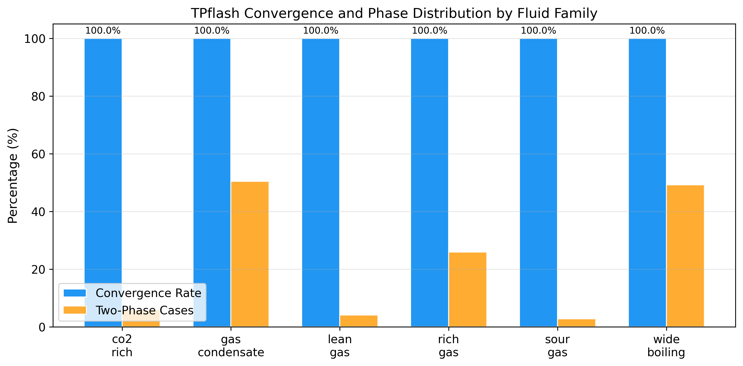
Fig. 1. TPflash convergence rate and two-phase case distribution across 6 fluid families (SRK EOS, 1664 total cases).

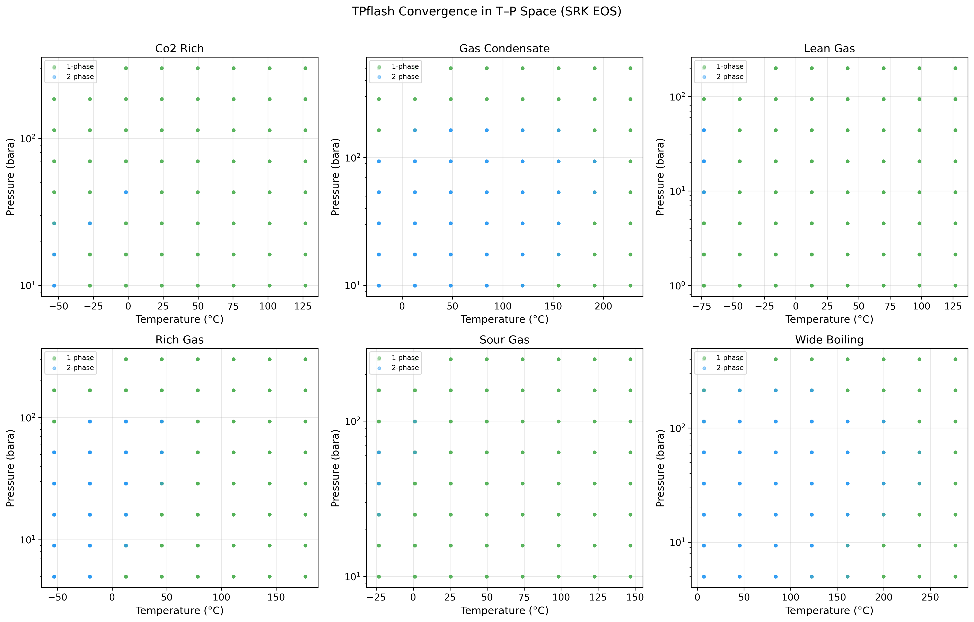
Fig. 2. Convergence success/failure mapped in temperature-pressure space. Green: single-phase converged; blue: two-phase converged; red cross: failed to converge.

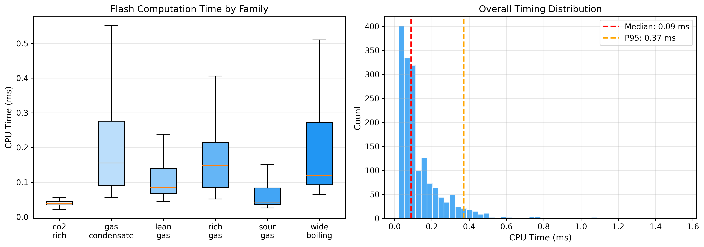
Fig. 3. CPU timing distribution: (left) box plots by fluid family; (right) overall histogram with median and 95th percentile markers.

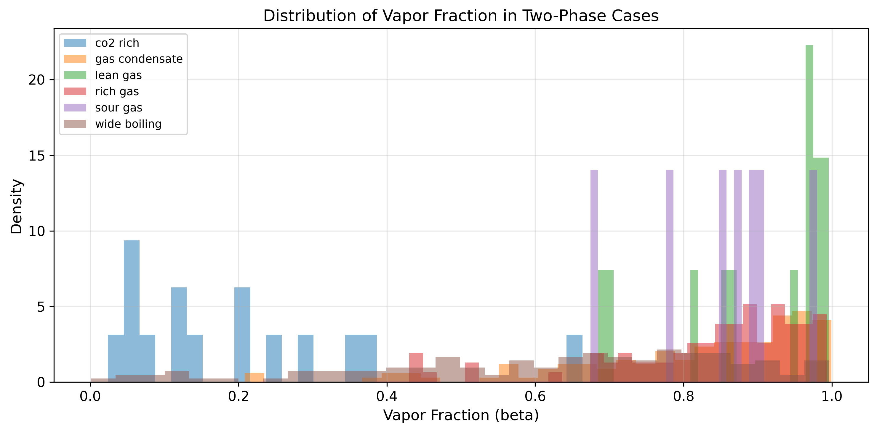
Fig. 4. Distribution of vapor fraction (beta) in two-phase cases by family.

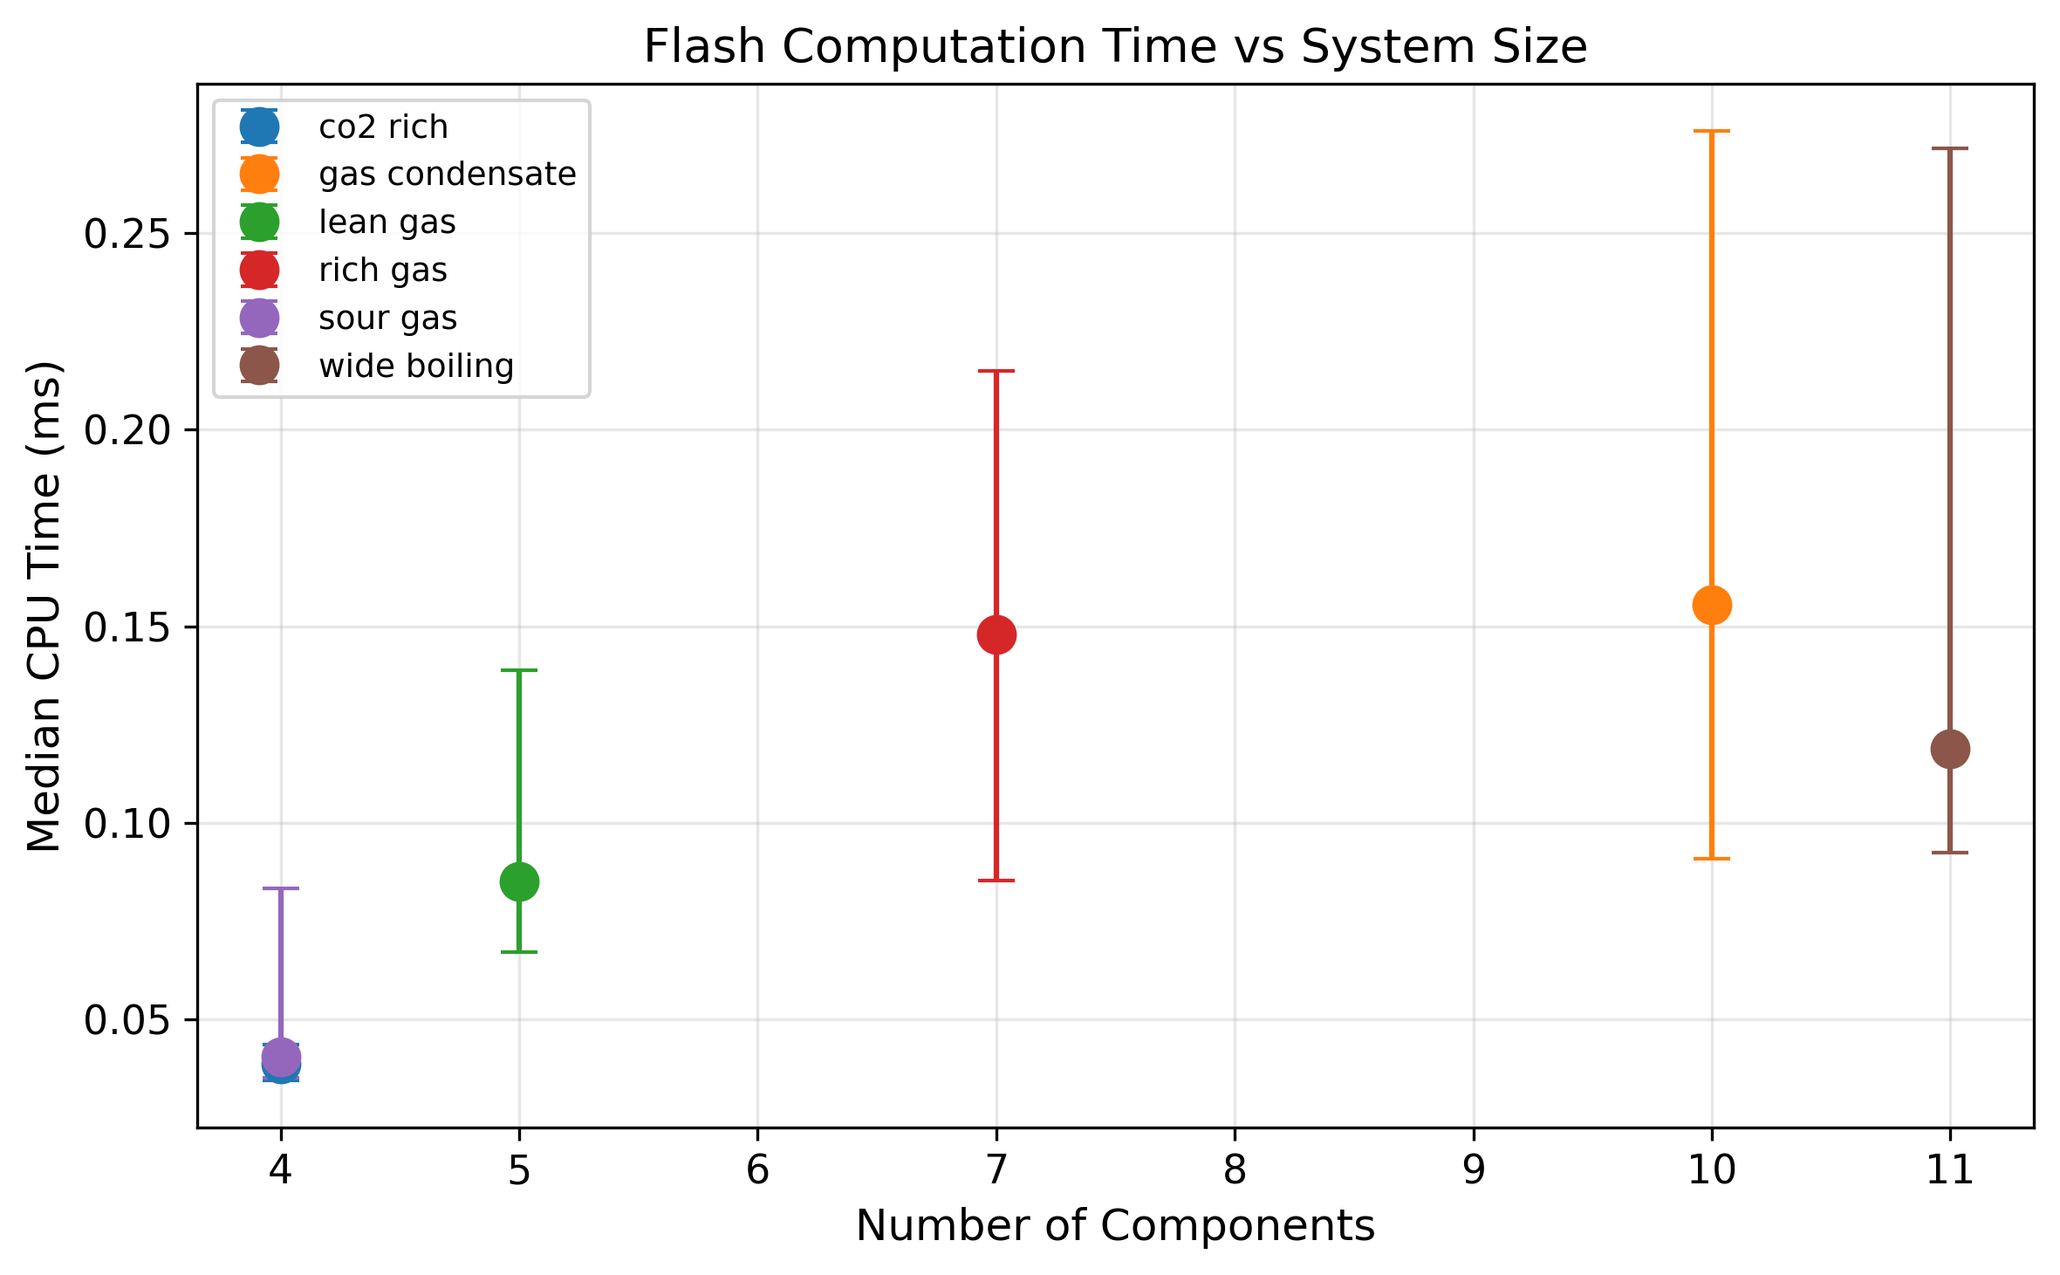
Fig. 5. Median flash computation time vs number of components, showing expected scaling with system size.

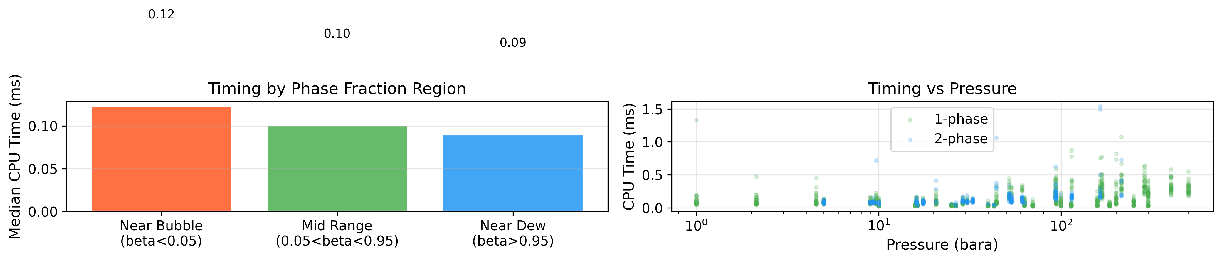
Fig. 6. Near-critical analysis: (left) timing by phase fraction region; (right) timing vs pressure colored by number of phases.

