# Oil stabilization process model

This document gives a description of how the oil stabilization process is implemented in NeqSim. The model is developed using the NeqSim process unit operations such as streams, separators, heat exchanger, etc. The model is set up according to the process flow diagram in Figure 1. The names of the unit operation (eg. “well stream”) given in the figure is used for accessing the unit operation from Java and Python code.

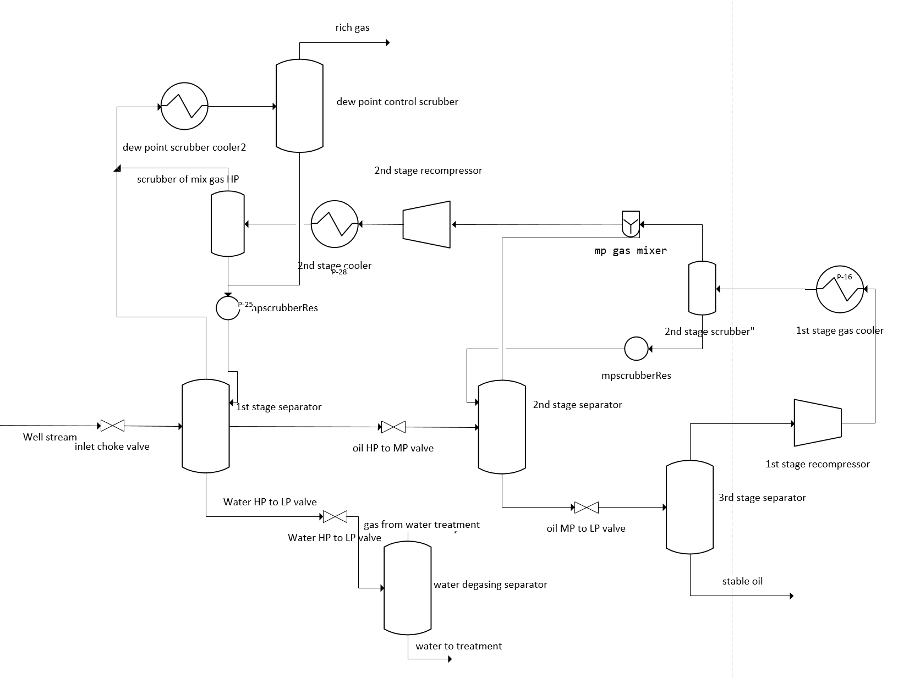

Figure 1 NeqSim offshore process flow diagram ([offshorePro.neqsim](https://github.com/equinor/neqsimprocess/blob/master/lib/offshorePro.neqsim" \o "offshorePro.neqsim))

The process is implemented in the Java code given in Apendix 1. The Java code sets up the process including all recycles. The process is converged according to the initial conditions set in the code. The process is saved in a file (eg. “[offshorePro.neqsim](https://github.com/equinor/neqsimprocess/blob/master/lib/offshorePro.neqsim" \o "offshorePro.neqsim)”), that can be opened and used for further calculations (in Java, Pyhon, Matlab etc.).

In Appendix 2 the offshore process is opened in Python, new input parameters are set and calculations are run. The calculations can be run in a single process or as a thread where multiple calculations can be run at the same time. When a calculation is run in a single process the program will wait for the process to converge before further calculations can be done.

# Appendix 1:

The following Java process script is used to set up the TEG process and store the process in the binary file [offshorePro.neqsim](https://github.com/equinor/neqsimprocess/blob/master/lib/offshorePro.neqsim" \o "offshorePro.neqsim) and sepproces.java.

<https://github.com/equinor/neqsimprocess/blob/master/src/neqsimprocess/oilgasprocess/sepproces.java>

# Appendix 2

Python process script

https://github.com/equinor/neqsimprocess/blob/master/example/offshoreSeparationProcess.py

To run the script:

1. Install the neqsim package in python. (pip install neqsim)
2. Download the sepprocess.neqsim file to your local computer (process files stored [here](https://github.com/equinor/neqsimprocess/tree/master/src/neqsimprocess/resour))
3. Modify input conditions and run calculations

The program can be run in the web browser using the Google Colab tool (without having to install any programs).

1. https://colab.research.google.com/github/equinor/neqsimprocess/blob/master/example/oilstabilizationprocess.ipynb