Online Analysis Instruments for Gas Quality Measurements in Statoil
dvDocno

Title:
 | Online Analysis Instruments for Gas Quality Measurements in Statoil
Document no.: |  |  | Contract no./project no.: |  |  |  | Filing no.:
dvDocno 200405260001 |  |  | dvProject |  |  |  | dvFileno
Classification: |  |  |  |  | Distribution:
dvClass1 |  |  |  |  | dvDistr
Distribution date: |  | Rev. date: |  |  | Rev. no.: |  |  | Copy no.:
 |  | dvRevDate |  |  | dvRevno
Author(s)/Source(s):
dvAuthor
Subjects:
Online analysis instruments for gas quality measurements.
Instrument theory, operational experience and statistics.
International standards related to gas quality.
Remarks:
Valid from: |  |  |  | Updated:
Responsible publisher: |  |  |  | Authority to approve deviations:
Techn. responsible: |  |  | Name: |  |  | Date/Signature:
Torbjørn Vegard Løkken
Responsible: |  |  | Name: |  |  | Date/Signature:
Even Solbraa
Recommended: |  |  | Name: |  |  | Date/Signature:
Arne Fredheim
Approved: |  |  | Name: |  |  | Date/Signature:
Sigbjørn Svenes

Table of contents

1 Summary 5
2 Introduction 6
3 Measurement principles and instruments 7
3.1 Water / water dew point 7
3.1.1 Impedance type sensors 8
3.1.2 Conductivity measurement in glycerol-salt mixture sensors 9
3.1.3 Piezoelectric sensor / hygroscopically-sensitive quartz crystal 10
3.2 Gas chromatography 11
3.2.1 Thermal Conductivity Detectors (TCD) 12
3.2.2 Flame Ionization Detectors (FID) 13
3.2.3 Flame Photometric Detector (FPD) 14
3.3 Sulphur 14
3.3.1 Lead Acetate Tape 14
3.3.2 Pulsed Ultra-Violet Fluorescence 16
3.3.3 High resolution UV technology 17
3.4 CO₂ - Non-Dispersive Infrared (NDIR) 17
3.5 Hydrocarbon Dew Point 19
3.5.1 Bovar 241 CE hydrocarbon dewpoint analyser 19
3.5.2 GC-analysis combined with phase envelop simulation 19
3.6 Oxygen 20
3.6.1 Electrochemical Sensor 20
3.6.2 Non-depleting Oxygen Cell with Electrolytic Oxygen Sensor 22
3.6.3 Sealed Electrochemical Cell 22
4 International standards related to gas quality 23
4.1 GCV and Wobbe Index determination 23
4.2 Water content and water dewpoint 24
4.3 Hydrocarbon dewpoint 25
4.4 Sulphur 25
5 Comments concerning each installation and instrument statistics 26
5.1 Installations 26
5.1.1 Kårstø 27
5.1.2 Kollsnes 27
5.1.3 Mongstad 28
5.1.4 Tjeldbergodden 28
5.1.5 Draupner 29
5.1.6 Sleipner 29
5.1.7 Veslefrikk / Huldra 29
5.1.8 Kvitebjørn 30
5.1.9 Gullfaks 30
5.1.10 Statfjord 30
5.1.11 Snorre 30
5.1.12 Heidrun 31
5.1.13 Åsgard 31
5.1.14 Norne 31
5.1.15 Kristin 32
5.1.16 Emden, Dornum, Zeebrugge and Dunkerque 32
5.2 Instruments in Statoil by category 32
5.2.1 Water dewpoint analysers 34
5.2.2 Gas chromatographs 35
5.2.3 Sulphur analysers 35
5.2.4 Carbon dioxide analysers 36
5.2.5 Hydrocarbon dewpoint analysers 36
5.2.6 Oxygen analysers 36
6 Acknowledgments 36
7 References 36
8 Complete information about analysis instruments by installation, contact persons and ISO standards 37
8.1 Appendix A – Detailed information about analysers and measurement instruments at Kårstø 37
8.2 Appendix B - Detailed information about analysers and measurement instruments at Kollsnes 37
8.3 Appendix C - Detailed information about analysers and measurement instruments at Mongstad 37
8.4 Appendix D - Detailed information about analysers and measurement instruments at Tjeldbergodden 38
8.5 Appendix E - Detailed information about analysers and measurement instruments at Draupner 38
8.6 Appendix F - Detailed information about analysers and measurement instruments at Sleipner 38
8.7 Appendix G - Detailed information about analysers and measurement instruments at Veslefrikk and Huldra 38
8.8 Appendix H - Detailed information about analysers and measurement instruments at Kvitebjørn 38
8.9 Appendix I - Detailed information about analysers and measurement instruments at Gullfaks 39
8.10 Appendix J - Detailed information about analysers and measurement instruments at Statfjord 39
8.11 Appendix K - Detailed information about analysers and measurement instruments at Snorre 39
8.12 Appendix L - Detailed information about analysers and measurement instruments at Heidrun 39
8.13 Appendix M - Detailed information about analysers and measurement instruments at Åsgard 39
8.14 Appendix N - Detailed information about analysers and measurement instruments at Norne 40
8.15 Appendix O - Detailed information about analysers and measurement instruments at Kristin 40
8.16 Appendix P - Detailed information about analysers and measurement instruments at Emden 40
8.17 Appendix Q - Detailed information about analysers and measurement instruments at Dornum 40
8.18 Appendix R - Detailed information about analysers and measurement instruments at Zeebrugge 40
8.19 Appendix S - Detailed information about analysers and measurement instruments at Dunkerque 41
8.20 Appendix T – List over contact persons 41
8.21 Appendix U – International standards (ISO) related to gas quality 41

Summary
The goal for this project was to obtain a complete overview of online analysis instruments for gas quality analysis in Statoil. This has to a large extent been accomplished. Feedback from contact persons has been, in general, very good. In some occasions mismatch between information gathered via information system for technical information and information received from support personnel or personnel at the installations was observed. In addition to information about which instruments that is found at each installation, also facts about each type of instruments have been acquired. Information from Kollsnes/Troll, Mongstad, Kårstø, Tjeldbergodden, Draupner, Heidrun, Norne, Åsgard, Kristin, Huldra, Veslefrikk, Kvitebjørn, Sleipner, Gullfaks, Statfjord, Snorre, Zeebrugge, Dunkerque, Emden and Dornum is included in this document.

Uncertainties relating how instruments have been counted have been difficult to address. Especially is this true for dew point analysers, where it can be difficult to be sure of whether it is the probes or the instruments that have been counted. Another important thing to notice is how one ranks the different instruments. An instrument’s score is subject to who gave the comment relating to experience, and poor performance can also be due to sampling system. Even if an instrument gives a good signal, the accuracy of that particular instrument can be difficult to judge.

It is intended that this document can be a part in exchanging operational experience between the different installations in Statoil, and also be a tool when considering purchasing new equipment.

A list over people, who have been contacted during this project, has been added to this document.

For each instrument category there are a couple of dominant instruments. Operational experience of same type instruments shows some variance between different installations. Many people who have provided information to this document has pointed out the great importance of having correct sample system to facilitate optimal performance of the instruments.

A trend in changing to more flexible instruments, and also instruments less prone to contaminations can be seen from the data collected. For KEP2005, Kristin and Snøhvit new type of dewpoint analysers have been chosen. For KEP 2005 a change from ABB to Siemens GCs are also seen.

Looking at each instrument category the dominant instruments are; For GCs the most frequently used is ABB PGC 2000, with increasing use of Siemens Maxum edII. Panametrics MIS1 is most common for water dewpoint analysis, but Ametek 3050-OLV is chosen for new projects and installations. Only one type of instrument dedicated to hydrocarbon dewpoint is in use, however at Kårstø for KEP2005 one of the new Siemens GCs (detailed analysis up to C10+) will be used to determine hydrocarbon dewpoint. For sulphur analysis Houston Atlas lead paper type is dominant. CO₂ measurements are done at 2 installations with IR instruments. While O₂ analysis is done at Åsgard, Heidrun and in Dunkerque, all being of electro-chemical cell type instruments. At Kårstø GCs are also used for CO₂ analysis, as well as H₂S, hydrocarbon dewpoint and water in nafta analysis.

Finally, this document is intended to be a dynamic document. This means that the document may be changed over time due to replacement of old or acquirement of new equipment in Statoil.

Introduction
An important factor in being able to process and transport gas efficiently is exact measurements and knowledge about the instruments used for measurements. Gathering experience regarding online analysis instruments can also be useful when purchasing new equipment. In addition, knowledge sharing throughout Statoil can help in the daily operation of such instruments and help make sure the right instrument is selected for the right task. With this in mind, the task of gathering information about analysis instruments in Statoil was undertaken.

This document includes information from Kollsnes/Troll, Mongstad, Kårstø, Tjeldbergodden, Draupner, Heidrun, Norne, Åsgard, Kristin, Huldra, Veslefrikk, Kvitebjørn, Sleipner, Gullfaks, Statfjord, Snorre, Zeebrugge, Dunkerque, Emden and Dornum. Visund will start producing gas from October 2005, but no information of choice of analysers has been registered or found. Specific information regarding Snøhvit has neither been registered.

The information in this document has been required from onshore personnel, technical and laboratory staff at the specific locations and through information systems for management of technical information (STID, AIM and PIM). Information about the different instruments has been obtained from producers, suppliers and from technical information systems used in Statoil.

Instruments are often replaced or upgraded and technical information systems are updated at different times, thus the information found in this document is not necessarily 100% accurate.

The project started by contacting personnel by telephone and/or e-mail. E-mails with a short description of the project were sent out. The e-mail also explained which instruments that were of interest, namely those measuring on gas quality parameters (calorific value, Wobbe index, hydrocarbon dew point, water dew point/water content, sulphur content (Total, H₂S, COS, mercaptans (methyl-/ethyl-/propyl-/...), odorants), CO, CO₂, N₂, O₂, H₂ and Hg). Pasted into the e-mail was a form that showed which kind of information that was requested.

In addition to all the information in this document, information (like datasheets, sales brochures, vendor information, etc) has been collected and is currently stored in an Arena database.

The summary gives an overview of the work that has been done. It gives a brief summary of the results and a general conclusion of the project and this report. The introduction explains what the projects intentions were, and how this was planned to be achieved.

Apart from the summary and this introduction, the report has 3 main chapters. Chapter 3, measuring principles and instruments, is divided into 6 sub-chapters. The sub-chapters address instruments measuring principles with focus on the types used in Statoil for GC-, water-, sulphur-, CO₂-, hydrocarbon dewpoint-, and O₂-analysis. In the gas chromatography chapter, the principles for the 3 most commonly used detectors are described. In the hydrocarbon dewpoint section, an alternative method by using GC-analysis followed by simulation of phase envelope is also described.

Chapter 4 gives an introduction to international standards in relation to analysis instruments.

Chapter 5 gives detailed information about instruments found at each installation. Information regarding operational experience is also presented in an easy to read table. It’s important to use the information in chapter 5 together with the more detailed information found in the appendices.

Detailed information for each installation together with contact persons are found in the appendices.

Measurement principles and instruments
This chapter has 6 main sections covering measuring principles for instruments that are used for analysis of water/water dew point, gas composition (GC), sulphur, CO₂, hydrocarbon dew point and O₂. Normally, only the most common instruments used in Statoil are described.

In general analysers used in Statoil operate online, and facilitate remote access in some way. The GCs used are normally accessible through LAN/Ethernet or for ABB’s instrument through Workstation/Vistanet. For some instrument probes can be located a considerable distance away from the analyser instrument itself, which again often can be remotely accessed from a normal PC. This is true for Panametrics dewpoint analysers.

Water content / water dew point
Several different types of humidity analysers are used in Statoil. Panametrics Moisture Image Series 1 (MIS 1) and the older Panametrics System 1, are the dominant analysers in Statoil as of today. For KEP2005, Kristin and Snøhvit a different type of analyser has been chosen, namely Ametek 3050-OLV. That analyser is based on a different measurement principle. In addition to the analyser principles mentioned in this section, there are also other types of humidity analysers. These will not be described since they are not frequently found in Statoil.

Impedance type sensors

Two types of sensors will be described in this section, namely the aluminium oxide sensor and the ceramic moisture sensor. Modern impedance dew point sensors are typically constructed using state-of-the-art thin and thick film techniques.

The most commonly used capacitor-based hygrometers are based on aluminium oxide (Al₂O₃), Panametrics MIS 1 being one.

The sensor consists of a layer of porous aluminium oxide deposited on a conductive substrate, and then coating the oxide with a thin film of gold (figure 1). The conductive base and the gold layer become the capacitor’s electrodes, forming what is basically an aluminium oxide capacitor. Moisture is transported quickly through the gold layer and equilibrates on the aluminium oxide pore walls, affecting the capacitance and resistive components of the device. Impedance changes can be directly related to moisture concentration at a set temperature and pressure.
Figure 1 – Layers in an Al₂O₃ sensor
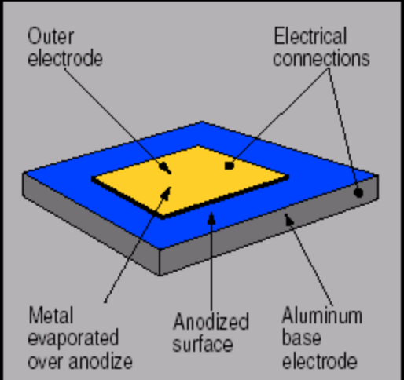

Construction an Al₂O₃ sensor is quite simple, complexity arises due to the fact that such sensors cannot be manufactured with great consistency and inter-changeability. The sensors also vary in degree of aging and hysteresis, and they require extensive calibration. Manufacturers, such as Panametrics, have calibration systems and per-aging routines such that the sensors maintain acceptable accuracy for process applications over an extended period of time.

Some of the aluminium oxide sensors advantages are rugged design; probes can be installed remotely and in process gases varying in temperature and pressure. However, monitoring of the operating condition and use of appropriate calibration are vital for accurate response. Since capacitor sensors are flow independent, they are useful for in-line measurements.

A big disadvantage of these kinds of sensors is the potential for decreased sensitivity over time. Hysteresis effects and drifts can also attribute to causes such as loss of sites for moisture absorption, trapping of water molecules within the Al₂O₃, and change in the structure of the porous alumina. Although some manufacturers guarantee 6 months stability period, at low moisture levels, drift may appear sooner and calibrations may also drift over time.

The following description is specific to Michell Instruments ceramic moisture sensor.
Figure 2 – Layers in impedance sensors
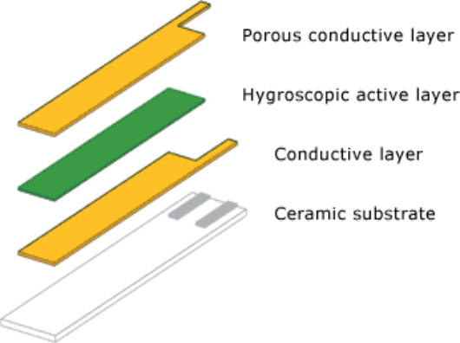

The active sensor layer is very thin - less than one micron (a millionth of a metre) and the porous top conductor that allows transmission of water vapour into the sensor is less than one thousand-millionth of a metre thick. Therefore the sensor responds very rapidly to changes in applied moisture, both when being dried (on process start-up) and when called into action if there is moisture ingress into a process.

To protect the sensor against contaminants it should be housed in a protective sintered stainless steel guard. The ceramic moisture sensor handles high gas pressures and also rapid changes in pressure, without damage. The sensor is constructed in such a way that virtually instantaneous pressurisation right up to the 30 MPa (300 bar) limit will not cause failure (according to Michell Instruments).

Conductivity measurement in glycerol-salt mixture sensors
The measurement of the instrument is based on the conductivity change of a glycerol-salt mixture. Hobré Instruments Hygromat 6002 represents this type of dew point analyser in Statoil. The following measurement principle is specific to the Hygromat 6002.

Measurement takes place by a sensor in a high pressure-measuring chamber with a total volume of approx. 30 cc. The flow rate through the chamber is controlled between 50- 100 Nl/hr. The sensor itself is exposed to the high-pressure gas, and responds to the water dew point of the gas at the operating pressure of the sensor.

The sensor itself consists of two stainless steel plates, separated by an insulation plate. Eight holes are drilled through one of the stainless steel plates and the insulation plate. The holes are partially filled with a conductive glycerol solution. Each hole behaves as an independent electrical resistor. By the absorption and desorption of the water into the glycerol an equilibrium is established between the water vapour pressure of the gas, and the water content of the solution.

With the change of the water vapour content of the glycerol solution the conductivity of the solution changes. This conductivity is measured with a frequency of 1 KHz, and takes place without electrolysis of the water.

To eliminate changes in the measurement caused by ambient or process gas temperature, the sensor is controlled at 30 ºC. This controlled temperature has a second advantage of avoiding the condensation of liquid hydrocarbon on the sensor.

The output of the Hygromat 6002 is in terms of water dew point at the operating pressure of the sensor. The reading is not affected by H₂S and/or CO₂. The gas composition and compressibility of the gas have no effect on the reading.

Advantages according to manufacturer:
- Less sensitive to contaminants compared to aluminium oxide sensors, due to lower impedance which makes it less sensitive to contamination by conductive materials
- Glycol traces does not result in loss of sensitivity to water. When exposed to traces of glycol the analyser remains the function of responding to an increase of the water dew point.

Piezoelectric sensor / hygroscopically-sensitive quartz crystal
An oscillating piezoelectric quartz crystal used for moisture analysis has been coated with thin film of a hygroscopic material. A piezoelectric crystal in a suitable oscillator circuit will oscillate at a frequency dependent on its mass. If the crystal has a stable hygroscopic film on its surface, the equivalent mass of the crystal varies with the mass of water sorbed in the film. Thus, the frequency of oscillation depends on the water in the film.

Measurements of the frequency changes relative to, normally, a second reference crystal that is not exposed to the gas stream. Typically, valves alternately direct the sample to one crystal and dry gas to the other on 30-s cycle. The oscillator frequencies of the two circuits are compared electronically, and the output is the difference between the two frequencies. The output is the representative of the moisture in the sample.

For the Ametek analysers used in Statoil, the piezoelectric sensors measures moisture by monitoring the vibration frequency changes of a hygroscopically-sensitive quartz crystal that is exposed alternatively to wet and dry gas.

For the Ametek analysers the sensor consists of a pair of electrodes, which supports the quartz-crystal microbalance (QCM) sensor. When voltage is applied to the sensor a very stable oscillation occurs. The faces of the oscillator are covered with a hygroscopic polymer. As the amount of moisture sorbed onto the polymer varies, the mass of the QCM changes, producing a corresponding change in the frequency of oscillation.

The measurement is accomplished by comparing sensor oscillation frequencies, when exposed to normal process gas, versus that when exposed to dried process gas. At continuous regular intervals, process and dried 'reference' gases alternately flow through a moisture-sensing chamber, or 'cell'. In sequence, the process sample gas is introduced and characterized, then the reference sample, and so on. The sensor's differential response is directly and uniquely related to moisture concentration in the process gas.

For accurate results at low moisture levels its essential that the dryer has high efficiency to provide a reliable zero. The amount of moisture absorbed on the sensor depends on temperature and pressure, thus it’s necessary to have control of these parameters for best repeatability and accuracy. Flow rate and differences in gas composition between sample and reference can also affect the accuracy. However for the Ametek analyser used in Statoil, uses dried process gas as reference such that the gas composition remains the same.

Since the amount of moisture absorbed by solid films depends on the film characteristics, periodic calibration is necessary.

Gas chromatography
Gas chromatography is a chromatographic technique that can be used to separate volatile organic compounds. A gas chromatograph (GC) consists basically of a flowing mobile phase, an injection port, a separation column containing the stationary phase, and a detector. The organic compounds are separated due to differences in their partitioning behaviour between the mobile gas phase and the stationary phase in the column.
Figure 3 - Simplistic figure of a gas chromatograph
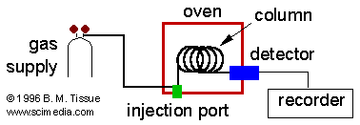

Mobile phases are generally inert gases such as hydrogen, helium, argon, or nitrogen. The injection port commonly consists of a rubber septum through which a syringe needle is inserted to inject the sample. The injection port is maintained at a higher temperature than the boiling point of the least volatile component in the sample mixture. For gas analysis a sample loop, ex. 250 μl volume, are commonly used. Since the partitioning behaviour is dependant on temperature, the separation column is usually contained in a thermostat-controlled oven. Separating components with a wide range of boiling points is accomplished by starting at a low oven temperature and increasing the temperature over time to elute the high-boiling point components. Most columns contain a liquid stationary phase on a solid support. Separation of low-molecular weight gases is accomplished with solid adsorbents.

GC columns are basically of two designs, packed or capillary. Packed columns are typically a glass or stainless steel coil (typically 1-5 m total length and 2-4 mm inner diameter), which is filled with the stationary phase. Capillary columns are thin fused-silica (purified silicate glass) capillary (typically 10-100 m in length and 250 µm inner diameter) that has the stationary phase coated on the inner surface. Capillary columns provide much higher separation efficiency than packed columns but are more easily overloaded by too much sample.

The great analytical strength of capillary gas chromatography lies in its high resolution. Capillary columns have more theoretical plates (a measure of column resolving power or efficiency) per meter as compared to packed columns, and since they have less resistance to flow they can be longer than packed columns. This means that the average capillary column (30 meters long) has approximately 100,000 theoretical plates while the average packed column (3 meters) has only 2500 plates. However with this separation power comes some limitations. Capillary columns, because they have smaller diameters (0.05 to 0.53 mm) than packed columns (2 to 4 mm), require relatively specialized injectors and ancillary flow and pressure controllers. Capillary column require a smaller amount of sample than packed columns. While the average sample mass of each component in a mixture that is separable by packed column GC can be in the microgram range (10⁻⁶ grams) per injection, capillary columns routinely only handle 50 nanograms (10⁻⁹ grams) of a particular component or less.

After the components of a mixture are separated using gas chromatography, they must be detected as they exit the GC column. The thermal-conductivity (TCD) and flame-ionization (FID) detectors are the two most common detectors on commercial gas chromatographs. The requirements of a GC detector depend on the separation application. For example, one analysis might require a detector that is selective for chlorine-containing molecules; another analysis might require a detector that is non-destructive so that the analyte can be recovered for further spectroscopic analysis.

Table 1 - Comparison of possible detectors in some GCs used in Statoil
Producer &  Model | ABB  PGC 2000 | Daniel  Model 500 | Siemens  Maxum II
Detectors available  (Multiple detector combinations are available) | TCD  FID  FPD  Inter-column TCD  3rd party detector possible | TCD  FID  FPD | TCD  FID  FPD  ECD  HID  ELCD
TCD - Thermal Conductivity Detector; FID - Flame-Ionization Detector; FPD - Flame Photometric Detector; ECD – Electron Capture Detector; HID – Helium Ionization Detector; ELCD – Electrolytic Conductivity Detector

Thermal Conductivity Detectors (TCD)
In the NORSOK standard I-104 Fiscal measurement systems for hydrocarbon gas (Rev. 2, June 1998), it is stated that chromatograph shall use thermal conductivity detector.

A TCD detector consists of an electrically heated wire or thermistor. The temperature of the sensing element depends on the thermal conductivity of the gas flowing around it. Changes in thermal conductivity, such as when organic molecules displace some of the carrier gas, cause a temperature rise in the element, which is sensed as a change in resistance. The TCD is not as sensitive as other detectors but it is universal, non-specific and non-destructive.
Figure 4 - Schematic of a bridge circuit for TCD detection
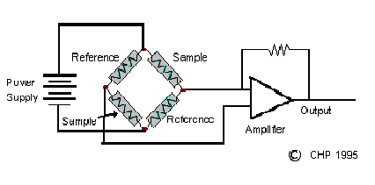

Two pairs of TCDs are used in gas chromatographs. One pair is placed in the column effluent to detect the separated components as they leave the column, and another pair is placed before the injector or in a separate reference column. The resistances of the two sets of pairs are then arranged in a bridge circuit.

Flame Ionization Detectors (FID)
A FID consists of a hydrogen /air flame and a collector plate. The effluent from the GC column passes through the flame, which breaks down organic molecules and produces ions. The ions are collected on a biased electrode and produce an electrical signal. The FID is extremely sensitive with a large dynamic range. FID detects only components with H-C bonding. This is often a disadvantage, since it’s necessary to use the much less sensitive TCD to detect O₂, N₂, CO₂, H₂S and so forth. Another disadvantage is that it destroys the sample.
Figure 5 - Schematic of FID
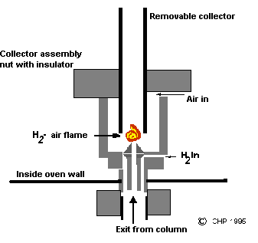

Flame Photometric Detector (FPD)
The FPD is used to detect sulphur compounds (e.g. H₂S, COS, SO₂, CS₂, and mercaptans).
The FPD provides a hydrogen rich flame where sulphur compounds are reduced to the elemental S2 species, which produce a blue chemiluminescent emission in the visible light spectrum. The blue light emission is passed through a narrow band optical filter to the photomultiplier tube. An electrometer and interface board further amplifies the signal from the photomultiplier tube. To minimize condensate build-up in the detector, the FPD block is typically maintained above 100° C. The photomultiplier tube housing is maintained at a cooler temperature to extend its service life.

The intensity of the blue light emission is approximately proportional to the square of the sulphur concentration in the flame. In some applications, a small amount of methyl mercaptan (2 to 5 ppm) is continuously added to the FPD air to bias the output level upward to the linear portion of the output curve. Generally, a permeation device is used to provide a consistent addition of methyl mercaptan to the FPD air. A small sample size is also used to ensure operation in the linear portion of the curve. The FPD is available with a square root extraction option that eliminates the need for sulphur addition.

Hydrocarbons entering the detector have a quenching affect causing false or real flameouts. If a component of interest and a hydrocarbon peak elute at the same time, erroneous readings can result. Large hydrocarbon peaks can cause a gradual build-up of carbon deposits on the detector wall and the quartz window. As these deposits reduce the amount of light entering the photomultiplier tube, detector sensitivity decreases. Valve and column arrangements should be used to minimize the amount of hydrocarbon materials entering the FPD detector.

Sulphur
There are many types of instruments available that detects various sulphur compounds. The absolute most common way of performing this analysis in Statoil is by “paper tape” based instruments. However, at Kårstø GCs with FPD detectors are used and in Dunkerque special GCs with electro-chemical detectors are applied. Mongstad is the only place where PUVF type analysers are in operation. At Mongstad UV type analysers are also found.

Lead Acetate Tape
Most sulphur measurements in Statoil are done with instruments that use lead acetate tape (LAT). Other “paper tape” based analysers are also used in Statoil, with varying tape type.

“Paper tape” in the context of toxic gas monitoring implies the use of the colorimetric principle. This is where a chemically impregnated carrier (the tape) reacts to the presence of the target gas/substance with a colour reaction. Litmus paper is a well-known example of this principle. Instruments, on the other hand, actively sample by pumping a measured volume of the target gas through the tape. In both applications the stain intensity is used to determine the dose, or concentration, of the monitored atmosphere. With badges, stain intensity is commonly judged by eye against calibrated colour references (a ‘colour wheel’ or dose estimator). In an instrument, accurate assessment of stain density is obtained by using an optical colorimeter, which measures the light reflected off the stain, and compares it to light reflected off an unstained reference area.
Figure 6 – Principle of LAT analysers
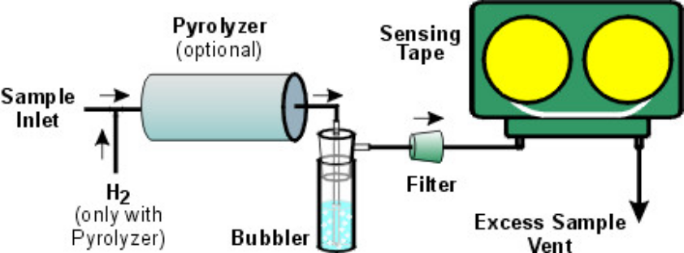
LAT is a well-established method that can be used for all total sulphur applications. Since the detector is generally linear over a short distance (one order of magnitude), it is best suited to very low-level measurements, below 1 ppm.

The chemistry is based on detection of hydrogen sulphide (H₂S). Sulphur-containing molecules in the sample stream are reduced to H₂S, either directly or after being oxidized to SO₂. The H₂S is passed through a bubbler for moisturization and then presented to a paper tape impregnated with lead acetate. H₂S in the presence of water reacts with the lead acetate to form lead sulphide. Lead acetate is white and lead sulphide is black. This forms a stain on the tape, which is measured with a precision colorimeter. H₂S is also a very stable molecule, making this method robust. The key factors in making lead acetate tape a simple and reliable analyser are the pyrolysis system, the choice of illuminating wavelength in the colorimeter, and temperature control of the tape and bubbler.
The pyrolysis system must equally convert all sulphurs contained in the sample stream to H₂S, and convert the remainder of the stream to CO, CO₂ and water. Unequal sulphur conversion can result from failure to vaporize high boiling point sulphur compounds or failure to break down all sulphur compounds. Failure to convert all hydrocarbons in the sample stream will not cause interferences. In fact, lead acetate has no known interferences. This situation will cause coke formation that acts to absorb H₂S, also causing errors. These problems can be prevented by pre-mixing the sample at a temperature sufficient to vaporize all hydrocarbons and sulphur compounds, and feeding the fuel-air mixture to the pyrolyzer at an even rate, avoiding overloading the pyrolyzer with hydrocarbons. The pyrolyzer should be kept at a temperature sufficient to break down all sulphur compounds without the use of a catalyst (1100° C).
Lead sulphide is a black crystal formation on the surface of the white tape impregnated with a white chemical, lead acetate. As the lead sulphide layer is deposited, additional H₂S must permeate through the first layer to reach lead acetate below. A short wavelength illumination source (blue light) is reflected from the surface and is thus more sensitive and faster to respond to small amounts of stain. A longer wavelength (red or IR) will penetrate further into the tape and thus “see” later-forming stains. This makes the longer wavelength more linear but less sensitive. It is important to match the illumination source with the application when using this type of analyser.
The chemical reaction that takes place on the tape is sensitive to temperature. Due to moisture absorption and other factors, the rate of reaction is a function of the temperature of the bubbler and of the tape. A temperature controlled tape deck housing eliminates this problem.

Pulsed Ultra-Violet Fluorescence
Pulsed Ultra-Violet Fluorescence (PUVF) is a method that is best suited to sulphur in fuels and total sulphur product quality applications in ppb to ppm levels. This type of analyser is found at Mongstad.
Figure 7 – Schematics of PUVF
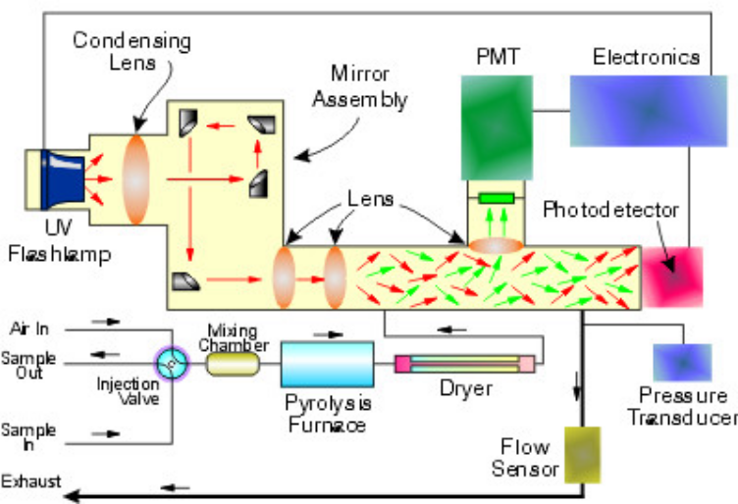

Since the detector is inherently linear over at least four orders of magnitude, PUVF is a good option when wide dynamic range is required. The chemistry is robust and the pyrolysis method required is simple. An analyser using this detection technology is low maintenance and is easy to apply to a wide range of applications.

PUVF’s strength is that it is based on simple chemistry. Sulphur-containing molecules in the sample stream are oxidized to SO₂. The SO₂ is excited with a specific wavelength of UV light. Excited SO₂ decays, emitting a second specific wavelength of light. A photomultiplier tube detects this light through an optical filter. SO₂ is a very stable molecule, making this method robust. The key factors in making PUVF a simple and reliable analyser are the pyrolysis system and the handling of combustion by-products.
The pyrolysis system must equally convert all sulphurs contained in the sample stream to SO₂, and convert the remainder of the stream to CO, CO₂ and water. Unequal sulphur conversion can result from failure to vaporize high boiling point sulphur compounds or failure to break down all sulphur compounds. Both of these conditions cause erroneous readings. In addition, failure to convert all hydrocarbons in the sample stream will cause errors since any that are unconverted will act as interference. These problems can be solved as described in section 2.3.1 Lead Acetate Tape.
Combustion by-products (water, CO and CO₂) can interfere with UV Fluorescence detectors. To prevent these compounds from interfering, a xenon flash lamp and a system of filtering mirrors to tune the excitation light to a wavelength that excites SO₂ can be used. Another way of solving the problem is to separate the pyrolysis output with a chromatographic column and heart-cut valve to isolate SO₂, preventing potentially interfering compounds from entering the detector.

High resolution UV technology
Some of the analysers operated by Statoil use high resolution UV technology in a dual beam with multiple wavelength configurations for the analysis of sulphur containing components. Resolution better than 0.02 nm is provided by high intensity, line source lamps. These sources emit at a fixed wavelength providing great measurement stability, and emit low total power removing the potential for sample photolysis. The high resolution enables linearity over a wide dynamic range (According to manufacturer, less than 1% deviation over 4 to 5 orders of magnitude) that, in turn, leads to simple, robust data analysis. A six-position filter wheel enables one reference and five measure wavelengths.
The dual-beam configuration, combined with the reference measurement, ensures low noise performance with minimal baseline and span drift.

UV measurements do not suffer from H₂O and CO₂ interference, as these species are transparent in the UV. This greatly simplifies sample handling. The sample cell and all components in contact with the sample are heated above the dew points of all gases in the sample stream. This results in a simpler and more accurate calculation of gas concentrations, requiring no corrections for condensed and dissolved components. It also results in a simpler analytical system, as there is no need for sample drying or conditioning. The analysers have built-in zero and span calibration and three-zone temperature control.

CO₂ - Non-Dispersive Infrared (NDIR)
Many gaseous compounds absorb infrared wavelengths to some degree. The degree of absorption at specific wavelengths depends on molecular structure and concentration. There are two common detectors for non-dispersive infrared analysers. These analysers normally have two beams of radiation, an analysing and a reference beam.

One type of detector consists of two gas-filled cells separated by a diaphragm. As the amount of infrared energy absorbed by the detector gas in one cell changes, the cell pressure changes. This causes movement in the diaphragm, which in turn causes a change in capacitance between the diaphragm and a reference electrode. This change in electrical capacitance is measured as the output.

The second type of detector consists of two thermopiles or two bolometers, one in each of the two radiation beams. The infrared radiation absorbed by the detector is measured by a differential thermocouple output or a resistance-thermometer (bolometer) bridge circuit.
Figure 8 - Schematic representation of the operating principle of the Maihak Unor analyser
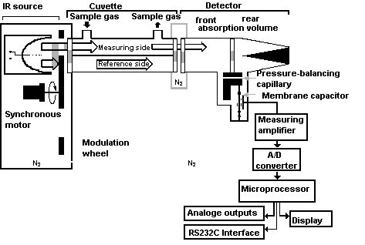

With gas-filled detectors, a chopped light system is normally used in which one side of the detector sees the source through the analysing beam and the other side the reference beam, alternating at a frequency of a few hertz.

At Sleipner the ABB Vista 3501 IR Process Photometers are used. The following description is for the newer ABB IR model PIR3502.

The PIR3502 Process Photometers optical path consists of an IR source, a brushless chopper motor, a multi-channel filter wheel, lenses, cell with windows, and a solid state IR detector, (See figure 9). The brushless chopper motor rotates the multi-channel filter wheel reference and measure filters, alternately and continuously, into and out of the optical path. The lenses, L1 through L4, focus and collimate the source radiation through the sample cell path to the detector. On a multi-channel photometer, a reference wavelength filter is chosen where the stream components have little or no absorbance. The measure wavelength or wavelengths are chosen where the measured components have absorbance. The microprocessor will then use matrix algebra and apply the proper response factor to each filter to eliminate interferences on the desired component and convert the absorbance to a component concentration.
Figure 9 – Schematic representation of the operating principle of the ABB analyser
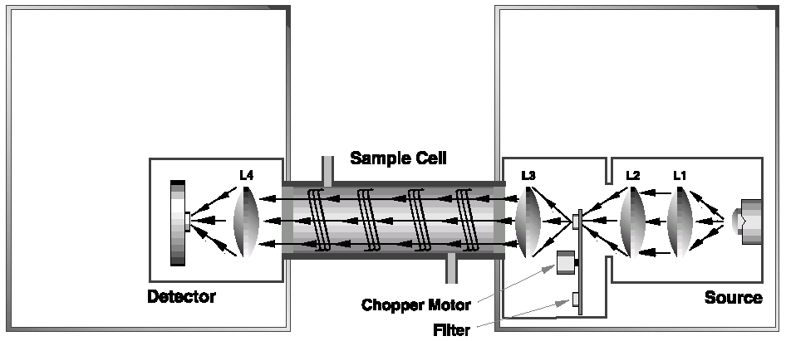

Hydrocarbon Dew Point
This chapter mainly give information about the type of hydrocarbon dewpoint analyser found at Kollsnes, however chapter 3.5.2 gives a brief description of an alternative method using a gas chromatograph.

Bovar 241 CE hydrocarbon dewpoint analyser
The hydrocarbon dew point analyser used in Statoil is from Bovar 241 CE Western Research instrument from Ametek. The 241 CE has according to Ametek, the possibility to detect and differentiate between water and hydrocarbon condensates. The following theory for the description of the measuring principle is taken mainly from the operating manual supplied with the instruments.
Figure 10 – Measuring cell of the Bovar 241 CE
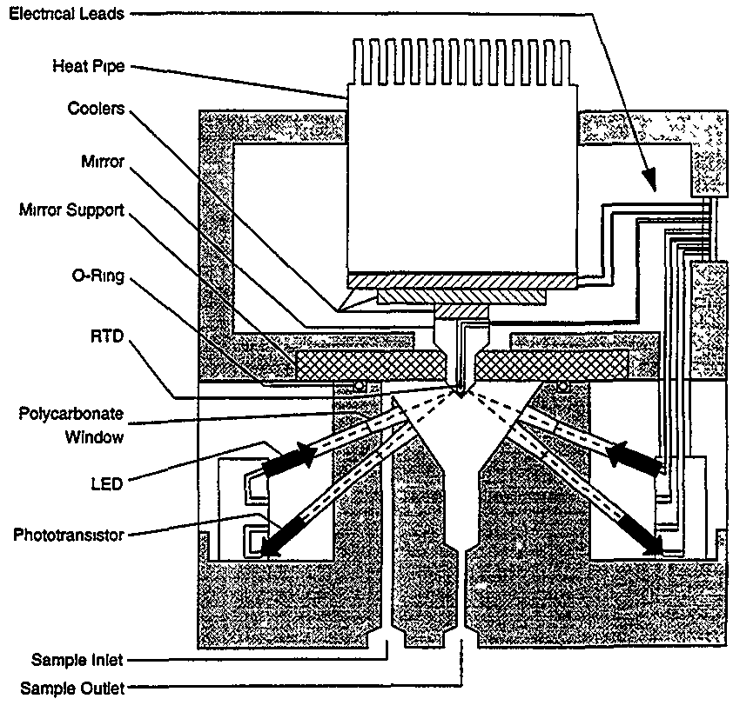

The mirror in the measuring cell has two plane surfaces, which are exposed to the gas sample. One plane is a polished, reflective surface used to detect the condensation of water. The other plane is a rough, black surface used to detect the condensation of hydrocarbons.

Inside the mirror close to the two plane surfaces is a resistance temperature device (RTD). The RTD is used by the micro-controller to monitor and control the mirror temperature. The mirror is mounted in a plastic support plate to give mechanical strength for containing the pressurized gas sample and poor thermal conductivity for thermally isolating the mirror.

GC-analysis combined with phase envelop simulation
An indirect approach to determine hydrocarbon dewpoint (HCDP) in natural gas involves the use of gas chromatographic analysis, from which the gas composition is found. The gas composition is then an input to an equation of state (EOS) to calculate the HCDP at the particular temperature or pressure of interest. The development of this approach depend on the development of several technologies: gas chromatography, equation of state models, and computing software and hardware.

Various computer programs are capable of calculating the hydrocarbon dewpoint temperature at various pressures. The accuracy of the calculated hydrocarbon dewpoint temperature depends on the calculation method used, the accuracy of the gas composition entered into the computer program and “heavy” (C6+) fractions.

The hydrocarbon dewpoint for a particular gas changes with temperature and pressure. Phase diagrams are therefore useful tools since they model the phase behaviour of a hydrocarbon mixture. Phase diagram illustrates the change in dewpoint and bubble point temperatures with changes in the gas pressure. In Statoil the program PVTsim is often used for to obtain phase diagrams.

For KEP2005 Siemens Maxum ed II GC will be used to determine hydrocarbon dewpoint.

Oxygen
Only at Heidrun, Åsgard and Dunkerque is oxygen analysis on natural gas performed. At the 3 installations different type of instruments are used, but all use a type of electro-chemical cell. Although O₂ analysis on natural gas is only performed at the mentioned locations, the instruments are also in use at other installations for somewhat different purposes.

Electrochemical Sensor
Electrochemical sensors are essentially fuel cells composed of noble metal electrodes in an electrolyte. The electrolyte is normally an aqueous solution of strong inorganic acids. When a gas is detected the cell generates a small current proportional to the concentration of the gas.
In its simplest form, an electrochemical sensor consists of a diffusion barrier, a sensing-electrode, a counter-electrode and an electrolyte. In an environment free of chemically reactive gases, oxygen diffuses into the cell and adsorbs on both electrodes.

A third electrode is often used as a reference electrode. This electrode has a stable potential from which no current is drawn. It is used to eliminate interference from side reactions with the counter-electrode.

The electrochemical cell typically consists of a casing containing an electrolyte gel and three electrodes. The top of the casing has a membrane which can be permeated by the gas sample. The electrodes are carefully constructed to provide maximum sensitivity and long life, through an electrode construction, which allows more surface area. This allows a larger signal, a quicker response and permits a smaller volume of electrolyte to provide the same life available from large sensors. Each cell is constructed using special filters, electrodes, and electrolytes to make the cell as specific as possible. Electronics should provide appropriate bias current to eliminate interfering gas sensitivity.
Because electrochemical reactions, like all chemical processes, are temperature dependent, electrochemical sensors should incorporate a sensitive temperature sensor, which the electronics use to compensate for temperature variations.

Interfering gases, often called cross-sensitivities, are gases other than the target gas that will cause the cell to react.

Blocking is a condition that causes the cell to function poorly or not at all until the condition is removed. Some of the most common blocking mechanisms for electrochemical cells are:
- Freezing the electrolyte. As the temperatures of the cell decreases, the chemical reaction which the user sees as a signal decreases. At some point the cell current stops.
- Oxygen depravation. If the oxygen supplied to the counter-electrode is cut off, the current cannot be sustained.

Oxygen deprivation can occur through a number of mechanisms, such as:
- The cell is exposed to large concentrations of a reactive gas over a sustained period.
- The cell is flooded with one or more reactive gases.

When measurements need to be made in a low oxygen environment, a separate access of air to the counter-electrode must be assured. Because of electrochemical sensor’s need for an adequate supply of oxygen, it is often recommended that the oxygen content of air be sampled first before relying on these sensors for safety. If the cell's diffusion barrier (or flame arrestor) becomes clogged or coated the normal supply of oxygen (as well as signal gas) may be cut off.
Vapour condensation on the cells diffusion barrier (or flame arrestor) can also effectively cut off the oxygen (as well as the signal gas). If the sensor temperature is lower than the atmosphere temperature, it is likely that condensation will occur. To prevent this the cell may need to be heated or the air being circulated to the cell may need to be dried.

Gases or vapours, which are electro-chemically reducible at the cathode, will cause a reverse reaction in sensor chemistry, which could mask the normal operation of a sensor designed to detect an oxidizable gas. The same problem will occur if an oxidizable gas were to cause a reaction in a sensor designed to detect a reducible gas.

A poison blocks and/or degrades the sensor’s operation on a permanent basis.
Some poisoning mechanisms are.
  - High concentrations of solvent vapours that attack the plastic housing or filters.
  - Continuous operation at high temperatures (usually above 40ºC) will not only cause the electrolyte to dry out, but could cause the electrolyte to boil.
  - Sudden pressure changes can cause more gas to be forced into the sensor producing a current transient.
  - Continuous operation below 15% or above 90% relative humidity can change the water content of the electrolyte affecting the operation of the cell

Some advantages of electrochemical cells:
  - Very linear
  - Good selectivity
  - Excellent repeatability and accuracy

Some disadvantages
- Limited temperature range and sensitive to changes in temperature
- Sensitive to electrical noise
- Limited storage life

Non-depleting Oxygen Cell with Electrolytic Oxygen Sensor
In Statoil, the instrument that uses a non-depleting oxygen cell with electrolytic oxygen sensor is Delta F sensor from Panametrics. The measuring principle given in this section is specific to the Delta F sensor.

The sample gas diffuses through a diffusion barrier to the cathode, which is in contact with the electrolyte solution. At the cathode, oxygen is reduced to hydroxyl ions. With electrical potential provided by the Panametrics analyser and assisted by the potassium hydroxide electrolyte, the ions migrate to the anode where they are oxidized. The current generated within the sensor cell, which is directly proportional to oxygen concentration, is then measured, analysed and displayed in proper units by the Panametrics analyser.

Sealed Electrochemical Cell
The oxygen sensor used in the Model 3000T series is a micro-fuel cell (MFC) designed and manufactured by Analytical Instruments. It is a sealed plastic disposable electrochemical transducer.
Figure 11 - Cross section of a micro-fuel cell
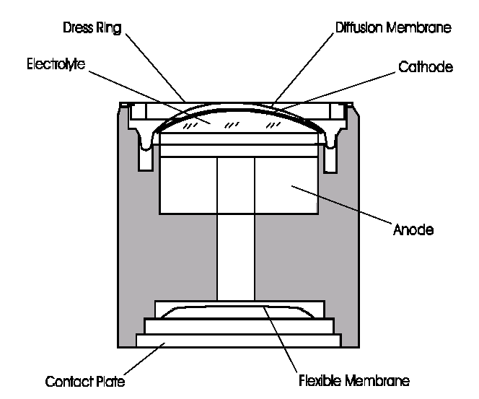

The active components of the MFC are a cathode, an anode, and the 15% aqueous KOH electrolyte in which they are immersed. The cell converts the energy from a chemical reaction into an electrical current in an external electrical circuit.

The MFC is a cylinder that is 3,175 cm in diameter and 3,175 cm thick. It is made of a particularly inert plastic, which can be placed in most environments or sample streams. It is effectively sealed, although one end is permeable to oxygen in the sample gas. The other end of the cell is a contact plate consisting of two concentric foil rings. The rings mate with spring-loaded contacts in the sensor block assembly and provide the electrical connection to the rest of the analyser.

At the top end of the cell is a diffusion membrane of Teflon, whose thickness is very accurately controlled. Beneath the diffusion membrane lays the cathode with a surface area almost 4 cm². The cathode has many perforations to ensure sufficient wetting of the upper surface with electrolyte, and it is plated with an inert metal.

The anode structure is below the cathode. It is made of lead and has a proprietary design, which is meant to maximize the amount of metal available for chemical reaction. At the rear of the cell, just below the anode structure, is a flexible membrane designed to accommodate the internal volume changes that occur throughout the life of the cell. This flexibility assures that the sensing membrane remains in its proper position, keeping the electrical output constant.

The entire space between the diffusion membrane, above the cathode, and the flexible rear membrane, beneath the anode, is filled with electrolyte. Cathode and anode are submerged in this common pool. They each have a conductor connecting them to one of the external contact rings on the contact plate, which is on the bottom of the cell.

International standards related to gas quality
Parallel to the work of gathering information regarding analysis instruments, international standards related to gas quality was also studied. International standards are widely used within Statoil, manufacturers of analysis instruments and other companies in the oil and gas industry. International standards such as ISO, gives amongst other things guidelines to common ways of operating, calibrating and how to calculate values related to gas quality parameters.

ISO standards that have been adopted by British Standards (BS) are available to all in Statoil through BS Online, after a short registration procedure. All standards presented in this paper are available, with a few exceptions, through BS Online. A list over ISO, ASTM, NORSOK and some other standards related to gas quality with standard numbers, publication year and abstracts are found in appendix U – 8.21. A table containing information regarding ISO standards and drafts related to gas quality is found in the attached document below.



GCV and Wobbe Index determination
When considering GCV and Wobbe index (WI) determination, there are some important international standards to consider. ISO 6976 is used widely in Statoil to give guidelines for calculation of calorific values, density, relative density and WI from composition. This standard gives method for calculations when the composition of the gas by mole fraction is known. The ASTM D1945 standard is used, amongst other installations, at Sleipner to give a method that covers the determination of the chemical composition of natural gas. The ASTM D1945 specifies a method for determination of composition of natural gas within the range given in table 2.
Table 2 - Components covered by ASTM D 1945
Component | Mol %
Helium | 0,01 to 10
Hydrogen | 0,01 to 10
Oxygen | 0,01 to 20
Nitrogen | 0,01 to 100
Carbon dioxide | 0,01 to 20
Methane | 0,01 to 100
Ethane | 0,01 to 100
Hydrogen sulphide | 0,3 to 30
Propane | 0,01 to 100
Isobutane | 0,01 to 10
n-Butane | 0,01 to 10
Neopentane | 0,01 to 2
Isopentane | 0,01 to 2
n-Pentane | 0,01 to 2
Hexane isomers | 0,01 to 2
Heptanes+ | 0,01 to 1

Another well-known standard is the NORSOK standard I-104 Fiscal measurement systems for hydrocarbon gas. This standard describes functional and technical requirements for fiscal measurement systems for gas. Both this NORSOK standard and the ASTM D 1945 demands the use of thermal conductivity detector to be used in gas chromatography.

The ISO 6976 gives methods for calculating calorific value on a molar, a mass and a volumetric basis. In addition, it also gives methods for calculating compression factor, relative density, density and Wobbe index.

Other standards of interest related to calculations of values such as heating value are:
- GPA 2172 - Calculation of Gross Heating Value, Relative Density and Compressibility Factor for Natural Gas Mixtures from Compositional Analysis.
- ASTM 3588 - This practice covers procedures for calculating heating value, relative density, and compressibility factor at base conditions (14.696 psia and 60°F (15.6°C)) for natural gas mixtures from compositional analysis.
- ISO 6974 - 1 to 6 Specifies gas chromatographic methods for the quantitative determination of natural gas constituents.

Water content and water dewpoint
Regarding water content there is one important standard, namely the ISO 11541. This standard describes a method for determination of water content at high pressure. In addition the draft standard ISO/DIS 18453 provides a mathematical relationship between water content and water dewpoint.

The ISO 6327 describes cooled surface condensation hygrometers for determination of water dewpoint. The ISO 10101 part 1- 3 describes water determination by Karl Fisher, titration and coulometric procedure.

Hydrocarbon dewpoint
The ISO 6570 describes two gravimetric methods for the determination of the potential hydrocarbon liquid content in natural gas.

Additional information is found in the ISO standard information section of this document.

Sulphur
In determination of sulphur compounds in natural gas, the ISO 6326-1:1989 is very useful. This standard gives a brief list of standardized methods that can be used for sulphur determination. The list is shown in table 3. In addition there exist a draft standard, which is a revision of ISO 6326-2:1981, that describes determination of sulphur compounds by gas chromatography.

Table 3 - Methods for the determination of sulphur compounds in natural gas
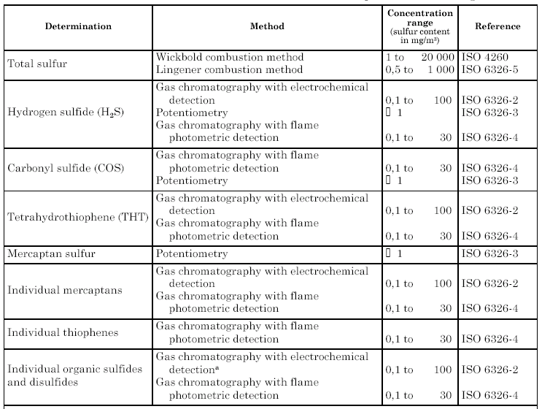

Comments concerning each installation and instrument statistics
This report focuses on instruments for gas quality measurements. Statistics over the different type of analysis instruments and where they are located are found in Table 4 and figure 12, respectively. Additional information about specific instruments, or instruments at specific locations are found in sub-sections in this chapter and in the appendixes. In gathering information from the different locations, the focus has been on operational experience, calibration- and maintenance routines. Operational experience has been summarized for each instrument in Table 4.

In this chapter comments to each installation in respect to what kinds of instruments that are in operation, are written. In these sub-section brief comments to instruments that have been reported, but are not used in relation to the gas quality parameters are also given.

Installations
Figure 12 – Map over installations
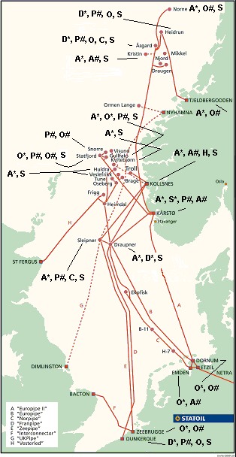

What type of instruments that are found on each installation, is shown in the figure to the right. More detailed instrument information such as manufacturer and model, are found in Table 4. Mongstad is not marked on the map, because no instrument measuring directly on gas has been reported. However information about the instruments at Mongstad is found in Table 4 and the appendixes.

The different instruments are indicated in the figure as follows:

Gas chromatographs = X*, where X equals A for ABB, S for Siemens, D for Daniel and O for others.

Water dewpoint = X#, where X equals P for Panametrics, A for Ametek and O for others.

Instruments for sulphur analysis are marked S, CO₂ marked C, O₂ marked O and hydrocarbon dewpoint marked H.

Kårstø
Kårstø has the largest amount and the largest diversity of analysers. A large number of both GCs and dew point analysers are found at Kårstø. ABB gas chromatographs have been dominating, however for KEP 2005 Siemens Maxum Ed II has been selected.
Some of the reasons for choosing Siemens GCs for KEP 2005 are that they use an open network, possibility for parallel analysis and faster analysis than the ABB GCs. In addition there have been a lot of problems with the ABB 2100 GCs, they have longer analysis time, higher maintenance and they operate in own network. It’s also worth noticing that the 3100 series ABB GCs are connected through Vista Work Station, while the 2000 series use Vistanet.
The 3100 model GC from ABB was acquired in 1996, and the experience with this model is good. However they went out of production in 1998. At that time 22 new GCs from ABB model 2100 was purchased. With these models a lot of problems have accrued since the very beginning. All pressure regulators for air purge of electrical parts had to be changed. There have been other problems with this model as well, see appendix.

Supplier of water dew point analysers for KEP 2005 is Norsk Analyse AS, with Ametek 3050-OLV dew point analyser. Until now Panametrics has been almost exclusively used with the exception of one Ametek analyser. According to manufacturer the Ametek analyser is less sensitive to contaminants than aluminium oxide analysers. The Ametek analyser that has been on loan at Kårstø has also functioned satisfactory during the time it has been in use.

At Kårstø there is additional instruments to the ones addressed in this document. Such instruments are IR instrument for methane analysis, pH, conductivity, silica, Wobbe Index (WI) and calorimeters. At Kårstø GCs are also used for various analyses, such as CO₂, H₂S, hydrocarbon dewpoint and water in nafta analysis.

Calorimeters are found in connection with system 22 – Sales gas compression. The experience with these instruments is bad, and they require very frequent calibrations (every 6th hour). The IR instruments are of the same type as found at other installations, such as Åsgard and Tjeldbergodden. O₂, pH (also system 62 – fresh water supply), conductivity and silica analysers are found in connection with system 52 – Steam and Condensate. The WI instrument is used with system 57 – Fuels, gas and diesel.

Kollsnes
All instruments that analyse the gas produced at Troll, are installed onshore at Kollsnes.
This is the only place hydrocarbon dew point analysers are found. The Bovar 241CE that is used has the ability to measure both HC and water dewpoint. A total of 5 of these instruments are in operation. The Bovar analyser uses a type of chilled mirror technology. As for all instrument at Kollsnes, the operational experience is good. The Bovar instruments require good cleaning procedures as well as control of pressure and filter change.

In connection with Troll upgrade project there will be installed 2 Ametek 3050-OLV water dew point analysers at Kollsnes, which are best known at Kårstø. This instrument is also chosen for at other installations, see figure 12 and Table 4.

Houston Atlas Tracker XP H₂S analysers are installed at Kollsnes. However there is no H₂S present, so no measurements signals are received. For these instruments there is not yet any operational experience of any value. This type of H₂S analyser has also been chosen for Kristin.

Mongstad
From Mongstad a total of about 80 analysers have been reported and included in the appendix. The information received from Mongstad contains information regarding many analysis instruments not directly related to gas quality parameters. Many of the instruments reported measure on stack gas. Instruments from manufacturers like Panametrics, Thermo and ABB are in highest number here as at Kårstø, but with different models.

The most commonly used GC in Statoil is also in operation at Mongstad. In addition to ABB GCs, also Applied Automation and Combustion Engineering are represented. Applied Automation GCs are also in use at Emden and Dornum.

At Mongstad some special analysers are in operation. Instruments from Western Research that analyse for H₂S, SO₂, and NO are used. These instruments apply high resolution UV technology in detection of sulphur compounds. A “paper tape” based instrument from ABB is also in operation for H₂S analysis. Houston Atlas SOLA total sulphur analysers are also in operation (3.3.2).

Oxygen analysers from Servomex are used at Mongstad. These types of oxygen analysers are also known at Åsgard and Snorre.

Tjeldbergodden
In the appendix with information regarding instruments at Tjeldbergodden, a variety of analysers can be found. However, only a few measure directly on natural gas in connection with Heidrun Gas Receiving Facilities (GRF). The moisture analyser chosen here is not found at other installations. The Michell Cermet hygrometer uses an impedance sensor as described in 3.1.1. The gas chromatograph in operation is the ABB Vista 3100, which is well known in Statoil. At Heidrun GRF a natural gas density analyser from Solartron is also in operation.

At the air separation plant various oxygen analysers from Systeck and Maihak, are installed.
Also GCs from Orthodyne dedicated to argon analysis are in operation.

At other plants instruments such as IR analysers, thermal conductivity, sodium, silica and CEMS analysers are found.

Draupner
At Draupner, analysis equipment for continuous surveillance of gas quality is installed on each of the export pipelines.

At the present time 2 gas chromatographs from Daniel, Model 500, are installed at Draupner. In addition 2 ABB PGC 2000 GCs have just been installed. The Daniel GCs are starting to get old, and require some maintenance.

At Draupner two types of H₂S analysers are now in operation, namely the Houston Atlas Model 722R and Houston Atlas Model Tracker. The 722R analysers are old, and according to the supplier it is getting hard to provide spare-parts. The representative for the manufacturer (Manufacturer is Thermo, and they are represented in Norway by Hobré Instruments) recommend replacing the model 722R with the Tracker model. If Statoil choose to replace the 722R, Hobré would like to make a deal so that they can use Statoil’s 722R models to supply spare-parts to other customers. The Tracker models have just been installed so no experience data is available yet.

Sleipner
Information regarding fiscal measurement instruments and analysers at Sleipner is very extensive. A large part of this information is found in DocMap, especially in document WR1204 – Handbook for fiscal measurement systems.

Sleipner has CO₂ IR measurement instruments because of the CO₂ removal unit installed. The instruments used are ABB IR process photometers. Out of 3 such instruments, one is taken out of operation. The dewpoint analysers at Sleipner are of the old Panametrics System 1 type. According to the supplier, these are no longer manufactured.

The gas chromatographs installed at the Sleipner platforms, are the ABB Vista 3100. In addition one Houston Atlas model VII H₂S analyser is in operation.

Veslefrikk / Huldra
At Huldra one ABB Vista 2000 GC and two Houston Atlas model VII are installed. In addition there is a GC for Huldra located on Veslefrikk. This GC is also an ABB Vista 2000 model. Veslefrikk has also the same set of analysers as found on Huldra, namely one ABB Vista 2000 and one Houston Atlas model VII.

All instruments on both Huldra and Veslefrikk operate online. The instruments used are among the most commonly used in Statoil for component and H₂S analyses, as shown in figure 12 and table 4.

Kvitebjørn
On Kvitebjørn two Houston Atlas Tracker instruments are installed for H₂S analysis. Kvitebjørn is one of two installations where the Tracker model is used (see figure 12 and table 4). In addition to H₂S analysis instruments, two ABB Vista 2000 GCs are installed. The GCs are used for determination of the calorific value, Wobbe index, N₂ and CO₂. Kvitebjørn is not yet in operation, so the reported operational experience is based on similar instruments found elsewhere in Statoil.

Gullfaks
The GCs at Gullfaks A are among the most common, ABB Vista 2000. Also the dew point and the H₂S analysers are the ones that are used the most in Statoil, namely Panametrics MIS1 and Houston Atlas VII respectively.

At Gullfaks C the same analysers as on Gullfaks A are used. In addition, Combustion Engineering (now ABB) model 002A and Panametrics System 3A are used. Combustion Engineering GC’s are also found at Mongstad. The GC from Combustion Engineering is not in operation now. However it might be set in operation again, if needed. The Panametrics System 3A dew point analysers are according to the supplier (Pemac AS) old analysers that are not produced any more.

Statfjord
At Statfjord ABB Bendix gas chromatographers have been in use. The 3 platforms will change gas chromatographs during 2004/2005. The new gas chromatographs will also be ABB GCs, probably the new model PGC 2000 (before known as Vista 2000).

At Statfjord A there is both Panametrics MIS1 dew point analyser and DuPont dew point analyser. The DuPont analyser is old, and demands quite a lot of maintenance. It has been requested to be replaced, probably with a new analyser from a different manufacturer.

Snorre
At Snorre A/B there are few analysers that measures on gas quality parameters. Since Snorre has changed between several companies, some information regarding analysers has been lost. The dew point analyser at Snorre A is Panametrics System 2. According to the supplier Pemac AS, this dewpoint analyser is no longer in production.

At Snorre B it is the laboratory that is responsible for control and calibration of online instruments. The dewpoint analyser at Snorre B is from Hobré Instruments, and is found at two more installations (see figure 12 and table 4). No operational experience data have been reported from Snorre B, but from the other locations information is available. The analyser is theory is found in 3.1.2, and the operational experience is discussed briefly in chapter 5.2.2.

Other instruments that are not used for gas quality analyses have also been reported, and included in the appendix. Such instruments are Maihak Unor 620Ex and Orbisphere oxygen analyser. These instruments are also found at for example Heidrun and Tjeldbergodden, respectively.

Heidrun
At Heidrun the Daniel Danalyzer 500 gas chromatograph is used. At the time when information from Heidrun was received the GC was used with a model 2551 controller, but it will in the near future be changed with model 2350A controller.

Heidrun is the only place where the Panametrics MIS2 is used for dew point measurements, while it’s the MIS1 that is used at most installations. At Heidrun MIS2 is also used with the Delta F oxygen analyser, see section 3.6.2. This analyser is used for oxygen measurements in Åsgard pipeline.

Åsgard
The information in this document relating to Åsgard is based on information from Åsgard B. At Åsgard B, one Daniel GC is in operation. The H₂S analysis is done by Houston Atlas model VII instruments. These analysers are getting old. For dewpoint analysis Panametrics MIS1 is used. This is the most commonly used dewpoint analyser in Statoil, figure 12 and table 4. In addition to GC, H₂S and dew point analysers, O₂ and CO₂ analysers are also installed. The O₂ analyser is from Orbisphere. This type of analyser is used other places in Statoil, but not to analyse on natural gas. The same is true for the Maihak Unor 620 that is used for CO₂ analysis.

The Orbisphere O₂ analyser is in use at other locations such as Snorre A, Kårstø and Heidrun.
The Maihak Unor 620Ex is found also at Tjeldbergodden and Snorre B.

Norne
At Norne the Hobré Instruments Hygromat 6002 dewpoint analysers are used. According to maintenance routines for these analysers, the probes are changed more frequently than for other dew point analysers in Statoil. In general the experience with these analysers are not good, but it is not known if this is due to the sampling system. The Hobré dewpoint instruments have been checked against portable analyser (Type Shaw), with unsatisfactory results.

H₂S analysers and gas chromatographs are also installed on Norne of the type Houston Atlas model VII and ABB Vista 2000, respectively. No special information regarding these instruments has been reported from Norne.

Kristin
Kristin is not yet in operation, but from Norsk Analyse AS and technical information system PIM it’s found that Ametek has also been chosen as dew point analyser here. For H₂S analysis Houston Atlas Tracker XP analysers are planned to be used. The Tracker XP model is only in use at one other location in Statoil, that is Kollsnes. However no operational experience have been gained yet. As most of the Houston Atlas instruments in Statoil, it is a “paper tape” based instrument (3.3.1). ABB PGC 2000 is the gas chromatograph of choice for Kristin. This is a very common instrument in Statoil, see figure 12.

Emden, Dornum, Zeebrugge and Dunkerque
The analysis instruments found at these terminals are also used at some installations in Norway. However, there are some instruments unique for these terminals.

At Emden, water dewpoint analyser from Ametek is used. Instruments from this manufacturer are also known at installations in Norway, but in Emden a different model, namely the 5812, is used.

In Dornum a gas chromatograph, revised for German regulations, is used. This is based on the ABB Total flow BTU transmitter, revised and sold as GPT 01 from Marquis. It’s used for GCV, RHON and CO₂. Marquis has also delivered the dew point analyser, which is named Hygromat 6002. It seems to be identical to Hobré Instruments Hygromat 6002.

In Dunkerque, Chromato-Sud Medor 8000 instruments are used for mercaptan, COS. For H2S MDA 8520 is used. In addition O₂ analyser from Teledyne Analytical is used. This is a different model from what is used at installations in Norway.

In Zeebrugge, dewpoint analyser from Endress & Hauser is used. Dewpoint analysers from Endress & Hauser are also used at Mongstad.

Instruments in Statoil by category
This chapter presents and discuss statistics and experience with each type of analysis instrument found in Statoil. Some of the instruments listed in Table 4 are also used on other installations than mentioned, but are not included in the statistics since they are not within the scope of this project. Such instruments are registered in the detailed information sheets in chapter 8. It’s important to remember that this project focused on instruments related to gas quality measurements and thus instruments that are used for other purposes have not been registered extensively.

Brief information about the analysis instrument by category is found in sub-chapters of 5.2. These sub-chapters discuss the operational experience with the instruments and the reasons for the score given in table 4. It is however recommended to contact the personnel at each installation for in-depth explanation of operational experience, calibration- and maintenance routines.

It’s worth noticing that experience data was not reported from every installation and not for each and every instrument. In addition, even if the instrument has gotten a low score, it is not always known whether it’s the sampling system or the instrument itself that performs badly. The experience “score” can therefore only be used as an indication to how the instrument has functioned in Statoil.

Table 4 - Instruments in Statoil by category
Instruments by category | % by category in Statoil | Experience | Installations
Water / Water dew point ¹⁾ | 65 = 100%
Panametrics MIS1 | 35.4 | ++ | ASGB, SLA, SLT, GFA, GFC, SFA, SFB, SFC, KÅ
Panametrics MIS2 | 3.1 | ++ | HD
Panametrics MMS3 | 3.1 | + | DTDA
Panametrics - System 1 | 24.6 | ++ | SLT
Panametrics System 3A | 1.5 | +++ | GFC
Panametrics System 2 (Type M2LR) | 1.5 | ++ | SNA
Hobré Instruments - Hygromat 6000/6002 | 9.2 | + | NORN, SNB, ERF
Ametek 3050-OLV | 10.8 | +++ | KÅ, KRIS, KO
Ametek Model 5812 | 1.5 | +++ | EMS
Endress+Hauser | 4.6 | +++ | ZPT, MO
DuPont Model 560 | 3.1 | + | SFA, MO
Michell Instruments - Cermet Hygrometer | 1.5 | +++ | TBO
Gas Chromatographs²⁾ | 99 = 100%
ABB Vista 2000 | 44.4 | +++ | MO, NORN, KRIS, HUA, VFR, KVB, GFA, GFC, KÅ, DRA
ABB Vista 3100 | 24.2 | +++ | KO, KÅ, TBO, SLA, SLT, SLR, ZPT
Siemens Maxum Ed II | 9.1 | +++ | KÅ
Daniel Danalyzer 500 | 7.1 | +++ / ++ | DRA, HD, ASGB, DTDA
Combustion Eng. Model 833/002A | 4.0 | +++ | MO, GFC
ABB Bendix | 4.0 | ++ | SFA, SFB, SFC
GPT 01 | 2.0 | +++ | ERF
Applied Automation - Optichrome Advance | 5.1 | +++ / ++ | MO, EMS, ERF
Sulphur³⁾ | 37 = 100%
Houston Atlas VII | 54.1 | +++ / ++ | HD, NORN, ASGB, HUA, VFR, SLA, GFA, GFC, SFA, SFB, SFC
Houston Atlas 722R | 5.4 | + | DRA
Houston Atlas Tracker | 13.5 | +++ | KVB, DRA
Houston Atlas Tracker XP | 18.9 |  | KRIS, KO
Chromato - Sud Medor 8000 "S" | 2.7 | + | DTDA
Chromato - Sud Medor 8000 "COS" | 2.7 | + | DTDA
MDA Scientific 8520 | 2.7 | ++ | DTDA
 | 6 = 100% | Mongstad
Western Research 920/910 | 16.7 | ++ | MO
Western Research 920 | 33.3 | ++ | MO
Thermo Houston Atlas SOLA | 16.7 | ? | MO
ABB 4230 H₂S analyser | 16.7 | + | MO
Western Research 700 | 16.7 | ++ | MO
CO₂⁴⁾ | 3 = 100%
Maihak Unor 620Ex | 33.3 | +++ | ASGB
ABB Vista 3501 IR Process Photometer | 66.7 | +++ | SLT
Hydrocarbon dewpoint⁵⁾ | 5 = 100%
(Ametek) Bovar – 241CE Western Research | 100 | ++++ | KO
O₂⁶⁾ | 3 = 100%
Orbisphere Lab Model 3660 Ex | 33.3 | ++ | ASGB
Teledyne Analytical 3000TA | 33.3 | +++ | DTDA
Panametrics MIS2, Delta F sensor | 33.3 | + | HD

Experience with the different instruments in table 4 are graded as follows:
- Very good = ++++
- Good = +++
- Ok = ++
- Bad = +

The abbreviations used in table 4 are; KÅ - Kårstø, KO - Kollsnes, MO – Mongstad, TBO – Tjeldbergodden, ZPT- Zeebrugge, DTDA – Dunkerque, ERF- Dornum, EMS – Emden, NORN – Norne, HD – Heidrun, ASGB – Åsgard B, KRIS – Kristin, SNA/B – Snorre A/B, SFA/B/C – Statfjord A/B/C, GFA/C – Gullfaks A/C, KVB – Kvitebjørn, HUA – Huldra, VFR – Veslefrikk, SLA/R/T – Sleipner A/R/T and DRA – Draupner.

Water dewpoint analysers
For dew point analysers, especially Panametrics, it has been difficult to know whether or not it’s the instrument or the probe that has been counted. Taking this into account, information about a total of 65 dewpoint analysers has been received.

6 different models from Panametrics represent roughly 70% of all dewpoint analysers in Statoil. According to supplier Pemac, the models named System 1, 2 and 3 are no longer produced. On average operational experience with Panametrics dewpoint analysers are reported to be satisfactory. It has been noted that the probes for some models are sensitive to glycol. However a big drawback is the fact that the probes need to be sent to supplier for calibration every 9 months, requiring spare probes available during the calibration period.

Ametek 3050-OLV is the dewpoint analyser of choice for new projects such as KEP2005, Kristin and Snøhvit. This type of analyser uses a different technology from Panametrics to determine dewpoint. Ametek analysers represent about 12% of dewpoint analysers in Statoil. The 3050-OLV model has been on loan from supplier to Kårstø for some time, and it has functioned very satisfactory. It requires less in terms of calibration and maintenance, and also from operational experience it’s less sensitive to contaminations.

The dewpoint analyser type from Hobré represents about 9% of total dewpoint analysers. At Norne the experience with these analysers are not satisfactory, however it is not known whether it’s the instruments that performs badly or if it’s the sampling system.

Operational experience for both the analyser from Michell Instruments (described in 3.1.1) and the type from Endress & Hauser (3.1.1) has been good.

At Statfjord an old dewpoint analyser is in operation, namely a DuPont analyser. Due to the fact that this is an old analyser, it requires a lot of maintenance. It has been requested to be replaced.

Gas chromatographs
Close to 70 % of all gas chromatographs in Statoil are from ABB. Generally the ABB 3100 model has performed satisfactory at all installations were it has been in use. Around 1998, 22 new ABB 2100 GCs were purchased to Kårstø, and with these there have been a lot of problems. The pressure regulators for air purge of electrical parts for all of the GCs had to be changed after installation, however ABB did not admit any faults with the GCs. Supplier had to take the cost of replacing the faulty regulators.

This ABB Vista 2000 models are now known as AnalyzeIT PGC 2000 series.

The gas chromatographs at Statfjord will be replaced with ABB type GCs in February 2004.

For KEP2005, Siemens Maxum II GC has been chosen. Some of the reasons for purchasing this type of GC compared to others have been that it operate in an open network, can analyse on parallel streams, uses 1/3 of carrier gas and has almost maintenance free valves.

Sulphur analysers
92% of instruments dedicated to sulphur/H₂S analysis are Houston Atlas models. Most models use a “paper tape” technology, and operational experience is satisfactory. At Draupner a model named 722R is in operation. This is an old model and supplier recommends replacement with the Houston Atlas Tracker.

At Kollsnes Houston Atlas Tracker XP is in operation, but no operational experience available yet. The Tracker XP model is also chosen for Kristin.

At Mongstad the Houston Atlas SOLA analyser is in operation. This is an instrument dedicated to total sulphur in liquid hydrocarbon process streams.

In Dunkerque a “paper tape” based instrument from MDA Scientific is used for H₂S analysis. As with other “paper-based” instruments the operational experience is satisfactory. In addition to the H₂S analyser, a special type of GCs with electro-chemical detectors are used for COS and mercaptan analysis. These instruments from Chromato-Sud have not been operating satisfactory.

Carbon dioxide analysers
At Sleipner IR process photometers are used for CO₂ analysis. The experience with these instruments is good. The instruments need even temperature environment to give stable measurements. There is one additional instrument at Sleipner, but it’s not in use.

The Maihak instrument type at Åsgard B is also used at other locations, but for different purposes. At Tjeldbergodden such instruments are used for methane analysis. At Åsgard B additional instrument is found measuring CO₂ concentration on Flexsorb train.

Hydrocarbon dewpoint analysers
The only place where instruments dedicated to hydrocarbon dewpoint determination are installed is at Kollsnes. The operational experience with the 5 Bovar 241 CE Western Research instruments is good. The instruments facilitate detection of both water and hydrocarbon dewpoint. However, the instruments do not function satisfactory for water dewpoint measurements. For hydrocarbon dewpoint detection the instruments functions well.

Oxygen analysers
Oxygen analyses on natural gas are performed at 3 installations, namely Åsgard B, Heidrun and Dunkerque. All instruments are of an electro-chemical cell type. The various models of the Orbisphere instrument at Åsgard is found at other installations, but at other locations the instruments does not measure on natural gas. The instrument at Åsgard B is not operating online anymore. The instrument is easily “poisoned”, and therefore the instrument is started approximately once a week.

The operational experience with the Panametrics instrument with Delta F sensor used at Heidrun is poor. The Teledyne Analytical instrument at Dunkerque is the only one, which has functioned well. The operational experience with this instrument is in general good.

Acknowledgments
People working in Statoil, both onshore and offshore have been very helpful in contributing information used in this document. Their cooperation has been highly appreciated.

References
- Manufacturers product information documents, datasheets etc.
- Review of scientific instruments volume 74, number 9: Techniques for the measurement of trace moisture in high-purity electronic speciality gases
- Water Vapor Measurement, Methods and Instrumentation. Pieter R. Wiederhold, Marcel Dekker, 1997, ISBN: 0-8247-9319-6.
- NORSOK standard I-104 Fiscal measurement systems for hydrocarbon gas (Rev. 2, June 1998)
- API Chapter 14 - Natural Gas Fluids Measurement, Section 1. Fifth edition, June 2001
- ISO 6976:1995, Natural gas – Calculation of calorific values, density, relative density and Wobbe index from composition
- ASTM D 1945:2003, Standard test method for analysis of natural gas by gas chromatograph
- ISO 6326-1:1989, Natural gas - Determination of sulfur compounds - Part 1: General introduction

Complete information about analysis instruments by installation, contact persons and ISO standards

Appendix A – Detailed information about analysers and measurement instruments at Kårstø
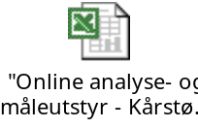

Appendix B - Detailed information about analysers and measurement instruments at Kollsnes
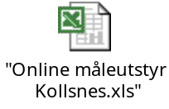

Appendix C - Detailed information about analysers and measurement instruments at Mongstad
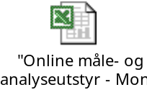

Appendix D - Detailed information about analysers and measurement instruments at Tjeldbergodden
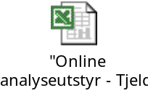

Appendix E - Detailed information about analysers and measurement instruments at Draupner
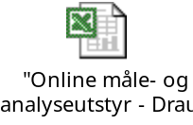

Appendix F - Detailed information about analysers and measurement instruments at Sleipner
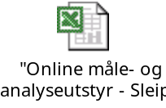

Appendix G - Detailed information about analysers and measurement instruments at Veslefrikk and Huldra
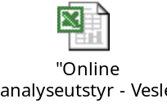

Appendix H - Detailed information about analysers and measurement instruments at Kvitebjørn
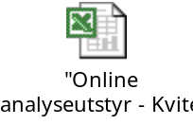

Appendix I - Detailed information about analysers and measurement instruments at Gullfaks
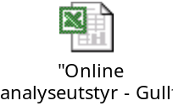

Appendix J - Detailed information about analysers and measurement instruments at Statfjord
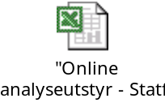

Appendix K - Detailed information about analysers and measurement instruments at Snorre
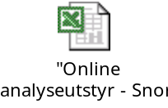

Appendix L - Detailed information about analysers and measurement instruments at Heidrun
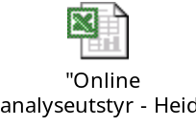

Appendix M - Detailed information about analysers and measurement instruments at Åsgard
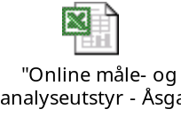

Appendix N - Detailed information about analysers and measurement instruments at Norne
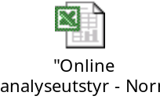

Appendix O - Detailed information about analysers and measurement instruments at Kristin
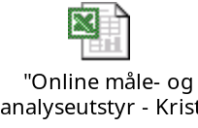

Appendix P - Detailed information about analysers and measurement instruments at Emden
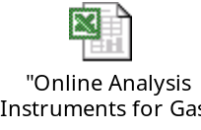

Appendix Q - Detailed information about analysers and measurement instruments at Dornum

Appendix R - Detailed information about analysers and measurement instruments at Zeebrugge

Appendix S - Detailed information about analysers and measurement instruments at Dunkerque

Appendix T – List over contact persons


Appendix U – International standards (ISO) related to gas quality


