# Technical Details

## Rain Water Collection and Harvesting System

The rain water collection system includes the following subsections

* Drain pipes
* GutterMate Filter and Diverter
* Storage Tank
* GutterMate Submersible Pump
* GutterMate Tri-Filter System
* Connecting pipes
* Washing Machine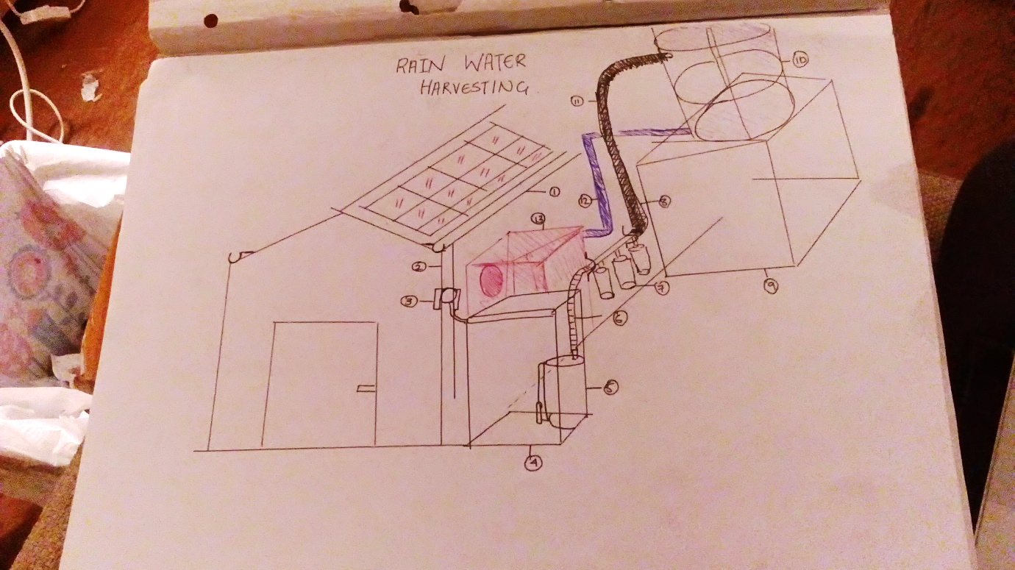

The recommended layout for the rain water collection system is as

Figure 2.1 Rain Water Collecting System Layout Recommendation. 1- Rain water collecting pipes; 2 – down pipe; 3- GutterMate Filter/Diverter; 4 -Rain Water Storage Tank; 5 – Submersible Pump; 6 – Connecting Pipe; 7 – tri-filter system; 8 – connecting pipe (black) ; 9 – concrete foundation; 10 – Header Tank; 11 – Washing Machine Inlet Pipe(Blue) ; 12 – Washing Machine (Red)

This configuration is so that all components are as concisely placed as possible – to minimise the pressure requirements from the pump. The header tank should be placed behind the wall the washing machine sits on. The water from the tank will directly drain into the washing machine. The header tank must be placed on a concrete slab. This is so that the elevation provides sufficient pressure for the inlet of the washing machine. On the same wall, alongside the concrete slab, the tri-filter pump will be placed. It must be attached to the wall – the height is arbitrary at this point. It should be as low as feasible. The tri- filter filters the water pushed through it by the multi-media submersible pump, located in the rain water storage tank. Again, these should be kept close to each other. There is only a 50 cm pipe connecting the diverter and the rain water storage tank (as provided by supplier). As such, the down-pipe must be located on the wall that the other components are utilising.

Depending on the dimensions of the building, it is recommended that the above installation is on the widest wall. This is so that there is enough space to put all the components in as little space as possible.

***Drain Pipes:-***

Drain pipe installation will include the collecting pipes and the down pipes:-

The collecting pipes will be installed on the sides of the roof. They will lead to the single down pipe. Ensure that this downpipe is the right diameter for the filter and diameter system:-

‘The GutterMate is designed to accept 68mm, 76mm and 80mm diameter and 65mm and 75mm square downpipes, without any adaptors or reducers, other than the square to round adaptor supplied with the filter, - See more at: <https://www.guttermate.co.uk/diverters-filters/gutter-mate-diverter-filter.html#sthash.SXSuU0kd.dpuf>’

***GutterMate Filter and Diverter:-***

The filter and diverter will be installed on the downpipe. Here is what is provided in the box:-

Each box contains: Gutter Mate Filter Square to round adaptor for Square Downpipes Blanking Cap for Diverter outlet, if needed Hose Adaptor for Water Butt Screws and plugs for fitting Gutter mate to wall. 500mm of hose to connect Gutter Mate to water butt or tank. Subject to distance between Gutter mate and water butt / tank a longer length of hose may be needed. Which is available on this link GutterMate hose

It will be fixed to the wall with mounting brackets and fixing screws. It must be assembled on site. At first, connect the diverter outlet to the rain water storage tank and allow the rain water to collect into that tank. The submersible pump will be located in that tank.

***Rain Water Storage Tank***

The rain water storage tank Requirements:-

It must have an inlet for the rain water. It must have an outlet to the tri-filter. The outlet pipe must suit the tri-filter (see: tri-filter section).

**Tank capacity:- 500L – 600L**

***Submersible Multi-Media Pump***

This submersible pressure-switch operated water pump is the solution for a working system. Standard pumps basically transfer from A to B, this pump has the features detailed below, allowing the operator to work with the water away from the pump and when stopping the pump is necessary the pump will sense when demand for water has stopped and will then shut down.

On sensing a drop in the water pressure in the discharge line the pump will start automatically thus eliminating the need for the operator to walk back the pump / starter to start and stop the pump. In addition there is also automatic control of the pump in low water level conditions, ensuring the pump does not run dry. The pump runs off a single phase supply.

Submersible pumps with built-in integrated electronics designed to automatically start and stop the pump and prevent against dry running.

- See more at: <https://www.guttermate.co.uk/pumps/multi-tech-submersible-multi-stage-pump.html#sthash.ly0kZ91M.dpuf>

Max flowrate UP TO – 120L/min ; 7200 L/hour

Max Pressure – 4.2 Bar; 42 m head

Flowrate Required:- around 100L/hour -150L/hour

Pressure required – 3.5 Bar

**LIMITS TO THE PUMP**

5m maximum immersion depth

Maximum heigh between pump and point of use 10m

Maximum liquid temperature +40 C.

Suction down to 22mm above ground level

Continuous service S1

***Tri-Filtration System***

The system has 1 inlet and 2 outlets. 1 outlet pushes the clean water out of the system into the header tank. The other outlet is for the collected dirt.

Size of the System:- - W x D x H: 336mm x 103mm x 395mm

Max flow rate at 3 BAR: 5500 l/h.   
Max Pressure drop at max flow rate: 1.7 BAR.   
IN / OUT threads 1/2”, 3/4” or 1”

The connecting pipes must fit the threads for the inlet and outlet sections, it must be screwed in place. The mechanism for this must be obtained from local sources and checked to fit.

***Concrete Slab Details***

Main Consideration: -

Width – Wide enough to hold the tank in place

Height – between 2 to 2.5 metres above ground level. (To give the necessary elevation)

However, slab must be fixed underground too. Concrete is stronger in compression than tension

Concrete Slab Calculation:-

External Force on Slab when tank is full:- 10,220 kg * 9.81 m/s2 – 100260 N

Area External Force acts on:- 2.532 m x pi() x 0.25 = 5.02 m2

Compressive Strength of Concrete:- 17Mpa to 28Mpa

Stress due to external force:- 100260 N /5.02 m2 = 19.94 Pa

Comment:- Concrete Safe to use under load.

***Header Tank:-***

Inlet: 620 mm screw lid  
Diameter: 2400mm

Height:- 2530 mm (2.53m)

Capacity: 10,000L

Weight 220kg approx. (empty)

Weight:- 10,220 (full)

***Piping Considerations***

All connecting pipes can be made of flexible material. It does not need to be stiff. It could be a flexible material. The connecting pipes for the rain-water system do not have any special requirements as the water is not that dirty.

Inlet Pipe requirements:- must run from the header tank to the washing machine inlet pipe. Therefore must be long enough to reach the distance but header tank must be close-by enough to avoid pressure losses.

Inlet Valve requirements:- Valves must be part of the design; at points where control of water is required.