EQUIPHYSICS LESSON · 2026  Horse Artery Lab  Blood pressure from heart to hoof, in a computer horse. A worksheet for the Colab notebook. | 

Name | Partner

BEFORE YOU START
Open the notebook in Google Colab: scan the code, use the link your teacher shares, or go to github.com/equiphysics/education, open labs/Horse-Artery-Lab, and click Open in Colab. Sign in with a Google account. If Colab warns that the notebook was not written by Google, click Run anyway. Run the Setup cell, then section 1. The red dots on the map are the five places you will measure. Each new horse takes about a minute to run, so start the runs in section 3 right away and read ahead while they work. |   Open in Colab
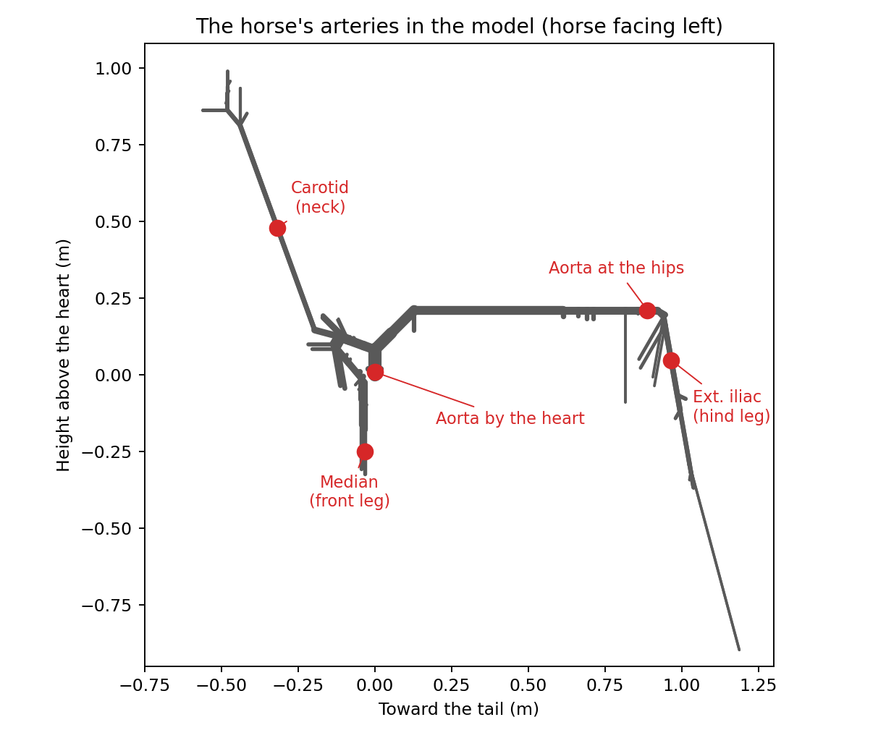

A · Meet the model (10 min)
A1. The heart in the model beats 40 times a minute. How many seconds does one heartbeat last?
______________________________________________________________________________________
A2. Run section 5 and write the three Womersley numbers.
Artery | Womersley number α
Horse aorta
Human aorta
Horse median artery (front leg)

A3. Whose aorta has the bigger Womersley number, the horse's or yours? What does a big Womersley number tell you about how blood moves near the artery wall? (Read the text above the cell.)
______________________________________________________________________________________
______________________________________________________________________________________

B · Lying down and standing up (15 min)
B1. Predict before you run. In a standing horse, where do you expect the average blood pressure to be highest: in the head, at the heart, or in the front leg? Why?
______________________________________________________________________________________
______________________________________________________________________________________
B2. In section 3, run horse A lying down and horse B standing up, both at 40 beats/min and stiffness 1 (the starting settings). Fill in the mean pressures from the printed table.
Site | Lying: mean (mmHg) | Standing: mean (mmHg) | Change (standing − lying)
Aorta by the heart
Carotid (neck)
Median (front leg)
Ext. iliac (hind leg)

B3. In the standing horse, how much higher is the mean pressure in the median artery than in the carotid? Now check it with gravity alone. Section 4 lists how high each site sits above the heart. Find the height difference h between the two sites and work out ρgh in mmHg (ρ = 1050 kg/m³, g = 9.81 m/s², 1 mmHg = 133.3 Pa). How close are the two answers?
Median − carotid in the model (mmHg) | Height difference h (m) | ρgh (mmHg)

B4. Compare the cardiac output and the share of blood going to the brain, lying and standing. What changed? Why might standing do that to a horse that has no reflexes?
______________________________________________________________________________________
______________________________________________________________________________________
B5. Look at the two pressure maps. Describe the color pattern of each in one sentence.
______________________________________________________________________________________
______________________________________________________________________________________

C · The pulse travels (15 min)
Use the last figure in section 3 and the lying horse (black).
C1. From the left panel, fill in the table. How can the peak pressure rise along the aorta while the average pressure stays the same?
Distance from the heart | Systolic (mmHg) | Mean (mmHg)
26 cm
86 cm

______________________________________________________________________________________
______________________________________________________________________________________
C2. In the right panel, read when the pulse arrives at 26 cm and at 86 cm. Work out the pulse wave speed: the distance it travels divided by the time it takes. The study measured 5.27 m/s in a real horse. How close is the model?
Arrives at 26 cm (ms) | Arrives at 86 cm (ms) | Wave speed (m/s)

C3. In the blood-speed plots, at which sites does the blood flow backward for a moment (speed below zero)? What could push blood backward in an artery?
______________________________________________________________________________________
______________________________________________________________________________________

D · Stiffer arteries (10 min)
D1. Predict: if every artery were 1.5 times stiffer, what would happen to the pulse pressure in the aorta, and to the pulse wave speed?
______________________________________________________________________________________
D2. Run horse A lying, 40 beats/min, stiffness 1, and horse B lying, 40 beats/min, stiffness 1.5.
Stiffness | Aortic pressure (sys/dia, mmHg) | Pulse pressure (mmHg) | Pulse wave speed (m/s)
1
1.5

D3. For a simple elastic tube, the wave speed goes as c ≈ √(1/(ρD)), where D measures how easily the wall stretches. If D falls by a factor of 1.5, by what factor should c rise? Did the model's wave speed rise that much? (Hint: compare the diastolic pressures. The model's arteries get softer at low pressure.)
______________________________________________________________________________________
______________________________________________________________________________________
D4. Older horses have stiffer arteries. Why might a bigger pulse pressure matter to an artery wall?
______________________________________________________________________________________

E · A faster heart (10 min)
E1. Predict: if the heart beats 60 times a minute instead of 40 (horse lying down), what happens to the stroke volume (blood per beat), the cardiac output (blood per minute), and the blood pressure?
______________________________________________________________________________________
E2. Run horse A lying, 40 beats/min, and horse B lying, 60 beats/min, both with stiffness 1.
Heart rate | Cardiac output (L/min) | Stroke volume (ml) | Aortic pressure (mmHg)
40
60

E3. Why does the stroke volume fall when the heart beats faster?
______________________________________________________________________________________
E4. At a gallop a horse's heart rate climbs past 200 and its cardiac output rises about eightfold, yet its blood pressure rises far less. What does a real horse do that this model cannot?
______________________________________________________________________________________
______________________________________________________________________________________

F · Models and measurements (10 min)
F1. Run section 6. Name one number where our model matches the study's model well, and one where they differ.
______________________________________________________________________________________
______________________________________________________________________________________
F2. In standing horses the study measured a peak blood speed in the carotid of 0.85 m/s and a carotid pulse pressure of 33 mmHg. Write the standing model's values (horse B in section 3). Give two reasons a model of an average horse might not match measurements in real horses.
______________________________________________________________________________________
______________________________________________________________________________________
______________________________________________________________________________________
F3. Name one thing the model leaves out, and one thing today that surprised you.
______________________________________________________________________________________
______________________________________________________________________________________

