EQUIPHYSICS OUTREACH · 2026  Horse Heart Lab  How a horse's heart beats, from standing still to a gallop. A worksheet for the web app. |   Scan to open the app  equiphysics.github.io/web-apps/heart

Name | Partner

BEFORE YOU START
Open the app on your phone. Tap Standing. Watch the heart squeeze, the ECG scroll by, and the dots appear in The Rhythm. Tap the Heartbeat button once so you can hear the beat. Now you are ready.

A · Read the ECG (10 min)
Tap each activity in turn and wait a few seconds for the heart rate to settle. Fill in the table from the three boxes under the heart and from the scrolling strip.
Activity | Heart rate (beats/min) | Breaths/min | One thing that changed in the trace
Standing
Walk
Trot
Canter
Gallop

A2. Here is one beat of the model. Write P, Q, R, S, or T in each box.
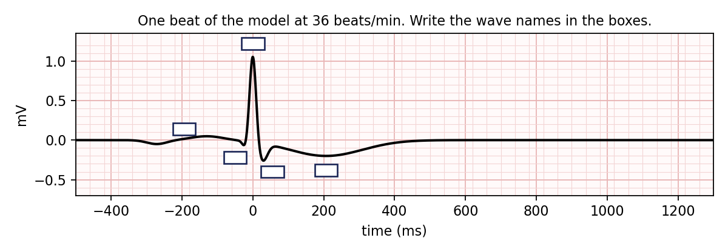
A3. Which part of the trace is the ventricles firing, and how do you know? Which part points down in Duque's strap, and what is the heart doing then?
______________________________________________________________________________________
______________________________________________________________________________________
A4. The strip is marked like ECG paper: each small square is 0.04 s. At a trot, count the small squares from one R wave to the next. How many? What heart rate does that give? (60 ÷ seconds per beat.)
______________________________________________________________________________________

B · The rhythm is not a metronome (12 min)
Go back to Standing. Scroll to The Rhythm. Each dot is one beat; the height is the time since the previous beat (the RR interval).
B1. Find the slider Breathing sway of the heart rate (RSA) in The Math Behind It. Set it to 0%, then 6%, then 20%. Watch the dots for ten beats each time. Describe the pattern at 20%.
______________________________________________________________________________________
B2. Leave RSA at 20%. Now set Breathing rate to 4 breaths/min, then to 40. Write SDNN and RMSSD for each. Which number barely moves when breathing is slow, and why? (Hint: RMSSD only looks at the change from one beat to the next.)
Breathing rate | SDNN (ms) | RMSSD (ms)
4 / min
40 / min

______________________________________________________________________________________
B3. Set RSA back to 6% and Breathing rate to 12. Now find the wander controls: Wander size s, Memory time τ, and the Random kicks button. Set s to 8%. Try τ = 2 s, then τ = 40 s, watching 30 beats each time. Sketch the dot pattern for each. Which one looks like scatter and which like slow drift? Which number (SDNN or RMSSD) responds to each?
______________________________________________________________________________________
______________________________________________________________________________________
B3b. Turn the Random kicks off and watch the next 30 beats. What happens to the wander, and how long does it take? (Look at τ.) What is left once it is gone?
______________________________________________________________________________________
B4. Set Dropped beats to 15%. Watch the strip and the dots for twenty beats. What does a dropped beat look like on the strip? What does it look like in the dots? Where is the P wave?
______________________________________________________________________________________
______________________________________________________________________________________

C · Build the beat (18 min)
The model is a clock. One hand (θ) sweeps around once per beat at speed ω. Each wave is a bump parked at its own angle on the clock face, and the ECG is just the sum of the bumps as the hand goes by.
C1. ω = 2π · HR / 60. The app shows ω in the corner of the clock. Check it: what is ω at 36 beats/min? Predict ω at 72 and at 120, then drag the Heart rate slider there and check.
Heart rate | ω predicted (rad/s) | ω in the app
36
72
120

C2. Turn Rate adaptation off. Push the heart rate to 180. What goes wrong on the strip? Turn it back on. What did the model change to fix it? (Read the note under the button: the QT interval scales with the square root of RR. This is Bazett's rule.)
______________________________________________________________________________________
______________________________________________________________________________________
C3. Match Duque. Scroll to Real Horse Data and tap Trot. Look at his real trot beat: how tall is the R wave, which way does the T wave point, and how big is it? Now scroll up and move the wave sliders until your model strip looks like his. Write your settings.
Heart rate | R height (mV) | T height (mV) | T width (ms) | QT (ms)

Then press the button Set the model to this recording. How close were you?
______________________________________________________________________________________
C4. The heart-rate wander follows the equation dx = −(x/τ) dt + σ dW. In your own words: what does the first term do, what does the second term do, and what does the app change when you press the Random kicks button?
______________________________________________________________________________________
______________________________________________________________________________________

D · Reality check: the real horse (15 min)
Real Horse Data shows Duque wearing a heart-rate strap: a single ECG lead plus the strap's own beat detector (the red ticks).
D1. Standing tab. Write Duque's heart rate, SDNN, and RMSSD from the table. Then set the model to Standing and compare with your model column. Which number is furthest off? What slider would you move to fix it?
______________________________________________________________________________________
______________________________________________________________________________________
D2. Trot tab. Find a gap between two red ticks that is twice as long as its neighbours. Look inside the gap on the ECG. Did the heart skip a beat, or did the strap miss one? What is your evidence?
______________________________________________________________________________________
______________________________________________________________________________________
D3. Whole ride tab. The dots are heart rate, beat by beat, for 17 minutes. Mark on the sketch below where Duque walked, where he trotted, and where he rested. How long did his heart rate take to come back down after the second trot?
______________________________________________________________________________________
______________________________________________________________________________________
D4. Name one thing the model does NOT capture about a real horse's heart, and one thing today that surprised you.
______________________________________________________________________________________
______________________________________________________________________________________

