Finealth — High-Level Design
Private financial health check and planner (web + Android)
Version 1.0 · 2026-11-03 · Equisteg

Contents
Contents
1. Purpose & scope
2. Key decisions
3. Context diagram
4. Monorepo components
5. Data flow
6. Third-party services
7. Deployment topology
8. Environments & env vars
9. Security architecture
10. Scalability & caching
11. Availability targets
12. Monthly cost estimate
13. Risks

1. Purpose & scope
Finealth turns a few numbers a person already knows (income, spending, debts, savings, insurance) into a financial health score and a plan: which debt to clear first, the monthly saving each goal needs, and the chance retirement savings last. It also keeps the 20+ free calculators (SIP, EMI, compound interest, India/US/UK tax, GST/VAT, mortgage, FIRE) that bring search traffic.
Business model: freemium. Calculators, the health score and basic plans are free with ads. Pro (₹399 / US$14.99 a year, ₹999 / US$29 lifetime, ₹49 / US$1.99 a month on Android) adds the full report, unlimited debts and goals, what-if scenarios, Monte Carlo retirement odds, progress snapshots, CSV export and no ads. Market research and pricing rationale: docs/competitor-analysis.md.
Out of scope for v1: bank linking or account aggregation, investment product recommendations (regulated advice), user accounts, cloud sync.

2. Key decisions
# | Decision | Rationale
D1 | Local-first: every financial number stays in the browser (localStorage) or app storage | Privacy is the product's promise and the finance category rule; no database to secure; zero cost
D2 | No bank linking | Bank sync needs paid aggregators (Plaid, Account Aggregator) and regulated data handling; breaks the zero-cost rule
D3 | Monorepo per Equisteg template v4 (npm workspaces + Turborepo) | One engine (packages/finance-core) shared by web and mobile; same tooling as InvoiceKit
D4 | Web = Next.js 16 static export served by a Cloudflare Worker (static assets) | Pre-rendered pages for SEO and AdSense; free hosting
D5 | No-signup Pro with a stateless licence Worker (same protocol as InvoiceKit) | No accounts, no database; Razorpay / Google Play are the only purchase records
D6 | Pro gating on the client, licence verified with an Ed25519 signature | Features are local maths; tampering only unlocks UI on the attacker's own device (accepted risk RSK-001)
D7 | Mobile stays a Capacitor wrapper of the static export for now | Ships today; move to Expo (template stack) is RSK-002 / next PR
D8 | Rules-of-thumb guidance, never product advice | Personalised investment advice is regulated (SEBI IA rules in India); category red line

3. Context diagram
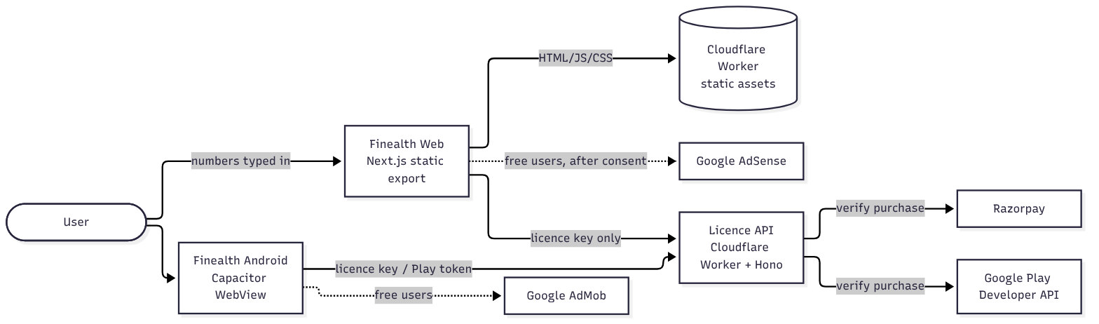
No financial data reaches any Finealth server. The only data that leaves the device is the licence key (Razorpay pay_…/sub_… id or Play purchase token) sent to the licence API.

4. Monorepo components
Path | What it is | Depends on
packages/finance-core | Pure TypeScript engines: statutory calculators, health score, debt payoff, goals, retirement projection and Monte Carlo, loan prepayment, plan limits, CSV, licence token verify | shared-types
packages/shared-types | Licence claims, API request/response types | —
apps/web | Next.js App Router site: calculators (/), product pages under app/(product), Pro provider, Razorpay checkout client | finance-core, shared-types
apps/api | Cloudflare Worker (Hono): /api/v1/checkout, /checkout/confirm, /licence/verify, /play/verify, /errors; serves apps/web/out | shared-types, finance-core/licence
apps/mobile | Capacitor Android/iOS shell around a static export | finance-core
tests/ | Playwright web specs, Appium native spec, test-case sheets, bug log, load tests, guard tools | —

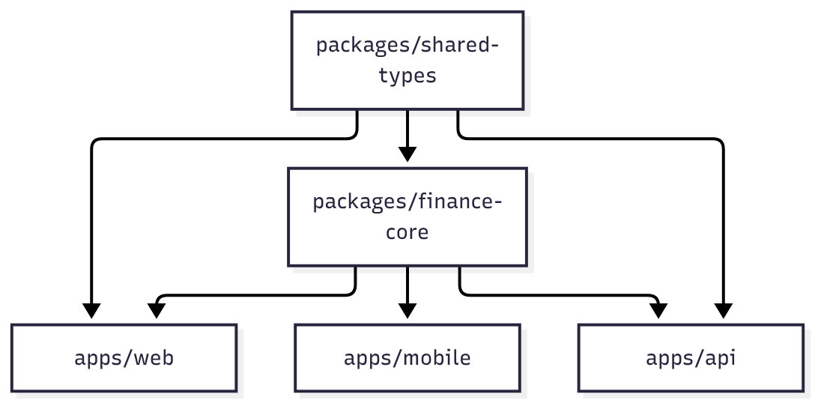

5. Data flow
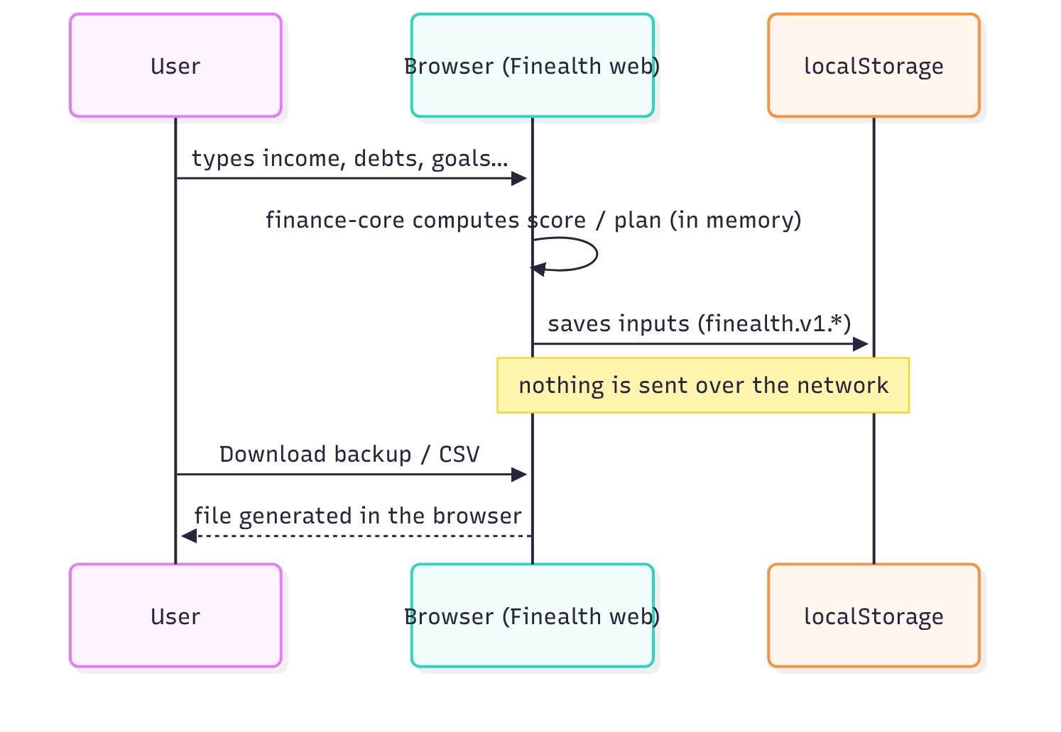

6. Third-party services
Service | Use | Plan / cost | Data shared
Cloudflare Workers + Static Assets | Hosting web and API | Free (100k requests/day) | IP for delivery; no logs kept by us beyond 3 days
Razorpay | Web payments (subscription + one-time order) | Per-transaction fee | Buyer payment details (to Razorpay only)
Google Play Billing | Android payments | Play fee | Purchase token
Google AdSense / AdMob | Ads for free users | Revenue share | Standard ad-request data after consent
GitHub Actions | CI | Free tier | Source code

7. Deployment topology
One Worker per environment (dev, staging, production, plus prelaunch) serves apps/web/out as static assets and runs code only for /api/*. Rate limits use Workers Rate Limiting bindings. No D1, KV or R2. Android builds come from apps/mobile (npm run cap:sync, Gradle).

8. Environments & env vars
Variable | Where | Purpose
NEXT_PUBLIC_SITE_URL | web build | Canonical URLs, sitemap
NEXT_PUBLIC_API_BASE | web build | Licence API origin (empty = same origin)
NEXT_PUBLIC_LICENCE_PUBLIC_KEY | web build | Ed25519 public key to verify Pro tokens
NEXT_PUBLIC_ENV | web build | Refuse tokens from another environment
NEXT_PUBLIC_RAZORPAY_ENABLED | web build | 1 turns on the buy buttons
NEXT_PUBLIC_ADSENSE_CLIENT, NEXT_PUBLIC_ADSENSE_SLOT_* | web build | Ads
LICENCE_SIGNING_KEY | Worker secret | Ed25519 private key (never in git)
RAZORPAY_KEY_ID / RAZORPAY_KEY_SECRET | Worker var / secret | Razorpay API
RAZORPAY_PLAN_ID_YEARLY_INR/USD | Worker var | Yearly subscription plans
PLAY_SERVICE_ACCOUNT | Worker secret | Play Developer API
KILL_SWITCHES | Worker var + web build | e.g. checkout pauses new purchases

9. Security architecture
- Browser and app are untrusted. Pro is granted only by a token signed by the licence Worker after the store confirms the purchase, valid ≤ 7 days and refreshed in the background, so refunds take effect within a week.
- The browser never sends a price: /checkout reads it from apps/api/src/config/skus.ts.
- Strict origin checks, JSON-only bodies, size limits and rate limits on every API route; constant-time Razorpay signature checks.
- No secrets in NEXT_PUBLIC_*. Pre-commit hook and CI block secret files and live keys (tests/tools/check-forbidden-files.mjs, Gitleaks, Semgrep, OSV-Scanner).
- CSV export escapes formula-leading cells (CSV injection).
- Pro users load no ad script at all.

10. Scalability & caching
All pages are static and cached at Cloudflare's edge; the maths runs on the user's device, so load grows only with licence checks (at most a few per user per week). Monte Carlo (1,000 runs × ≤ 80 years) completes in well under 100 ms on a mid-range phone.

11. Availability targets
Static pages: Cloudflare availability (pages keep working if the API is down). Licence API: 99.5 %; a failed refresh keeps Pro "unconfirmed" (no ads, Pro features locked) and retries every minute.

12. Monthly cost estimate
Item | Cost
Hosting (Cloudflare free) | ₹0
CI (GitHub free) | ₹0
Domain | ~₹1,000 / year (NEEDS HUMAN)
Payments | Razorpay ~2 % + GST per sale; Play 15 %

13. Risks
ID | Risk | How we tackle it | Residual
RSK-001 | Pro gating is client-side | Accepted: features are local; tokens are signed and short-lived | Determined users can unlock UI on their own device
RSK-002 | Mobile is Capacitor, template says Expo | Next PR ports to Expo reusing finance-core | Play Billing not wired in the Capacitor app yet
RSK-003 | Rules of thumb read as advice | Disclaimer on every result, editorial policy, no product names | Low
RSK-004 | Overlap with PayCheckly (take-home pay) | Finealth leads with health score and plans; salary tools stay secondary | Low
RSK-005 | Statutory rates and thresholds change yearly | Dates in code comments; yearly re-check issue | Low

