Finealth — Low-Level Design
Modules, formulas, contracts and sequences
Version 1.0 · 2026-11-03 · Equisteg

Contents
Contents
1. Workspace structure
2. Shared types (@finealth/shared-types)
3. @finealth/finance-core contracts
3.1 Health score
3.2 Debt payoff
3.3 Goals
3.4 Retirement
3.5 Prepayment
3.6 Universal tools (tools.ts)
3.7 Country tax engines (world.ts, finance.ts)
4. Web modules
4.1 Free vs Pro gating
4.2 Local storage keys
5. Mobile modules
6. APIs & database
7. Validation rules
8. Key sequences
9. Error handling & logging
10. Accessibility

1. Workspace structure
finance-calculators/
├── apps/
│ ├── web/ @finealth/web Next.js 16 static export
│ │ └── src/
│ │ ├── app/ / (calculators), sip/emi/compound routes, robots, sitemap
│ │ ├── app/(product)/ health-check, debt-payoff, goal-planner, retirement-planner,
│ │ │ loan-prepayment, my-plan, pricing, pro, about, privacy, terms, refund, contact
│ │ ├── components/ ProProvider, PriceCards, ActivatePro, AdLoader, AdSenseBanner, ui.tsx, site/, tools/
│ │ └── lib/ config, ads, pro, checkout, storage, usePersistent
│ ├── api/ @finealth/api Cloudflare Worker (Hono)
│ └── mobile/ @finealth/mobile Capacitor shell (android/, ios/)
├── packages/
│ ├── finance-core/ formulas + licence verify (pure TS, no DOM)
│ └── shared-types/ API and token types
├── tests/ web/ (Playwright), mobile/native (Appium), cases/, bugs/, load/, tools/
├── scripts/ test-cases.mjs, docs-export.mjs, gen-licence-keys.mjs, make-test-licence.mjs
└── docs/ HLD, LLD, USER_MANUAL, test-cases, standards/

2. Shared types (@finealth/shared-types)
Type | Fields
ProPlan | 'pro_monthly' | 'pro_yearly' | 'pro_lifetime'
LicenceClaims | v: 1, plan, src: 'razorpay' | 'play', iat, exp (≤ 7 days), kh? (16-byte key hash), env?
CheckoutRequest | plan: 'pro_yearly' | 'pro_lifetime', currency: 'INR' | 'USD'
LicenceResponse | token, plan, exp, licenceKey?

3. @finealth/finance-core contracts
All functions are pure and synchronous. Inputs that are negative, NaN or infinite are treated as 0. Money inside loops is integer minor units (paise/cents); results are rounded to whole units (or 2 dp for schedules) only at the end.
Module | Function | Returns
health.ts | financialHealth(input, fmt?) | { score 0-100, grade, pillars[6], actions[] (ranked), metrics }
debt.ts | planDebtPayoff(debts, budget, strategy) | { feasible, reason?, months, totalInterest, totalPaid, payoffs[], schedule[] }
debt.ts | compareDebtStrategies(debts, budget) | minimum / avalanche / snowball plans, best, interestSaved, monthsSaved
goals.ts | planGoal(goal), planGoals(goals, budget) | future cost, savings growth, gap, monthly needed, allocation by priority
retirement.ts | projectRetirement(input) | corpus at retirement, corpus needed, run-out age
retirement.ts | retirementOdds(input, runs = 1000, seed) | success rate, p10/p50/p90 corpus, median run-out age
prepayment.ts | comparePrepayment(input) | EMI, baseline, reduce-tenure and reduce-EMI options, better
plan.ts | FREE_LIMITS, PRO_FEATURES, PLAN_PRICES, limitFor() | display-only prices (server prices in apps/api/src/config/skus.ts)
tools.ts | universal tools (see 3.6) | inflation, real return, CAGR, doubling time, simple interest, RD, yearly deposit (PPF), savings target, retirement corpus, NPV, IRR, XIRR, card payoff, affordability, true loan rate, flat-rate loan, rent vs buy, 50/30/20, emergency fund, net worth, percentages, discount, margin, break-even, salary, tip
world.ts | australiaTax, canadaTax, singaporeTax, newZealandTax, CA_SALES_TAX, WORLD_VAT_RATES, RATES_LAST_CHECKED | country tax engines (see 3.7)
csv.ts | toCsv(header, rows) | RFC 4180 text with formula-injection guard
licence.ts | verifyLicence, signLicence, licenceKeyHash … | Ed25519 token helpers (WebCrypto)

3.1 Health score
Six pillars, each 0-100, weighted sum rounded to a whole number (float noise trimmed first).
Pillar | Measure | Full marks | Zero | Weight | Source
Savings rate | (income − spending − loan payments) / income | ≥ 20 % | ≤ 0 % | 20 % | 50/30/20 rule
Emergency fund | savings / (spending + loan payments) | ≥ 6 months | 0 | 20 % | CFPB emergency-fund guide (3-6 months)
Debt payments | loan payments / income | ≤ 10 % | ≥ 50 % | 20 % | CFPB debt-to-income (36 % / 43 %)
Costly debt | card + personal-loan balance / yearly income | 0 | ≥ 50 % | 10 % | —
Retirement | investments / yearly income vs age multiple | ≥ target | 0 | 15 % | Fidelity: 1× at 30, 3× at 40, 6× at 50, 8× at 60, 10× at 67 (linear between)
Protection | life cover / yearly income (if dependants) and health cover | 10× and yes | none | 15 % | Income-replacement rule (IRDAI consumer education)

Grades: ≥ 80 Excellent, ≥ 60 Good, ≥ 40 Fair, else Needs attention. Actions are ranked by points recoverable = (100 − pillar score) × weight. Golden case: the example household scores 75 / Good (planning.test.ts).

3.2 Debt payoff
Each month, for every open debt: interest = round(balance × APR / 1200) is added; the minimum (or whole balance) is paid; the rest of the budget goes to the first open debt in strategy order and rolls to the next when one is cleared. Avalanche = highest APR first (ties: smaller balance); snowball = smallest balance first; custom = list order; minimum = minimums only, no roll-over. Infeasible when budget < sum of minimums, when month 1 payments do not cover interest, or after 600 months. Golden: ₹1,000 at 12 % paying ₹100 → 11 months, ₹58.98 interest (closed form n = −ln(1 − rB/P)/ln(1 + r) = 10.59).

3.3 Goals
future cost = cost × (1 + inflation)^years; savings grow at (1 + r/12)^(12·years); monthly saving = gap / F where F = ((1 + i)^n − 1)/i × (1 + i) (annuity-due, i = r/12, n = 12·years), or a month-by-month sum when stepping up yearly. Rounded up so the goal is met. Golden: ₹10 lakh in 10 years at 6 % inflation, 12 % return → future cost ₹17,90,848, ₹7,708 a month.

3.4 Retirement
Yearly model. Working years: corpus = (corpus + 12 × monthly saving) × (1 + r). Retired years: corpus −= spending, then × (1 + r_retired); spending grows with inflation. Corpus needed = present value at retirement of the growing spending stream. Monte Carlo: yearly return ~ Normal(mean, volatility) with mulberry32 seeded PRNG and Box-Muller; retired volatility is scaled by r_retired / r; a year cannot lose more than 95 %. With volatility 0 the odds equal the straight-line verdict (test).

3.5 Prepayment
EMI = P·r·(1 + r)^n / ((1 + r)^n − 1). Reduce tenure: keep EMI (+ extra monthly) on the reduced balance and amortise until zero. Reduce EMI: new EMI over the same remaining months. Golden: ₹10 lakh, 9 %, 240 months, ₹1 lakh prepaid → EMI ₹8,997.26, new EMI ₹8,097.53, tenure 186 months (54 saved).

3.6 Universal tools (tools.ts)
Tool | Formula | Source / golden
Inflation | FV = PV(1 + i)ⁿ; buying power = PV / (1 + i)ⁿ | ₹1,00,000 at 6 % for 10 y → ₹1,79,085 / ₹55,839
Real return | (1 + n)/(1 + i) − 1 (Fisher) | 10 % and 6 % → 3.77 %
CAGR | (end/start)^(1/y) − 1 | 1 → 2 in 5 y → 14.87 %
Doubling | ln 2 / ln(1 + r); Rule of 72 = 72/r | 8 % → 9.01 y / 9 y
RD | Σ P(1 + r/4)^(4(n − k + 1)/12), quarterly compounding (Indian bank method) | ₹5,000 × 12 at 7 % → ₹62,311
PPF / yearly deposit | annuity-due, yearly compounding | ₹1.5 L × 15 y at 7.1 % → ₹40,68,209 (matches published calculators)
Savings target | gap / (((1 + i)ⁿ − 1)/i), i = r/12, after growing current savings | ₹10 L in 10 y at 12 % → ₹4,347
Retirement corpus | Σ month k: E(1 + g)ᵏ / (1 + r)ᵏ, monthly equivalents of yearly rates | return = inflation → months × expense
NPV / IRR | Σ CFₜ/(1 + r)ᵗ; IRR by bisection on (−99.99 %, 10⁶ %) | −1000, 300, 400, 500 at 10 % → −21.04; IRR ≈ 8.9 %
XIRR | Σ CFᵢ/(1 + r)^(days/365) = 0 (spreadsheet convention) | +10 % over one year → 10 %
Card payoff | monthly interest at APR/12 before payment; capped at 600 months | 5,000 at 24 % paying 200 → 36 months, 2,001 interest
Affordability | max payment = income × limit − debts; loan = PMT(1 − (1 + r)⁻ⁿ)/r | 1,00,000, 50 %, 10,000, 9 %, 20 y → ₹44,45,798
True loan rate | solve PV(payments) = principal − fees, × 12 | no fee → quoted rate
Flat rate | interest = P·r·t on the original amount; equivalent reducing rate solved | 1 L at 10 % flat, 3 y → EMI 3,611, ≈ 17.9 % reducing
Rent vs buy | month-by-month: both spend the same, the cheaper side invests the difference; buyer's wealth = home value × (1 − selling costs) − loan + invested | ignores tax
50/30/20 | Warren & Tyagi (2005) | —

3.7 Country tax engines (world.ts, finance.ts)
Rates last checked 9 Nov 2026 (RATES_LAST_CHECKED, shown on every tax tool with a link to the official calculator).
Engine | Rules | Golden
Australia 2026-27 | ATO resident rates 0/15/30/37/45 % at 18,200/45,000/135,000/190,000; LITO $700 tapering 5c over 37,500 and 1.5c over 45,000; Medicare 2 % with 10 % shade-in over $27,222 | A$90,000 → tax $17,520, Medicare $1,800
Canada 2026 | federal 14/20.5/26/29/33 % at 58,523/117,045/181,440/258,482; BPA 16,452 → 14,829; credits at 14 % on BPA, employment amount 1,501, base CPP and EI; enhanced CPP and CPP2 deducted; CPP 5.95 % (YMPE 74,600, exemption 3,500), CPP2 4 % to 85,000, EI 1.63 % to 68,900; provincial = flat estimate | C$60,000 → federal $5,338, CPP $3,362, EI $978
Singapore (YA 2025 on) | resident rates 0-24 %; CPF employee 20 % to the S$8,000 monthly ceiling; earned income relief S$1,000 | S$60,000 → tax $1,040
New Zealand | 10.5/17.5/30/33/39 % at 15,600/53,500/78,100/180,000; ACC levy editable | NZ$80,000 → $16,278
US 2026 joint | Rev. Proc. 2025-32: brackets 24,800 … 768,700, standard deduction 32,200, Additional Medicare from 250,000 | $150,000 → federal $15,340
India old regime | age bands (₹2.5 L / 3 L / 5 L exemption); 80D capped separately for self (₹25k, ₹50k if 60+) and parents (₹25k, ₹50k if 60+); HRA = least of three limits; gratuity = wage × 15/26 × years, > 6 months rounds up, cap ₹20 L | ₹15 L with 80D 40k + 60k (senior parent) → 80D ₹75,000, tax ₹1,87,200
UK SDLT | + 2 % non-resident surcharge on the whole price | £300k → +£6,000
World VAT | standard rates for 27 EU states + 40 other countries (no Pakistan); EU_STANDARD_VAT_RATES must equal the EU rows (test) | DE 119 incl. → 19.00 VAT

Audit, Nov 2026. Fixed: 80D used one ₹1 L cap for everyone (now separate caps; under-60 with senior parents max ₹75,000); EU VAT lacked BG, HR, CY, CZ, LV, LT, MT, SI; old regime ignored senior-citizen exemptions; US had single filers only; SDLT lacked the non-resident surcharge. Re-verified unchanged: India new-regime slabs, 87A marginal relief and surcharge relief (₹13 L → ₹26,000; ₹60 L → ₹15,52,980), US 2026 single ($80,000 → $8,770), UK 2026/27 (£60,000 → tax £11,432, NI £3,211), SDLT first-time buyer, EMI (₹10 L, 8.5 %, 20 y → ₹8,678), SIP (₹10k, 12 %, 10 y → ₹23,23,391).

4. Web modules
Module | Responsibility
lib/config.ts | Reads NEXT_PUBLIC_* once (inlined at build)
lib/pro.ts | Stored licence (finealth.pro.v1), token verification, background refresh, clock-rollback guard, restore
lib/checkout.ts | Razorpay Checkout: /checkout → Razorpay modal → /checkout/confirm; pending-confirm recovery (finealth.pending.v1)
lib/storage.ts | Validated localStorage read/write under finealth.v1.*, backup export/import, file download
lib/usePersistent.ts | React state remembered after mount (no hydration mismatch)
components/ProProvider.tsx | usePro(), useAdsAllowed(); re-checks on focus and at token expiry
components/AdLoader.tsx | Injects the AdSense script only for confirmed free users
components/ui.tsx | ToolPage (heading + disclaimer + ad slot), ProGate, NumberField, Stat, ScoreRing, LineChart, Bar
components/tools/* | One client component per product page

4.1 Free vs Pro gating
Feature | Free | Pro
Health check | Score, grade, top action | All actions, six-pillar breakdown, print, snapshots
Debt planner | 3 debts, debt-free date, strategy comparison | Unlimited, what-if, chart, schedule, CSV
Goal planner | 1 goal | Unlimited, priority order, step-up, CSV
Retirement | Straight-line projection | Monte Carlo odds
Prepayment, calculators, backup | Yes | Yes
Ads | Yes (after consent) | None; script never loaded

Saved data above the free limit is kept, shown faded and excluded from the maths, and comes back with Pro.

4.2 Local storage keys
Key | Shape | Validator
finealth.v1.health | HealthInput | isHealthInput
finealth.v1.debts | Debt[] (≤ 50) | isDebtList
finealth.v1.goals | Goal[] (≤ 50) | isGoalList
finealth.v1.retirement | RetirementInput | isRetirementInput
finealth.v1.snapshots | Snapshot[] (≤ 500) | isSnapshotList
finealth.pro.v1 | { key, plan, token, lastSeen } | readStoredPro

Backup file: { app: 'finealth', version: 1, exportedAt, data: { …keys } }; import writes only sections that validate.

5. Mobile modules
apps/mobile is a Next.js static export (src/app/page.tsx, splash, tab bar) loaded by Capacitor (appId com.tezech.finealth, webDir out). It imports formulas from @finealth/finance-core. Build: npm run cap:sync -w @finealth/mobile, then Gradle. Expo port and Play Billing: next PR (RSK-002).

6. APIs & database
No database. API (apps/api, details in apps/api/README.md):
Route | Body | Success
POST /api/v1/checkout | { plan, currency } | Razorpay order (lifetime) or subscription (yearly) at the server price
POST /api/v1/checkout/confirm | Razorpay ids + signature | First Pro token + licence key
POST /api/v1/licence/verify | { key, activate? , token? } | Fresh 7-day token
POST /api/v1/play/verify | { purchaseToken, productId } | Token for Play purchases
POST /api/v1/errors | scrubbed error report | 204

Purchases are recognised by Razorpay notes { product: 'finealth', plan }; activations per key are counted in payment notes fh_activations (max 5).

7. Validation rules
- Numeric inputs: non-finite → 0; negatives → 0 in the engines; ages capped in the UI (0-110), years ≤ 60, months ≤ 480.
- Text: debt/goal names ≤ 60 characters (UI) and ≤ 80 (storage validator).
- Backup import: ≤ 2 MB, must be app: 'finealth', version: 1.
- Licence key: ^(pay|sub)_[A-Za-z0-9]{8,40}$.

8. Key sequences
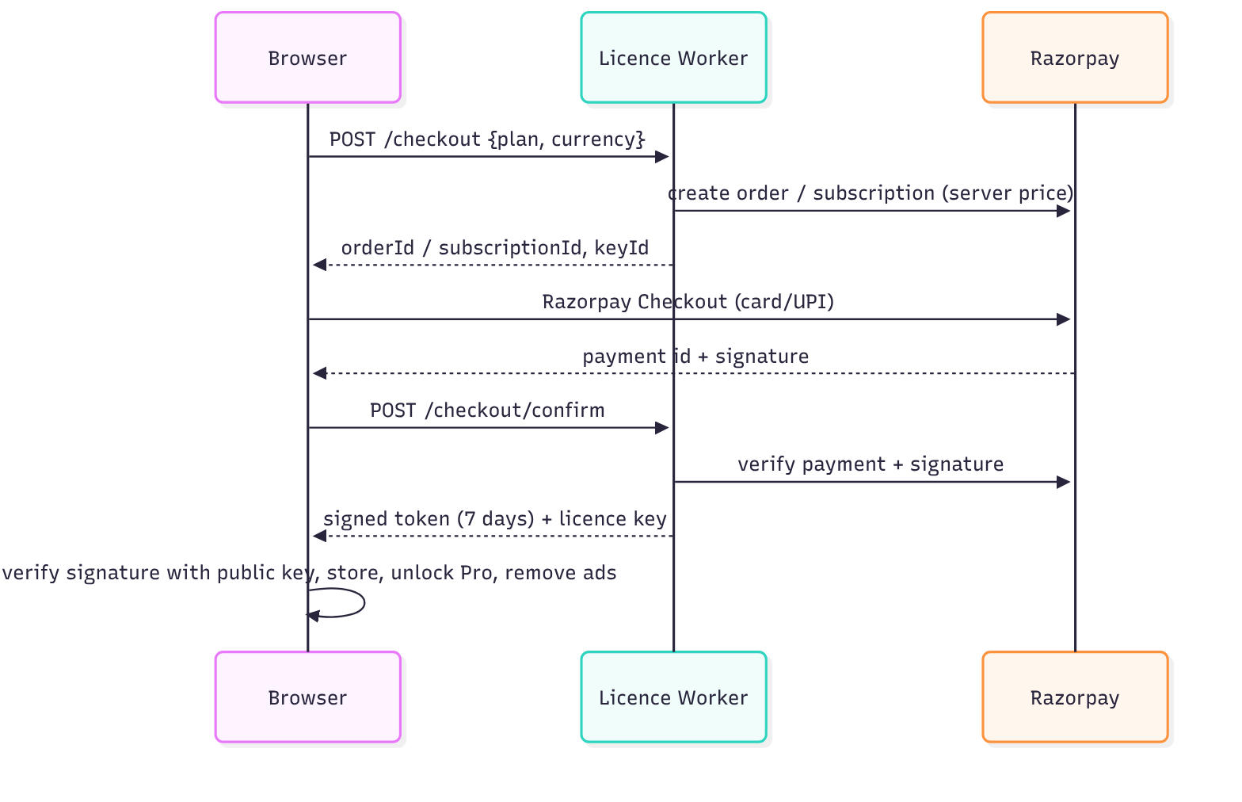
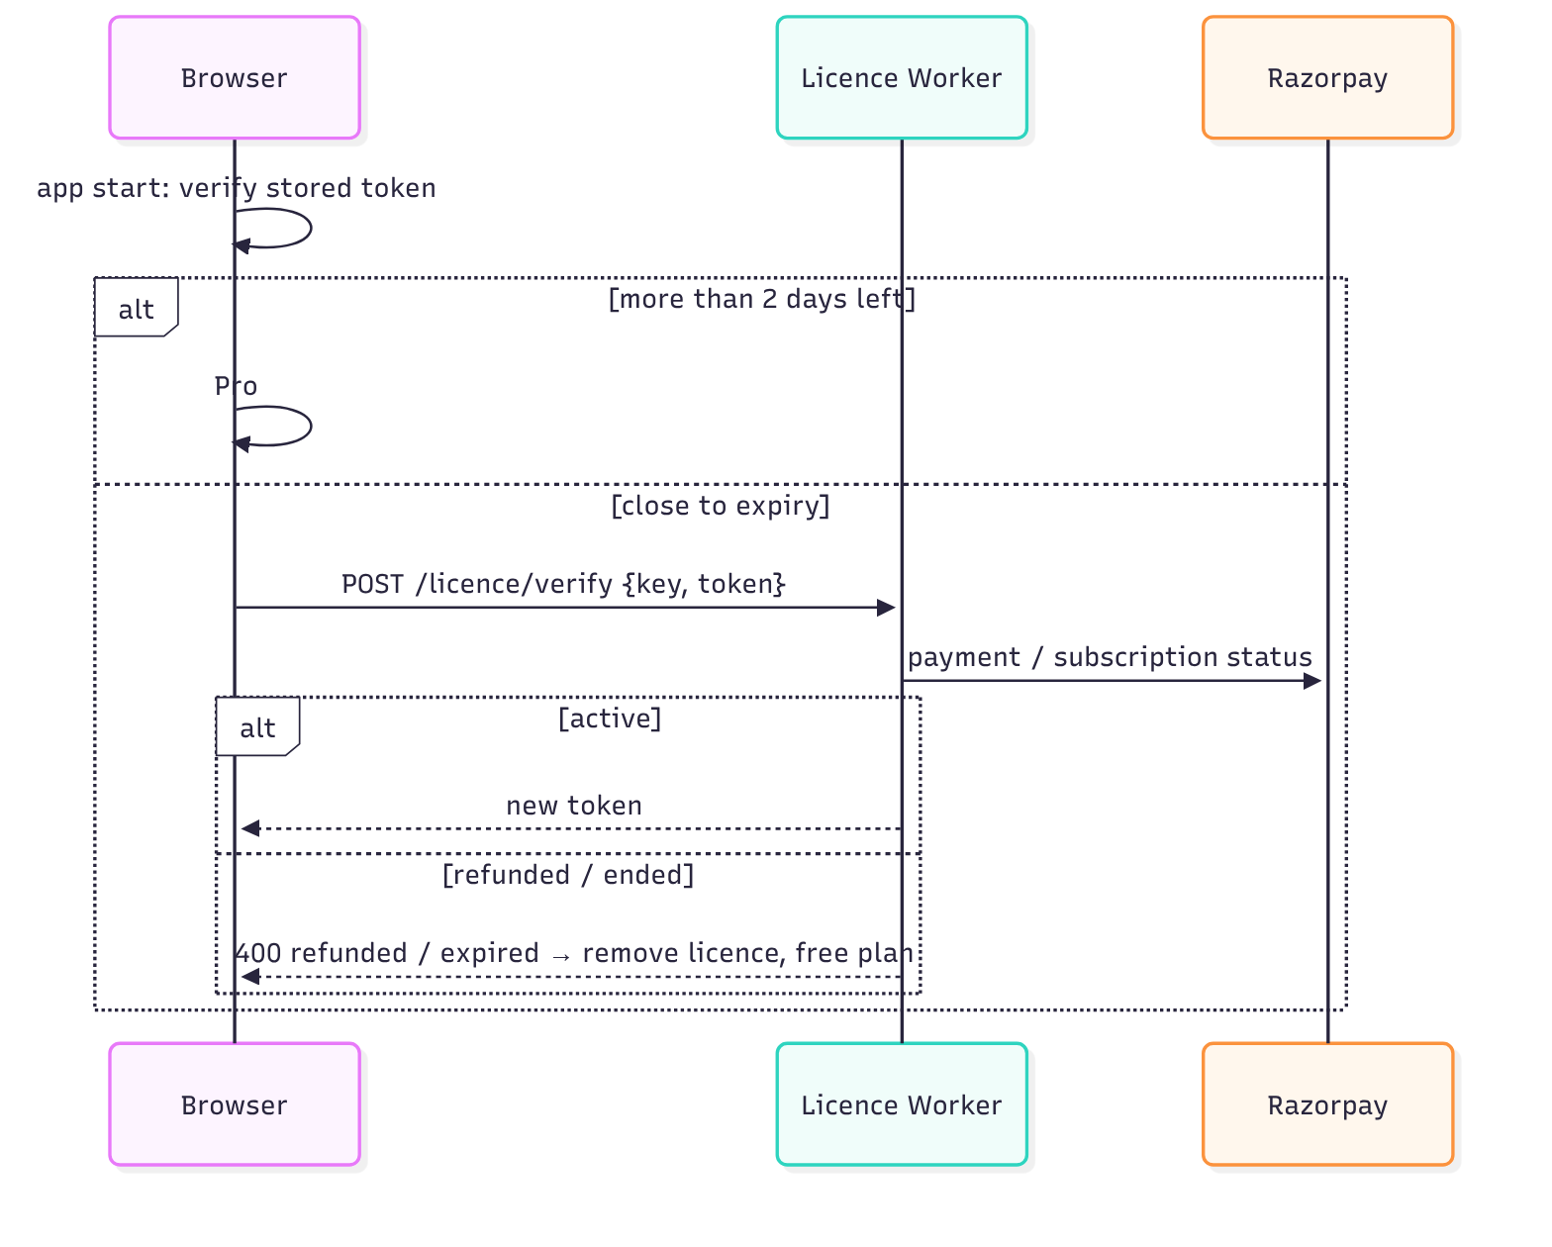

9. Error handling & logging
Engines never throw for bad numbers; infeasible plans return feasible: false with a plain-English reason shown in a danger notice. Storage failures (private mode, quota) are swallowed: the session keeps working. The Worker logs one scrubbed line per request (no IP, body, query, or key in clear).

10. Accessibility
Every input has a visible label; result values have test ids and text equivalents; the score ring has role="img" with an aria-label; toggles use aria-pressed; colour is never the only signal (status text accompanies bars); the disclaimer uses normal text size and AA contrast.

