PSG COLLEGE OF TECHNOLOGY, COIMBATORE – 641 004 DEPARTMENT OF COMPUTER APPLICATIONS
Academic Year 2025-2026 MCA G1 & G2 Sem 4
23MX41- Project Work
Software Requirement Specification (SRS) Document

- Title of the Project

EMERGENT – A competitive platform for executing and ranking autonomous
agents in dynamic environments.

- Student Detail

Roll No. | Name of the Student | Name of the Faculty Guide | Name of the Industry Guide
24MX125 | SHARUN A | Dr. R. Manavalan

- Project Goal

The primary goal of this project is to design and develop EMERGENT, a comprehensive competitive programming platform that fundamentally shifts the paradigm of algorithmic assessment. While traditional platforms focus on static, isolated problem-solving, this project aims to evaluate developer proficiency through dynamic, adversarial simulations. The core objective is to move beyond binary "pass/fail" metrics and instead measure a developer's ability to create autonomous agents that can adapt to changing environments, manage limited system resources, and counter active opponent strategies in real-time.
From a technical perspective, the project seeks to engineer a robust and fully deterministic execution environment. A critical goal is to solve the engineering challenge of running untrusted user code in a secure, isolated manner without compromising the speed or fairness of the competition. By leveraging containerization technologies, the system aims to ensure that every match is mathematically reproducible. This "determinism" is essential for the platform's debugging capabilities, allowing users to analyze their failures with precision—a feature often missing in existing competitive gaming platforms.
Furthermore, EMERGENT is designed to bridge the significant gap between theoretical computer science education and practical system engineering. The project aims to provide a standardized framework for skill assessment that is valuable to both academic institutions and technical recruiters. By implementing "Tiered Benchmark Bots," the platform intends to offer an objective baseline for competence, allowing for the generation of Elo-based skill ratings that reflect a candidate's absolute engineering maturity. Ultimately, the goal is to foster a learning environment that rewards resilience and strategic foresight, capabilities that are essential for modern software engineering but difficult to assess through conventional written exams.

- Project Abstract
In the current landscape of computer science education and technical recruitment, the evaluation of algorithmic proficiency is predominantly tethered to static problem-solving models. Traditional competitive programming platforms evaluate code against a fixed set of pre-defined test cases in isolation, a method that—while effective for teaching fundamental data structures—fails to simulate the chaos and complexity of real-world software engineering. This project identifies a critical gap in how developers are assessed: the inability of current tools to measure adaptability, resource management, and decision-making under adversarial pressure. To address this, we present EMERGENT, a competitive platform designed to execute and rank autonomous agents within dynamic, multi-agent environments.
Unlike standard coding challenges that result in binary "pass/fail" outcomes, EMERGENT shifts the evaluation paradigm to a continuous performance metric based on head-to-head competition. Users are tasked with developing autonomous bots that must parse complex game states, predict opponent strategies, and execute logic in real-time. To support this, the platform utilizes a sophisticated, custom-built execution engine based on containerization technology. This ensures that every match is run in a secure, isolated sandbox and is fully deterministic, meaning every interaction is mathematically reproducible. This determinism allows the platform to provide a "Flight Recorder" style debugging system, enabling developers to step through match replays frame-by-frame to identify the exact moment their logic failed.
The platform is designed to serve a dual purpose for two distinct user groups: aspiring developers and technical recruiters. For students, it provides an advanced learning environment that rewards code resilience and strategic foresight over rote memorization. For recruiters, the integration of "Tiered Benchmark Bots" creates a standardized framework for assessment, offering a tangible, objective metric of a candidate’s engineering maturity. Ultimately, EMERGENT aims to democratize access to high-quality system design training, providing a robust proving ground where the next generation of software engineers can demonstrate their ability to build systems that not only function but survive and thrive in uncertain conditions.

- Existing System
The current landscape of automated programming assessment is dominated by two primary categories: static algorithmic problem solvers and gamified coding platforms. A review of existing literature and market solutions reveals significant gaps in testing real-world engineering resilience.
1. Static Algorithmic Platforms (LeetCode, HackerRank) Platforms such as LeetCode and HackerRank are the industry standard for technical recruitment and skill assessment. They operate on a Static Analysis and Unit Testing model, where a user's code is evaluated against a fixed set of pre-defined input/output cases. While effective for assessing basic proficiency in Data Structures and Algorithms (DSA), recent studies highlight that these platforms fail to simulate "day-to-day" engineering challenges. The evaluation is binary (Pass/Fail) and isolated, meaning the code never interacts with external systems or active adversaries. This limits the ability to test for adaptability or system design skills, as the environment is perfectly predictable.
2. Gamified Coding Platforms (CodinGame) To address the lack of engagement in static platforms, services like CodinGame introduced gamification elements. These platforms use visual feedback and "bot battles" to motivate learning. Research indicates that such gamified environments significantly improve student retention and cognitive engagement compared to traditional methods. However, a key limitation identified in the literature is the "Relative Skill" problem. Most of these platforms rank users solely against each other without a standardized baseline. Without "Tiered Benchmark Bots" (calibrated AI opponents), it is difficult for recruiters to determine a candidate's absolute skill leve, a high rank might simply mean the user played against weak opponents.
3. The Gap: Dynamic vs. Static Testing There is a fundamental difference between checking if code is correct (Static) and checking if a system is robust (Dynamic). Literature on software testing emphasizes that static testing allows for early defect detection but cannot uncover runtime anomalies caused by race conditions, resource exhaustion, or adversarial inputs. EMERGENT addresses this gap by implementing a Dynamic Execution Engine. Unlike the "Black Box" execution of existing platforms, EMERGENT’s proposed architecture utilizes containerized, deterministic simulations to provide a "White Box" replay system, allowing for the deep debugging capabilities that are currently absent in the market.

- Project Flow Analysis
This diagram illustrates the end-to-end workflow of the EMERGENT platform. It details the asynchronous interaction between the User Interface (Frontend), the Main Orchestration Server (Backend), and the Deterministic Execution Engine (Docker). The flow captures the critical path from code submission and syntax validation to the generation of the match replay JSON, handling both successful executions and runtime exceptions.

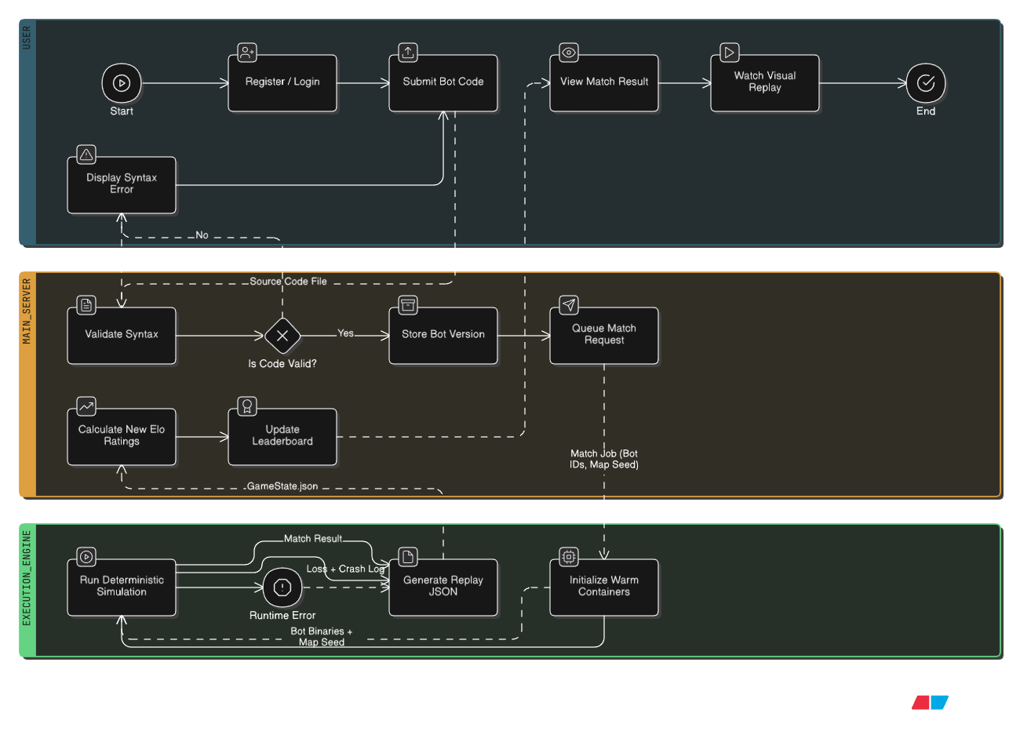

- Outcome of the Proposed Project
The successful completion of the EMERGENT project will result in the deployment of a fully functional, competitive programming ecosystem. The specific outcomes of this implementation are categorized into technical deliverables and functional impact:
1. Deployment of a Deterministic Execution Engine The primary technical outcome is the creation of a containerized "Referee System" capable of running untrusted user code in isolation. This engine successfully demonstrates the feasibility of "Warm Pool" architecture to reduce startup latency in serverless environments, providing a scalable model for low-latency, high-security code execution.
2. A Standardized Skill Assessment Framework The project delivers a quantifiable metric for "engineering resilience." Unlike traditional platforms that offer a binary "Solved/Not Solved" status, EMERGENT produces a Continuous Elo Rating for every user. This outcome provides academic evaluators and recruiters with a more granular tool to assess a candidate's absolute skill level relative to fixed benchmarks (Tier 1–3 Bots).
3. Enhanced Debugging Capabilities (The "Flight Recorder") The platform creates a new standard for debugging in competitive environments by generating Turn-by-Turn Replay Logs (JSON). This outcome empowers users to perform "White Box" testing on their algorithms, allowing them to visualize exactly why a specific strategy failed in a dynamic environment—a learning outcome currently unavailable in standard "Black Box" testing platforms.
4. Creation of a "Live" Learning Environment The final outcome is an active, community-driven platform where students can compete in real-time. This shifts the learning process from solitary memorization to active, adversarial problem solving, resulting in students who are better prepared for the complexities of distributed systems and game theory.

- Modules of the Proposed Project – Functional Requirements
The EMERGENT platform is divided into four distinct functional modules. Each module handles a specific aspect of the user workflow and system architecture.

Module 1: User Interface & Bot Management (Frontend)
This module acts as the primary interaction layer for students and developers.
- Integrated Development Environment (IDE): The system shall provide an embedded code editor (powered by Monaco Editor) with syntax highlighting and line numbering for Python/C++.
- Bot Submission & Versioning: Users shall be able to save multiple versions of their bot code.
- Dashboard & Statistics: The interface shall display the user's current Elo rating, win/loss ratio, and a history of recent matches.

Module 2: Matchmaking & Orchestration (Backend)
This module manages the logic of pairing opponents and scheduling games.
- Asynchronous Match Queue: The system shall utilize a priority queue (Redis) to handle incoming match requests without blocking the main server threads.
- Skill-Based Pairing: The matchmaking algorithm shall automatically pair users with opponents of similar Elo ratings
- Leaderboard Management: The system shall calculate new ratings after every match using the Elo formula and update the global leaderboard in real-time.

Module 3: The Execution Engine (The "Referee")
This is the core technical module responsible for running the code securely.
- Containerized Isolation: The system shall execute every match inside an ephemeral Docker container. This ensures that a user’s code cannot access the host file system or network.
- Warm Pool Strategy: The engine shall maintain a pool of pre-initialized, paused containers to ensure match startup latency is under 500ms.
- Deterministic Simulation: The game engine must process inputs (bot commands) sequentially and deterministically. Given the same random seed and bot inputs, the engine must always produce the exact same match result.

Module 4: Replay & Visualization System
This module handles the post-match analysis features.
- JSON Log Generation: Upon match completion, the execution engine shall generate a GameState.json file containing the turn-by-turn history of the game.
- Visual Replay Player: The web interface shall parse the JSON log to render a graphical, step-by-step replay of the match, allowing users to pause, rewind, and inspect the state of the board at any specific tick.

- Non- functional requirements of the Project
To ensure the "EMERGENT" platform is viable for academic and competitive use, the system must adhere to the following quality constraints:
1. Security & Isolation (Critical)
- Sandboxing: All user-submitted code must be executed within strictly isolated Docker containers. The system must prevent "container escape" attacks and restrict access to the host network and file system.
- Resource Quotas: To prevent Denial of Service (DoS) attacks from infinite loops or memory leaks, every bot execution must be capped at 512MB of RAM and 1.0 seconds of CPU time per turn. If a bot exceeds these limits, it must be forcefully terminated immediately.
2. Performance & Latency
- Startup Time: The time between a match request and the first turn of simulation must be less than 2 seconds. This is achieved using the "Warm Pool" strategy to avoid cold-start delays.
- UI Responsiveness: The web interface must load the dashboard and code editor in under 1.5 seconds on a standard 4G network.
- Leaderboard Updates: Global rankings must update within 5 seconds of a match concluding to maintain real-time engagement.
3. Reliability & Determinism
- Reproducibility: The system must guarantee 100% Determinism. If a match is re-run with the same bot code and the same random seed, the outcome must be bit-for-bit identical to the original match. This is non-negotiable for the replay system to be valid.
- Availability: The platform should maintain 99% uptime during scheduled tournament windows.
4. Scalability
- Concurrency: The backend architecture must support a minimum of 50 concurrent matches (100 active Docker containers) on the standard deployment hardware without degrading simulation speed.
- Queue Management: The system must handle sudden spikes in submissions (e.g., during a deadline) by gracefully queuing jobs rather than crashing.
5. Usability
- Error Clarity: Syntax error messages returned to the user must be parsed and presented in a human-readable format, highlighting the specific line number in the Monaco Editor.

- Project Deliverables
Upon the successful completion of the EMERGENT project, the following deliverables will be submitted:
1. The EMERGENT Web Platform (Source Code)
- A fully responsive web application built with React.js, featuring user authentication, profile management, and the integrated Monaco Code Editor.
- The complete frontend codebase, including the logic for real-time WebSocket communication and the dynamic leaderboard UI.
2. The Deterministic Execution Engine (Backend Service)
- The backend orchestration system built with Python (FastAPI) and the containerization logic using Docker.
- This includes the "Warm Pool" management scripts and the game simulation logic that enforces the rules of the competitive environment.
3. The Interactive Replay System
- A visualization module capable of parsing the JSON Game State Logs.
- This tool allows users and evaluators to watch a graphical, turn-by-turn replay of any match played on the platform for verification and debugging purposes.
4. Standardized Benchmark Bot Suite
- A collection of three pre-programmed autonomous agents (Tier 1: Random Mover, Tier 2: Greedy Algorithm, Tier 3: Minimax Strategy).
- These bots serve as the fixed "Rulers" against which student code is measured to generate the initial Elo ratings.
5. Project Documentation
- User Manual: A guide for students on how to register, use the API methods, and submit their first bot.
- System Architecture Document: Technical documentation detailing the API endpoints and the setup instructions for deploying the platform on a local server (LAN) or cloud instance.

- Technology to be used
The EMERGENT platform utilizes a modern, microservices-oriented technology stack to ensure high-performance concurrency and strict security isolation. By decoupling the interface, orchestration, and execution layers, the system allows for independent scaling. This architecture specifically addresses the critical engineering challenge of executing untrusted code securely while maintaining a responsive, real-time user experience.

1. Frontend: React.js (JavaScript Library)
- Role: Used to build the dynamic Single Page Application (SPA), including the user dashboard and match visualization.
- Reason for Choice: React was chosen for its Virtual DOM and efficient state management. Since the platform requires real-time updates for the leaderboard and frame-by-frame rendering of match replays, React’s ability to selectively re-render components minimizes browser load. Additionally, its component-based architecture allows for the seamless integration of complex third-party tools like the Monaco Editor (the engine powering VS Code), providing a professional coding experience within the browser.

2. Backend: Python (FastAPI Framework)
- Role: Acts as the main orchestration server handling API requests, authentication, and communication with the execution engine.
- Reason for Choice: Python was selected for its extensive ecosystem in data science and ease of prototyping. FastAPI specifically was chosen over Django or Flask because of its native support for Asynchronous I/O (ASGI). This allows the server to handle thousands of concurrent match requests and WebSocket connections without blocking threads, which is critical for a high-traffic competitive platform.

3. Database Layer: PostgreSQL & Redis
- Role: Hybrid data storage strategy.
- Reason for Choice:
  - PostgreSQL: Chosen for its strict relational integrity and ACID compliance. It is used to store critical persistent data such as User Profiles, Authentication Credentials, and Match History where data consistency is paramount.
  - Redis: Chosen as an in-memory message broker. It is used to manage the Job Queue for the execution engine and to cache the Real-Time Leaderboard. Its sub-millisecond read/write speeds allow for instant ranking updates that a traditional SQL database could not handle efficiently under load. This is very essential as the responsiveness of the system would depend very heavily upon the match queue and the queuing algorithm which would need the redis in memory database to work.

4. Execution Infrastructure: Docker
- Role: Provides the sandboxed environment for executing user-submitted code.
- Reason for Choice: Docker is the cornerstone of the platform’s security. It allows the system to isolate untrusted user code in ephemeral containers, preventing access to the host file system or network. It also ensures Reproducibility; by defining the exact OS and library versions in a Dockerfile, we guarantee that code runs exactly the same way on the server as it does on a developer's local machine, eliminating "it works on my machine" errors.

12) Timeline of Activities planned/completed

Sprint | Duration | Module | Key Activities
Sprint 1 | Dec 08 – Jan 10 | System Analysis & Design | • Requirement gathering and SRS documentation.  • Definition of System Architecture (BPMN).  • Setup of Development Environment (GitHub, Docker).  • Frontend UI/UX Prototyping (Figma & React Setup).
Sprint 2 | Jan 12 – Feb 14 | Core Backend Implementation | • Development of Python (FastAPI) Orchestration Server.  • Implementation of Database Schemas (PostgreSQL & Redis).  • Creation of the "Warm Pool" Docker Management System.  • Implementation of User Authentication (JWT) as well as allow guest users.
Sprint 3 | Feb 16 – Mar 20 | Integration & Testing | • Integration of React Frontend with Backend APIs.  • Development of the "Replay Visualization" Module.  • Programming of Tier 1–3 Benchmark Bots.  • End-to-End System Testing & Bug Fixes.  • Final Project Report Generation.



Signature of the Student Signature of the Guide

