Multivariate Copula Analysis Toolbox (MvCAT)

Purpose: MvCAT is developed in Matlab as a user-friendly toolbox (software) to help scientists and researchers perform rigorous and comprehensive multivariate dependence analysis. It uses 25 copula families with 1 to 3 parameters to describe the dependence structure of two random variables. MvCAT uses local optimization and Markov chain Monte Carlo simulation within a Bayesian framework to infer the parameter values of the copula families by contrasting them against available data (empirical bivariate probabilities). If Bayesian analysis with MCMC simulation is performed, an estimate of uncertainty for each copula family can be obtained from the posterior distribution of copula parameters. MCMC within Bayesian framework not only provide a robust estimate of the global optima, but also approximate the posterior distribution of the copula families which can be used to construct a prediction uncertainty range for the copulas. Local optimization methods are prone to getting trapped in local optima (see Sadegh et al., 2017 for more information).
The user can select any subset of the available 25 copulas and MvCAT will perform the analysis and rank the selected copula families based on their performance. Performance metrics used in this toolbox are Likelihood, Akaike Information Criterion (AIC), Bayesian Information Criterion (BIC), Nash-Sutcliffe Efficiency (NSE), and Root Mean Squared Error (RMSE). While Likelihood, NSE and RMSE only focus on minimizing the residuals between observations and model simulations, the other metrics take into consideration additional criteria. For example, AIC takes into account the model complexity and BIC account for model complexity and number of observations.
New version of MvCAT also include “pvalue” estimation using Monte Carlo analysis. The null hypothesis is that $"H_{0}= C_{n} ϵ C_{θ}"$ i.e. underlying copula (represented by empirical copula;$C_{n}$) is a member of parametric copula ($C_{θ}$)
If p-value is <= 0.05 null hypothesis is rejected
If p-value > 0.05 the null hypothesis cannot be rejected

It is noteworthy that marginal distribution of each variable is modeled using best of the fitted (1) Beta, (2) Birnbaum-Saunders, (3) exponential,(4) extreme value, (5) Gamma, (6) generalized extreme value, (7) generalized Pareto, (8) inverse Gaussian,(9) logistic, (10) log-logistic, (11) lognormal, (12) Nakagami, (13) normal, (14) R ayleigh, (15) Rician, (16) t loca-tion scale, and (17) Weibull distributions (listed alphabetically). Best marginal is selected according to BIC. These marginal distributions are used to back-transform from probability space to original data space. However, to construct copulas, only the empirical univariate probabilities are used.

Reference:
Sadegh, M., Ragno, E. and AghaKouchak, A. (2017), Multivariate Copula Analysis Toolbox (MvCAT): Describing dependence and underlying uncertainty using a Bayesian framework. Water Resources Research, 53, doi:10.1002/2016WR020242
Link: http://onlinelibrary.wiley.com/doi/10.1002/2016WR020242/epdf

Sadegh, M., Moftakhari, H.,
Gupta, H. V., Ragno, E., Mazdiyasni, O.,
Sanders, B., Matthew, R.,
& AghaKouchak, A. (2018).
Multihazard scenarios for analysis
of compound extreme events.
Geophysical Research Letters, 45.
https://doi.org/10.1029/2018GL077317
Sadegh, M., Moftakhari, H.,
Gupta, H. V., Ragno, E., Mazdiyasni, O.,
Sanders, B., Matthew, R.,
& AghaKouchak, A. (2018).
Multihazard scenarios for analysis
of compound extreme events.
Geophysical Research Letters, 45.
https://doi.org/10.1029/2018GL077317
Sadegh, M., Moftakhari, H.,
Gupta, H. V., Ragno, E., Mazdiyasni, O.,
Sanders, B., Matthew, R.,
& AghaKouchak, A. (2018).
Multihazard scenarios for analysis
of compound extreme events.
Geophysical Research Letters, 45.
https://doi.org/10.1029/2018GL077317
Sadegh, M., Moftakhari, H.,
Gupta, H. V., Ragno, E., Mazdiyasni, O.,
Sanders, B., Matthew, R.,
& AghaKouchak, A. (2018).
Multihazard scenarios for analysis
of compound extreme events.
Geophysical Research Letters, 45.
https://doi.org/10.1029/2018GL077317
Sadegh, M., Moftakhari, H., Gupta, H. V., Ragno, E., Mazdiyasni, O., Sanders, B., Matthew, R., & AghaKouchak, A. (2018). Multihazard scenarios for analysis of compound extreme events. Geophysical Research Letters, 45. https://doi.org/10.1029/2018GL077317

How to Run:
Make sure to change the directory of matlab, to the directory where you have saved MvCAT files in.
The package comes with a Graphical User Interface (GUI) and the source scripts. Please follow the instructions for each:
- GUI: Run either “Run_MvCAT_GUI.m” or “MvCAT.m” in matlab to open up the graphical user interface.

In the GUI, select the input data by browsing through “Browse Data” button, and select all or any subset of copulas. (In order to choose several copulas, hold “Ctrl” button and click on the desired copulas). The default setting tries all built in copulas (“All”) for analysis. The next step is to either select “Local Optimization” OR “Local Optimization and MCMC”. The latter offers a more rigorous parameter estimation and uncertainty analysis but it takes longer than the local optimization approach. The next step is to choose whether you like to see empirical bivariate probability isolines in your final figure. The default setting does not show the empirical probabilities. Finally, click “Run simulation & create graphs”.

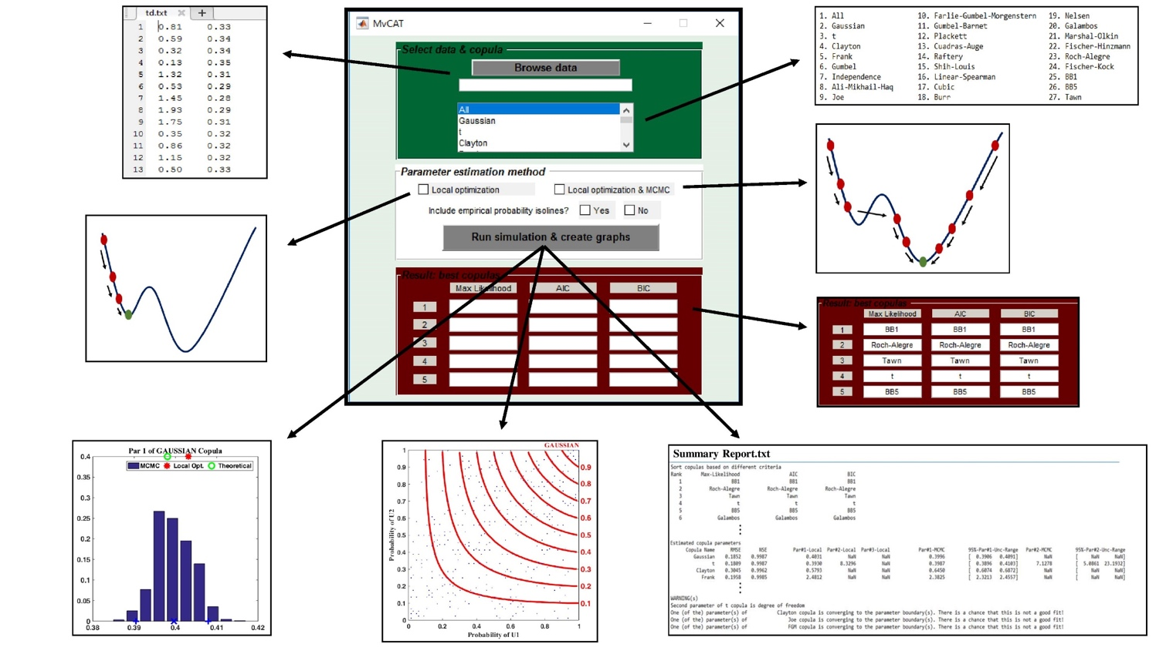

2. Script: If you do not want to run GUI, you can still run MvCAT scripts. This is especially helpful if you want to run MvCAT many times. To run the script, run “Run_MvCAT_Script.m” in matlab. You should first modify the script by linking to the input data. Within the script, select whether you want to see the bivariate empirical probability isolines, choose the type of parameter estimation algorithm, and select the ID of copulas to be considered. Please follow the comments in the script for any modification. Failure to follow the comments may result in error warnings in matlab.

Input:
Input file is a text file (“.txt” format) containing two variables (in two columns) without any header. Variables should be in the original space, and not transformed to the probability space! The current version of MvCAT only works for bivariate analysis. Efforts are underway to further develop the package for higher dimensions.

Outputs:
Outputs include figures (“.fig” format) that depict posterior distribution of selected copula parameters, if MCMC is selected, as well as probability isoline (0.1-0.9) figures in the probability space and in the actual variable space. Return period isolines are also provided. The same figures will be saved into a folder entitled “Results” with a “.png” format. MvCAT will also write a text file and report out the performances of different copulas based on Likelihood value, AIC and BIC. The summary report also includes the NSE and RMSE associated with each copula family as well as their parameter values and their uncertainty ranges, if MCMC is selected. Note that all metrics reported are associated with MCMC best parameter set, if this option is selected. Finally, potential warnings will be reported, such as if a parameter value hits the boundary limit, or if a copula is not a good fit for the data.

Remarks:
Figures are save with the option of “visible” being “off”. Users should use one of the following to open “.fig” files and see them:
a. Open the figure (double click) and then execute set(gcf,’visible’,’on’)
b. openfig('filename.fig','new','visible')

