1)

using System;  
  
namespace Lern_pract_2._1  
{  
 public class Program  
 {  
 public static void Main(string[] args)  
 {  
 string S = "Якудза";  
 string J = "Фудзи";  
 int count = 0;  
 for (int i = 0; i < S.Length; i++)  
 {  
 for (int g = 0; g < J.Length; g++)  
 {  
 if (J[g] == S[i])  
 {  
 count += 1;  
 }  
 }  
   
 }  
 Console.WriteLine(count);  
 }  
 }  
}

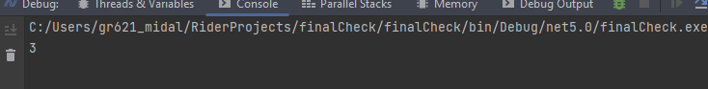

2)

using System;  
using System.Collections.Generic;  
  
namespace Lern_pract_2._1  
{  
 public class Program  
 {  
 public static void Main(string[] args)  
 {  
 *// Нуууу хз наверно надо лучше что-то сделать, потому что это какашечка!!!!* List<int> candidates = new List<int>() {1,2,3,4,5};  
 int target = 7;  
 *//List<int> result;* String result = "";  
 for (int i = 0; i < candidates.Count; i++)  
 {  
 if (candidates[0] + candidates[i] == target)  
 {  
 result = $"{candidates[0]} + {candidates[i]}";  
 Console.WriteLine(result);  
 }  
  
 if (candidates[0] + candidates[1] + candidates[i] == target)  
 {  
 string resultS = $"{candidates[0]} + {candidates[1]} + {candidates[i]}";  
 Console.WriteLine(resultS);  
 }  
   
 if (candidates[0] + candidates[1] + candidates[2] + candidates[i] == target)  
 {  
 string resultS = $"{candidates[0]} + {candidates[1]} + {candidates[2]} + {candidates[i]}";  
 Console.WriteLine(resultS);  
 }  
   
 if (candidates[0] + candidates[1] + candidates[2] + candidates[3] + candidates[i] == target)  
 {  
 string resultS = $"{candidates[0]} + {candidates[1]} + {candidates[2]} + {candidates[3]} + {candidates[i]}";  
 Console.WriteLine(resultS);  
 }  
 }}  
 }  
}

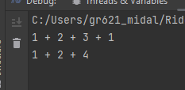

3)

using System;  
using System.Collections.Generic;  
  
namespace Lern_pract_2._1  
{  
 public class Program  
 {  
 public static bool func(int[] nums)  
 {  
 for (int i = 0; i < nums.Length; i++)  
 {  
 for (int j = i + 1; j < nums.Length; j++)  
 {  
 if (nums[i] == nums[j])  
 {  
 return true;  
 }  
 }  
 }  
 return false;  
 }  
   
   
 public static void Main()  
 {  
 int[] nums = new[] { 1, 2, 3, 4, 5, 6, 7, 2 };  
 func(nums);  
 Console.WriteLine(func(nums));  
 }  
 }  
}

