Form: TMV1  Issue No 15  Issue Date: DEC 2015 | 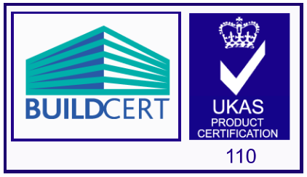 | 

BUILDCERT THERMOSTATIC MIXING VALVE SCHEMES TMV2 & TMV3 APPROVAL

1. Thank you for your recent enquiry, the information below explains the Scheme’s procedures and requirements. The application form TMV2 and/or TMV3, as appropriate, must be completed and returned to the scheme administrator to progress the TMV approval sjohnson@nsf.org

1.1 Applicants agree to abide by the terms and conditions of the scheme and associated audit procedures by submitting an Application Form (TMV2 or TMV3). Details of the terms and conditions and the audit procedures are available from the TMV section of the BuildCert website (www.buildcert.com).

2. The BuildCert Thermostatic Mixing Valve Scheme assesses the performance requirements of thermostatic mixing valves against one of the following standards.

- TMV2 approval, EN 1111 and or EN 1287
- TMV3 approval, Department of Health performance specification D 08

The Scheme’s requirements are as follows:

- Initially, and after every 5 years the thermostatic valve shall meet the performance requirements detailed above in either, 2. a) or b), dependent upon TMV2 or 3 approval.
- Initially and annually thereafter the manufacturer/factor has an ISO 9001 quality system in place. Where this is not available BuildCert shall conduct its own quality audit.
- The thermostatic mixing valve satisfies the BuildCert performance audit requirements (audit testing within the 5 years approval period)

3. GENERAL INFORMATION

  - An applicant can be either a manufacturer or a factoring agent. Whichever party pays the test fee of a successful application shall own the licence. Where the same product is sold by a number of factoring agents each individual agent shall possess a licence with their own unique product reference.

  - The manufacturer and / or factor, must have in place an ISO 9001 BuildCert recognised quality system. Where this is not available BuildCert shall conduct its own quality audit.

  - Information about the valve’s Installation and Maintenance (I&M) must be provided with the valve. This can be full information provided on paper, or partial information being provided on paper and the remaining information being provided electronically. Electronic versions of the I&M documents must be made available on the manufacturer’s website and a link will be provided by BuildCert from the approved TMV list.

The following installation requirements that detail the exact operating conditions of the valve must be supplied with the valve.

These are:
- Operating conditions of the valve
- NOTE: Valves operating outside these conditions cannot be guaranteed by the Scheme to operate as Type 2 valves
- The valves designation(s) of use
- Statement that further details and a full Installation document can be obtained from a designated website, and a link be provided
For full details upon the information that must be included within the I&M document refer to the BuildCert website www.buildcert.com or contact the Scheme Manager.

3.4 TMV3 valves must be identified by a unique identification mark that is permanent and legible. If the marking if applied to a detachable part of the valve e.g. a cap or indice, this detachable part shall be attached to the valve by means of a fixing that requires a tool other than a standard screwdriver to remove it.

Note: the unique identification cannot be:
- Located where disconnection of the hot and cold pipework is required to verify the product by its unique identification mark.
- Located on the water supply pipe.
- Located in such a position that it requires isolation of the water supply and disassembly to verify the product by its unique identification mark.

3.5 The Technical Assessment Panel (TAP) comprises independent experts who, if necessary, confirm the test and audit requirements and review the test and audit reports and any additional requirements of the scheme in accordance with BuildCert policies.

3.6 The laboratory undertaking the testing must be registered with BuildCert. Laboratories shall comply with the BuildCert Guidance Document BGD01 and be ISO 17025 accredited by UKAS (or equivalent) with a scope of accreditation that includes D 08 (TMV3) and/or EN 1111 and EN 1287 (TMV2). BuildCert will require inter-laboratory trials and details of the laboratory procedures (in English) for testing to D 08 and reserve the right to carry out site inspections as necessary. For testing to EN 1111 and EN 1287 BuildCert reserve the right to require inter-laboratory trials and to carry out site inspections, as necessary. The list of approved test laboratories can be found in Appendix A.

3.7 Conditions of use for Type 2 and Type 3 valves

 | Low Pressure TMV2  EN 1287 | High Pressure TMV2  EN 1111 | Low Pressure TMV3  DH Spec D 08 | High Pressure  TMV3  DH Spec D 08
Maximum Static Pressure (bar) | 10 | 10 | 10 | 10
Flow Pressure, Hot & Cold (bar) | 0.1 to 1 | 0.5 to 5 | 0.2 to 1 | 1 to 5
Hot Supply Temperature (°C) | 55 to 65 | 55 to 65 | 55 to 65 | 55 to 65
Cold Supply Temperature (°C) | ≤ 25 | ≤ 25 | 5 to 20 | 5 to 20

NOTE: Valves will not be approved for any conditions of use (see appropriate Table) for which testing has not been undertaken. Therefore licenced valves operating outside these conditions cannot be guaranteed by the Scheme to operate as Type 2 or 3 valves.

4. SUBMISSION OF APPLICATION

  - An applicant wishing to submit a Thermostatic Mixing Valve for BuildCert approval must complete the appropriate Application Form TMV2 or TMV3, and return this to the Scheme Administrator at: BuildCert Ltd. Unit 30 Fern Close. Pen-y-Fan Industrial Estate. Oakdale. Gwent. NP11 3EH. United Kingdom.
Alternatively email sjohnson@nsf.org or ptaylor@nsf.org

4.2 A copy of the applicant’s ISO 9001 quality assurance certificate, with accompanying scope of certification must be supplied. Where this is not available then BuildCert shall conduct its own quality audit.

  - Only production valves will be considered for certification by the scheme.

5. TEST REQUIREMENTS

  - Type 2 Valves (TMV2) will be tested in accordance with the standards EN 1111:1999 “Sanitary tapware Thermostatic mixing valves (PN 10). General technical specification” and/or EN 1287:1999 “Sanitary tapware Low pressure thermostatic mixing valves General technical specifications “. (Acoustic testing is excluded unless otherwise requested by the client). Valves for Bath and Bidet use will be additionally tested to verify: -

- Cold water isolation at an elevated mixed water temperature of 46ºC
- Temperature override (if provided) is set at the recommended mixed water temperature and when overridden will not provide a mixed water temperature greater than 48 ºC.

  - Type 3 Valves (TMV3) will be tested in accordance with the document “Department of Health Performance Specification D 08: Thermostatic mixing valves (healthcare premises); latest applicable revision.

5.3 Economy flow rate approvals are available for TMV’s having the designations of use bidet, shower and washbasin only.
- For TMV3 approval, the mixed water flowrate must be less than 8 litre/minute.
- For TMV2 approval, economy approval is only applicable to HP valves approved to EN 1111 (excluding bath use), and the mixed water flowrate must be between 4.8 and 12 litre/minute.

5.4 For sample selection for testing, three valves must be selected from a minimum sample batch size of 30 valves. An independent representative (as agreed by BuildCert), a BuildCert auditor, a TAP committee member, or an independent third party approved by the BuildCert shall select the valves for test. Test samples selected shall be kept under the possession and control of the person making the selection and packaged and sealed in their presence. A letter documenting the person(s) making the selection and verifying the chain of custody of the samples must be forwarded to BuildCert for inclusion within the application file.

Note: It is not permissible to transport valves by air without adequate protection against damage e.g. by freezing or depressurisation, as the performance of the valve may be affected.
BuildCert will retain one sample for comparison with future production batches as required.

5.5 Valves will be required to undergo/comply with the following:

a) Mechanical testing. Tests will not commence until the test laboratory has received the testing requirements designated by BuildCert and the tests for the effects on water quality have been verified as being acceptable unless instructed otherwise by the client). Applicants are notified that it may be necessary to destroy or mutilate a fitting for the purpose of examination or test.

b) Have a current WRAS approval, or the non metallic materials in contact with water are verified by BuildCert as complying with BS 6920 and the Guidance on the Requirements for Approval of Non-Metallic Materials in Fittings, Appendix A.

5.6 Communication with the designated test laboratory and the payment of the laboratory’s testing fee are the responsibility of the applicant, who shall arrange for the Scheme to be provided with a copy of the test report.

5.7 Any applicant who submits a valve to the Scheme, which is advertised as having TMV3 approval without possessing a current certificate, must understand that a new unique product identity will be required before certification will be granted. Similarly, TMV2 approval cannot be claimed until the certificate has been issued. The Schemes use of the BuildCert logos (BuildCert Guidance Document - BGD 03) is available on the BuildCert website www.buildcert.com

6. SCHEMES PROCEDURES

  - TMV3 approval, each application for a product type must be made on a separate TMV3 form including all the designations of use.

  - TMV2 approval, each application for a product type must be made on a separate TMV2 form and must indicate the pressure application (high or low pressure, or both) for the valve.

  - When a completed Application Form has been received the Scheme Administrator/Manager will review the information supplied and agree with the TAP (if appropriate) the testing schedule, verify the applicants Quality System (ISO 9001) and arrange a BuildCert audit if required. The applicant will then be issued with a letter detailing the BuildCert sample number, issues to be resolved, testing to be undertaken and an administration invoice.

  - Applications will be cancelled which have been on the Scheme’s files for more than twelve months.

  - It is a pre-requisite of the BuildCert/TMV Scheme that the valve(s) must be either WRAS approved or the non-metallic materials in contact with water must be verified by Buildcert as being compliant with BS 6920 and Water Industry Guidance before TMV2 or TMV3 approval can be granted. Factored valves may rely upon the primary products WRAS approval if sufficient information is provided to BuildCert.

  - When the tests have been completed the test laboratory will forward the test results and a report to BuildCert along with one test sample (B), which is to be retained by the Scheme (see 5.4). The TAP will then decide as to whether the product passes or fails to meet the requirements of the product standard (EN 1111 and or EN 1287 or D 08) and the additional requirements of the Scheme. Any approval certificate will be based upon the submission date to the TAP Committee. The BuildCert Manager will notify the applicant of the Scheme’s decision and if appropriate request further information or, if successful, an approval letter and certificate will be issued along with the Scheme’s invoice for approval; an additional invoice for professional fees will be attached for additional work above that normally expected for an application, or as and when necessary.

  - If the fitting satisfies all the Scheme’s requirements then a Licence for TMV2 or TMV3 approval will be granted and a description of the product will be entered on the BuildCert/TMV Schemes web site.

  - Approval will relate solely to the valve(s) referred to in the BuildCert approval letter. Statements by applicants in sales literature must refer only to the specifically approved product (s) as designated by the manufacturer’s unique model reference.

  - Annually BuildCert will verify that the licence holder continues to have a recognised quality system in place, or BuildCert will conduct a quality audit.

  - Approved products require audit testing within the 5-year approval period (TMV3 twice, TMV2 once). The license holder will be notified when audit testing is required, an Audit Application Form (Form Audit 1), must be completed and returned to BuildCert who will specify the valves and tests needed for auditing. The license holder must then liaise with the test laboratory to undertake the audit testing.

  - Approval may be withdrawn for the following reasons: -

- Expiration of licence
- Failure of a test audit
- Failure to maintain ISO 9001 certification or a quality system verified by BuildCert
- Reported product failure in service
- License holder’s request
- Accumulation of penalty points for misuse issues

- Breach of specific terms of agreed conditions

6.12 In the event that certification is suspended or withdrawn, the licence holder shall discontinue reference to the valve(s) being certified in promotional and advertising literature.

7.0 ACCESS FOR QUALITY AUDITS

7.1 BuildCert shall be granted access to all facilities and production locations of the Company, except where precluded from doing so by restrictions included in agreements between the Company and BuildCert or by government regulations, and where BuildCert has been notified in advance and is satisfied as to the validity of these restrictions. Refused or delayed access may result in withdrawal of Certification.

8.0 COOPERATION WITH BUILDCERT

8.1 Audit and sampling of Products by BuildCert is for the benefit of the Company as well as in the public interest. While engaged in the performance of these duties, BuildCert shall be given every assistance necessary, and shall have the right to examine all records, equipment, areas, personnel and Company’s subcontractors; and investigation of complaints; bearing upon the duties and responsibilities of BuildCert or the Company with respect to compliance with BuildCert requirements. No BuildCert representative shall be required, nor authorized to make any agreements, waive any rights or privileges, or enter into any compromises as a condition of audit.

8.2 While in a Company's facility, BuildCert representatives shall comply with all applicable health and safety rules and be accompanied by authorized Company personnel. The Company shall notify BuildCert in advance of any health and safety equipment necessary for access to the Company’s facility, or shall provide the necessary health and safety equipment for the BuildCert auditor’s use during the audit, along with instructions for proper use.

8.3 BuildCert auditors may discontinue an audit at a site where their health and safety may be at risk, if they are subject to sexual harassment or discrimination, or the conduct of the Company staff hampers the completion of a valid audit. The Company may, at any time for any reason, require that an auditor of BuildCert leave the facilities of the Company. An auditor shall immediately notify executive management of the Company and BuildCert if an audit is to be discontinued. If an audit is terminated its status is “attempted.”

9.0 COMPANY RECORDS OF COMPLAINTS ABOUT ITS CERTIFIED PRODUCTS

9.1 The Company shall retain a record of complaints and remedial actions taken by the Company since the last on-site audit performed by BuildCert, and shall make the record available to BuildCert upon request.

9.2 All complaints received by the Company, the subject of which is under the Company's control, and referring to Certified Products or services covered by the scope of the Certification provided by BuildCert, are included in this policy. At a minimum, the record shall include:

- The nature of the complaint;
- Identification of the Product and/or services pertinent to the complaint;
- Confirmation that remedial action(s) have been taken; and
- The status (open or closed) of the complaint, as known to the Company.

9.3 All records and other information provided to BuildCert shall remain the property of the Company and be handled by BuildCert as confidential information.

9.4 If the complaint record required is not retained by the Company at the facility location being audited, BuildCert shall be advised by the Company in writing of the location of the record. The Company shall provide the record to BuildCert upon request by whatever means selected by BuildCert.

10. MODIFICATION TO APPROVED PRODUCTS

  - A modification to a listed valve(s) must be made using Application Form TMV2 or TMV3. The exact details of the modification should be stated and highlighted in a general assembly drawing.

  - The TAP will then determine the test requirements for the modified valve(s).

  - If appropriate, Test Reports from the BuildCert approved test laboratory will then be required as well as a sample valve, which is to be retained by the Scheme. The TAP will then agree if the modification can be accepted as having no detrimental effect upon the valves performance.

11. FEES

11.1 The following fees apply:-
- An administration fee invoiced upon receipt of an application
- A certification fee invoiced upon final approval
- A initial listing fee
- Professional fees for additional work above that expected for a TMV application
- An annual BuildCert membership fee
- An annual listing fee per product
- Amendments to approvals and / or certification issues chargeable at the Scheme’s agreed professional rate.

12. COMPLAINTS & APPEALS

  - Complaints and appeals regarding BuildCert should be addressed to the BuildCert Director in the first instance. These are reviewed with the TAP committee as necessary.

  - In the event of there being irreconcilable differences between and applicant and the TAP regarding appeals, these will be forwarded to the Chairman of the BuildCert Advisory Committee for review.
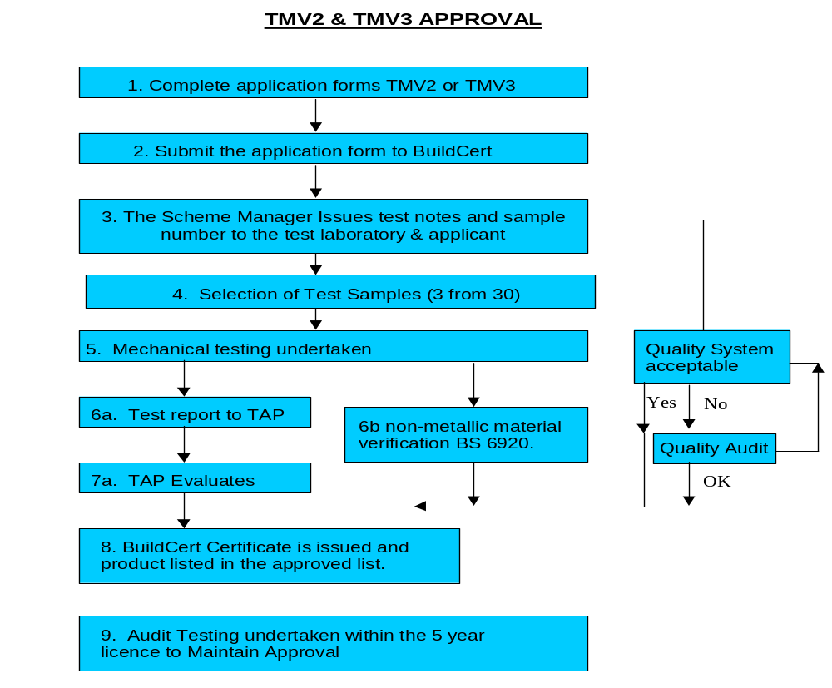

Yes

10. Retest required every 5 years

TAP =Technical Assessment Panel

Appendix A

BuildCert Approved test laboratories
TMV3 and TMV2 TESTING

NSF-WRc Ltd  Unit 30, Fern Close  Pen-y-Fan Industrial Estate  Oakdale  Gwent  NP11 3EH  Tel: 0044 (0)1495 236260  Fax: 0044 (0)1495 249234  Email: rwilliams@nsf.org  All Designations of use | Kiwa N.V  Sir W. Churchill-Iaan 273  Postbus 70  2280 AB Rijswijk  The Netherlands  Tel 0031 704144510  Fax 0031 704144422  Email rob.van.deursen@kiwa.nl  All Designations excluding LP-T44 and T46

