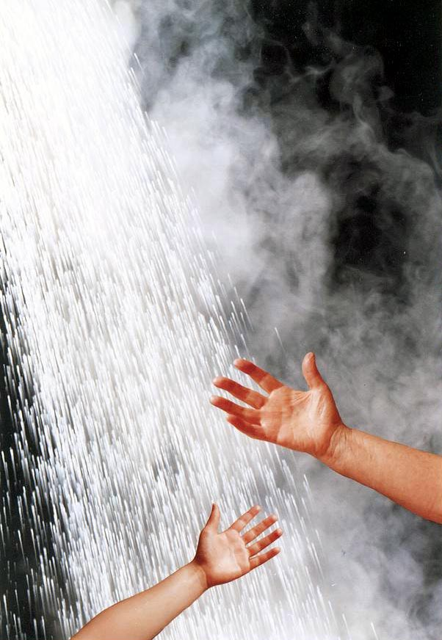

The Easy

Guide to
TMV3

Approval

 | October 2012  Version 1.2  © BuildCert 2012



Introduction
BuildCert approves two categories of Thermostatic Mixing Valves; TMV2 and TMV3. The different valve types are explained in Table 1.
TMV3 approval is for thermostatic valves for use in Healthcare and Commercial installations and certifies that valves comply with the requirements of the NHS specification D 08.

Table 1 Types of valves
Type 1 | a mechanical mixing valve with maximum temperature stop (including single lever taps).
Type 2 | a thermostatic mixing valve which conform to BS EN 1111 and BS EN1287 (originally BS 1415 Part 2). These can have a maximum temperature stop.
Type 3 | a thermostatic mixing valve with enhanced thermal performance complying with NHS Estates requirements D 08.

Pre-approval requirements
The BuildCert approval Scheme requires the following as a pre-requisite for approval.
- All manufacturers and factors must have ISO 9001 accreditation covering valve manufacture, production and handling or be audited by a BuildCert appointed Auditor.
- All BuildCert approval holders must become a subscriber of the BuildCert Scheme.
- The Scheme requires three test valves be selected from a batch of 30 production valves. Valve selection may be undertaken by an independent 3rd party (if this is the case then BuildCert will require a signed declaration from that 3rd party).
- The Installation and Maintenance document (I&M) provided with the valve must include specific information stated by the Scheme (see Section 5).
- Upon gaining approval the valve must meet the Schemes audit requirements (performance tested twice within the 5 year approval period).
Manufacturers of Thermostatic mixing valves can demonstrate compliance with the BuildCert quality requirements by supplying the Scheme with a copy of a valid ISO 9001 certificate and scope of accreditation or an approved quality system. Where this cannot be supplied a quality audit will be conducted by the scheme to verify compliance with the requirements of the Scheme.
A Primary factor is a company/individual who does not manufacture the valve but distributes a certified valve under his own trade name, the product having only cosmetic changes. An approval for the primary factor is sometimes referred to as a piggyback approval.

Recommended maximum mixed water outlet temperatures TMV3
The BuildCert/TMV Scheme recommends the maximum mixed hot water temperatures for safe use for the installations in Table 2.

Table 2 Maximum Temperatures
44°C | for bath fill (46°C for assisted bathing)
41°C | For shower applications.
38°C | For bidet applications

Operating conditions
Type 3 Thermostatic Mixing Valves are suitable for use when the hot and cold water supplies to the valves are within the limits specified in Table 2 below for each operating range and where the mixed water temperature is set during commissioning at the appropriate temperature for its intended use (designation) see Table 3 below).
Only thermostatic mixing valves with no user-accessible adjustment of the mixed water temperature should be used where more than one outlet may discharge simultaneously when operated by more than one user at the same time.
Type 3 Thermostatic mixing valves having user-accessible adjustment may not be used for supplying two different maximum mixed water temperatures, e.g. Shower/Bath Mixers unless the movement of the diverter mechanism or some other device will automatically adjust the temperature to the maximum mixed water temperature allowed for that mixed water outlet.
The maximum nominal size of mixing valves covered by this standard is DN25.

Table 3 Conditions for normal use
 | High pressure | Low pressure
Maximum static pressure | 10 bar | 10 bar
Flow pressure, hot & cold | Between 1.0 and 5.0 bar | Between 0.2 and 1.0 bar
Hot supply temperature | Between 52°C and 65°C | Between 52°C and 65°C
Cold supply temperature | Between 5°C and 20°C | Between 5°C and 20°C

Designation
Some valves will be suitable for a number of purposes (or across a range of designations).

Table 4 Designation codes
HP-B | High pressure |  | Bidet – maximum temperature 38°C
HP-S | High pressure |  | Shower – maximum temperature 41°C
HP-W | High pressure |  | Washbasin – maximum temperature 41°C
HP-T44 | High pressure |  | Bath with fill temperature up to 44°C
HP-T46 | High pressure |  | Bath with fill temperature up to 46°C (Assisted bathing)
HP-D44 | High pressure |  | Bath with fill temperature up to 44°C and shower up to 41°C
HP-D46 | High pressure |  | Bath with fill temperature up to 46°C (Assisted bathing) and shower up to 41°C
LP-B | Low pressure |  | Bidet – maximum temperature 38°C
LP-S | Low pressure |  | Shower – maximum temperature 41°C
LP-W | Low pressure |  | Washbasin – maximum temperature 41°C
LP-T44 | Low pressure |  | Bath with fill temperature up to 44°C
LP-T46 | Low pressure |  | Bath with fill temperature up to 46°C (Assisted bathing)
LP-D44 | Low pressure |  | Bath with fill temperature up to 44°C and shower up to 41°C
LP-D46 | Low pressure |  | Bath with fill temperature up to 46°C (Assisted bathing) and shower up to 41°C
Key
B - Bidet |  | S - Shower |  | W - Washbasin |  | T - Tub (bath)
D - Diverter |  | HP - High Pressure |  |  | LP - Low Pressure

Full approval
- Complete and return the application form TMV3, to BuildCert along with the Installation and Maintenance document, ISO 9001 documentation and scope of accreditation for the manufacturer and the applicant.
- Arrange the WRAS approval of the valve if required.
- BuildCert will inform the applicant in writing of the allocated BuildCert sample number and either request verification of issues or request sample valves for test, an administration invoice will be appended.
- The applicant sends test sample valves to the test house.
- The test house undertakes the mechanical testing.
- The test house will forward the test report and the test sample valve B to BuildCert.
- The test report, sample valve and documentation will be presented to the BuildCert Technical Assessment Panel (TAP) for verification and agreement.
- An approval letter, Certificate and invoice will be forwarded to the applicant, as appropriate.
- The valve details will be entered into the approved valve list on the BuildCert website (www.buildcert.com).

Factored approval (piggyback)
- Complete and return the application form TMV3, to BuildCert along with the installation and maintenance document and the ISO 9001 documentation with scope of accreditation for the manufacturer and the applicant.
- BuildCert requires a letter from the original license holder giving consent for the applicant to use the original TMV approval. The letter must state the original BuildCert and WRAS approval numbers if appropriate. A written statement is required that the existing approved product and the piggyback product are identical in all respects except identification and or handle variants.
- BuildCert will then inform the applicant in writing of the allocated BuildCert sample number and either request verification of issues or request a sample valve for verification, an administration invoice will be appended.
- The applicant will send a sample valve to BuildCert.
- The sample valve and its documentation will then be presented to the BuildCert Technical Assessment Panel (TAP) for verification and agreement.
- An approval letter and Certificate and invoice will be forwarded to the applicant.
- The valve details will be entered into the approved valve list on the BuildCert website (www.buildcert.com).

Flow chart of full TMV3 approval

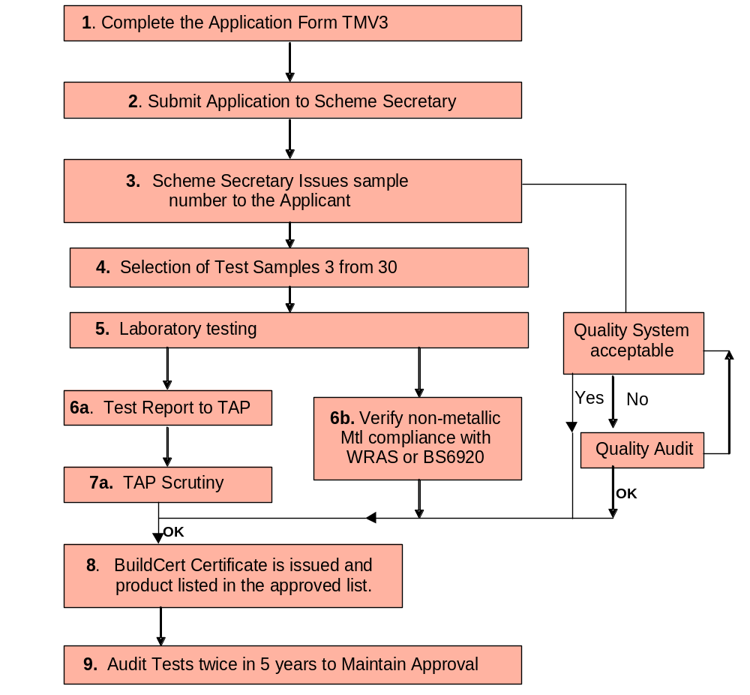

Information to be included in the Information and Maintenance documentation.
The following points must be included within the Installation and Maintenance (I&M) Documentation.
- Information upon the designation of use i.e.HP-T46, LP-S etc.
- Information upon the commissioning of the valve. This will include:
  - Operating pressures for the valve.
  - The water supply temperatures for the valve.
  - Method of adjusting the mixed water temperature.
  - Method for commissioning the valve.
  - Mixed water temperature.
  - Method for performing the In-service tests.
- To facilitate the information required in 2) a) b) and e) and to present the information in a standardized fashion, the relevant information contained in Tables 1 and 2 in the NHS document D 08 is to be included in a tabular format within the I & M documentation.
- Information upon the frequency of in-service tests and service work.
- Information on the Backflow prevention devices that will be fitted, including the specification of the Backflow preventer, i.e. size, type and position (in-body/ handset/ hose/ tail/ servicing valve). If the Backflow preventer is not supplied as part of the package then details of the type of device to be used are to be specified
- Position of isolating valves if provided, if not provided the need for isolation valves and their position when fitted.
- Position of strainers if provided, if not provided their position if fitted at the time of installation.
- State the temperature differential characteristics of the valve.

The BuildCert Scheme has produced an I&M template that can be used by license holders to fulfil their requirements of information that must be included within the I&M documentation supplied with the TMV3 approved valve. To view the template, please see the BuildCert Website.



BuildCert Ltd
Unit 30, Fern Close, Pen-y-Fan Industrial Estate, Oakdale, Gwent, NP11 3EH, UK.
Tel: +44 (0)1495 236260
e-mail: buildcert@wrcnsf.com
web: www.buildcert.com

