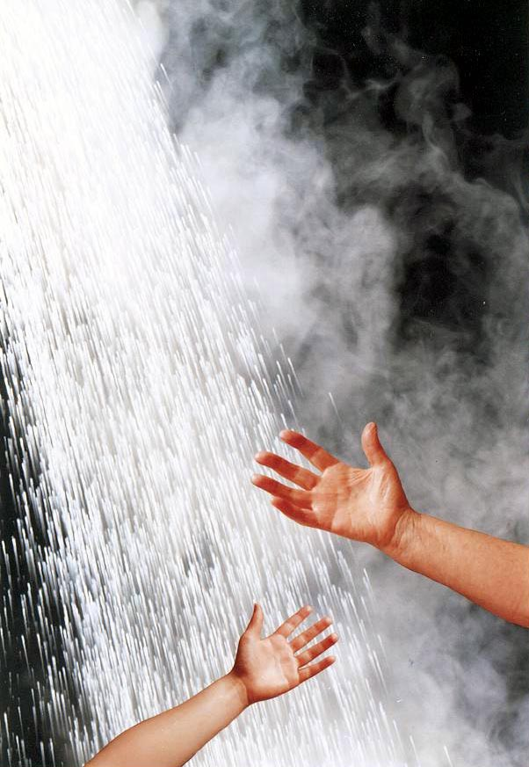

The Easy

Guide to
TMV2

Approval

 | October 2012  Version 1.2  © BuildCert 2012



Introduction
BuildCert approves two categories of Thermostatic Mixing Valves; TMV2 and TMV3. The different valve types are explained in Table 1.
TMV2 approval is for thermostatic valves for use in domestic installations and certifies that valves comply with the performance requirements of BS EN 1111 and or BS EN 1287.

Table 1 Types of valves
Type 1 | A mechanical mixing valve with maximum temperature stop (including single lever taps).
Type 2 | A thermostatic mixing valve which conform to BS EN 1111 and BS EN1287 (originally BS 1415 Part 2). These can have a maximum temperature stop.
Type 3 | A thermostatic mixing valve with enhanced thermal performance complying with NHS Estates requirements D 08.

Pre-approval requirements
The BuildCert approval Scheme requires the following as a pre-requisite for approval.
- All manufacturers and factors must have ISO 9001 accreditation covering valve manufacture, production and handling or be audited by a BuildCert appointed Auditor.
- All BuildCert approval holders must become a subscriber of the BuildCert Scheme.
- The Scheme requires three test valves be selected from a batch of 30 production valves. Valve selection may be undertaken by an independent 3rd party (if this is the case then BuildCert will require a signed declaration from that 3rd party).
- The Installation and Maintenance documents (I&M) provided with the valve must include specific information stated by the Scheme (see Section 5).
- Upon gaining approval the valve must meet the Schemes audit requirements (performance tested once within the 5 year approval period).
Manufacturers of Thermostatic mixing valves can demonstrate compliance with the BuildCert quality requirements by supplying the Scheme with a copy of a valid ISO 9001 certificate and scope of accreditation or an approved quality system. Where this cannot be supplied a quality audit will be conducted by the scheme to verify compliance with the requirements of the Scheme.
A Primary factor is a company/individual who does not manufacture the valve but distributes a certified valve under his own trade name, the product having only cosmetic changes. An approval for the primary factor is sometimes referred to as a piggyback approval.

Recommended maximum mixed water outlet temperatures TMV2
The BuildCert/TMV Scheme recommends the maximum mixed hot water temperatures for safe use for the installations in Table 2.

Table 2 Maximum temperatures
44°C | For bath fill (46°C for assisted bathing)
41°C | For shower applications.
38°C | For bidet applications

Operating conditions
Type 2 Thermostatic Mixing Valves are suitable for use when the hot and cold water supplies to the valves are within the limits specified in Table 3 and where the mixed water temperature is set during commissioning at the appropriate temperature for its intended use (see Table 2).

Table 3 Conditions for normal use
 | High pressure  (BS EN 1111) | Low pressure  (BS EN 1287)
Maximum static pressure | 10 bar | 10 bar
Flow pressure, hot & cold | Between 0.5 and 5.0 bar | Between 0.1 and 1.0 bar
Hot supply temperature | Between 55°C and 65°C | Between 55°C and 65°C
Cold supply temperature | Up to 25°C | Up to 25°C

Full approval
- Complete and return the application form TMV2 to BuildCert along with the Installation and Maintenance document, ISO 9001 documentation and scope of accreditation for the manufacturer and the applicant.
- Arrange the WRAS approval of the valve if required.
- BuildCert will inform the applicant in writing of the allocated BuildCert sample number and either request verification of issues or request sample valves for test, an administration invoice will be appended.
- The applicant sends test sample valves to the test house.
- The test house undertakes the mechanical testing.
- The test house will forward the test report and the test sample valve to BuildCert.
- The test report, sample valve and documentation will be presented to the BuildCert Technical Assessment Panel (TAP) for verification and agreement.
- An approval letter, Certificate and invoice will be forwarded to the applicant, as appropriate.
- The valve details will be entered into the approved valve list on the BuildCert website (www.buildcert.com).

Factored approval (piggyback)
- Complete and return the application form TMV2 to BuildCert along with the installation and maintenance document and the ISO 9001 documentation with scope of accreditation for the manufacturer and the applicant.
- BuildCert requires a letter from the original license holder giving consent for the applicant to use the original TMV approval. The letter must state the original BuildCert and WRAS approval numbers if appropriate. A written statement is required that the existing approved product and the piggyback product are identical in all respects except identification and or handle variants.
- BuildCert will then inform the applicant in writing of the allocated BuildCert sample number and either request verification of issues or request a sample valve for verification, an administration invoice will be appended.
- The applicant will send a sample valve to BuildCert.
- The sample valve and its documentation will then be presented to the BuildCert Technical Assessment Panel (TAP) for verification and agreement.
- An approval letter and Certificate and invoice will be forwarded to the applicant.
- The valve details will be entered into the approved valve list on the BuildCert website (www.buildcert.com).

Flow chart of full TMV2 approval

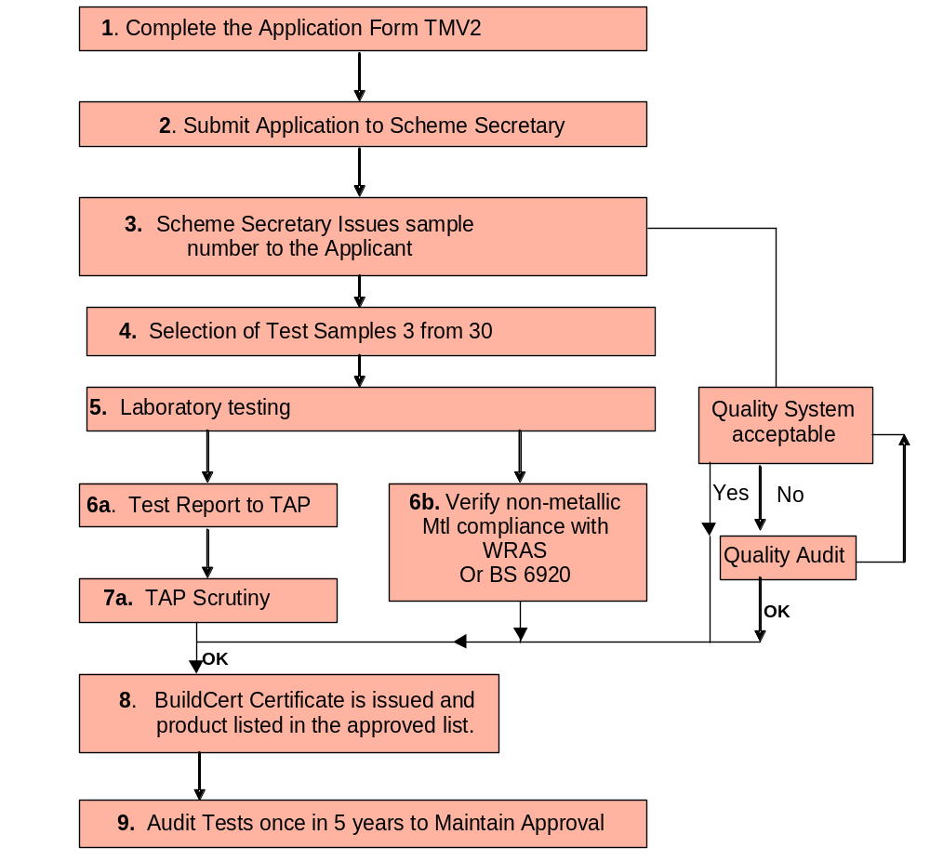

Information to be included in the Information and Maintenance documentation.
The following points must be included within the Installation and Maintenance (I&M) documentation.
- Operating conditions of use, pressure & temperature (hot & cold) Table 1 in BS EN 1111 and or BS EN 1287.
- Statement that valves operating outside these conditions of use cannot be guaranteed to operate as Type 2 valves.
- Its designation of use L.P if tested against BS EN 1287, H.P if tested against BS EN 1111 and H.P and L.P if tested against both documents.
- Valves approved for designation of use H.P only, must state: - If a water supply is fed by gravity then the supply pressure should be verified to ensure the conditions of use are appropriate for the valve.
- Recommended maximum set mixed water temperatures for applications of use, including the recommended safe water temperatures for children.
- Information upon the installation of the valve, this will include: -
  - Requirements for valve accessibility to commission and maintain the valve
  - Maintenance instructions
  - If isolation valves are not provided then a statement is required that states ‘The fitting of isolation valves is required’ and identify preferred location.
  - If strainers are not provided then a statement is required that states ‘The fitting of strainers is recommended’ and identify preferred location
- Information upon the commissioning and testing of the valve, this will include:
  - Method of adjusting the mixed water temperature
  - Method for commissioning the valve.
  - Statement that ‘the mixed water temperature at the terminal fitting should never exceed 46°C’
  - Method and frequency (1 year maximum) for performing the In-service tests
  - Information on residual water flow during the cold water supply isolation test
- Reference be made to the ‘Water Supply (Water Fittings) Regulations 1999.
- Valves approved for low pressure tub/bath applications that only achieve the minimum flowrate requirement at a supply pressure of 0.2 bar must indicate that the minimum supply pressure for tub/bath applications is 0.2 bar.
The BuildCert Scheme has produced an I&M template that can be used by license holders to fulfil their requirements of information that must be included within the I&M documentation supplied with the TMV2 approved valve. To view the template, please see the BuildCert Website.



BuildCert Ltd
Unit 30, Fern Close, Pen-y-Fan Industrial Estate, Oakdale, Gwent, NP11 3EH, UK.
Tel: +44 (0)1495 236260
e-mail: buildcert@wrcnsf.com
web: www.buildcert.com

