

**PROJECT REPORT ON**

**VEHICLE SECURITY SYSTEM USING FACIAL RECOGNITION**

**SUBMITTED TO: - MR. ISHAN KUMAR**

**SUBMITTED BY: -**

* **PRATEEK TRIPATHI, 11908181**
* **SAHYOGVIR SINGH, 11904949**
* **PARITOSH PARIHAR, 11909576**
* **RISHIKESH CHOUKSEY, 11904832**

**School of Computer Science & Engineering Lovely Professional University, Phagwara**

**INDEX: -**

1. Abstract
2. Introduction
3. Modules Used
4. Learning Method
5. Face Detection
6. Face Recognition
7. Algorithm
8. Flow Chart
9. Git Hub Reference
10. Student Work
11. Conclusion and Future Work
12. Result

**ABSTRACT: -**

Facial Recognition has been one of the most interesting and important research fields since its introduction to the world. The reasons arise from the need of automatic facial recognitions and surveillance systems, the interest in human visual system on facial recognition, and the design of human computer interface, etc.

**INTRODUCTION: -**

The project that we made is basically on vehicle security system using face detection and face recognition using several classifiers available in the open computer vision library i.e., OpenCV.

In this project we basically made a system such that when the person will enter his/her car its wheel and other functions will be behind the dashboard there will be only a start button. When he will start the car screen will turn on in front of the driver’s seat and it will start the face recognition, if the face will be recognized then the wheel and other function will come outside and driver will be able to drive his/her car, otherwise if the face is not recognized then it will ask for backup password, if it is correct then wheel will come out, otherwise the siren will start and nothing will come out. Towards this goal, we generally separate the face recognition procedure into three steps: **Face Detection**, **Feature Extraction**, and **Face Recognition** (shown at Fig. 1).

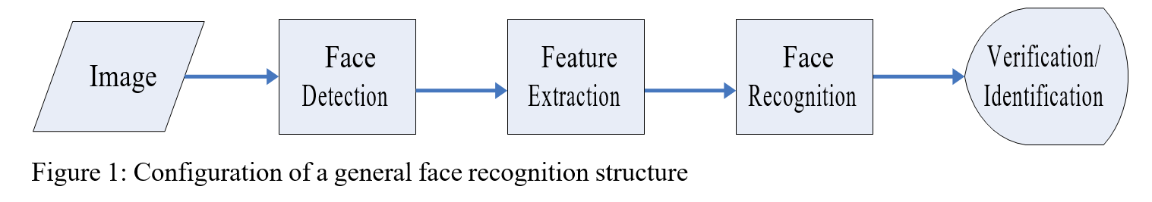

Face recognition is a non-invasive identification system and faster than other systems since multiple faces can be analyzed at the same time. The face detection means to identify a face from an image and locate the face and face recognition means making the decision whose face is it, using an image database.

**MODULES USED: -**

1. **Tkinter: -**

* It is the most commonly used GUI in python.
* In python, tkinter is the fastest and easiest way of creating GUI applications.
* It is not a single library; it consists of a few modules.

1. **Messagebox: -**

* It belongs to tkinter library.
* This module is used to display message boxes in python.
* It has four parameters.
* It consists of seven functions.

1. **OS: -**

* This module in Python provides functions for interacting with the operating system.
* This module provides a portable way of using operating system-dependent functionality.

1. **PYTTSX3: -**

* It is a text-to-speech conversion library in Python.
* Unlike alternative libraries, it works offline.
* The pyttsx3 module supports two voices i.e., female and male.

1. **OpenCV: -**

* It is a huge open-source library for computer vision, machine learning and image processing.
* It supports a wide variety of programming languages like Python, C++, Java, etc.
* It can process images and videos to identify objects, faces, or even the handwriting of a human.

1. **NumPy: -**

* It is a general-purpose array-processing package.
* It provides a high-performance multidimensional array object, and tools for working with these arrays.

1. **Pillow (PIL): -**

* Python Imaging Library (expansion of PIL) is the de facto image processing package for Python language.
* It incorporates lightweight image processing tools that aids in editing, creating and saving images.

1. **Playsound: -**

* The playsound module contains only one thing - the function (also named) playsound.
* It requires one argument - the path to the file with the sound you’d like to play. This may be a local file, or a URL.
* There’s an optional second argument, block, which is set to True by default. Setting it to False makes the function run asynchronously.

**LEARNING METHOD: -**

There are two general tasks in pattern recognition and machine learning: Supervised Learning and Unsupervised Learning. The main difference between the two tasks is if the label of each training sample is known or unknown.

When the label is known, then during the learning phase in facial recognition, we’re trying to model the relation between the feature vectors and their corresponding labels, and this kind of learning is called Supervised Learning.

On the other hand, if the label of each training sample is unknown, then what we learn is the distribution of the possible categories of feature vectors in the training data set, and this kind of learning is called Unsupervised Learning.

**FACE DETECTION: -**

**Based on HAAR Features.**

The Haar features are used to capture the significant characteristics of

human faces, especially the contrast features. A 19x19 window typically contains more than one thousand Haar features and results in huge computational cost, while many of them don’t contribute to the classification between face and non-face samples because both face and non-face samples have these contrasts. To efficiently apply the large amount of Haar features, the Adaboost algorithm is used to perform the feature selection procedure and only those features with higher discriminant abilities are chosen.

The chosen features are utilized in a cascade fashion, where the features with higher discriminant abilities are tested at the first few stages and the image windows passing these tests are fed into the later stages for detailed tests. The cascade procedure could quickly filter out many non-face regions by testing only a few features at each stage and shows significant computation saving.

In the face detection phase, several window scales and locations are chosen to ex- tract possible face patches in the image, and we test each patch by the trained cascade procedure and those which pass all the stages are labeled as faces. There are many works later based on their framework.

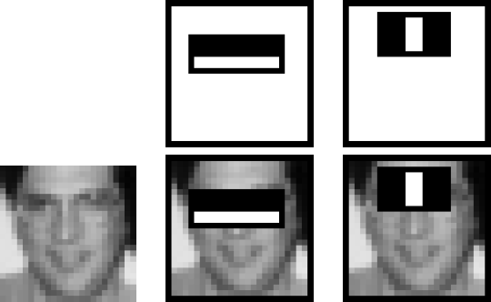

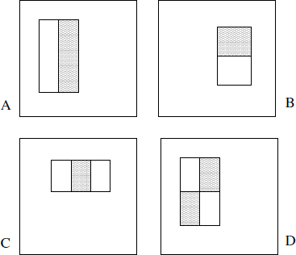

Figure : The Haar features and their abilities to capture the significant contrast feature of the hu- man face

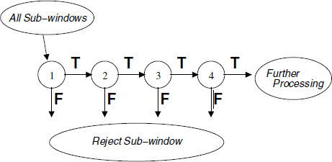

Figure: The cascade procedure during the training phase. At each stage, only a portion of patches can be denoted as faces and pass to the following stage for further verifications. The patches denoted as non-face at each stage are directly rejected.

**FACE RECOGNITION: -**

In order to achieve automatic facial recognition, a face database is required to build. For each person/user, several images are taken and stored in database. Then when a face comes in front of the camera, we perform facial recognition by comparing the image with the image stored in the database.

**Based on Local Binary Pattern Histograms.**

Ahonen et al proposed to extract the local binary pattern (LBP) histograms with spatial information as the face feature and use a nearest neighbor classifier based on Chi square metric as the dissimilarity measure. The idea behind using the LBP features is that the face images can be seen as composition of micro-patterns which are invariant with respect to monotonic gray scale transformations. Combining these micro-patterns, a global description of the face image is obtained

The original LBP operator, introduced by Ojala et al, is a powerful means of texture description. The operator labels the pixels of an image by thresholding the neighborhood of each pixel with the center value and considering the result as a binary number. Then the histogram of the labels can be used as a texture descriptor.

Figure 2 illustrates the basic LBP operator. Later the operator was extended to use neighborhoods of different sizes based on circular neighborhoods and bilinear interpolation of the pixel values. The notation (P, R), where P means the number of sampling points on a circle of radius R, is adopted and illustrated in figure 3.

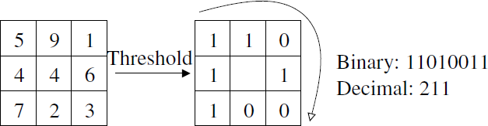

Figure 2: The basic LBP operator

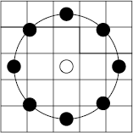

Figure 3: The circular (8,2) neighborhood. The pixel values are bilinearly interpolated whenever the sampling point is not in the center of a pixel.

Another extension to the original operator uses so called uniform patterns [54]. A local binary pattern is called uniform if it contains at most two bitwise transitions from 0 to 1 or vice versa when the binary string is considered circular. Ojala et al. noticed that in their experiments with texture images, uniform patterns account for a bit less than 90 % of all patterns when using the (8, 1) neighborhood and for around 70% in the (16, 2) neighborhood.

This histogram contains information about the distribution of the local micro-patterns, such as edges, spots and flat areas, over the whole image. For efficient face representation, one should retain also spatial information.

In this histogram, we effectively achieve a description of the face on three different level of locality: the labels for the histogram contain information about the patterns on a pixel-level, the labels are summed over a small region to produce information on a region level and regional histograms are concatenated to build a global description of the face

**ALGORITHM: -**

1. Start.
2. Click on any button.
3. If clicked on ‘developers’ go to step 4, If clicked on ‘how to use’ go to step 5, If clicked on ‘user authentication’ go to step 6, If clicked on quit go to step 39.
4. Developers: -

Information, Project Group: 1

1. Name: - Prateek Tripathi

Roll No.: - RKM024A21

Regd. No.: - 11908181

1. Name: - Sahyogvir Singh

Roll No.: - RKM024A13

Regd. No.: - 11904949

1. Name: - Paritosh Parihar

Roll No.: - RKM024A22

Regd. No.: - 11909576

1. Name: - Rishikesh Chouksey

Roll No.: - RKM024A06

Regd. No.: - 11904832

Click OK!!

Go to step 2.

1. User Manual

1. Pre-Registered User:

a. On the welcome interface click on login button.

b. It will lead to new window User Authentication.

c. Input the Credentials provided in the Manual.

= If the credentials are correct then okay,

= If not then you are in trouble.

Contact to the CUSTOMER CARE.

d. After this, two options will appear.

e. Add New User and Facial Recognition.

f. Click on Facial Recognition.

g. It will start Recognizing your face.

= if validation is done, steering wheel will come out

of the dashboard and the other function of the

vehicle will come online.

= If the camera will not be able to recognize you,

then it will ask for the master password.

= If that password is correct, steering wheel will come out

of the dashboard and the other function of the

vehicle will come online.

= Else You will be locked out of the system and Security protocol will come online.

2. New User:

a. On the welcome interface click on login button.

b. It will lead to new window User Authentication.

c. Input the Credentials provided in the Manual.

= if the credentials are correct the n okay,

= If not then you are in trouble.

Contact to the CUSTOMER CARE.

d. After this, two options will appear.

e. Add New User and Facial Recognition.

f. Click on New User.

g. new interface will open.

: - It will ask you to face towards the camera and it will take 100 pictures of you.

: - It will take few time. So, BE PATIENT.

: - After this Trainer interface will open.

: - It will train the machine to recognize the face fed to the machine via the samples.

After that Restart the vehicle and proceed.

Click on OK after reading this

Go to step 2

1. Take user to next program i.e., User Authentication.
2. If clicked on quit go to step 39
3. Enter username and password
4. Click on check login

If username == ‘admin’ && password== ‘secret’, go to step 12 else go to step 11

Display invalid login, please try again

1. Display ‘authentication successful, welcome, please browse through your options’.
2. Take user to next program i.e., New User or Login
3. Click any button
4. If clicked on add new face go to step 16, if clicked on continue to face recognition go to step 25, if clicked on quit go to step 39
5. Take user to next program i.e., 1 Facial Recognition Dataset Building
6. Enter numeric user id and press enter
7. Display initializing face capture, look at the camera and wait
8. Open camera and take pictures
9. Display samples taken, now moving to next step
10. Take user to next program i.e., 2_Facial_Recognition_Dataset _Training
11. Train the camera to detect that face
12. Display training faces, it will take a few seconds wait
13. Display model trained and go to step 6
14. Take user to next program i.e., 3_Facial_Recognition
15. Open camera and take pictures
16. If present face matches any trained user face go to step 28 else go to step 30
17. Display authentication successful, welcome, wheel and other functions are available now
18. Display happy driving and go to step 39
19. Display authentication unsuccessful, please provide your credentials
20. Take user to next program i.e., Nonrecognition.
21. If clicked on quit go to step 39
22. Enter username and password
23. Click on check login
24. If username== ‘MASTERADMIN’ && password== ‘MASTER@101’ go to step 36 else go to step 37
25. Display authentication successful, sorry for inconvenience, welcome, wheel and other functions are available now and go to step 39
26. Display authentication was not successful, please step outside the vehicle, the owner is being alerted for intruder alert via Email and Message bombardment protocol
27. Play alert sound
28. Stop

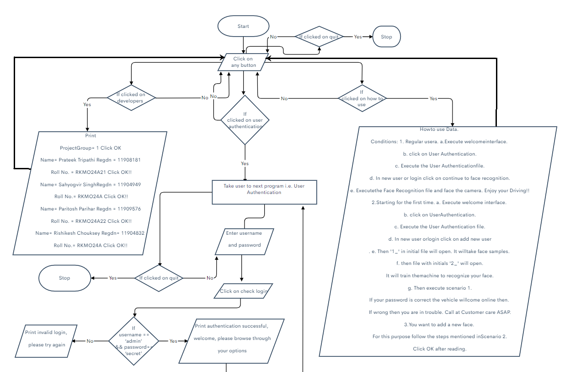**FLOW CHART: -**

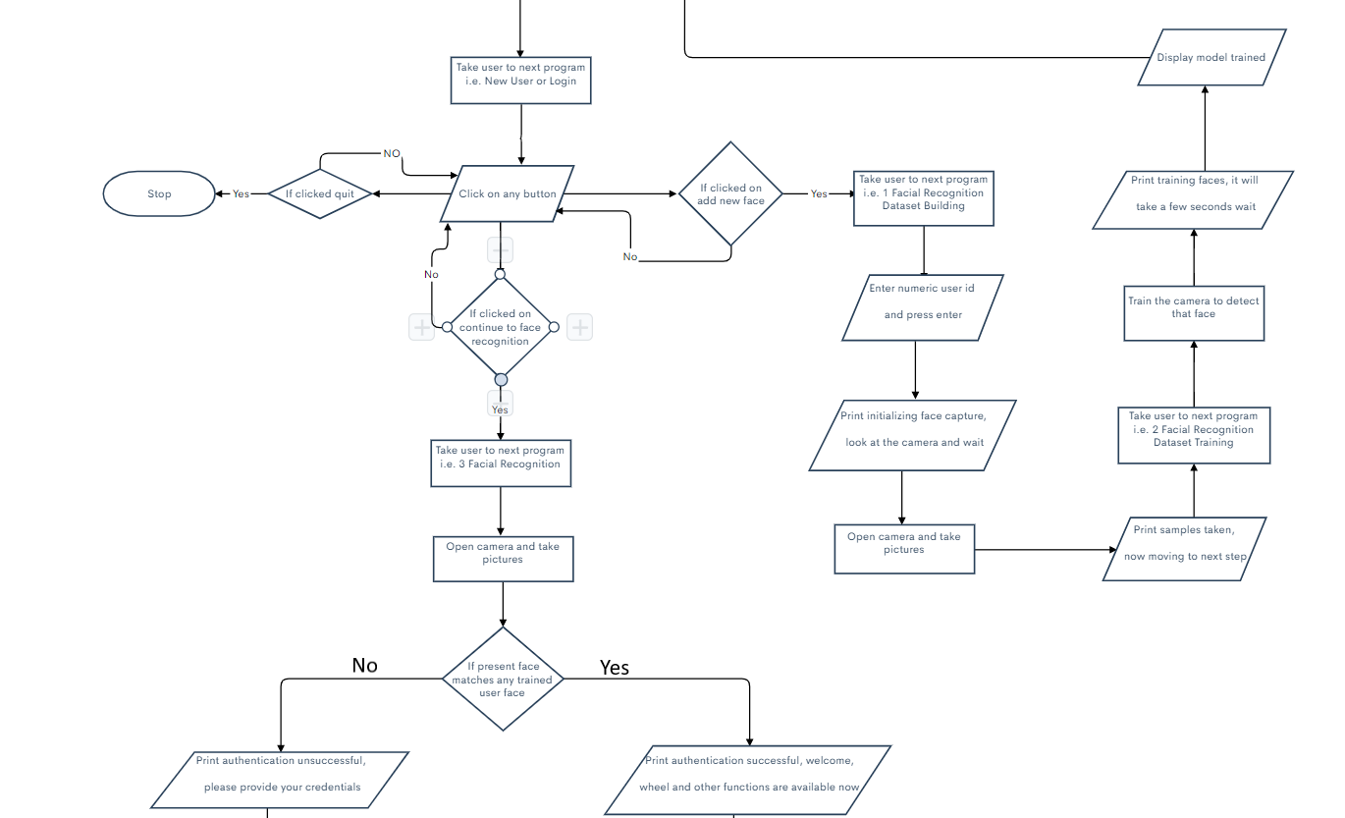

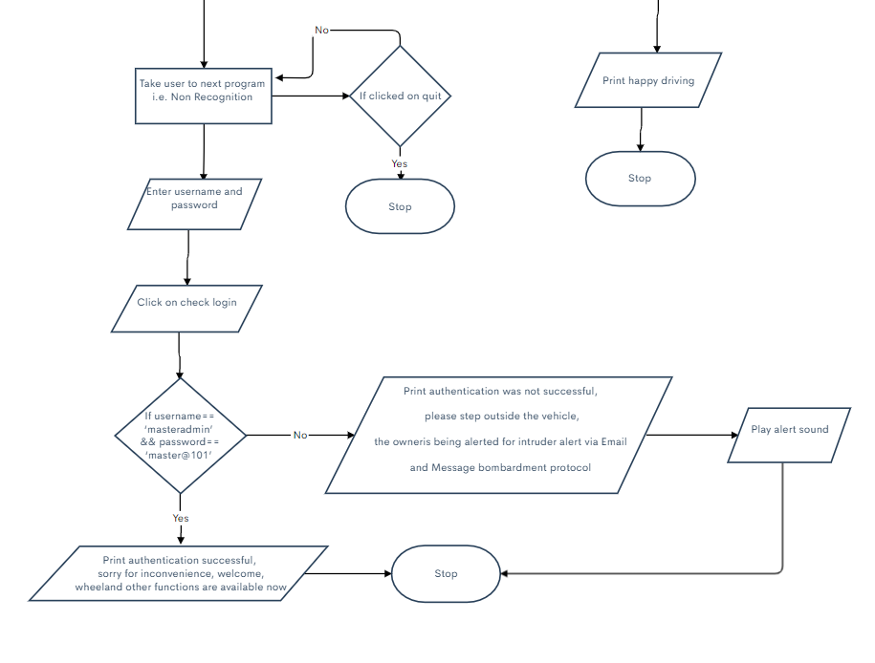

**GIT - HUB REPOSITORY FOR THIS PROJECT: -**

[Vehicle Security System Using Facial Recognition](https://github.com/er-prateek-tripathi/Vehicle-Security-System-Using-Facial-Recognition.git)

**STUDENT WORK: -**

1. Prateek Tripathi:

1_Facial_Recognition_Dataset_Building.py

2_Facial_Recognition_Dataset_Training.py

3_ Facial_Recognition.py

1. Sahyogvir Singh:

User_Authentication.py

New_User_OR_Login.py

Report

1. Paritosh Parihar:

Welcome_Interface.py

Report

1. Rishikesh Chouksey:

Non_Recognition.py

PPT

**CONCLUSION AND FUTURE WORK: -**

We have represented a facial recognition-based security system that is able to identify a registered user when presented in front of the camera. The Ids of the images are not generated only on single image, instead whole image sequences are taken into account. The facial recognition system and the interface build around it are a bit primitive.

In future we plan to do some experiments provided that ample amount of capital is available in hand with 100% confidence from the sponsor company.

**RESULT: -**

The Machine is capable of: -

1. Capturing Face Samples
2. Training itself for the collected samples.
3. Facial Recognition