Customer Churn Rate Per Cohort
SQL Query Documentation, Cohort Results Data Table & MySQL Workbench Output

1. Overview & Objective
This document details the Customer Churn Rate Per Cohort calculated from the `Ecommerce_Transactions_Clean` database. The analysis evaluates first-time successful buyers (`Payment_Status = 'Success'`), grouping them into acquisition cohorts by month and determining the initial cohort size, Month 1 retained customer count, Month 1 churn volume, and the resulting Month 1 churn rate percentage.

2. SQL Query Implementation
WITH Customer_Cohort AS (
SELECT
Customer_ID,
MIN(STR_TO_DATE(Purchase_Date, '%d-%m-%Y')) AS cohort_start_date
FROM Ecommerce_Transactions_Clean
WHERE Payment_Status = 'Success'
GROUP BY Customer_ID
),
Cohort_Activity AS (
SELECT
t.Customer_ID,
DATE_FORMAT(c.cohort_start_date, '%Y-%m') AS cohort_month,
(YEAR(STR_TO_DATE(t.Purchase_Date, '%d-%m-%Y')) - YEAR(c.cohort_start_date)) * 12 +
(MONTH(STR_TO_DATE(t.Purchase_Date, '%d-%m-%Y')) - MONTH(c.cohort_start_date)) AS month_number
FROM Ecommerce_Transactions_Clean t
JOIN Customer_Cohort c ON t.Customer_ID = c.Customer_ID
WHERE t.Payment_Status = 'Success'
),
Cohort_Counts AS (
SELECT
cohort_month,
COUNT(DISTINCT CASE WHEN month_number = 0 THEN Customer_ID END) AS initial_size,
COUNT(DISTINCT CASE WHEN month_number = 1 THEN Customer_ID END) AS retained_month_1
FROM Cohort_Activity
GROUP BY cohort_month
)
SELECT
cohort_month AS Cohort,
initial_size AS Cohort_Size,
retained_month_1 AS Retained_Month_1,
(initial_size - retained_month_1) AS Churned_Month_1,
ROUND(100.0 * (initial_size - retained_month_1) / initial_size, 2) AS `Churn_Rate_Month_1_%`
FROM Cohort_Counts
ORDER BY cohort_month;

3. Customer Churn Rate Results Table
Below are the cohort size, retention counts, churned counts, and Month 1 churn rate percentage per cohort:
Cohort | Cohort_Size | Retained_Month_1 | Churned_Month_1 | Churn_Rate_Month_1_%
2025-01 | 60 | 23 | 37 | 61.67
2025-02 | 74 | 36 | 38 | 51.35
2025-03 | 72 | 34 | 38 | 52.78
2025-04 | 69 | 29 | 40 | 57.97
2025-05 | 53 | 23 | 30 | 56.60
2025-06 | 57 | 33 | 24 | 42.11
2025-07 | 54 | 26 | 28 | 51.85
2025-08 | 69 | 28 | 41 | 59.42
2025-09 | 78 | 33 | 45 | 57.69
2025-10 | 60 | 32 | 28 | 46.67
2025-11 | 59 | 29 | 30 | 50.85
2025-12 | 61 | 23 | 38 | 62.30
2026-01 | 8 | 2 | 6 | 75.00

4. Result Grid Screenshot
MySQL Workbench execution result grid output:
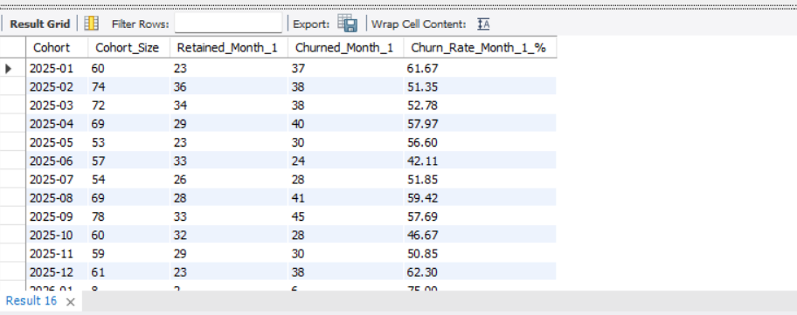

5. Summary Insights
- Best Cohort Retention (Lowest Churn): The `2025-06` cohort recorded the lowest Month 1 churn rate at 42.11% (24 churned out of 57).
- Highest Churn Volume: The `2025-09` cohort recorded the highest absolute count of churned customers at 45 (out of 78 total).
- Annual Average Churn Rate: Across full annual cohorts in 2025, Month 1 churn rate averaged around 54% across all months.

