E-Commerce Customer Cohort Retention Analysis
SQL Query Code, Formatted Result Table & Workbench Result Screenshot

1. Overview & Objective
This report documents the cohort retention analysis performed on the `Ecommerce_Transactions_Clean` database. The analysis identifies customer acquisition cohorts based on their first successful transaction month (`Month 0`) and measures month-over-month user retention rates through `Month 5`.

2. SQL Query
WITH Customer_Cohort AS (
SELECT
Customer_ID,
MIN(STR_TO_DATE(Purchase_Date, '%d-%m-%Y')) AS cohort_start_date
FROM Ecommerce_Transactions_Clean
WHERE Payment_Status = 'Success'
GROUP BY Customer_ID
),
Cohort_Activity AS (
SELECT
t.Customer_ID,
DATE_FORMAT(c.cohort_start_date, '%Y-%m') AS cohort_month,
(YEAR(STR_TO_DATE(t.Purchase_Date, '%d-%m-%Y')) - YEAR(c.cohort_start_date)) * 12 +
(MONTH(STR_TO_DATE(t.Purchase_Date, '%d-%m-%Y')) - MONTH(c.cohort_start_date)) AS month_number
FROM Ecommerce_Transactions_Clean t
JOIN Customer_Cohort c ON t.Customer_ID = c.Customer_ID
WHERE t.Payment_Status = 'Success'
),
Cohort_Counts AS (
SELECT
cohort_month,
COUNT(DISTINCT CASE WHEN month_number = 0 THEN Customer_ID END) AS m0,
COUNT(DISTINCT CASE WHEN month_number = 1 THEN Customer_ID END) AS m1,
COUNT(DISTINCT CASE WHEN month_number = 2 THEN Customer_ID END) AS m2,
COUNT(DISTINCT CASE WHEN month_number = 3 THEN Customer_ID END) AS m3,
COUNT(DISTINCT CASE WHEN month_number = 4 THEN Customer_ID END) AS m4,
COUNT(DISTINCT CASE WHEN month_number = 5 THEN Customer_ID END) AS m5
FROM Cohort_Activity
GROUP BY cohort_month
)
SELECT
cohort_month AS Cohort,
m0 AS Cohort_Size,
ROUND(100.0 * m0 / m0, 1) AS `Month_0_%`,
ROUND(100.0 * m1 / m0, 1) AS `Month_1_%`,
ROUND(100.0 * m2 / m0, 1) AS `Month_2_%`,
ROUND(100.0 * m3 / m0, 1) AS `Month_3_%`,
ROUND(100.0 * m4 / m0, 1) AS `Month_4_%`,
ROUND(100.0 * m5 / m0, 1) AS `Month_5_%`
FROM Cohort_Counts
ORDER BY cohort_month;

3. Query Result Data Table
Tabulated cohort size and month-by-month retention rates (%):
Cohort | Cohort_Size | Month_0_% | Month_1_% | Month_2_% | Month_3_% | Month_4_% | Month_5_%
2025-01 | 60 | 100.0 | 38.3 | 41.7 | 16.7 | 3.3 | 0.0
2025-02 | 74 | 100.0 | 48.6 | 24.3 | 17.6 | 2.7 | 1.4
2025-03 | 72 | 100.0 | 47.2 | 37.5 | 20.8 | 9.7 | 4.2
2025-04 | 69 | 100.0 | 42.0 | 37.7 | 10.1 | 1.4 | 1.4
2025-05 | 53 | 100.0 | 43.4 | 28.3 | 15.1 | 5.7 | 0.0
2025-06 | 57 | 100.0 | 57.9 | 40.4 | 28.1 | 17.5 | 7.0
2025-07 | 54 | 100.0 | 48.1 | 20.4 | 13.0 | 11.1 | 7.4
2025-08 | 69 | 100.0 | 40.6 | 29.0 | 13.0 | 4.3 | 1.4
2025-09 | 78 | 100.0 | 42.3 | 38.5 | 19.2 | 5.1 | 5.1
2025-10 | 60 | 100.0 | 53.3 | 25.0 | 13.3 | 1.7 | 1.7
2025-11 | 59 | 100.0 | 49.2 | 28.8 | 15.3 | 11.9 | 1.7
2025-12 | 61 | 100.0 | 37.7 | 19.7 | 9.8 | 3.3 | 0.0
2026-01 | 8 | 100.0 | 25.0 | 0.0 | 0.0 | 0.0 | 0.0

4. Result Grid Screenshot
Execution result image from MySQL Workbench:
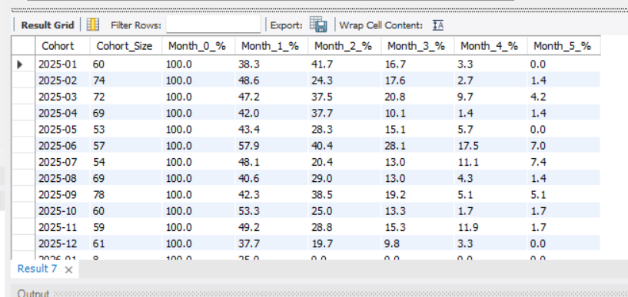

5. Analytical Insights
- Peak Retention Performance: The 2025-06 cohort recorded the highest Month 1 retention rate at 57.9%, followed closely by 2025-10 at 53.3%.
- Retention Curve Decay: Initial retention across all cohorts stays between 37.7% and 57.9% in Month 1, before dropping significantly by Month 3 (9.8% – 28.1%) and Month 5 (0.0% – 7.4%).
- Strongest Cohort Trajectory: The June 2025 (2025-06) cohort maintained superior retention across all months, ending with a high 7.0% retention in Month 5 compared to an average below 2% for other months.

