Customer Cohort Retention Analysis by Acquisition Channel
SQL Query Documentation, Results Data Table & MySQL Workbench Output Screenshot

1. Overview & Objective
This report analyzes multi-month customer retention curves broken down by acquisition channel and monthly acquisition cohort. By tracking customer purchase activity across Month 0 (acquisition month), Month 1, Month 2, and Month 3, this query evaluates initial user retention and drop-off patterns across specific marketing and sales channels.

2. SQL Query Implementation
WITH Customer_Cohort AS (
SELECT
Customer_ID,
Acquisition_Channel,
MIN(STR_TO_DATE(Purchase_Date, '%d-%m-%Y')) AS cohort_start_date
FROM Ecommerce_Transactions_Clean
WHERE Payment_Status = 'Success'
GROUP BY Customer_ID, Acquisition_Channel
),
Cohort_Activity AS (
SELECT
t.Customer_ID,
c.Acquisition_Channel,
DATE_FORMAT(c.cohort_start_date, '%Y-%m') AS cohort_month,
(YEAR(STR_TO_DATE(t.Purchase_Date, '%d-%m-%Y')) - YEAR(c.cohort_start_date)) * 12 +
(MONTH(STR_TO_DATE(t.Purchase_Date, '%d-%m-%Y')) - MONTH(c.cohort_start_date)) AS month_number
FROM Ecommerce_Transactions_Clean t
JOIN Customer_Cohort c ON t.Customer_ID = c.Customer_ID
WHERE t.Payment_Status = 'Success'
)
SELECT
Acquisition_Channel,
cohort_month AS Cohort,
COUNT(DISTINCT CASE WHEN month_number = 0 THEN Customer_ID END) AS Month_0,
COUNT(DISTINCT CASE WHEN month_number = 1 THEN Customer_ID END) AS Month_1,
COUNT(DISTINCT CASE WHEN month_number = 2 THEN Customer_ID END) AS Month_2,
COUNT(DISTINCT CASE WHEN month_number = 3 THEN Customer_ID END) AS Month_3
FROM Cohort_Activity
GROUP BY Acquisition_Channel, cohort_month
ORDER BY Acquisition_Channel, cohort_month;

3. Cohort Retention Data Table
The table below presents the extracted cohort retention data for the Amazon acquisition channel across Month 0 to Month 3:
Acquisition_Channel | Cohort | Month_0 | Month_1 | Month_2 | Month_3
Amazon | 2025-01 | 7 | 3 | 3 | 0
Amazon | 2025-02 | 9 | 5 | 1 | 1
Amazon | 2025-03 | 7 | 2 | 2 | 2
Amazon | 2025-04 | 15 | 5 | 5 | 2
Amazon | 2025-05 | 5 | 4 | 2 | 1
Amazon | 2025-06 | 7 | 4 | 2 | 3
Amazon | 2025-07 | 10 | 4 | 3 | 2
Amazon | 2025-08 | 15 | 3 | 3 | 2
Amazon | 2025-09 | 14 | 3 | 4 | 3
Amazon | 2025-10 | 8 | 4 | 1 | 0
Amazon | 2025-11 | 9 | 5 | 2 | 2

4. Result Grid Screenshot
Below is the output grid image captured directly from MySQL Workbench:
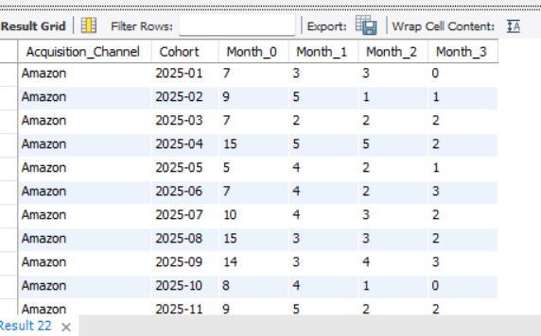

5. Analytical Observations & Channel Insights
- Peak Acquisition Months: April 2025 (`2025-04`) and August 2025 (`2025-08`) brought in the largest initial Amazon cohorts with 15 customers each in Month 0.
- Month 1 Retention Peak: The highest Month 1 retention was observed in February 2025 (`2025-02`), April 2025 (`2025-04`), and November 2025 (`2025-11`), retaining 5 active purchasing customers.
- Month 3 Retention Peak: The June 2025 (`2025-06`) and September 2025 (`2025-09`) cohorts demonstrated the strongest long-term stability with 3 customers remaining active in Month 3.

