## **Assignment-based Subjective Questions**

### **From your analysis of the categorical variables from the dataset, what could you infer about their effect on the dependent variable?**

* The categorical variables available in the assignment are “season”, “workingday”, “weathersit”, “weekday”, “yr”, “holiday”, and “mnth”.
* “season” –
  + Based on the data available, the most favourable seasons for biking are summer and fall.
    - Higher targets can be planned in summer and fall with strategic advertising.
  + Spring has significant low consumption ratio.
* “workingday” –
  + Working day represents weekday and weekend/holiday information.
  + The registered users are renting bikes on working days whereas casual users prefer the bikes on non-working days. This effect is nullified when we look at the total count because of the contradictory behaviour of registered and casual users.
  + Registered and casual users’ identity and relevant strategy for working and not working days shall help to increase the numbers.
* “weathersit” –
  + Most favourable weather condition is the clean/few clouds days.
  + Registered users count is comparatively high even on the light rainy days, so the assumption can be drawn that the bikes are being used for daily commute to the workplace.
  + There is no data available for heavy rain/snow days.
* “weekday” –
  + If we consider “cnt” column we do not find any significant pattern with the weekday.
  + However if the relation is plotted with “registered” users, we observe that bike usage is higher on working days. And with “casual” users it opposite.
* “yr” –
  + 2 years data is available and the increase in the bikes has increased from 2018 to 2019.
* “holiday” –
  + Holiday consumption of bikes if compared within “registered” and “casual” users then the observation is “casual” users are using bikes more on holiday.
* “mnth” –
  + The bike rental ratio is higher for June, July, August, September and October months.
  + 75 quantile grows in the months mentioned in point 1.

### **Why is it important to use drop_first=True during dummy variable creation?**

Using one-hot encoding the dummy variables are created to cover the range of values of categorical variable. Each dummy variable has 1 and 0 values. 1 is used to depict the presence and 0 for absence of the respective category. This means if the category variable has 3 categories, there will be 3 dummy variables.

The drop_first = True is used while creating dummy variables to drop the base/reference category. The reason for this is to avoid the multi-collinearity getting added into the model if all dummy variables are included. The reference category can be easily deduced where 0 is present in a single row for all the other dummy variables of a particular category.

### **Looking at the pair-plot among the numerical variables, which one has the highest correlation with the target variable?**

* “temp” is the variable which has the highest correlation with target variable i.e. 0.63.
* The casual and registered variables are actually part of the target variable as values of these columns sum up to get the target variable, hence ignoring the correlation of these 2 variables.
* “atemp” is the derived parameter from temp, humidity and windspeed, hence not considering it as it is eliminated in the model preparation.

### **How did you validate the assumptions of Linear Regression after building the model on the training set?**

1. **Linear relationship between independent and dependent variables** – The linearity is validated by looking at the points distributed symmetrically around the diagonal line of the actual vs predicted plot as shown in the below figure.

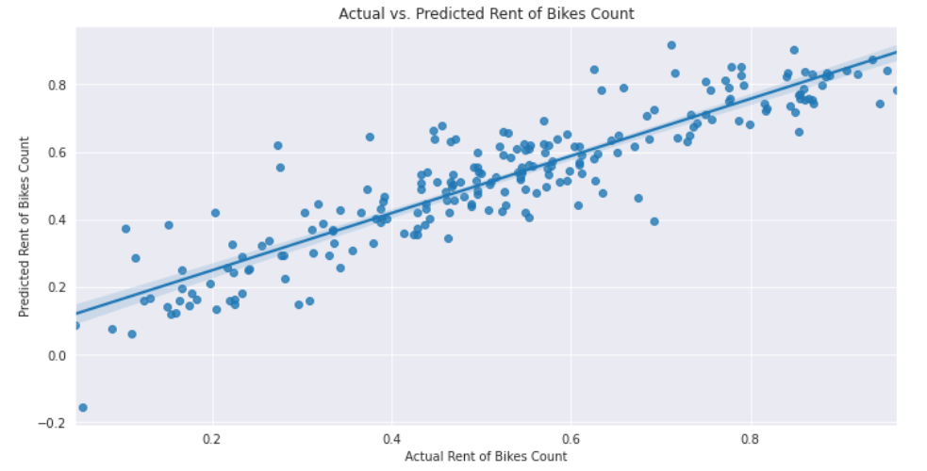

1. **Error terms are independent of each other** – **We can see there is no specific Pattern observed in the Error Terms with respect to Prediction, hence we can say Error terms are independent of each other**

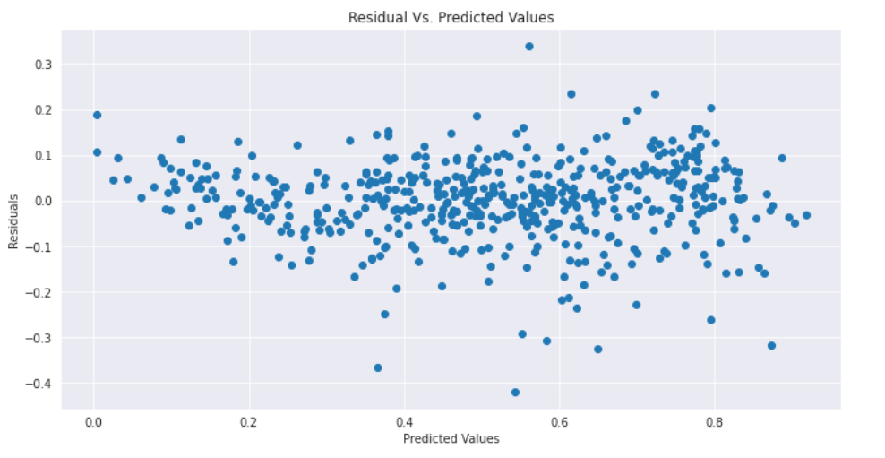

**3. Error terms are normally distributed**: Histogram and distribution plot helps to understand the normal distribution of error terms along with the mean of 0. The figure below clearly depicts the same.

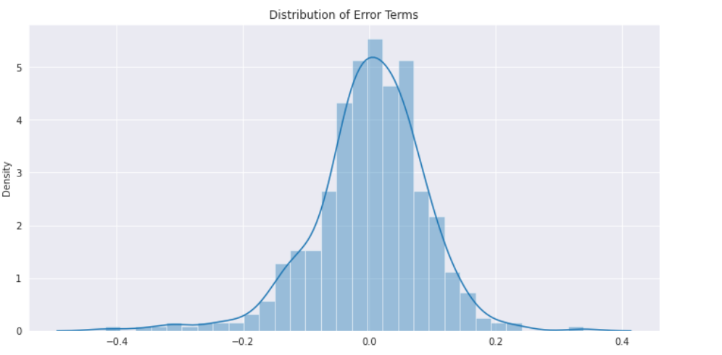

1. **Error terms have constant variance (homoscedasticity)**: **We can see Error Terms have approximately a Constant Variance, hence it follows the Assumption of Homoscedasticity.**

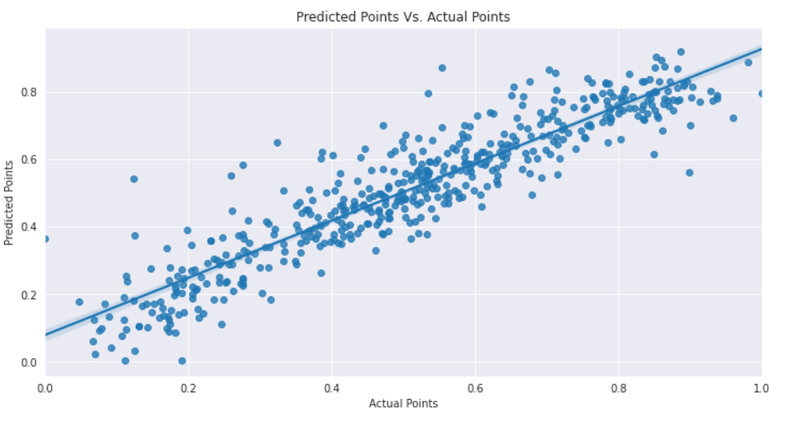

### **Based on the final model, which are the top 3 features contributing significantly towards explaining the demand of the shared bikes?**

The top 3 variables are:

* **weathersit** :

Temperature is the Most Significant Feature which affects the Business positively, Whereas the other Environmental condition such as Raining, Humidity, Windspeed and Cloudy affects the Business negatively**.**

* **‘Yr’:**

The growth year on year seems organic given the geological attributes.

* **‘season’:**

Winter season is playing the crucial role in the demand of shared bikes.

## **General Subjective Questions**

### **Explain the linear regression algorithm in detail.**

* Linear regression is the method of finding the best linear relationship within the independent variables and dependent variables.
* The algorithm uses the best fitting line to map the association between independent variables with dependent variable.
* There are 2 types of linear regression algorithms
  + Simple Linear Regression – Single independent variable is used.
    - $Y= β_{0}+ β_{1}X$ is the line equation used for SLR.
  + Multiple Linear Regression – Multiple independent variables are used.
    - $Y= β_{0}+ β_{1}X_{1}+…+ β_{p}X_{p}+ ∈$ is the line equation for MLR.
$β_{0}=value of the Y when X=0 (Y intercept)$

$β_{1}, β_{2},…, β_{p}=Slope or the gradient.$

* Cost functions – The cost functions helps to identify the best possible values for the $β_{0}, β_{1}, β_{2}, …$, $β_{p}$ which helps to predict the probability of the target variable. The minimization approach is used to reduce the cost functions to get the best fitting line to predict the dependent variable. There are 2 types of cost function minimization approaches – **Unconstrained and constrained**.
  + Sum of squared function is used as a cost function to identify the best fit line. The cost functions are usually represented as
    - The straight-line equation is $Y= β_{0}+ β_{1}X$
    - The prediction line equation would be $Y_{pred}= β_{0}+ β_{1}x_{i}$ and the actual Y is as Y*i*.
  + The unconstrained minimization are solved using 2 methods
    - Closed form
    - Gradient descent
* While finding the best fit line we encounter that there are errors while mapping the actual values to the line. These errors are nothing but the residuals. To minimize the error squares OLS (Ordinary least square) is used.
  + $e_{i}=y_{i}- y_{pred}$ is provides the error for each of the data point.
  + OLS is used to minimize the total e2 which is called as Residual sum of squares.
$RSS = =\sum_{i=1}^{n}{{\left(y_{i}- y_{pred}\right)}^{2}}$

* Ordinary Lease Squares method is used to minimize Residual Sum of Squares and estimate beta coefficients.

### **Explain the Anscombe’s quartet in detail.**

Statistics like variance and standard deviation are usually considered good enough parameters to understand the variation of some data without actually looking at every data point. The statistics are great to for describing the general trends and aspects of the data.

Francis Anscombe realized in 1973 that only statistical measures are not good enough to depict the data sets. He created several data sets all with several identical statistical properties to illustrate the fact.

* Illustrations
  + One of the data set is as follows:

* + If the descriptive statistics are checked for above data set then all looks same:

* + However, when plotted these points, the relation looks completely different as depicted below.

* Anscombe's Quartet signifies that multiple data sets with many similar statistical properties could still be different from one another when plotted.
* The dangers of outliers in data sets are warned by the quartet. Check the bottom 2 graphs. If those outliers would have not been there the descriptive stats would have been completely different in that case.
* Important points
  + Plotting the data is very important and a good practice before analysing the data.
  + Outliers should be removed while analysing the data.
  + Descriptive statistics do not fully depict the data set in its entirety.

### **What is Pearson’s R?**

The Pearson’s R (also known as Pearson’s correlation coefficients) measures the strength between the different variables and the relation with each other. The Pearon’s R returns values between -1 and 1. The interpretation of the coefficients are:

* *-1 coefficient indicates strong inversely proportional relationship.*
* *0 coefficient indicates no relationship.*
* *1 coefficient indicates strong proportional relationship.*

$$r= \frac{n\left(Σx*y\right)-\left(Σx\right)*\left(Σy\right)}{\sqrt{\left[nΣx^{2}-{\left(Σx\right)}^{2}\right]*\left[nΣy^{2}-{\left(Σy\right)}^{2}\right]}}$$

Where:

*N = the number of pairs of scores*

*Σxy = the sum of the products of paired scores*

*Σx = the sum of x scores*

*Σy = the sum of y scores*

*Σx2 = the sum of squared x scores*

*Σy2 = the sum of squared y scores*

### **What is scaling? Why is scaling performed? What is the difference between normalized scaling and standardized scaling?**

* What - The scaling is the data preparation step for regression model. The scaling normalizes these varied datatypes to a particular data range.
* Why – Most of the times the feature data is collected at public domains where the interpretation of variables and units of those variables are kept open collect as much as possible. This results in to the high variance in units and ranges of data. If scaling is not done on these data sets, then the chances of processing the data without the appropriate unit conversion are high. Also, the higher the range then higher the possibility that the coefficients are impaired to compare the dependent variable variance.  
  The scaling only affects the coefficients. The prediction and precision of prediction stays unaffected after scaling.
* Normalization/Min-Max scaling – The Min max scaling normalizes the data within the range of 0 and 1. The Min max scaling helps to normalize the outliers as well. $$MinMaxScaling:x=\frac{x-\min\left(x\right)}{\max\left(x\right)-\min\left(x\right)}$$
* Standardization converges all the data points into a standard normal distribution where mean is 0 and standard deviation is 1. $$Standardization:x=\frac{x-mean\left(x\right)}{sd\left(x\right)}$$

### **You might have observed that sometimes the value of VIF is infinite. Why does this happen?**

$$VIF=\frac{1}{1-R^{2}}$$

The VIF formula clearly signifies when the VIF will be infinite. If the R2 is 1 then the VIF is infinite. The reason for R2 to be 1 is that there is a perfect correlation between 2 independent variables.

### **What is a Q-Q plot? Explain the use and importance of a Q-Q plot in linear regression.**

Q-Q plots are the quantile-quantile plots. It is a graphical tool to assess the 2 data sets are from common distribution. The theoretical distributions could be of type normal, exponential or uniform. The Q-Q plots are useful in the linear regression to identify the train data set and test data set are from the populations with same distributions. This is another method to check the normal distribution of the data sets in a straight line with patterns explained below

* Interpretations
  + Similar distribution: If all the data points of quantile are lying around the straight line at an angle of 45 degree from x-axis.
  + Y values < X values: If y-values quantiles are lower than x-values quantiles.
  + X values < Y values: If x-values quantiles are lower than y-values quantiles.
  + Different distributions – If all the data points are lying away from the straight line.
* Advantages
  + Distribution aspects like loc, scale shifts, symmetry changes and the outliers all can be daintified from the single plot.
  + The plot has a provision to mention the sample size as well.