**Data and PC Securer**

**MAJOR PROJECT**

**Submitted in Partial Fulfillment of the Requirements for the Degree of**

**BACHELOR OF TECHNOLOGY**

**In**

**Computer Science & Engineering**

Submitted by

Shrey Kumar Jain

T09111253

Under the guidance of

Lec. Mrs. Gulista Khan

## Assistant Prof.

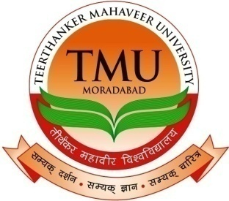

**Department of Computer Science & Engineering**

**College of Engineering**

**Teerthanker Mahaveer University**

## **Moradabad-244001**

Submission Date May- 2013

**Data and PC Securer**

**MAJOR PROJECT**

**Submitted in Partial Fulfillment of the Requirements for the Degree of**

**BACHELOR OF TECHNOLOGY**

**In**

**Computer Science & Engineering**

Submitted by

Shrey Kumar Jain

T09111253

Under the guidance of

Mrs. Gulista Khan

## Assistant Prof.



**Department of Computer Science & Engineering**

**College of Engineering**

**Teerthanker Mahaveer University**

## **Moradabad-244001**

Submission Date May- 2013