**Chapter 3**

**DATA FLOW DIAGRAM:**

A data flow diagram (DFD) is a graphical representation of the "flow" of data through an information system, modeling its process aspects. Often they are a preliminary step used to create an overview of the system which can later be elaborated. DFDs can also be used for the visualization of data processing (structured design).

DFD OF:

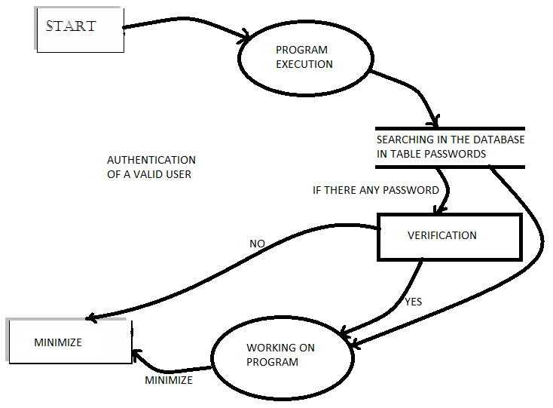

Settings

Fig: 3.1 STARTING A PROGRAM – AUTHENTICATION FOR A VALID USER: And Using its

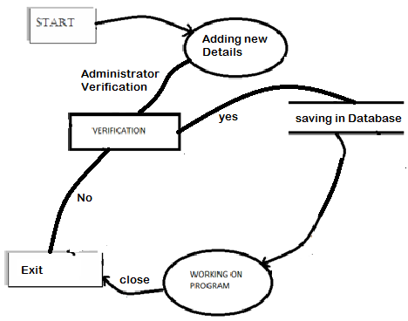

Fig: 3.2 Adding User

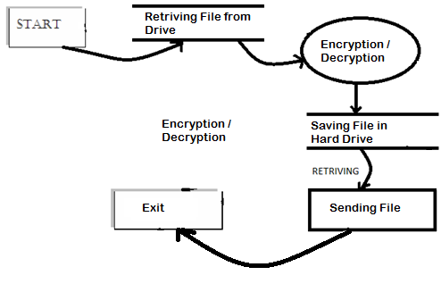

Fig 3.3: Encryption / Decryption:

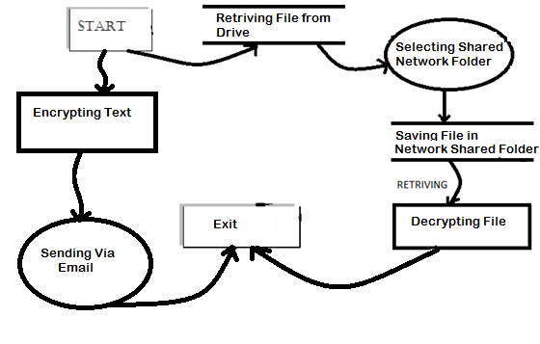

Fig 3.4: Sending Email and Sending File in Network: