DATA FLOW DIAGRAM:
A data flow diagram (DFD) is a graphical representation of the "flow" of data through an information system, modelling its process aspects. Often they are a preliminary step used to create an overview of the system which can later be elaborated. DFDs can also be used for the visualization of data processing (structured design).

DFD OF:
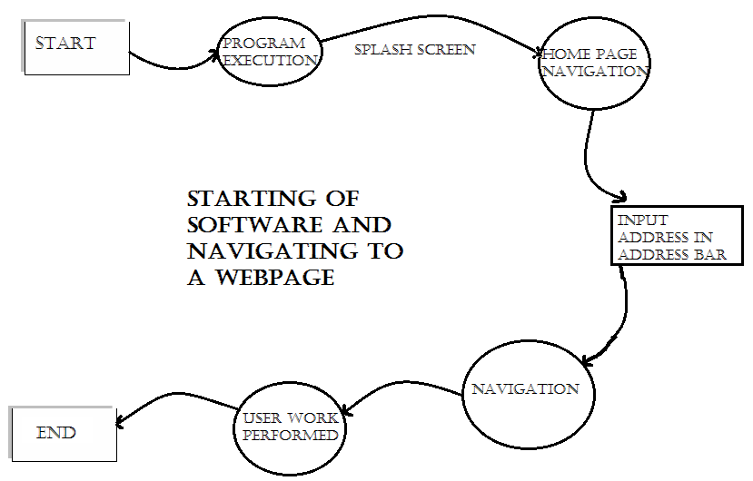
- STARTNG OF PROGRAM AND NAVIGATING TO A WEBPAGE:

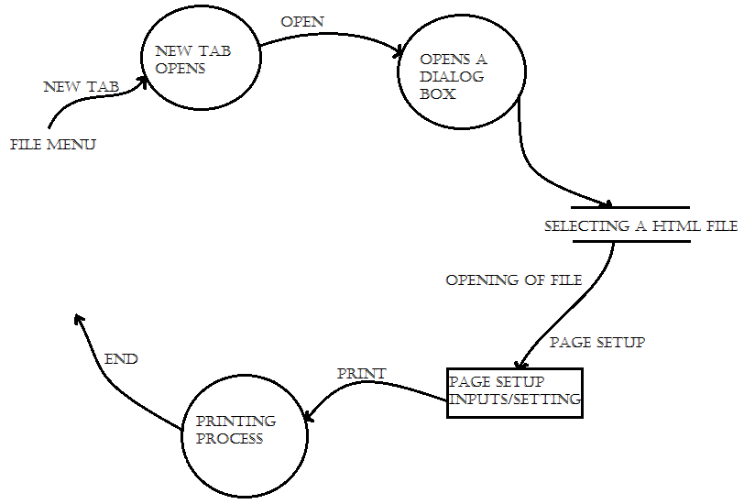
- File menu operations:
- Tools Menu:
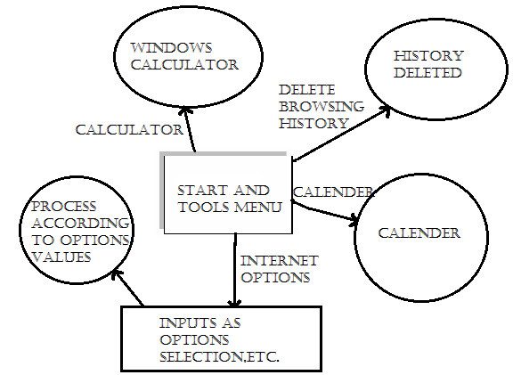

- Edit Menu operations:
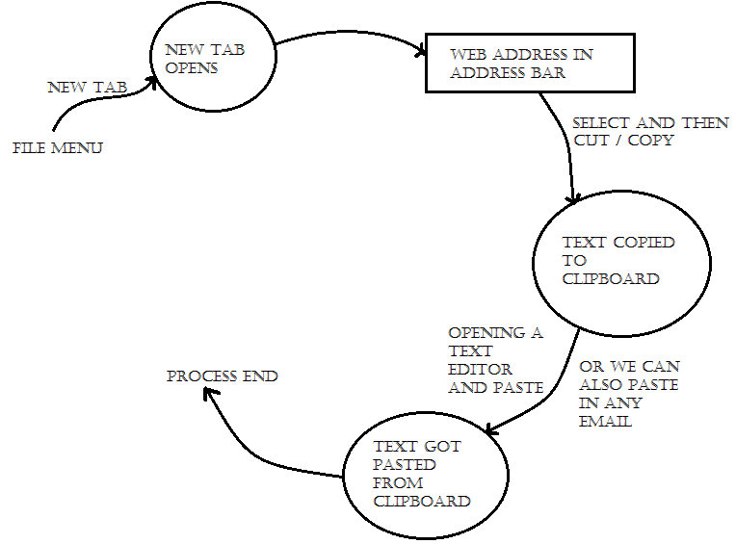

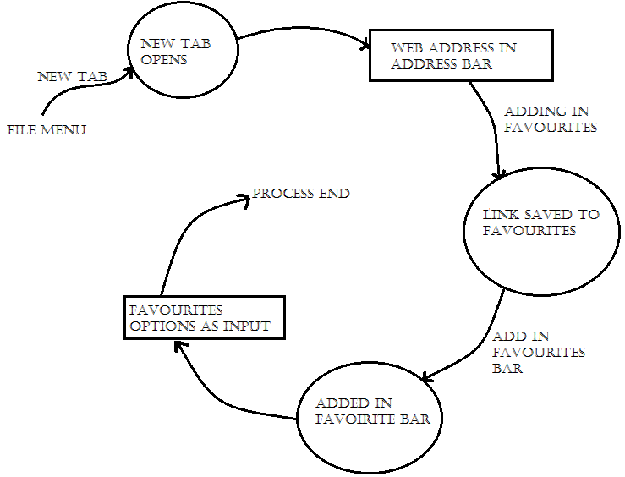
- Favourites menu:

