**SYSTEM TAB**

This is like the HOME page for my Application. It includes basic functionality like:

* Starting program as the System starts i.e. placing the software in “Startup list”.
* “Restricted Setting Mode” provide user to Enable/Disable password prompt and also the functionality to change older password or to add new password.

System tab looks like:

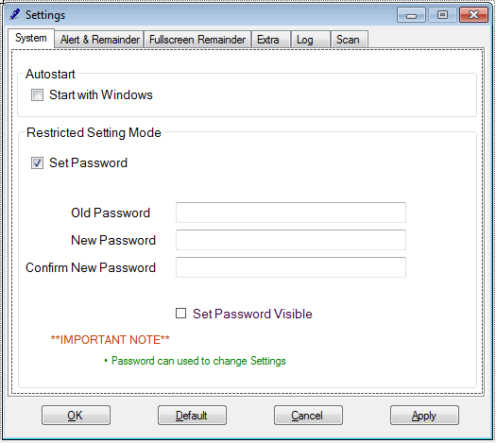

* Its Coding will be shown in Extra Coding Part.