**PASSWORD**

Password as the name it shows there must be some authentication for the user to prove himself as an Authorized one to use the particular Software/Application, Database, etc.

Here some of you can say “What was the need of Password here?”, this application is Generic and also does not contain such a functionality that need to be secret from other user of that computer.

But here I’ve used password so that the Application can be operated by only one authorized user generally Administrator of that computer. This is because as the Application have functionality to save user’s settings and there is also a function of hidden copy which stores the final folder destination (which must be secret from other user). So, there is a Password option.

Some points related to Password field:

* Every time the Application got maximized or restored to use, at that time user have to proof his/her authorization.
* It is totally depended on user to put password or not.
* User can change password any time when the application is restored.

What happen if password got wrong or not entered?

* The application will always remain in its minimized form unless a valid password is not entered.
* In case of wrong password a message box will be showed giving user about “what is going wrong?”

Is there any “User Name” field?

* No, because this application is intended to be used by only one User so it is not needed to include User Name.
* Including User Name field can make in irritating or that field too can act as a password field because there is only one user and if third user wants to use application then he must have user name and the password.
* As it was not necessary to put user name so it is not included in this application.

Password field looks like:

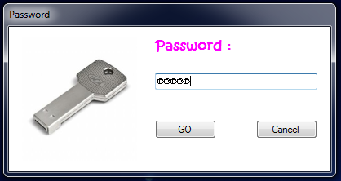

Clicking on “GO”:

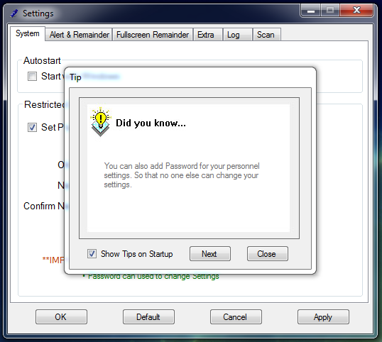

Changing old Password:

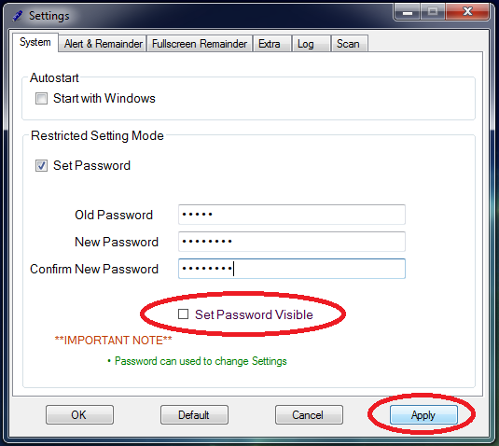

Set password visible checkbox will make password to be visible to user.

To change password:

* Put old password.
* Then put new password and the reconfirm it again.
* Then click on “Apply” button.
* In case you want to remove password, just put old password and leave “New Password and Confirm” field to blank. Then click on “Apply” button. This will remove the Password.

**Coding:**

* When “Apply” button is clicked:

private void button1_Click(object sender, EventArgs e)

{

SqlConnection con = new SqlConnection("Data Source=SHREYKUMARJAIN\\SHREYKUMARJAIN; Initial Catalog=usb_mgmt; Integrated Security=TRUE");

SqlCommand cmd, cmd1, cmd2,cmd3;

if (textBox1.Text != "")

{

if (textBox1.Text == textBox2.Text)

{

con.Open();

SqlDataReader rd;

cmd = new SqlCommand("select * from password", con);

rd = cmd.ExecuteReader();

if (rd.Read() == true)

{

if (textBox6.Text == rd[0].ToString())

{

con.Close();

con.Open();

cmd1 = new SqlCommand("update password set password= '" + textBox1.Text + "'where upno=1", con);

int temp = cmd1.ExecuteNonQuery();

if (temp > 0)

{

MessageBox.Show("Password updated");

}

else

{

MessageBox.Show("password not updated");

}

con.Close();

}

else

{

MessageBox.Show("Wrong Old Password");

textBox6.Clear();

textBox6.Focus();

}

}

}

}

//update settings....

con.Open();

cmd2 = new SqlCommand("delete from user_settings", con);

try

{

cmd2.ExecuteNonQuery();

}

catch (Exception exp)

{

MessageBox.Show(exp.ToString());

}

con.Close();

//insert new 1st row....

con.Open();

cmd3 = new SqlCommand("insert into user_settings values(1,'" + checkBox1.CheckState.ToString() + "','" + checkBox3.CheckState.ToString() + "','" + radioButton2.Checked.ToString() + "','" + checkBox4.CheckState.ToString() + "','" + checkBox5.CheckState.ToString() + "','" + checkBox6.CheckState.ToString() + "','" + checkBox7.CheckState.ToString() + "','" + radioButton4.Checked.ToString() + "','" + textBox5.Text + "','" + checkBox8.CheckState.ToString() + "')", con);

int tempo = cmd3.ExecuteNonQuery();

if (tempo > 0)

{

MessageBox.Show("Settings Applied");

}

else

{

MessageBox.Show("Unknown error during Application of Settings");

}

}

* Code behind Password Dialog box:

using System;

using System.Collections.Generic;

using System.ComponentModel;

using System.Data;

using System.Drawing;

using System.Text;

using System.Windows.Forms;

using System.Data.SqlClient;

using System.IO;

namespace SimpleDetector

{

public partial class Password : Form

{

public Password()

{

InitializeComponent();

}

private void button1_Click(object sender, EventArgs e)

{

if (textBox1.Text=="")

{

MessageBox.Show("Enter Password");

textBox1.Focus();

}

else

{

SqlConnection con = new SqlConnection("Data Source=SHREYKUMARJAIN\\SHREYKUMARJAIN; Initial Catalog=usb_mgmt; Integrated Security=TRUE");

SqlCommand cmd;

con.Open();

SqlDataReader rd;

cmd = new SqlCommand("select * from password", con);

rd = cmd.ExecuteReader();

if (rd.Read() == true)

{

if (textBox1.Text == rd[0].ToString())

{

this.Close();

}

else

{

MessageBox.Show("Invalid Password");

textBox1.Clear();

textBox1.Focus();

}

}

}

}

private void button2_Click(object sender, EventArgs e)

{

this.Close();

try

{

FileInfo f1 = new FileInfo("c:\\cancle_check.shrey");

StreamWriter sw = f1.CreateText();

sw.WriteLine("1");

sw.Close();

}

catch (IOException e1)

{

Console.WriteLine("an exception=>" + e1);

}

}

}

}