**TIPS**

This is the general functionality of utility software to give Tip as the software starts.

Tip dialog box is used to provide:

* Help options.
* Extra functionality.
* Tips to use software efficiently.
* Tips to use software as an expert user.
* Update information, etc.

Here tips are used to give its general functionality.

Tips are displayed:

* After every restart of the application.
* Displays many tips randomly and also one can see next tip by clicking on Next button.

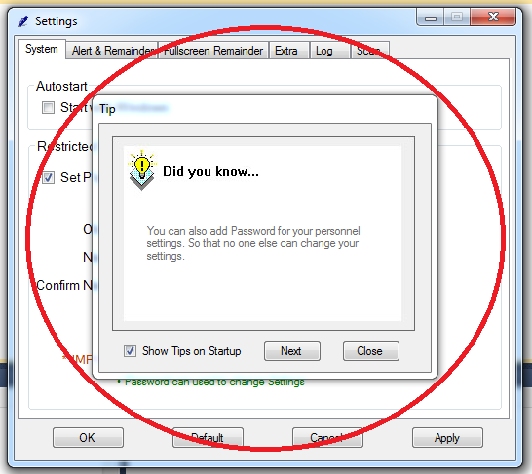Tips are displayed as:

**Coding:**

using System;

using System.Collections.Generic;

using System.ComponentModel;

using System.Data;

using System.Drawing;

using System.Text;

using System.Windows.Forms;

namespace SimpleDetector

{

public partial class Tip : Form

{

int choose=1;

public Tip()

{

InitializeComponent();

}

private void Tip_Load(object sender, EventArgs e)

{

// randomize choose;

switch (choose)

{

case 1: textBox1.Text = "You can also add Password for your personnel settings. So that no one else can change your settings.";

break;

case 2: textBox1.Text = "Icons can be added as Default icon for the Removable Disks not only for this PC but for all other too.";

break;

case 3: textBox1.Text = "After Setting icon to any Removal Disk then Don not format it else you'll loose the icon.";

break;

case 4: textBox1.Text = "For getting idea whats inside the Removable disk you can click on Scan to get details in TREE formate";

break;

case 5: textBox1.Text = "Log of insertion of Removable disk will be only Saved untill the software is Open";

break;

default: textBox1.Text = "You can also set a Path to copy all data from any Removable drive automatically. That too in Hidden form.";

break;

}

}

private void button2_Click(object sender, EventArgs e)

{

this.Close();

}

private void button1_Click(object sender, EventArgs e)

{

choose++;

if (choose > 6)

{

choose = 1;

}

Tip_Load(sender, e);

}

}

}

Note: Randomize coding is made abstracted to other than Developer that’s why deleted in this coding part.

Here only six tips are used but we can use much more as the developer wants.

In new version of this software there can be updatable Tip box too.