**FULLSCREEN REMAINDER**

It is also a good functionality contain some unique features. Full-screen Remainder is added to remained user about USB drive that any Pen Drive is still plugged in, so that he/she will not forget to safely remove.

What Full Screen Remainder has?

* It changes desktop wallpaper as the USB Drive got plugged in.
* User can set wallpaper from per loaded wallpapers.
* User can also give link to his other images which can be made as desktop wallpaper on plugging in of a Pen Drive.
* User can also make preview of his selected wallpaper.
* If user does not want to set selected wallpaper he/she can also reset back to his original wallpaper that was applied by them manually earlier.

Full Screen tab looks like:

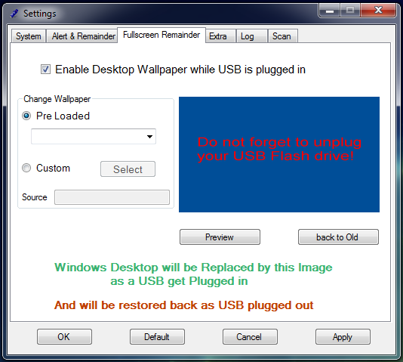

You can also Enable/ Disable this feature by the checkbox provided at the top:

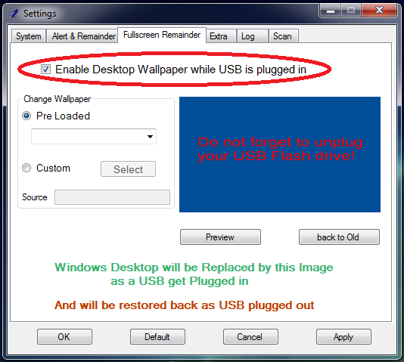

* This is a user defined setting.

Change wallpaper:

* Includes two functionality
  + To select Pre-Loaded wallpapers.
  + To select Custom wallpaper.
* In this version of Software only six pre-loaded wallpaper are provided and I am working to make it Updatable so that I can provide user to select more wallpaper that I’ll provide they later.
* Custom wallpaper selection can be done as:

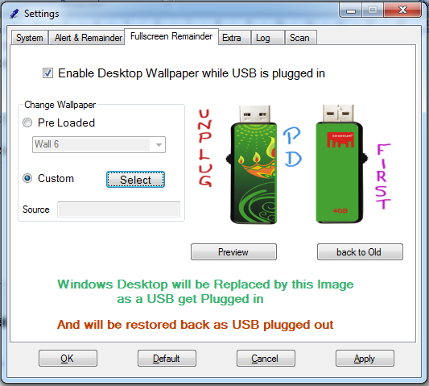

**Coding For Change wallpaper:**

**Custom:**

private void button5_Click(object sender, EventArgs e)

{

openFileDialog1.Filter = "images|*.jpg||*.png";

openFileDialog1.InitialDirectory = @"c:\";

if (openFileDialog1.ShowDialog() == DialogResult.OK)

{

textBox3.Text = openFileDialog1.FileName;

pictureBox1.ImageLocation = openFileDialog1.FileName;

}

}

Taking Preview of the Wallpaper that we selected:

* Select the Wallpaper you want to check.
* Then click on Preview button.
* As you click Preview button as the wallpaper of your desktop will change.
* You can also get back to your original Wallpaper which was selected by you earlier.

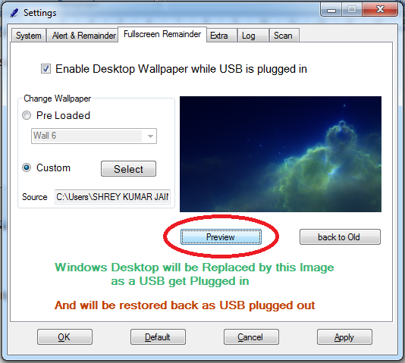

**Coding For Change wallpaper:**

**Preview:**

private void button13_Click(object sender, EventArgs e)

{

SystemParametersInfo(20, 0, pictureBox1.ImageLocation, 0x01 | 0x02);

RegistryKey rkWallPaper = Registry.CurrentUser.OpenSubKey("Control Panel\\Desktop", true);

rkWallPaper.SetValue("WallpaperStyle", 0);

rkWallPaper.Close();

}

**Back to Old:**

private void button14_Click(object sender, EventArgs e)

{

SystemParametersInfo(20, 0, old_wall, 0x01 | 0x02);

RegistryKey rkWallPaper = Registry.CurrentUser.OpenSubKey("Control Panel\\Desktop", true);

rkWallPaper.SetValue("WallpaperStyle", 3);

rkWallPaper.Close();

}