**ALERT AND REMAINDER**

Alert and remainder is also for the ease of user. It does following functionality:

* Set a User defined Message as Remainder for the Balloon Tip when any PD got inserted or plugged in.

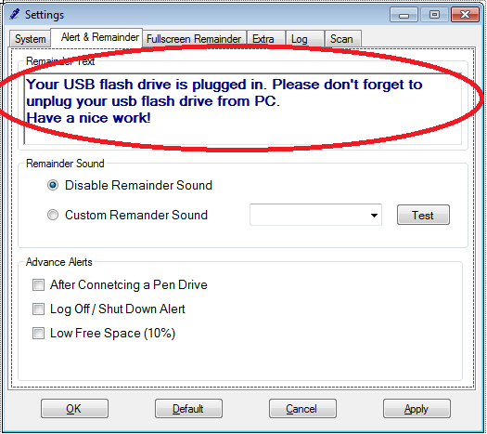

* Plays a sound clip also when there is any plugging in of any PD.
* It is a function which can be enable or disabled any time.
* The limitation here is only that user can select for sound clip which are provided be me i.e. developer.
* One functionality of testing the sound clip is provided.
* For this user have to click on “Test” button.

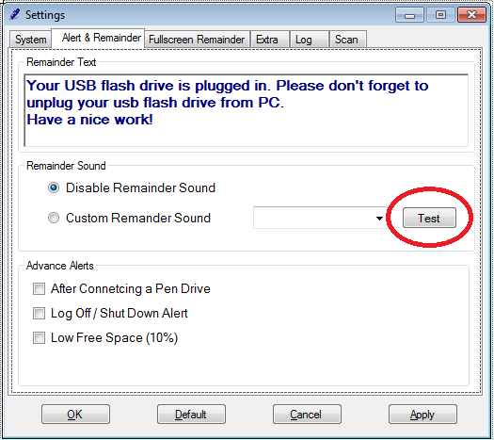

*Coding of this part is shown in Extra coding part.