**EXTRA**

As the name Extra provides user a different and extra functionalities or can be said that it provides some advanced features that can be used to utilize his/her USB drive in much more cool way.

Extra functionalities are provided under “Extra” tab:

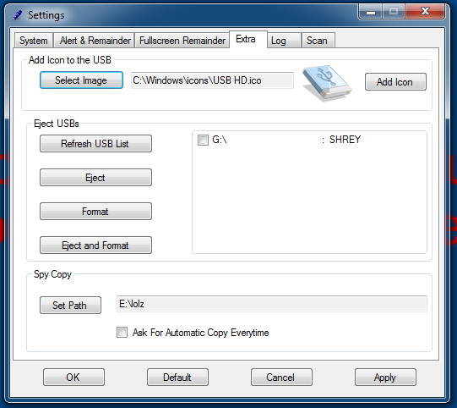

Includes functionalities like:

* Adding icon to the USB Drive:
  + It adds icon not only for user’s computer but that icon will be shown in every other computer in which that PD will be used.
  + For this user have to provide an icon file that can be used.
  + I am working on a new procedure that can convert any image to icon file, so that user will have more ease to add image as icon to PD. This feature will be definitely included in next version.
* Ejecting USB:
  + This functionality is used when user needs to eject one or more USB drives that are plugged in.
  + Includes a “Refresh USB List” button that can verify user that all USBs that are plugged - in are here.
  + Format function is also for the same task as its name.
    - Format can format every single USB that are selected.
  + “Format and eject” function first format and then eject all PD that are selected

**Coding for Refresh USB List:**

private void button7_Click(object sender, EventArgs e)

{

checkedListBox1.Items.Clear();

richTextBox3.Clear();

DriveInfo[] allDrives = DriveInfo.GetDrives();

foreach (DriveInfo d in allDrives)

{

if (d.DriveType.ToString() == "Removable")

{

checkedListBox1.Items.Add(d.Name);

richTextBox3.Text = richTextBox3.Text + " : " + d.VolumeLabel + "\n";

}

}

}

* SPY Copy:
  + It provides functionality of “Hidden Copy”*.

*See Hidden Copy in the index.