**SCAN**

Scan is the functionality provided in this software to give user:

* A short summary of all files and folder in the USB Drive they select from the checkbox.
* They can also get summary of folder and file folder separately.
* Here user can know the summary without opening the USB drive manually.
* User will get the detail as a tree and done within seconds.

This technique of searching and scanning also opens a new way to scan viruses in faster way.

But here virus checking is not included because it is another process uses some other algorithm and can make my project quite lengthier and much more like a highly professional software.

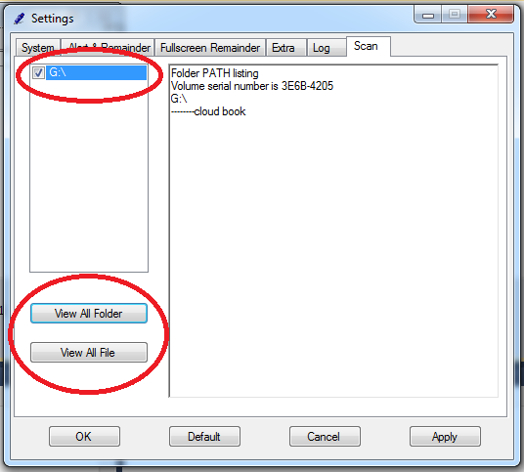Scan function Looks like:

In the upper red circle you can see a USB drive is selected i.e. checked which is to be selected.

As the selection part is over you can click on two buttons have usual meaning :

* “View All Folder” only shows folder.
* “View All Files” it also shows files with folders.

**Functionality:**

It uses the **System.Diagnostics.Process** library to run “Tree” command for the selected USB Drive.

As the textbox cannot function well for extra support of character to display, so I used Rich Text Box.

**Coding:**

public void ExecuteCommandSync(object command)

{

try

{

System.Diagnostics.ProcessStartInfo procStartInfo = new System.Diagnostics.ProcessStartInfo("cmd", "/c " + command);

procStartInfo.RedirectStandardOutput = true;

procStartInfo.UseShellExecute = false;

procStartInfo.CreateNoWindow = true;

System.Diagnostics.Process proc = new System.Diagnostics.Process();

proc.StartInfo = procStartInfo;

proc.Start();

string result = proc.StandardOutput.ReadToEnd();

richTextBox2.Text = result;

richTextBox2.Text = richTextBox2.Text.Replace("À", "--");

richTextBox2.Text = richTextBox2.Text.Replace("Ä", "--");

richTextBox2.Text = richTextBox2.Text.Replace("³", "|");

richTextBox2.Text = richTextBox2.Text.Replace("Ã", "--");

}

catch (Exception objException)

{

MessageBox.Show(objException.ToString());

}

}

On button click event:

private void button16_Click(object sender, EventArgs e)

{

string command = String.Empty;

command = "tree "+checkedListBox2.SelectedItem.ToString().Trim();

ExecuteCommandSync(command);

}

private void button17_Click(object sender, EventArgs e)

{

string command = String.Empty;

command = "tree " + checkedListBox2.SelectedItem.ToString().Trim() + " /f";

ExecuteCommandSync(command);

}