**DATA FLOW DIAGRAM:**

A data flow diagram (DFD) is a graphical representation of the "flow" of data through an information system, modelling its process aspects. Often they are a preliminary step used to create an overview of the system which can later be elaborated. DFDs can also be used for the visualization of data processing (structured design).

DFD OF:

1. 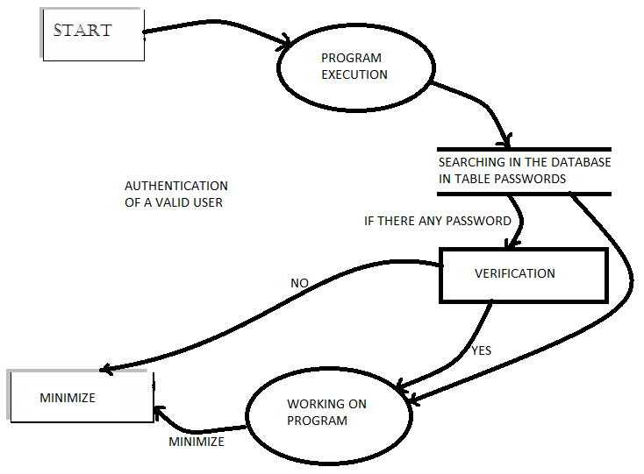STARTING A PROGRAM – AUTHENTICATION FOR A VALID USER:
2. 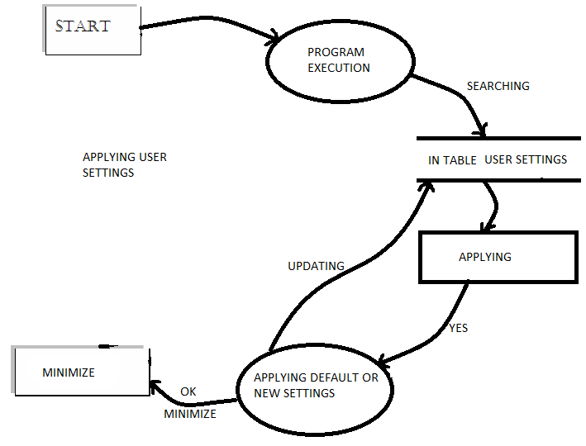GETTING OR APPLYING USER SETTINGS:

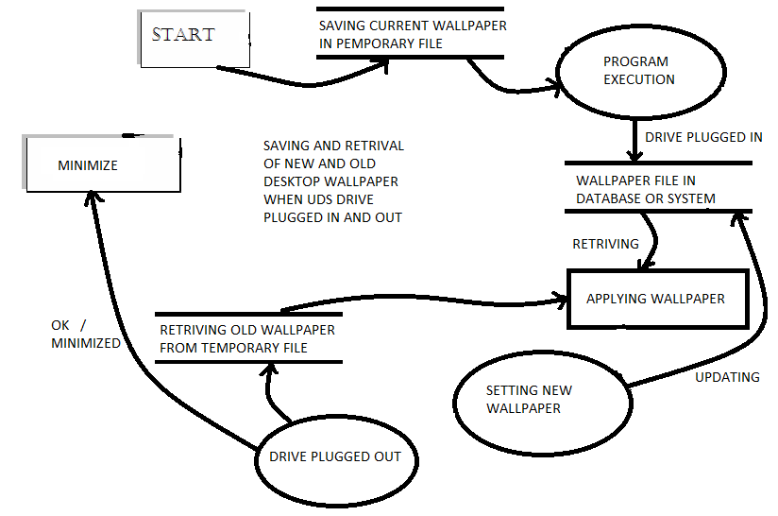

1. SETTING WALLPAPER AS USB DRIVE PLUGGED IN :
2. PLAYING OF SOUND CLIP, BALOON TIP, SCANNING AND OTHER FUNCTION :

